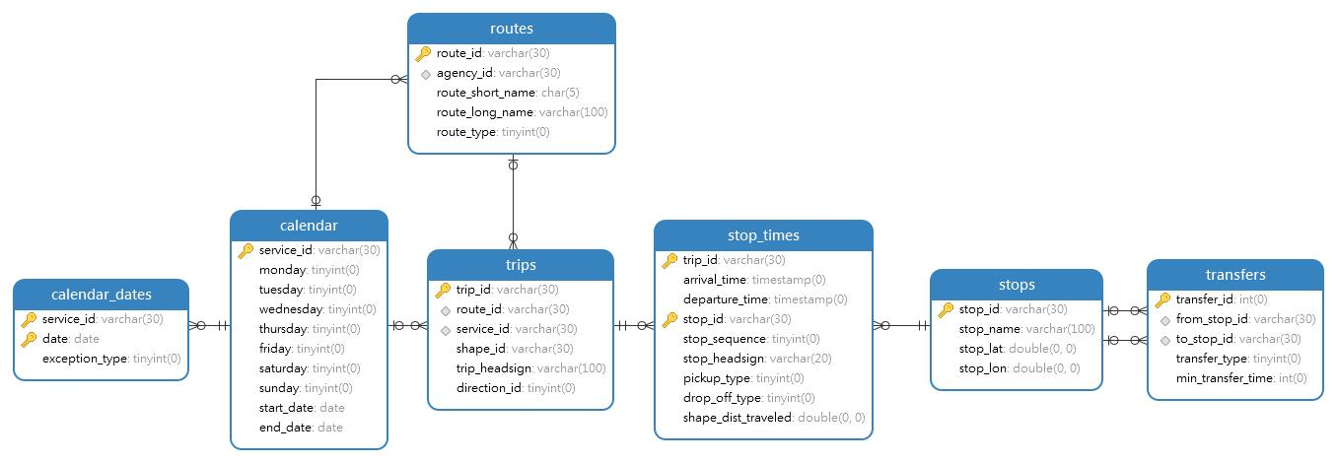
Relation schema
stops(stop_id,stop_name ,stop_lat ,stop_lon );

routes(route_id,agency_id,route_short_name,route_long_name,route_type );

trips(trip_id,route_id,service_id,shape_id,trip_headsign,direction_id);

stop_times(trip_id,arrival_time,departure_time,stop_id,stop_sequence,
stop_headsign ,pickup_type,drop_off_type,shape_dist_traveled);

transfers(transfer_id,from_stop_id,to_stop_id,transfer_type,min_transfer_time );

calendar(service_id,monday,tuesday,wednesday,thursday,friday,saturday,sunday,start_date,
end_date date);

calendar_dates(service_id,date,exception_type);

Foreigk keys
routes(agency_id) REFERENCES calendar(service_id)
stop_times(trip_id) REFERENCES trips(trip_id)
stop_times(stop_id) REFERENCES stops(stop_id)
trips(route_id) REFERENCES routes(route_id)
trips(service_id) REFERENCES calendar(service_id)
transfers(from_stop_id) REFERENCES stops(stop_id)
transfers(to_stop_id) REFERENCES stops(stop_id)
calendar_dates (service_id) REFERENCES calendar(service_id)

Query
select s.stop_id from trips t
join stop_times s on t.trip_id=s.trip_id
and t.route_id='' and direction_id=1
ORDER BY stop_sequence;

