Jiaqi Zhang  
Shuhui Yang  
Yu Qiu

Finalized Project Requirements (Foodelivery)

18-641 Java Smart Phone DEVELOPMENT

Catherine Yang

2016

1. **USER STORY**

**Overview**

Foodelivery is an O2O platform that provides connection between online/physical restaurants and offline consumers. Foodelivery offers both restaurant and consumer interfaces. Restaurant owners can manage menu, receive orders and process delivery while consumers are able to browse or search restaurants, scan the menu and place orders.

**Consumer Perspective**

* **Problem Identification:**

In the daily life, people always bother to think of where to eat and what to eat. On the one hand, employees and students are busy. They don’t have enough time to find restaurants or walk a long way to have meals. On the other hand, people are surrounded with a variety of restaurants and ubiquitous annoying advertisements, nevertheless, there’s no platform to help them intelligently find a satisfactory restaurant or place delivery order easily.

* **Product Vision:**

Foodelivery introduces a variety of restaurants that provide food delivery. On this platform, consumers can easily compare different restaurants and find a satisfactory one by browsing nearby restaurants, searching restaurants according to dish category, location or restaurant name. Furthermore, consumers could check the menu of each restaurant and place orders directly on Foodelivery. All these powerful functions such as effective search, order management and online payment make the whole process friendly, easy and time-efficient.

* **Stories:**

Christine is a graduate student in Carnegie Mellon University. Like most her classmates, Christine is occupied with consistent homework, quizzes and projects, therefore, she has no time to cook and nearly goes out for lunch and dinner every day. However, these days, Christine was more and more unsatisfied with such life. After having meals in limited nearby restaurants day by day, she finally got tired of these unsavory food. She wanted to improve her diet quality. Nevertheless, she knew little about delicious restaurants and really didn’t have enough time or energy to find them by herself. What’s worse, most delicious restaurants are not in a walk distance during lunch break, so it is inconvenient for her to have regular meals there.

The other day, one of Christine’s friends recommended her the Foodelivery application and she decided to have a try. After signing up as a consumer, Christine came to the consumer page and saw a variety of restaurants. Moreover, she surprisingly found it convenient to search for a restaurant via dish category, location or restaurant name. Christine finally chose a Chinses restaurant, Little Asia, and came to the page of it. This page described the basic information of Little Asia, such as location, telephone, etc. and provided a well-organized menu. More interestingly, Christine found that she could order these dishes directly via just several clicks. After placing the order, she filled in the Hamburger Hall as delivery address and her phone number and chose to pay online. Now, what she needed to do was just continuing her staff in comfortable sofa, and about 40 minutes later, she would be able enjoy delicious Chinese food.

Christine was very satisfied with the Foodelivery experience and becomes an active user now. She always says that the Foodelivery saved her stomach.

**Restaurant Perspective**

* **Problem Identification:**

Promotion is key component of restaurant success. However, most restaurant owners have difficulty in locating the target consumers and advertising in proper way. Traditional methods, such as issuing flyers, are proven to be ineffective, while online advertisement costs too much that small business owners usually can’t afford.

* **Product Vision:**

Foodelivery provides an opportunity for restaurants to touch their target consumers directly. By participating in Foodelivery, they obtain great benefits:

1. Advertisement effect: Restaurants owners can advertise them products to target consumers with little cost.
2. Distribution effect: Foodelivery offers a low-cost and effective online distribution channel for restaurants to sell their products.
3. Free of physical restaurant: By participating in Foodelivery, restaurants can get free of physical form and only service as selling takeout. In this business model, the restaurant owner could save great investment in restaurant rent and daily maintenance.

* **Stories:**

Stephen started a small restaurant two year ago, however, his business has been not good. Not able to afford the expensive rent of the best locations, his restaurant was kind of far from the two most-populated universities. What’s worse, he was not good at advertising his restaurant, consequently, few people knew or came to his restaurant.

Stephen heard about the Foodelivery application by chance and determined to participate in it. Scanning the restaurant guide, he found the process easy and effective. After signing up as a restaurant owner, Stephen filled in the basic information about his restaurant, such as address, telephone number, etc. Then, in the main page for restaurant user, Stephen found two easy-to-use functions: manage the menu and manage the order. He first chose the menu page and completed a well-organized menu, including flavor, ingredients, price, and pictures to make sure the menu was detailed and appealing. After deploying everything, Stephen started his first online delivery business. A few days later, he surprisingly found that some consumers learned about his restaurant through Foodelivery and he received many orders, especially during lunchtime when he received nearly as twice more orders then before.

After several months’ attempt, Stephen received more and more orders from Foodelivery so that he was considering to close his physical restaurant and focus on the delivery business. Now, Stephen is no longer worried about the poor physical location or his disadvantage in promotion because Foodelivery has solved all of these problems for him.

1. **PAGE FLOW DIAGRAM**
   1. Page Flow Diagram 1: Main Page  
      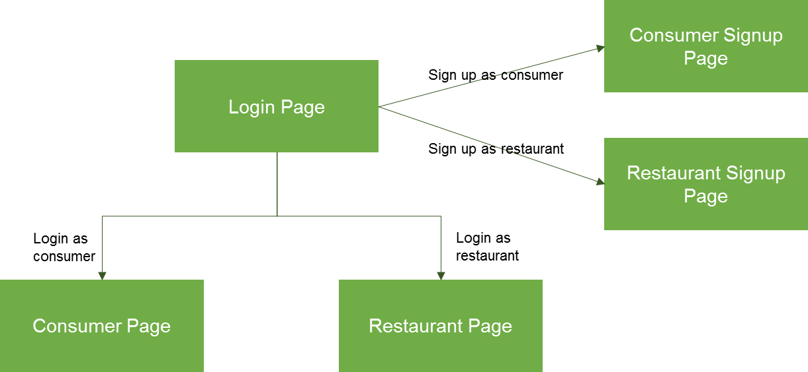
   2. Page Flow Diagram 2: Consumer Page  
        
      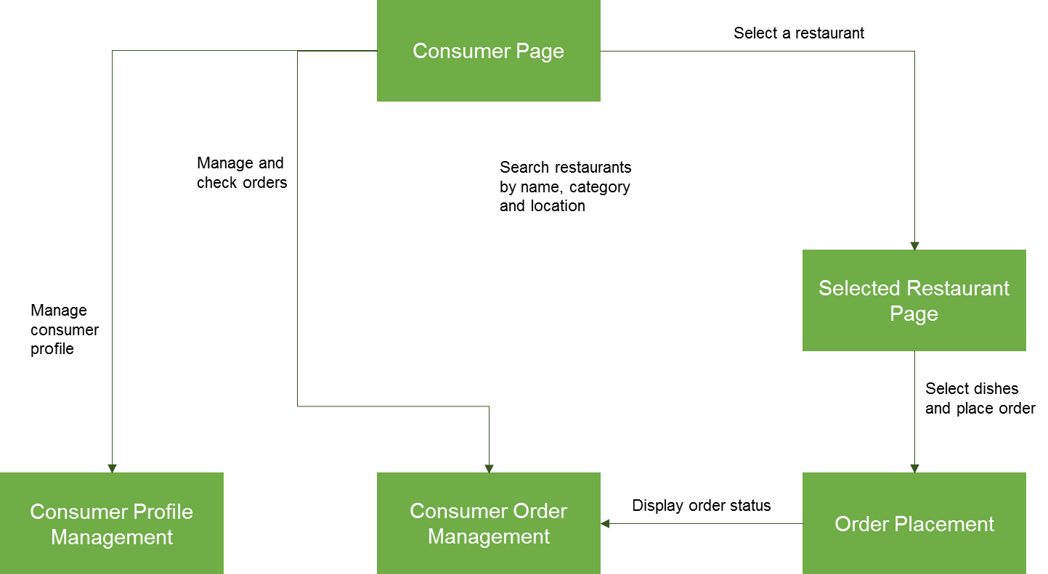
   3. Page Flow Diagram 3: Restaurant Page  
        
      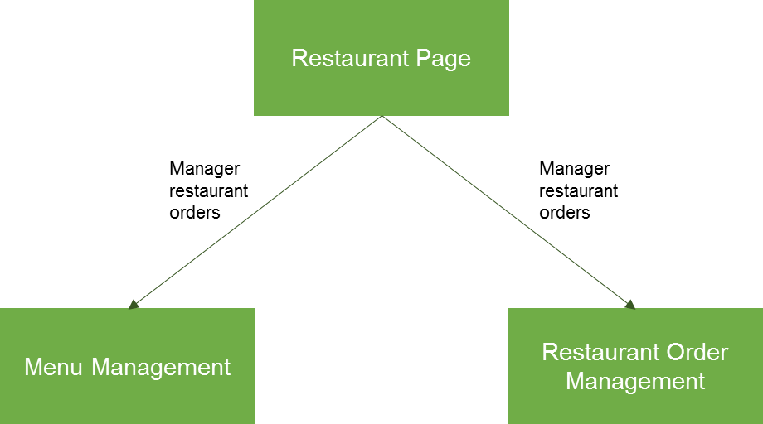

1. **USE CASES**
   1. Use Case Summary

|  |  |  |
| --- | --- | --- |
| **Use Case ID** | **Use Case Name** | **Use Case Description** |
| 1 | Login | Users log in the application |
| 2 | Customer Signup | Users sign up as customer |
| 3 | Restaurant Signup | Users sign up as restaurants |
| 4 | Customer | Users search restaurants based on name, category and location; System displays a list of selected restaurants |
| 5 | Order Placement | Users place orders |
| 6 | Customer Order Management | System displays order status; customers cancel order; customers confirm order |
| 7 | Customer Profile | Users manage profiles including name |
| 8 | Menu Management | Restaurants add or modify food name and pictures |
| 9 | Restaurant Order Management | System displays order status; restaurants accpet order; restaurants deliver order |
| 10 | Restaurant Profile | Users manage profiles including name |

* 1. Use Case 1: Login

|  |  |  |  |
| --- | --- | --- | --- |
| Use Case ID: | 1 | Use Case Name: | Login |
| Primary Actor(s): | Foodelivery users including restaurants and consumers | | |
| Secondary Actor(s): | N/A | | |
| Description: | Log in Foodelivery application; Go to sign up Foodelivery users. There are two types of user types; Consumer user and Restaurant user. Users select what kind of user type to sign up. | | |
| Preconditions: | Users succeed in opening Foodelivery application. | | |
| Normal Flow of Events: |  | | |
| 1 | Foodelivery displays the following edit texts and buttons:  a. *User E-mail*  b. *Password*  c. *Sign In As Customer*  d. *Sign In As Restaurant*  e. *Sign Up As Consumer*  f. *Sign Up As Restaurant* | | |
| 2 | User enters *User E-mail* and *Password.* | | |
| 3 | User clicks on *Sign In* *As Customer / Restaurant* button. | | |
| 4 | Foodelivery displays *Customer / Restaurant* page | | |
| 5 | User clicks on *Sign Up As Customer* button. | | |
| 6 | Foodelivery displays *Sign Up As Customer* page. | | |
| 7 | User clicks on *Sign Up As Restaurant* button. | | |
| 8 | Foodelivery displays *Sign Up As Restaurant* page. | | |
| Postconditions: |  | | |
| 1 | If the user is customer, FooDelivery displays *Customer* page. | | |
| 2 | If the user is restaurant, FooDelivery displays *Restaurant* page. | | |
| 3 | If the user chooses to sign up as customer, FooDelivery displays Sign Up As customer page. | | |
| 4 | If the user chooses to sign up as restaurant FooDelivery displays Sign Up As Restaurant page. | | |
| Frequency of Use: | High | | |
| Alternative Flows: | TBD | | |
| Exceptions: | N/A | | |

* 1. Use Case 2: Customer Signup

|  |  |  |  |
| --- | --- | --- | --- |
| Use Case ID: | 2 | Use Case Name: | Customer Signup |
| Primary Actor(s): | New foodelivery customer users | | |
| Secondary Actor(s): | N/A | | |
| Description: | Sign up Foodelivery application as customer users | | |
| Preconditions: | Users succeed in opening Foodelivery application and going to Customer Signup page. | | |
| Normal Flow of Events: |  | | |
| 1 | Foodelivery displays the following edit texts and buttons:  a. E-mail  b. Password  c. Confirm Password  d. Card  e. Address  f. Phone Number  g. Submit | | |
| 2 | User enters User E-mail, Password, Confirm Password, Card Number, Address and Phone Number. | | |
| 3 | User clicks on Submit button to submit application. | | |
| 4 | Foodelivery displays *Login* page. | | |
| Postconditions: | If the user enters information correctly and succeeds in signing up, FooDelivery displays *Login* page. | | |
| Frequency of Use: | Medium | | |
| Alternative Flows: | TBD | | |
| Exceptions: | N/A | | |

* 1. Use Case 3: Restaurant Signup

|  |  |  |  |
| --- | --- | --- | --- |
| Use Case ID: | 3 | Use Case Name: | Restaurant Signup |
| Primary Actor(s): | New foodelivery restaurant users | | |
| Secondary Actor(s): | N/A | | |
| Description: | Sign up Foodelivery application as restaurant users | | |
| Preconditions: | Users succeed in opening Foodelivery application and going to Restaurant Signup page. | | |
| Normal Flow of Events: |  | | |
| 1 | Foodelivery displays the following edit texts and buttons:  a. Restaurant Name  b. E-mail  c. Phone Number  d. Password  e. Confirm Password  f. Card  g. Address  h. Location  i. Category  j. Image Source URL | | |
| 2 | User enters Restaurant name, E-mail, Phone Number, Password, Confirm Password, Card Number, Address, Location, Category and Image Source URL. | | |
| 3 | User clicks on Submit button to submit application. | | |
| 4 | Foodelivery displays *Login* page. | | |
| Postconditions: | If the user enters information correcly and succeeds in signing up, FooDelivery displays *Login* page. | | |
| Frequency of Use: | Medium | | |
| Alternative Flows: | TBD | | |
| Exceptions: | N/A | | |

* 1. Use Case 4: Customer

|  |  |  |  |
| --- | --- | --- | --- |
| Use Case ID: | 4 | Use Case Name: | Customer |
| Primary Actor(s): | Foodelivery customer users | | |
| Secondary Actor(s): | N/A | | |
| Description: | Users search restaurants based on name, category and location | | |
| Preconditions: | Users succeed in logging in Foodelivery application. | | |
| Normal Flow of Events: |  | | |
| 1 | Foodelivery displays the following edit texts, spinners and buttons:  a. *Search*  b. *Category*  c. *Location*  d. *Submit* | | |
| 2 | User enters *Search* Word, and chooses *Category* and *Location.* | | |
| 3 | User clicks on *Submit* button to search target restaurants. | | |
| 4 | Foodelivery displays list of results. | | |
| Postconditions: | If the user enters information correctly, Foodelivery displays a list of selected restaurants. | | |
| Frequency of Use: | High | | |
| Alternative Flows: | TBD | | |
| Exceptions: | N/A | | |

* 1. Use Case 5: Order Placement

|  |  |  |  |
| --- | --- | --- | --- |
| Use Case ID: | 5 | Use Case Name: | Order Placement |
| Primary Actor(s): | Foodelivery customer users | | |
| Secondary Actor(s): | N/A | | |
| Description: | This page is used to collect order details including order quantity, delivery address, phone number, payment methods to place the order. | | |
| Preconditions: | Users succeed in logging in Foodelivery application and selected a restaurant. | | |
| Normal Flow of Events: |  | | |
| 1 | Foodelivery displays the following edit texts, spinners and buttons:  a. *Available food list*  b. *Delivery Address*  b. *Phone#*  e. *Payment*  f. *Place Order button* | | |
| 2 | User chooses food and selects quantity. | | |
| 3 | User enters divery address and phone number. | | |
| 4 | User clicks on Place Order button. | | |
| Postconditions: | Foodelivery submits the order and redirects the user to Customer page | | |
| Frequency of Use: | High | | |
| Alternative Flows: | TBD | | |
| Exceptions: | Insufficient balance | | |

* 1. Use Case 6: Customer Order Management

|  |  |  |  |
| --- | --- | --- | --- |
| Use Case ID: | 6 | Use Case Name: | Customer Order Management |
| Primary Actor(s): | Foodelivery customer users | | |
| Secondary Actor(s): | N/A | | |
| Description: | System displays order status; customers cancel order; customers confirm delivery | | |
| Preconditions: | Users succeed in logging in Foodelivery application. | | |
| Normal Flow of Events: |  | | |
| 1 | Foodelivery displays the following view texts and buttons:  a. *Order#*  b. *Restaurant*  c. *Status*  d. *Confirm Order*  e. *Cancel Order* | | |
| 2 | User checks the checkbox of corresponding order | | |
| 3 | User clicks on *Confirm Order* button to confirm food order | | |
| 4 | User clicks on Cancel Order button to cancel order and delivery | | |
| Postconditions: | If the user clicks on *Confirm Order* button, the order is closed successfully. If the user clicks on *Cancel Order* button, the order is canceled successfully. | | |
| Frequency of Use: | High | | |
| Alternative Flows: | TBD | | |
| Exceptions: | N/A | | |

* 1. Use Case 7: Customer Profile

|  |  |  |  |
| --- | --- | --- | --- |
| Use Case ID: | 7 | Use Case Name: | Customer Profile |
| Primary Actor(s): | Foodelivery customer users | | |
| Secondary Actor(s): | N/A | | |
| Description: | This page is used to display and manage customer information including password, card, address, and phone#. | | |
| Preconditions: | Users succeed in logging in Foodelivery application. | | |
| Normal Flow of Events: |  | | |
| 1 | Foodelivery displays the following edit texts and buttons:  a. *E-mail, Password, card, address, phone number*  b. *Edit button*  c. *Save button* | | |
| 2 | User clicks on Edit button to enable update. | | |
| 2 | User modifies corresponding fileds, such as password, credit card number, address, etc. | | |
| 3 | User clicks on Save button to commit the modification. | | |
| Postconditions: | Foodelivery displays modified consumer information. | | |
| Frequency of Use: | Low | | |
| Alternative Flows: | TBD | | |
| Exceptions: | N/A | | |

* 1. Use Case 8: Menu Management

|  |  |  |  |
| --- | --- | --- | --- |
| Use Case ID: | 8 | Use Case Name: | Menu Management |
| Primary Actor(s): | Foodelivery restaurant users | | |
| Secondary Actor(s): | N/A | | |
| Description: | Restaurants add or delete food | | |
| Preconditions: | Users succeed in logging in Foodelivery application. | | |
| Normal Flow of Events: |  | | |
| 1 | Foodelivery displays the following view texts and buttons:  a. *Name*  b. *Price*  c. *Add*  d. *Delete*  e. *New Name*  f. *New Price*  g. *New Image URL* | | |
| 2 | User enters new food name, price and image url | | |
| 2 | User clicks on *Add* Food button to add new food | | |
| 3 | User checks the checkbox of corresponding food to be deleted | | |
| 5 | User clicks on *Delete* Food button to delete food | | |
| Postconditions: | If the user clicks on *Add* Foodbutton, new food is added to menu. If the user clicks on *Delete* Food button, an existing food with the name is deleted from the restaurant menu. | | |
| Frequency of Use: | High | | |
| Alternative Flows: | TBD | | |
| Exceptions: | N/A | | |

* 1. Use Case 9: Restaurant Order Mangaement

|  |  |  |  |
| --- | --- | --- | --- |
| Use Case ID: | 9 | Use Case Name: | Restaurant Order Mangaement |
| Primary Actor(s): | Foodelivery restaurant users | | |
| Secondary Actor(s): | N/A | | |
| Description: | This page is used to display and process orders that the restaurant received. | | |
| Preconditions: | Users succeed in logging in Foodelivery application. | | |
| Normal Flow of Events: |  | | |
| 1 | Foodelivery displays the following edit texts and buttons:  a. Order details including *date, price and status*  b. *Accept button*  *c*. *Deliver button* | | |
| 2 | Restarant User clicks on *Accept* button to accept the order | | |
| 3 | Restarant User clicks on *Deliver* button to delivery the order | | |
| Postconditions: | Order status is changed to In Delivery after restaurant user clicks on Accept or Deliver button. | | |
| Frequency of Use: | High | | |
| Alternative Flows: | TBD | | |
| Exceptions: | N/A | | |

* 1. Use Case 10: Restaurant Profile

|  |  |  |  |
| --- | --- | --- | --- |
| Use Case ID: | 10 | Use Case Name: | Restaurant Profile |
| Primary Actor(s): | Foodelivery restaurant users | | |
| Secondary Actor(s): | N/A | | |
| Description: | This page is used to display and manage restaurant information including password, card, address, and phone#. | | |
| Preconditions: | Users succeed in logging in Foodelivery application. | | |
| Normal Flow of Events: |  | | |
| 1 | Foodelivery displays the following edit texts and buttons:  a. Restaurant details including *Category, Address and Location*  b. *Edit button*  *c*. *Save button* | | |
| 2 | Restarant User clicks on *Edit* button to enable profile update | | |
| 3 | User modifies corresponding fileds, such as password, credit card number, address, etc. | | |
| 4 | Restarant User clicks on *Save* button to save changes | | |
| Postconditions: | Order status is changed and SMS message is sent to customer. | | |
| Frequency of Use: | High | | |
| Alternative Flows: | TBD | | |
| Exceptions: | N/A | | |

1. **WIREFRAMES**
   1. Use Case 1: Login

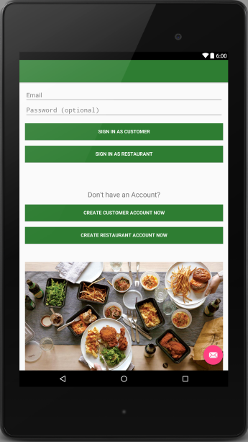

* 1. Use Case 2: Consumer Signup

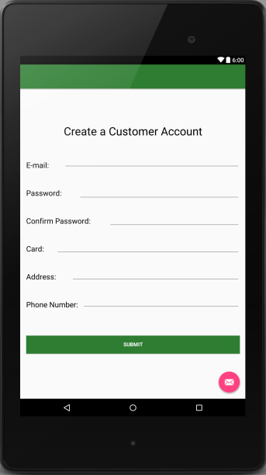

* 1. Use Case 3: Restaurant Signup  
     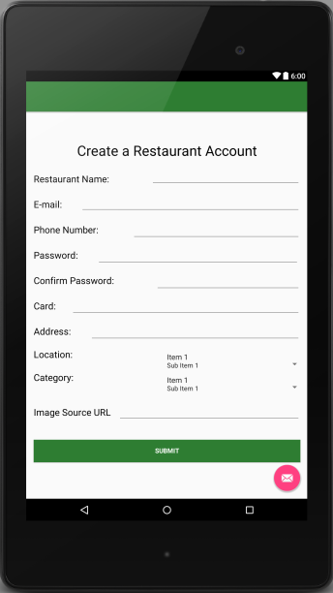
  2. Use Case 4: Consumer search page

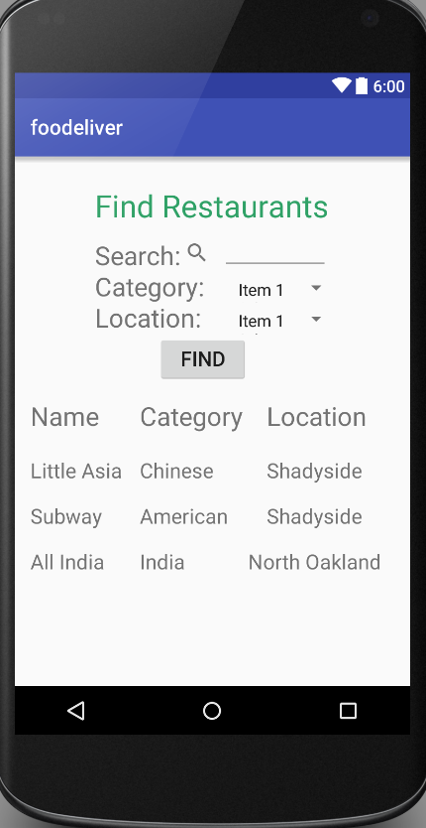

* 1. Use Case 5: Selected Restaurant

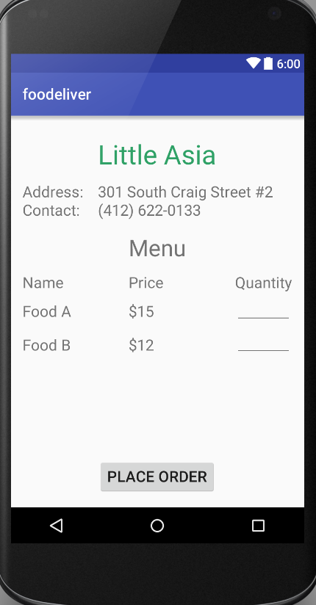

* 1. Use Case 6: Order Placement

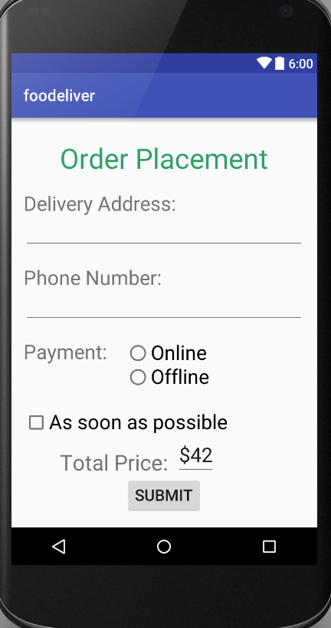

* 1. Use Case 7: Consumer Order Management

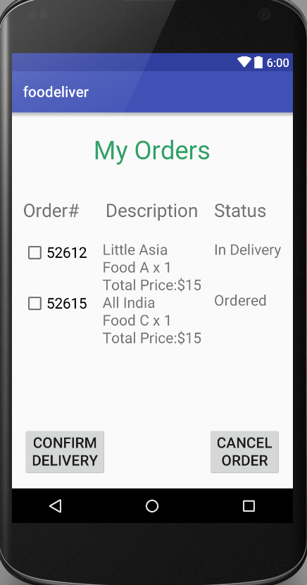

* 1. Use Case 8: Consumer Profile

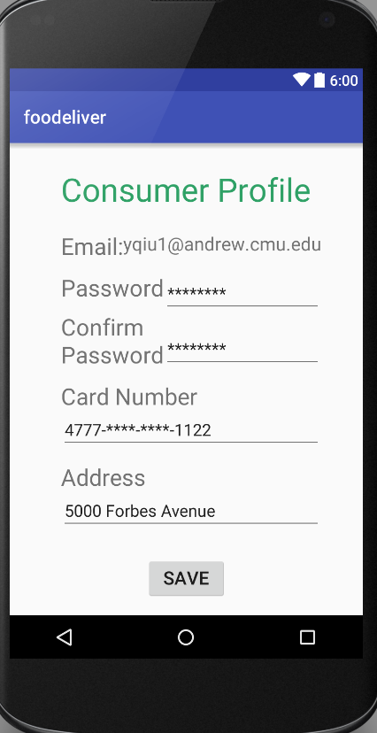

* 1. Use Case 9: Restaurant Profile

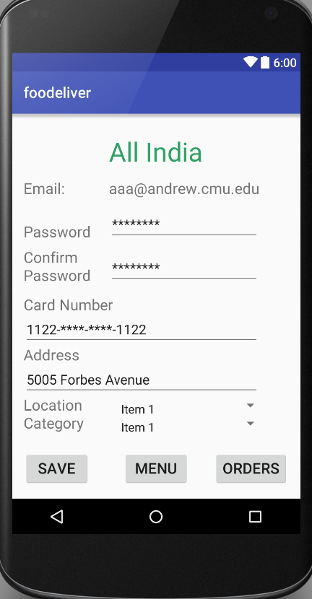

* 1. Use Case 10: Menu Management

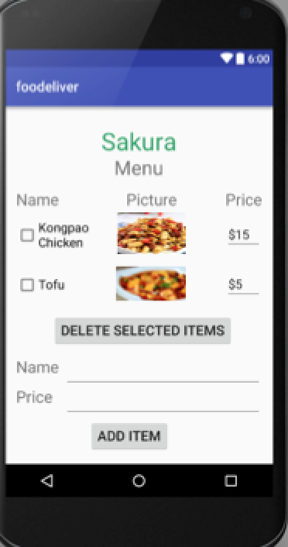

* 1. Use Case 11: Restaurant Order Management

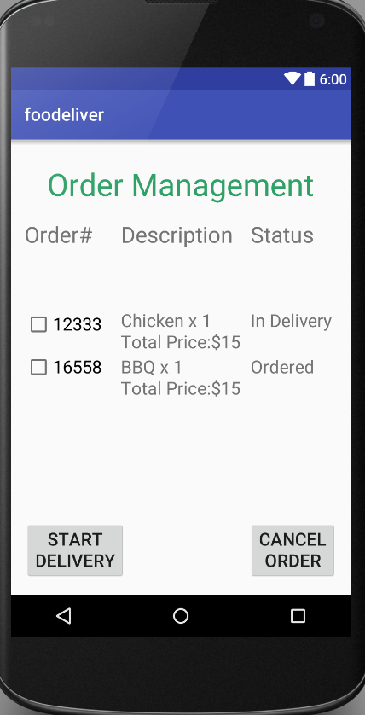

1. **HARDWARE REQUIREMENTS**

* System takes customer’s current GPS information to recommend some near restaurants in Search Restaurant page
* System sends SMS message with updated order status to customer
* System requires device’s access to internet