Experiment 2: DC Motor Transfer Function Estimation by Explicit Measurement

Introduction
There are three common methods for determining a plant’s transfer function. They are:

- Measure all the physical parameters of the system used to derive the equations. Then compute the overall transfer function. – (Experiment 2)
- Treat the system as a black box and use:
  - frequency response, or
  - step response methods to determine DC gain, poles, and zeros of the system. – (Experiment 3)

The following physical quantities of the DC Motor need to be measured to determine its transfer function:

  - Armature resistance: R_{a} [ohms]
  - Armature inductance: L_{a} [Henries]
  - Torque constant: K_{T} [N-m/amp]. Proportionality constant that relates Torque and current. Please refer to equation 5.
  - Back EMF constant: K_{b} [volts-s/rad]. Proportionality constant that relates Angular velocity and back e.m.f. . Please refer to equation 2.
  - Viscous friction coefficient: B [N-m-s/rad]
  - Rotor moment of inertia: J [kg-m²]

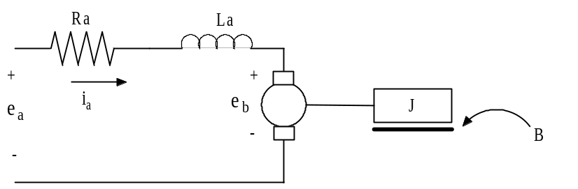
Figure 1: D.C. Motor Diagram

This lab focuses on measuring motor properties by manipulating the system in order to reduce its describing equations, permitting parameter measurement via the output characteristics from a given input. For example, we might stop the motor from rotating and thus nullify all velocity terms from the equations of motion.

Experiment 3 Pre-Lab
- In your own words, define what a mathematical model is. Why are mathematical models important in engineering?
- Describe (with figures) two methods for determining the time constant of an exponential decay.
- Based on conservation of energy principals, set mechanical power equal to electrical power and show that K_{b} = K_{T}. (Use SI units for all your calculations). The easiest way to do this is to think of the situation where the motor+ and motor– leads are shorted together, e_{a} = 0. In this case if you manually move the motor the only voltage generated in the circuit is due to the back-emf of the motor. Recall that in this case, P_{el} = E_{B} * I_{A} and P_{mech} = T_{m} * ω.
- Write the 4 electrical and mechanical equations that may be used to find the transfer function of the DC motor ω(s)/Ea(s). Use Figure 1 as a guide.
- Using the equations in question 4, describe how you would measure:
  - Viscous friction
  - Rotor moment of inertia
  - Armature resistance
- Compute the voltage drop across R_{s} in the circuit shown in Figure 2. Also find the time constant for this R-L circuit

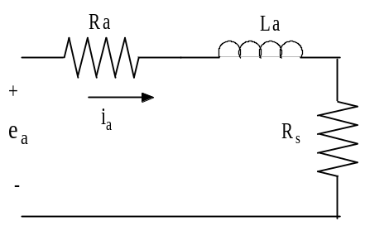
Figure 2: RL circuit

Armature Resistance: R_{a}
Public Service Announcement: Many of the values obtained in this lab will need to be recorded and saved for future use. Please record all coefficient and parameter values on your data sheet and also on something that you will not turn in with a lab report and bring the values to subsequent labs.

Equation 1 (see below) describes the relationship between the input voltage, the armature resistance, armature inductance and the back EMF. If the rotor is restricted from rotating (see Figure 3), the back EMF will become zero (due to the fact that back EMF is proportional to angular velocity, Equation 2). Similarly, the armature inductance term will reduce to zero once steady state conditions have been reached. Hence, by measuring the input voltage and the resultant current we can measure R_{a}. Follow the directions below:

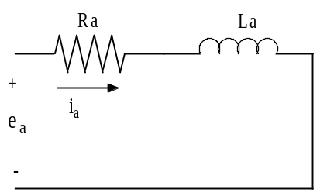
Figure 3: Model of locked motor
- Place the binder clip on the elevated surface to prevent the motor from moving. Connect the HP 0-20V power supply to the motor.
- Turn on all the equipment (don’t forget the HP 6632A programmable power supply) and then open the Agilent VEE file: “n:/labs/ge320/exp2/ra.vxe”
- From the computer, “Reset” the power supply and then switch “Output Enable” off. Set the current to 1 amp and the voltage to 5V.
- At the Agilent VEE console, toggle the “Output Enable” of the power supply to “ON”. This enables the power supply’s voltage. You can look at the power supply’s display and see what actual voltage and current is being applied. Record these values and those obtained by incrementing the applied voltage in increments of 0.5volts to 7volts. Record the data from each trial in your data sheet.
- Toggle “Output Enable” to “OFF” on the power supply console and show your measurements to the TA.
- Keep the Agilent VEE file open as you will use it for the rest of the expirment.

Equation 1: Circuit Voltage Equation
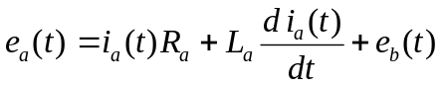
Equation 2: Angular Velocity - Back EMF
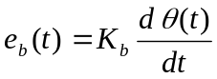

Armature Inductance, L_{a}

Consider again Equation 1. By locking the rotor (Figure 3) we will once again reduce the back EMF to zero. However, we are now concerned with finding the armature inductance and hence will consider the transient response of the resulting armature circuit. By putting a “Resistor Box” in series with the motor we can then measure the voltage drop across the resistor to graphically obtain the time constant. Once the time constant is found Equation 3 can be solved for the motor’s inductance.
Equation 3: Time constant for RL circuit
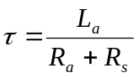
If you are not clear where this equation comes from, ask your TA for further explanation.

- The time constant of this motor is very small. Your TA will demonstrate a close approximation to the time constant with the oscilloscope.
- To obtain a more accurate measurement of Inductance you will use an LCR meter. There is only one LCR meter in the lab. When it is available measure the armature inductance of your motor by attaching the red wire meter to green of the motor and black of the meter to blue of the motor. The dial should be on the 20mH setting. Record this value in your data sheet.

Back – EMF Constant and Viscous Friction Coefficient

The goal of this section will be to compute the back – EMF constant (K_{b}). To do so, the motor will be permitted to spin freely and measurements will be taken when the system has reached its steady state. Consider Equation 1. Once steady state is reached, I_{a} will be constant, therefore, its derivative will be zero. Substituting Equation 2 into Equation 1 yields Equation 4:
Equation 4
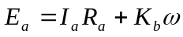

The angular velocity ( ω ) can be found by measuring the tachometer voltage and using the gain found in Lab 1. Since K_{b} = K_{T} (in the SI system, as you proved in the prelab), finding K_{b} will give K_{T}. At steady state conditions, combining Equation 5 and Equation 6 yields Equation 7, which allows us to compute the viscous Friction Coefficient (B).

Equation 5: Torque – current Equation
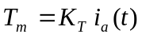

Equation 6: Mechanical equation
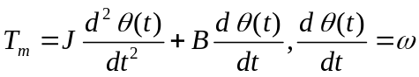
Equation 7
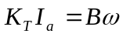

Follow the directions below:

- Remove the binder clip. Connect the power supply directly to the motor.
- You will use Simulink to measure the motor’s speed via the tachometer.
- Copy the Simulink file: “n:/labs/ge320/kit/exp2/tach.slx” to the folder on the hard drive that you have used in previous semesters (c:/Matlab/GE320/netid).
- Change the MATLAB path to the same folder on the hard drive.
- In the MATLAB Command window, run the following command
  - mypi=raspi(‘ipaddress’,’pi’, ’raspberry’), where ipaddress refers to the actual IP address on the label affixed to the base of the kit.
- From the computer “Reset” the power supply and then switch “Output Enable” off. Set the current to 1 amp and the voltage to 5V.
- Press play on the Simulink model. Then record the speed from the “tach” plot on the scope.
- When the command window pops to indicate the model is about to run on the Raspberry Pi, switch “Output Enable” to On
- Measure the applied voltage (E_{a}) and the steady–state current (I_{a}) drawn by the motor
- Turn off the power supply using the “Output Enable” button.
- Record the tachometer speed from the scope in Simulink.
- Compute the parameters K_{b}, K_{T}, and B and record these values.
- Repeat steps 7-12 of this section with 7.5 volts applied to the motor.

Rotor Moment of Inertia
The motor’s moment of inertia (J) and the friction coefficient (B) establish the angular velocity decay rate once current to the motor has been cut. Equation 6 links J and B to the time constant of the velocity decay since the T _{m} = 0. With B known, we can find J. (τ = J/B). A thumb switch is used to cut the current instantaneously. If you are not clear where τ = J/B came from, ask your TA for further explanation.

- Connect the “Thumb Switch Box” in series with the motor. Depressing the thumb switch will disconnect the power supply to the motor.
- You will use the same Simulink model and Agilent VEE program as the last step to view the tachometer.
- Set the HP Power Supply to 7.5 volts and 1 amp in Agilent VEE.
- Press the play button in Simulink.
- When the command window pops to indicate the model is about to run on the Raspberry Pi, switch “Output Enable” to On
- After the Simulink model is running on the Raspberry Pi, let go of the thumb switch. Do this several more times while the model is running.
- Estimate the time-constant τ_{m}. Using the values of B and τ_{m} calculate J.
- Make sure that all values are recorded in your data sheet.

Lab 3: Post Lab
Include answers to the following questions in your lab report. Be brief.

- Using the various quantities measured in this experiment, compute the voltage to angular velocity second order transfer function ω(s)/Ea(s).
- Theoretically, in the experiment for the measurement of J the angular velocity of the rotor should decay exponentially. Do you think the decay looked exponential? Explain your observation.
- Compute the poles of the second order transfer function ω(s)/Ea(s). Justify, in terms of speed of the poles, that a first order transfer function can be used to model this motor. Derive the first order transfer function ω(s)/Ea(s).
- What is the motor’s voltage to angular position transfer function θ(s)/Ea(s)?

Lab 3: Data Sheet
Armature Resistance
Current | Voltage | Ra
Average

Armature Inductance
Armature Inductance (L)

Back – EMF Constant and Viscous Friction Coefficient
E_{a} | I_{a} | ω | K_{b} (=K_{t}) | B
5V
7.5V

Rotor Moment of Inertia
Time Constant (τ)
Moment of Inertia (J)

