Experiment 5: Position Control Systems

Introduction
The objective of this lab is to convert the DC motor to an electromechanical positioning actuator by properly designing and implementing a proportional and a proportional-plus-derivative (P-D) controller. Simulation and design values for the controller gains computed in the pre-lab will be compared to values obtained by empirical testing.

Lab 5: Pre-Lab
The pre-lab uses previous lab results as well as an understanding of the proposed closed loop system. Refer to the Implementation Diagrams in: Figure 2, Figure 3 and Figure 4 for guidance. Ensure to take into account all the gains!
- From Lab 3 and Lab 4, we found the following transfer function for a DC motor:
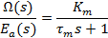
Using integration in the Laplace domain, derive the transfer function for motor position from the velocity transfer function above.

- Place the position transfer function in a unity feedback loop with proportional gain controller. See Figure 1. Calculate the closed loop transfer function of this system. Hint: it should simplify into the form of an ideal second order system.

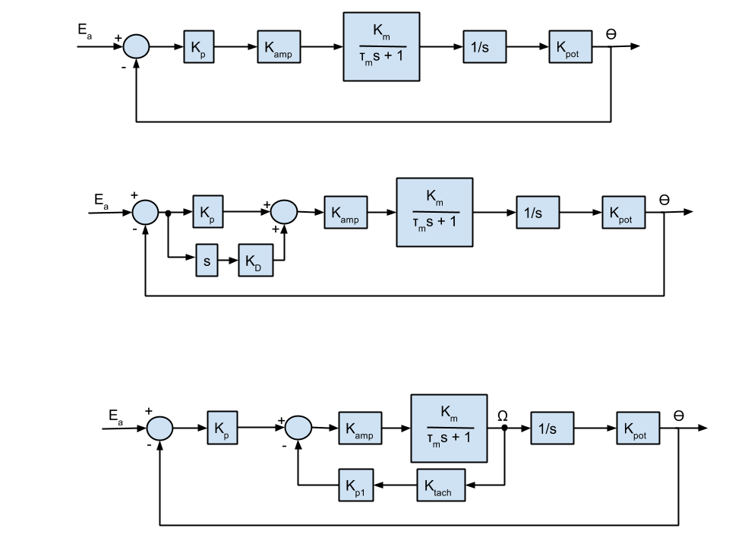
Figure 1: Proportional controller block diagram

Substitute in the values for and from the step response in Lab 4. Then choose K_{p} (using Equation 1 and Equation 2) to satisfy the following designs with their constraints. If not possible, explain why:

Design 1:
    - Peak overshoot < 10 % (Use Eq.1 below or text Fig.4.16)
    - Settling time < 600 ms
Design 2:
- Peak overshoot < 10 % (Use Eq.1 below or text Fig.4.16)
- Settling time < 180 ms

Equation 1: Peak overshoot
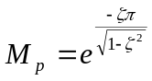
Equation 2: Settling time
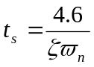

- Change the controller in the previous question to a P-D as shown in Figure 2. Hint: it should simplify into the form of an ideal second order system. Calculate the closed loop transfer function and choose values of K_{d} and K_{p} so as to satisfy the same design constraints as in question 2, Design 2.

Figure 2: Proportional + Derivative Controller Block Diagram
- Adjust the system to feedback the voltage from the tachometer as well as from the output potentiometer as in Figure 3. Hint: it should simplify into the form of an ideal second order system. Then choose K_{p} and K_{p1} to satisfy the same design and the constraints from question 2, Design 2.
Figure 3: Proportional + Speed Controller Block Diagram

Simulation
Using MATLAB’s Simulink, create three simulations to simulate the systems in questions 2, 3, and 4 using the gains you calculated in those questions. Start with the file GE320_lab4starter.slx. Make sure to save this file with a new name and bring the file with you to lab. Then use Figures 1, 2, and 3 as a guide to create you Simulink simulations. You will compare these simulated step responses to actual step responses of the motor. Ensure that you include all these gains and system components:

Signal Generator: Use a square wave with a 1Hz frequency and amplitude of .
Constant: Offset the signal input by .
Gains: K_{p}, K_{d} and K_{p1} depending on the controller.
H-bridge Gain: We will use the H-bridge to convert the Raspberry Pi signal to a voltage for the motor. It has a gain of 0.036.
Motor Transfer function: Use the Motor Gain, time constant, and starting friction values found in Lab 3.

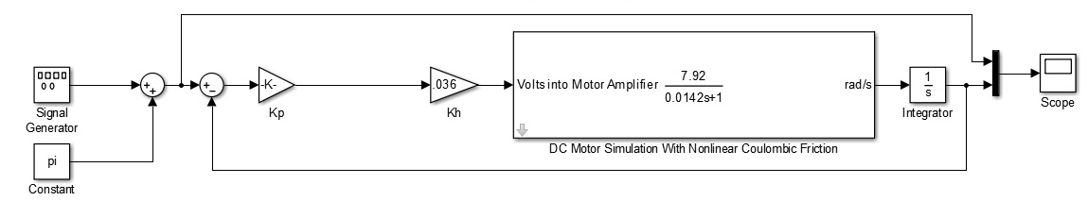
Figure 4: Proportional Gain Control Simulink Block Diagram

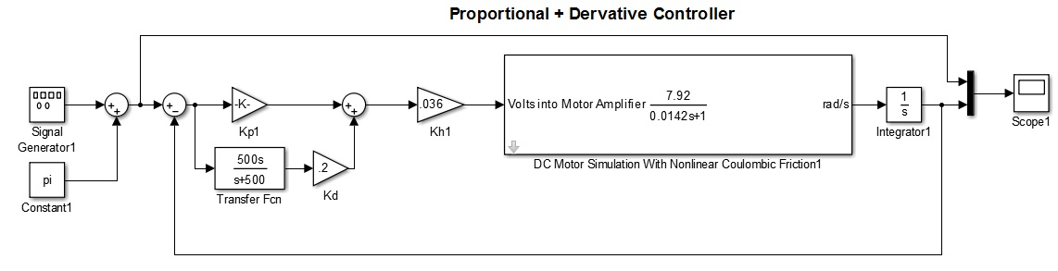
Figure 5: Proportional-Derivative Controller Simulink Block Diagram

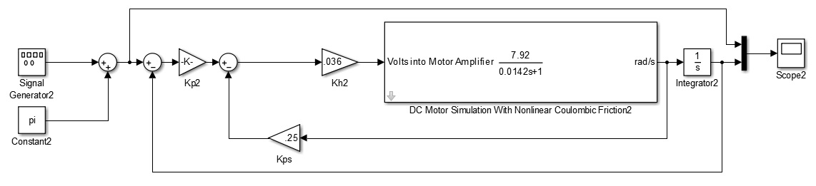
Figure 6: Proportional and Speed Controller Simulink Block Diagram

Lab Exercises
Figure 7 shows the root locus of a 2nd order system with poles at –1 and –2. If the gain of a proportional type controller is slowly increased from zero, the behavior changes from an over damped (both roots of the root locus plot on the real axis), to critically damped (double/repeat roots on the real axis), and finally to an under damped system behavior. These three system behaviors will be observed in this section: proportional, proportional + derivative, and proportional + speed.
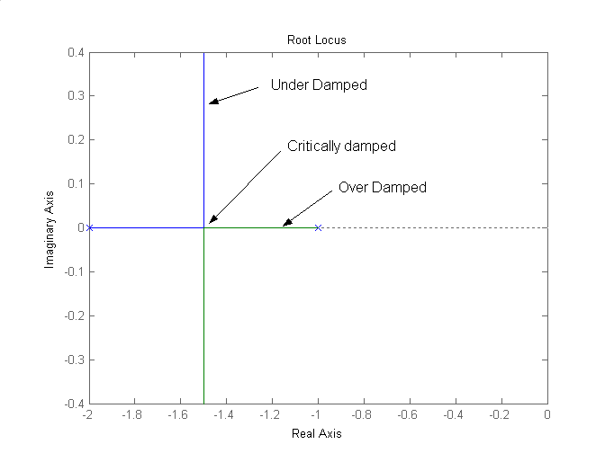
Figure 7: Root locus

Setup
- Make sure the Raspberry Pi is powered using the micro USB power source.
- Make sure the motor is powered using the DC transformer power source into the barrel jack adapter on the end of the breadboard
- Using the black banana jack to hook wire, connect the green bench ground port on patch panel to the ground side of one of the LEDs. This is the lead of the LED that is plugged into the horizontal row of holes next to a blue line on the breadboard.
- Open MATLAB.
- In the MATLAB command window, run the following command
  - mypi=raspi(‘ipaddress’,’pi’, ’raspberry’), where ipaddress refers to the actual IP address on the label affixed to the base of the kit.
- Once MATLAB has completed the above command without returning errors, run the following two commands:
  - mypi.enableSPI
  - mypi.AvailableSPIChannels
If these commands have run successfully you should see ‘CE0’ ‘CE1’ printed in the command window.
- Once all of the above commands have run successfully, move on to the next step. If these steps do not run successfully check the following:
  - The SD Card is fully inserted into the Raspberry Pi
  - The network cord is plugged into the Raspberry Pi
  - The power light is on and the ACT light is blinking on the Raspberry Pi
If these are all true, try running the commands again. If this doesn’t work ask your TA for help.

Proportional Gain Control
For this part of the lab you will test the proportional controller you designed in Prelab question 2 with the actual motor.

- Open a new Simulink model and save it as Lab4 in C:\MATLAB\GE320\yourfolder, where “yourfolder” is the folder on the hard drive you have been using all semester.
- Set your MATLAB working directory to the same folder.
- On the Tools menu go to Run on Target Hardware, then click prepare to run.
- Once the Configuration Parameters window opens up, select Raspberry Pi from the drop down menu, ensure that the Host Name matches the IP Address on the label of your kit.
- Then select Solver from the menu on the left. Set the Fixed-step size to 0.01.
- Then click OK.
- In the drop down menu that is third from the right on the toolbar select External.
- Set the simulation time to 100 seconds using the box in the toolbar
- Build the Simulink model to match the model in Figure 8.
  - Note: The Simulink file, Lab4_blocks.slx, in N:\labs\ge320\kit\exp4 contains several blocks that have been custom made for this lab and cannot be found in the normal Simulink libraries. Please use these blocks as you are building the controller models in this lab.
- The Kp block is a Slider Gain block like you used in Lab 1. The range should be 0 to 100 and the starting value should initially be set to the gain you found when you simulated the proportional controller in the prelab.
- The Pulse Generator should have the following settings:
  - Amplitude: π/4
  - Period (secs): 10
  - Pulse Width (% of period): 50
  - Phase delay (secs): 0
  - All of the rest of the parameters should stay at their default settings.
- The Step block that is labeled Step2 should have the following settings:
  - Starting value = 1
  - Final value = 0
  - Step time = 99.5 seconds
  - Sample time = 0
  - Note: The purpose of this block is to disable the motor before the simulation finishes so it stops running, so make sure that the step time stays set to a time just before the end of the simulation time.
- The Scope block settings will also need to be modified (Click the gear button once the scope is open):
  - Number of axes: 2
  - Time Range: 20
  - History tab, uncheck the box next to Limit the data point to last:
- The block that combines the signals into one for the scope block is called a Bus Creator.
- The GPIO Write Block should be set to GPIO Number 18 the board should be set to Model B Rev 2.
- Double click on each S-Function Builder block (the blocks with the icon that looks like a piece of paper with the corner folded over). Once the box opens click the Build button in the upper right corner. Once the build has completed, click Cancel in the lower right corner.
- Open your Scope and Slider Gain dialog boxes.
- Press the Play button.
- Make sure the Scope and slider gain windows are on top so you can see the data as the model is running on the Raspberry Pi. Once you have observed a couple steps, adjust your gain using the slider so that your output meets the criteria of Design 1 in the prelab.
- In your data table record the rise time and % overshoot with the gain from the prelab and the gain you found with experimentation.
- Keep running the model and adjusting the gain as needed to achieve the desired performance.

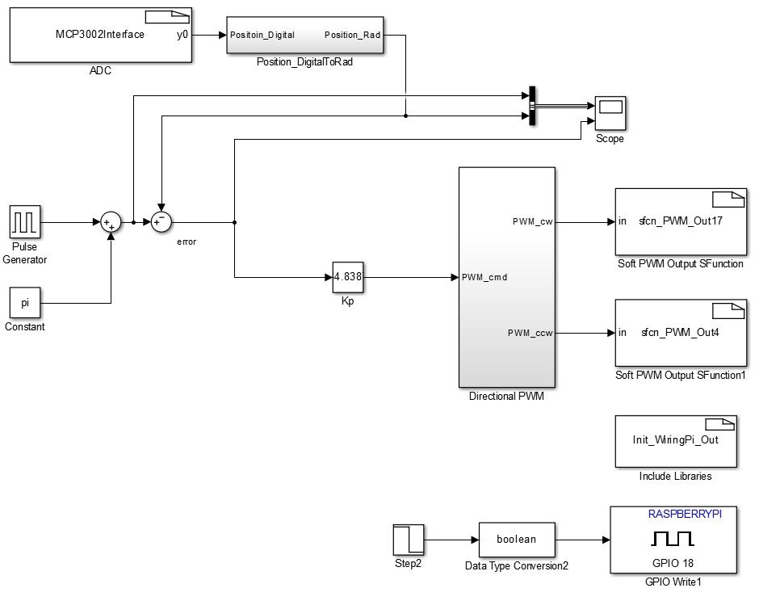
Figure 8 - Simulink Proportional Controller for Raspberry Pi

Proportional-Plus-Derivative Control System
You will now replace the previous controller with a P-D controller similar to the one shown in Figure 9.

- Modify the Simulink model from the last part to match the model in Figure 9.
- The derivative block and values can be found in the Lab4_blocks model.
- The Kp and Kd blocks are Slider Gains. The range of Kp should be 0 to 100 and the range of Kd should be 0 to 2.
- Open your Scope and Slider Gain dialog boxes.
- Press the Play button.
- Make sure the Scope and slider gain windows are on top so you can see the data as the model is running on the Raspberry Pi. Once you have observed a couple steps, adjust your gain using the slider so that your output meets the criteria of Design 2 in the prelab.
- In your data table record the rise time and % overshoot with the gain from the prelab and the gain you found with experimentation.
- Keep running the model and adjusting the gain as needed to achieve the desired performance.
- Once you have gains that meet the criteria of Design 2, repeat the experiment and adjust the gains to get the fastest rise time possible.

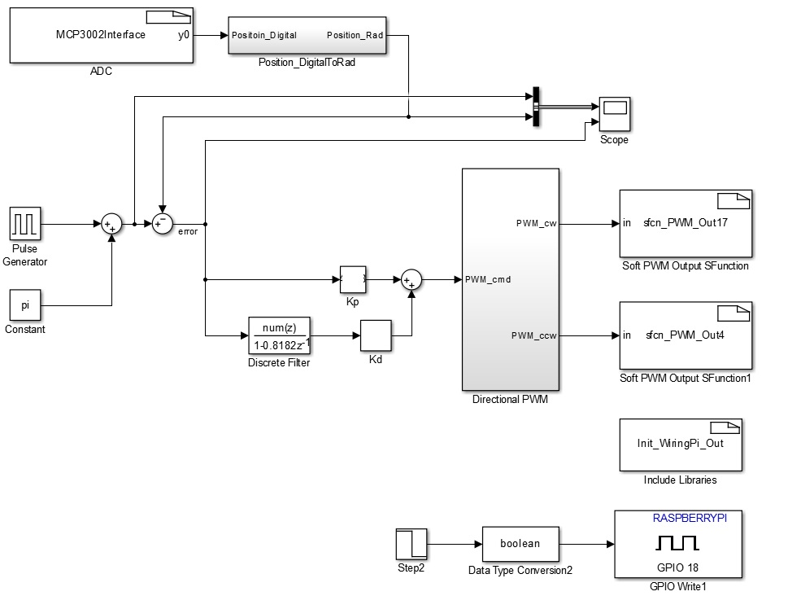
Figure 9 - Simulink Proportional + Derivative Controller for Raspberry Pi

Position and Speed Feedback Control System
Instead of differentiating the error to add a derivative term in the control law, you will use the tachometer feedback times a gain as the derivative term in your control. See Figure 10.

- Modify your Simulink model to match the model in Figure 10.
- The Kp and Kp1 blocks are Slider Gains. The range of Kp should be 0 to 100 and the range of Kp1 should be 0 to 2.
- Open your Scope and Slider Gain dialog boxes.
- The GPIO Read block the Board should be set to Model B Rev 2 and a Sample Time of 0.01.
- Press the Play button.
- Make sure the Scope and slider gain windows are on top so you can see the data as the model is running on the Raspberry Pi. Once you have observed a couple steps, adjust your gain using the slider so that your output meets the criteria of Design 2 in the prelab.
- In your data table record the rise time and % overshoot with the gain from the prelab and the gain you found with experimentation.
- Keep running the model and adjusting the gain as needed to achieve the desired performance.
- Once you have gains that meet the criteria of Design 2, repeat the experiment and adjust the gains to get the fastest rise time possible.

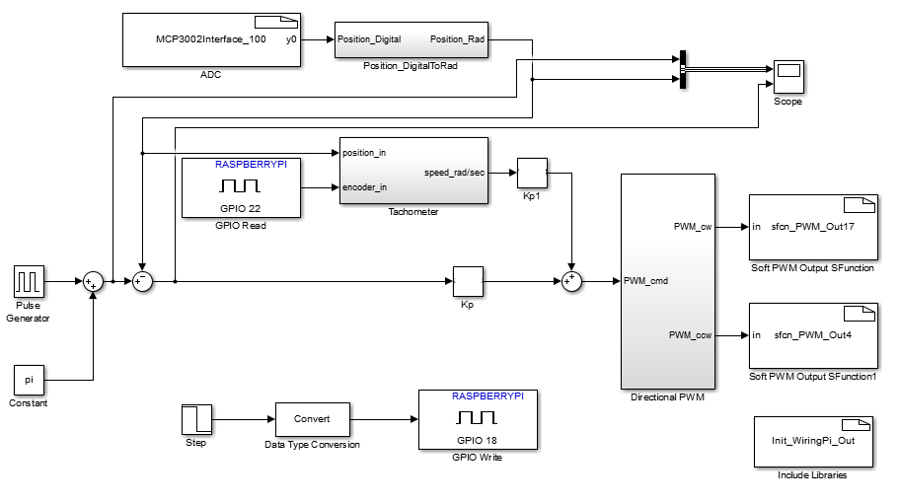
Figure 10 - Simulink Proportional + Speed Controller for Raspberry Pi

Lab 5: Post-lab
  - When implementing the P-Controller, what did you observe with steady state error when adjusting Kp from a smaller value to a larger value? What causes the steady state error?
  - Were there significant differences between your pre-lab controller gains and the values you obtained in the lab? Explain.
  - What are the performance differences between the controllers? What about their settling time? Percent overshoot?
  - Which of these controllers do you see having problems in a noisy (electrical noise/interference) environment? Why?

Lab 5: Data Sheet

 | Prelab | Experimental
Kp
% Overshoot
Settling time
Comparison to simulation’s Overshoot and Settling Time

Proportional + Derivative Controller
 | Prelab Value | Experimental | Fastest Settling Time
K_{p}
K_{d}
% Overshoot
Settling Time
Comparison to simulation’s Overshoot and Settling Time

Proportional + Speed Controller
 | Prelab Value | Experimental | Fastest Settling Time
K_{p}
K_{h}
% Overshoot
Settling time
Comparison to simulation’s Overshoot and Settling Time

