At this stage of lettuce growth modeling, the focus has shifted to focusing on accumulated water use, leaf area, and fresh weight that correlates with dry weight with sunlight as its main input. In “Dynamic Simulation of Supplemental Lighting for Greenhouse Hydroponic Lettuce Production” by A.J. Both, lettuce growth predictions based on light are based on 4 main equations:

“Logistic equation:

Wt = Wi * Wf/[Wi + (Wf - Wi) * exp(-k1 * t)], (2.1)

Gompertz equation:

Wt = Wf * exp[-k0 * exp(-k2 * t)/k2], (2.2)

Richards equation:

Wt = Wi * Wf/[Win + (Wfn - Win) * exp(-k3 * t)]1/n, (2.3)

Second order exponential polynomial:

Wt = exp(a + b * t + c * t2), (2.4)

where:

Wt = weight at time t,

Wi = initial weight at t = 0,

Wf = weight at final harvest,

ko, k1, k2, k3 = proportionality factors,

n = determines the shape of the growth curve,

t = time,

a, b, c = coefficients.” (Both, A.J.., 22).

These set of equations are then broken down into different parameters to predict different aspects of lettuce growth such as leaf area ratio, plant density, and fresh/dry weight, to name a few. Coefficients used to determine the relationship between PAR light measurements and maximum growth rates were determined from different experimental values and averaged resulting in the next graphs and equations:

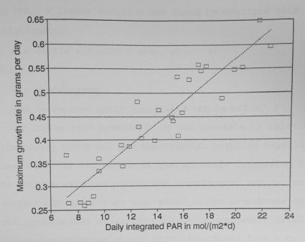

**Figure 1.** Maximum growth rate dW/dtmax) versus daily integrated PAR (PARi). (Both, A.J.., 1995).

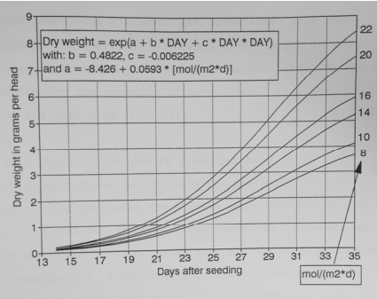

**Figure 2.** Fitted growth curves for different values of the daily integrated PAR (PARi).

These set of curves and lines show possible predicting equations for growth based on different PAR values that were further broken down into different parameters.

Two parameters that were further examined from these experimental values are fresh weight and leaf area measurements. Regarding these two parameters, “…were only collected during the December and March experiments. During each harvest, measurements were performed on five plants and the data was averaged” (Both, A.J., 49). An equation was further developed to provide a correlation between fresh weight in grams per head (FW) and dry weight in grams per head (DW):

DW = 0.0448 * FW, r2 = 0.98 (Both, A.J., 49).

Experimental data showed that most lettuce had an average water content of 95.5% and an average fresh weight (FW) of 150 grams per head. This data was further developed to find a relationship with leaf area (LA) resulting in the equation

LA = 23.89 + 27.57 * FW – 0.04834 * FW2, r2 = 0.98 (Both, A.J., 49).

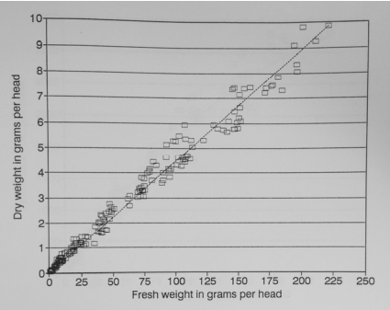

**Figure 3)** Leaf dry weight (DW) versus leaf fresh weight (FW). (Both, A.J., 50).

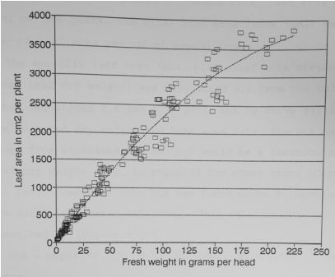

**Figure 4)** Leaf area (LA) versus leaf fresh weight (FW). (Both, A.J., 50).

These parameters and how they interact with each other have been developed and explained by this experimental values. Further literary research needs to be developed in order to determine the specific way that sunlight affects these equations. However, once we show how sunlight affects the fresh weight of lettuce, the outlined equations shown here can be used to create a cascade effect for predicting values of lettuce growth across dry weight and leaf area measurements.

References:

Both, A.J. (1995). Dynamic Simulation of Supplemental Lighting for Greenhouse Hydroponic Lettuce Production. 10.13140/RG.2.2.11209.29282.