# ABC summary

Data can be found at: reports/ABC/cbs.csv

Total segments: 150

Number of unique segments: 81 -- defined by matching other segments. match is defined as being 85% similar

Found 47 potential climate related segments when comparing (my) climate related words

Found 23 potential climate related segments when comparing given (CC) climate related words

# Word Cloud:

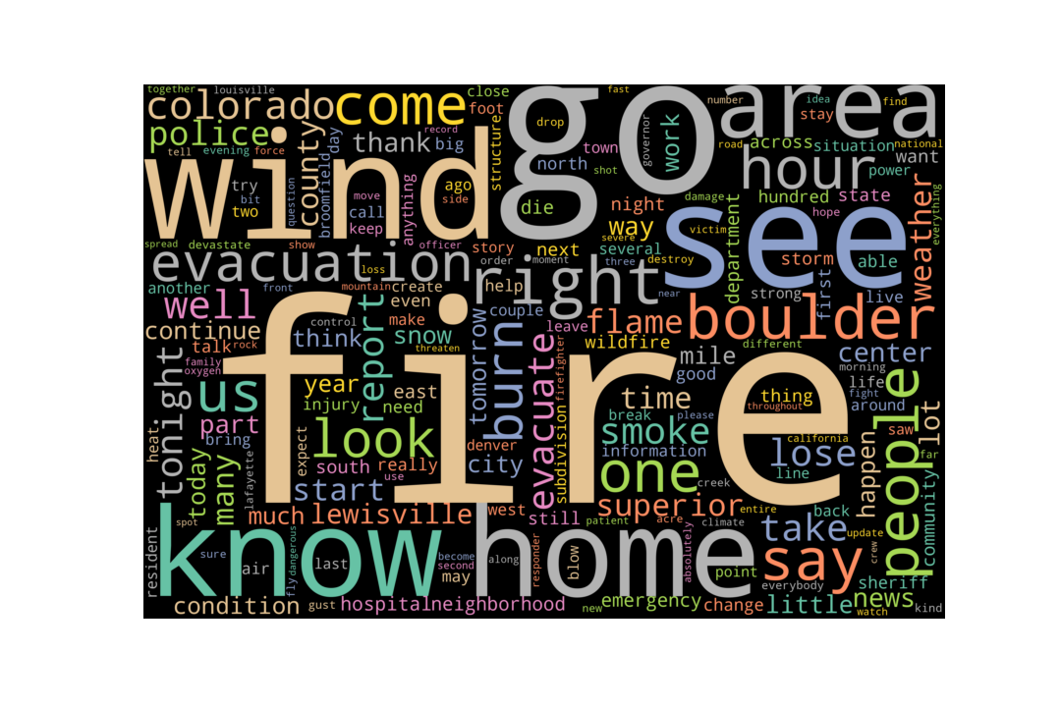

# Word Comparison: My words

|  |  |
| --- | --- |
| Word type | Counts |
| Climate-related | 139 |
| Non Climate-related | 5097 |

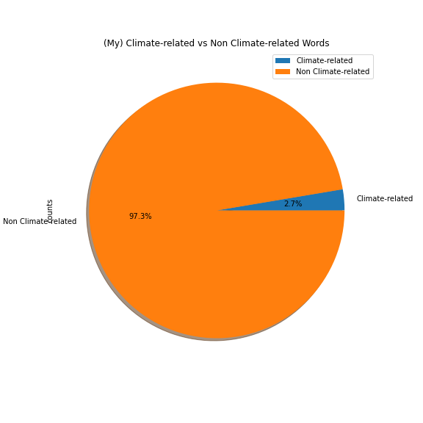

# Climate Related Words Graph: My words

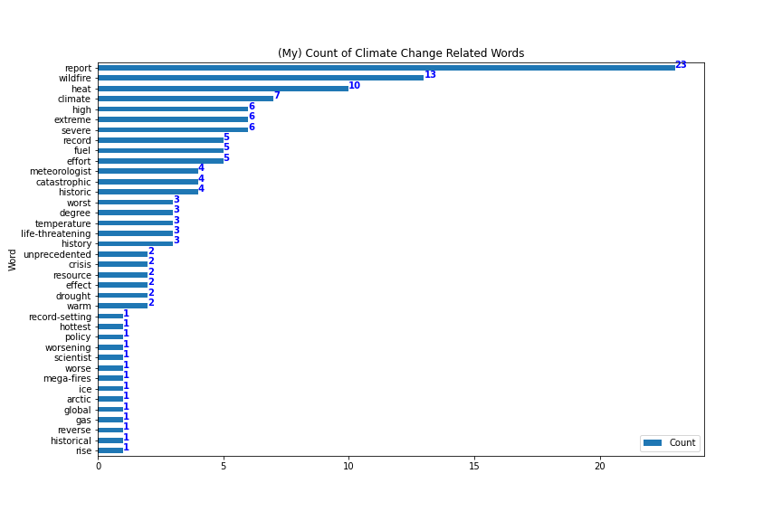

## List of My Climate Related Words Found

* arctic
* catastrophic
* climate
* crisis
* degree
* drought
* effect
* effort
* extreme
* fuel
* gas
* global
* heat
* high
* historic
* historical
* history
* hottest
* ice
* life-threatening
* mega-fires
* meteorologist
* policy
* record
* record-setting
* report
* resource
* reverse
* rise
* scientist
* severe
* temperature
* unprecedented
* warm
* wildfire
* worse
* worsening
* worst

## List of My Climate Related Phrases Found

* severe weather
* record breaking
* climate change
* climate crisis

## Potential segments with my climate related words:

*** row 1 ***

us many of these travel troubles will likely continue into the new year in an alley abc news new york brandon thank you well time now for the mount in in this snapshot of the stories making headlines across the region in boulder county colorado look at these images crews are responding to what they're calling a life-threatening situation several small grass fire spreading fast burning hundreds of homes and forcing entire towns to evacuate authorities say the fire sparked from downed power lines and tonight strong winds are fueling the flames in montana snowmobilers were killed in an avalanche near cooke city authorities say the time of the slide people were on the to were able to escape but the other were buried the avalanche broke feet deep in roughly feet wide and finally in california south lake tahoe saying a record

*** row 2 ***

homes and businesses destroyed it is unreal to even think of yeah this is an area south of boulder it's north of denver the fire spread so quickly there acres just within hours we're hearing a hotel and a target has both burned and evacuations are now in effect at a hospital in the area and people already in the hospital but the county sheriff they're saying it is likely that there will be severe

*** row 5 ***

need this time it's outside gambling groups and they'll do anything to win don't sign these petitions we may be older but were young enough to get it breaking news is just one touch away download the free abc action news app paul lagrone happening right now developing situation we're watching multiple fires tonight burning in boulder colorado this is tape playback from just a few moments ago this fire causing evacuations in that area emergency management saying that if you see fire and backed away go east go north but we've now so the situation obviously urgent we could see the flames close to jumping the highway there hasn't done so yet but that could happen at any moment high

*** row 6 ***

northwest it was sporadic weather patterns connected to climate change that created a once in a millenia heat wave resulting in some of the highest temperatures ever recorded in the region temperatures in portland seattle and parts of canada soaring well above degrees adlibs people dying in washington state and oregon alone electricity went off and so it's quickly getting warmer and warmer kicking off an unprecedented summer of heat twenty twenty one will go down in history as the hottest summer on record for the united states mega-fires

*** row 7 ***

be evacuated because there are several grass fires burning out there this is happening just north of denver about a half hour out of denver you can see the smoke from the fires blowing in the wind a hospital in the area now working to evacuate the patients there and this fire wrapping up a year of extreme catastrophic weather events scientists say climate change contributes to the worsening conditions this year also brought historic levels of funding for climate related projects around the nation nbc's al roker walks us through the severe weather and climate policy efforts of twenty twenty one another blistering year of climate and weather extremes from wildfires and drought to catastrophic flooding hurricanes almost no state escaping unscathed this year seem to pick up where left off with one major exception four years after withdrawing from the paris climate

*** row 8 ***

living with a risk factor they may not know about i am josie sterman for spotlight on america this is really important information you can batch more of her in depth reporting on wjlacom look under the spotlight on america section carl well alison a breaking update on news we brought you a few minutes ago a wildfire is forcing evacuations in colorado right now we just got this new video in from the city of superior you can see how hard it is to see anything on that road there driving through that dense smoke vaccinations are under way there and the nearby city of louisville colorado high winds are fanning the flames and causing the fire to spread out quickly alison when you first brought us this you saw the thick plume of smoke out there it is getting even worse

*** row 9 ***

but jeff says too little too late police are searching for a man who robbed a postal worker who was delivering mail in the bronx the robber approached the 43 year old worker on monday threatened to shoot the postal worker then took some of the mail that postal worker suffered no serious injuries a car crashed into a gas

*** row 10 ***

exploding in size burping more than twice the acreage of last year's record fire season they be catastrophic

*** row 11 ***

story apartment building collapsing outside miami beach desperate to find survivors time to end america's longest war mayhem in kabul the airport overrun the deadliest attack on us forces in afghanistan in a decade marking the end of america's longest war thousands of diplomats activists and world leaders bringing the global climate crisis to the center stage we are drowning the world has warmed more in the last years than in the past years arctic air power grids failing and millions left to cope with the bitter cold texas getting pummeled with snow like a walk in freezer people freezing to death inside their homes dangerous heat waves hitting both coasts it feels like an armageddon disblmplets record shattering temperatures in the pacific northwest now blamed for dozens of deaths it's like you're on fire nearly two thirds of the west exceptional or extreme drought

*** row 29 -- matches rows: [12, 14, 15, 19, 25, 27, 29, 32, 33, 35, 36, 96]***

it is supposed to start snowing in the morning in colorado but at that point the damage will have been done whit until then still so much concern will thank you let's get right to abc's senior meteorologist rob marciano and rob you're tracking those dangerous fire conditions in colorado when are the winds expected to finally let up reporter we expect the strongest winds whit to retreat into the foothills over the next couple of hours but this has turned out to be a historic what we call a mountain wave event and it's going to flip the switch to snow as will mentioned we have advisories that are up in the colorado area and now winter storm watches that are posted for kansas city and chicago as this low that was in california emerges into the plains it will bring a severe weather threat again to the mid south tomorrow but icing conditions in kansas city by saturday morning lincoln will see some snow that presses into chicago and detroit by saturday heavy rain across the area they got the tornadoes two weeks ago and an expansive severe

*** row 39 -- matches rows: [38, 39, 40, 42, 44, 45, 47, 54, 58, 62, 64, 97]***

to heed the warning and get out i have a party near the element hotel that's going to be trying to evacuate on foot towards you they are actively running from fire behind them reporter across the area at least six people rushed to the hospital due to the magnitude of this fire intensity of this fire and its presence in such a heavily populated area we would not be surprised if there are injuries or fatalities reporter millions across the country facing dangerous weather conditions in california a slow moving storm dumping torrential rain floodwaters inundating this campground in malibu before dawn everyone okay reporter first responders racing to rescue families and their pets some people in all brought to safety to the south a tree crashing down on the pacific coast highway bringing utility lines with it shutting down the roadway while it's raining here in california it's been a record-setting dry season in colorado add in those winds up to miles per hour and you're looking at perfect wildfire conditions

*** row 56 ***

the rescheduled game i don't like it disrespectful to everybody else and it's bad because people can get hurt that are not even in the fight it's dangerous and folks are cutting up i don't know what they've been doing before they got here reporter security will be increased here for the rest of the day but the games should go on as scheduled tamara scott abc11 eyewitness news police are searching for the person who opened fire at a high school basketball tournament in catawba county two juveniles were hurt when shots rang out inside that gym lobby last night their conditions

*** row 68 -- matches rows: [65, 66, 67, 68, 71, 75, 76, 78, 81, 84, 99]***

murder in texas the teenager considered armed and dangerous and america strong tonight a graduation story to remember good evening thanks for joining us on a busy thursday night i'm whit johnson in for david and we begin tonight with that breaking news life-threatening

*** row 87 ***

to be somebody's livelihood and we're watching as they're turning into embers that's what we'll be seeing over the next several hours and into tomorrow is these homes that are just pieces they're just rubble on the ground this is the north end of the rock creek subdivision we've seen maybe a mile of homes just going up in flames fortunately the winds have died down so hopefully that means that fire crews can get in and maybe start to create some kind of barrier for the flames but definitely turning into a realistic situation people are grasping the reality of what this means now that all of those homes are smoldering thank you for that report

*** row 90 ***

property so this situation is sort of changing from an evacuation situation to you know a firefighting situation again i hope we can get an update at some point tonight from them on where they're at and what the conditions

*** row 92 ***

seems there has unfortunately been some ignition there in louisville we have not got any specific information on where the worst

*** row 93 ***

broomfield at because of all of that heat with this massive fire there's a lot of turbulence in the atmosphere in the area and the swirling winds will continue to come in lighter at some points and getting going again fast for the next couple of hours this is a three hour map of what we're expecting wind gusts to do it does get lighter along highway and i 25 the stronger winds dropping back into the foothills and the mountains they're elevations of feet to the west of us conditions

*** row 100 ***

tonight breaking news as we come on the air life-threatening wildfires sweeping through parts of colorado late today the governor declaring a state of emergency reports of multiple injuries burn victims rushed to the hospitals high winds fueling the flames tens of thousands of people in the denver suburbs told to get out right now evacuations under way throughout boulder county powerful gusts downing power lines transformers exploding store customers rushing for the exits the area expecting snow tomorrow but it may not come soon enough rob marciano standing by with the fire conditions and severe

*** row 101 ***

said he wasn't expecting to evacuate in a residential area the last thing he was expecting tonight he said it so well what so many of us are thinking you get your shot your shot your second shot your second shot a booster a wildfire a shooting another shooting and we all feel a little overwhelmed right now but the only thing i can say is we're all feeling it do reach out and feel that none of us is alone in all of this and we're all going through this together tonight we have a new chapter to add on to this you're seeing a live look on the left side of your screen a fire burning live in superior it's not a wildfire

*** row 104 ***

he's in and out you keep doing your thing we'll come to you as you're reporting we'll bring you live coverage that's a live picture of a fire storm in a cold cold and blustery night things will go wrong in conditions

*** row 105 ***

air over the range because this thing is swirling the winds in we continue to keep the winds going for longer than we normally would see without this type of a big heat source along the front range tragically this occurred in an yarp that's health populated i know you would have a perfect answer for that chief meteorologist

*** row 106 ***

tremendous amount of heat so think of the fire triangle the food oxygen you need the heat and so with that you're creating an upgraft that goes up much like it did with a hot air balloon or a big thunderstorm the air swirls in from all different directions let me go back to the graphic i was working on and i got this pulled together moments ago if you look kind of carefully here this is the area of the fire but look at the win direction coming strong in from the west here blowing in from the south from the denver area and then swirling in like a great big circulation and that's why it's so erratic is because there's so much heat

*** row 107 ***

gusty but we're talking gusty of to miles an hour from the northeast which would mean that it would actually tend to blow a lot of anything that's burned back over areas that have already been burned this was just unprecedented with extremely strong winds in an area that is prone to get the strongest winds along the front range the rocky flats highway blowing across lewisville and superior december has been extremely warm

*** row 108 ***

the fire mountains will see one to two feet of snow in the short term it's still very very active up there winds will begin to ease and that should be happening in the next hour or two they have eased off a little bit already because but because th is so hot it's created its own weather three to five inches of snow does not arrive until tomorrow afternoon and tomorrow night by the time we get to saturday morning lows will drop to near zero degrees mike if i could keep you on here for another couple of minutes i had a couple of questions this snowstorm that's coming in thank goodness will it i know sometimes when storms come in fronts come in they bring with them a new wind higher winds are we going to see that with this storm nothing is going to be too extreme

*** row 110 ***

fire storms we've been seeing we've been hoping that the atmosphere would start to settle out but we are seeing something similar to a fire storm that you would have seen from bombing missions in world war ii this has become a large concentration here and i just got the graphic up and i haven't worked with it too much the areas in the pink is the fire these are the wind vektctors in the entire fire storm that's why it's continued to be erratic because of the heat

*** row 111 ***

winds are dying down a little bit let's check in with meteorologist

*** row 112 ***

superior still under mandatory evacuation for obvious reasons city of lewisville as well except for the old town part parts of broomfield under evacuation as well pre evacuation now for parts of arvada and other parts of broomfield also lafayette also recommending residents be on standby and be on alert in case they have to evacuate as well just naming all of that area that gives you an idea of just you know how many communities are impacted by this and also the steps that emergency officials are taking to protect those in the path of this fire those who are evacuating have been told to go north and east not go south that's where the fire has been burning at its worst

*** row 113 ***

evacuees from the area and we have seen lots and lots of people leave this area before the flames came through so that's a good piece of news the flames you can see from the screen right now just absolutely continuing to devastate this neighborhood on the south side of the rock creek subdivision just devastating and also shocking to see how intense the fire is now burning in the subdivision you can see that the wind is continuing to fuel it it's continuing to fan the flames and push it throughout thank you for your report

*** row 118 ***

you're curious about what you're looking at now that it's dark that's the neighborhood the neighborhood is on fire those are homes that are lost that's rock creek in superior happy to say right now there are no reports of anybody killed in all of this unfortunately that also could change because of a population densely population that the fire is moving through right now only one injury reported that was a responding officer who had something go into his eye when he was responding this speaks to the evacuation notices and how good we've gotten as reverse

*** row 119 ***

destroyed so far and the fire is continuing to burn to put this in perspective it's possibly the most deadly wildfire in colorado history

*** row 120 ***

my preference is this television station i think we're doing a good job but also do make use of our website thedenverchannelcom and our denver plus app i think you'll find it terribly useful because conditions

*** row 122 ***

are under wind and storm warnings unfortunately the snow doesn't come in until tomorrow afternoon as a sharp cold front drops in from the northwest it's going to be our most significant snowfall we've had all season and the most significant moisture we've had all out of the sky since last summer about three to five inches of snow the winds will begin to ease i wish they had about an hour ago because of this fire storm it's taking longer for the atmosphere to start to settle down there's colder weather on the way and some snow coming but that doesn't arrive until tomorrow afternoon conditions will get better but it remains extremely active and unpredictable situation right now due to the size and the heat from this fire thank you for the information not for the content of the that's bad bad news but thank you so much glad you're with us tonight on this turning out to be historic

*** row 123 ***

area that does show signs of easing backward but because this fire is so big and so hot now it's pulling in air from all around to feed it the oxygen from the fire that's why we're continuing to see strong and erratic winds that may last longer than unfortunately we had hoped this is what it looked like on radar that is not precipitation that is smoke and it is very very thick right through the northern part of the denver area southwestern boulder county along broomfield and extending out miles to the east of us out across the far eastern plains out to akron that's how far to the east the smoke is going at the present time there's not much to see on radar as far as precipitation but there is a little bit of hope coming our way this will fill in slowly because there's so many advisories we have extreme fire conditions

*** row 125 ***

my understanding is this is a different vantage point of the flames that you can see off in the distance i think sloan is just a little bit closer to that subdivision and again don't lose sight this is not just a clump of a fire or fire event those are a lot of individual homes burning right there in superior at this hour we heard from law enforcement as well as different mayors and they say that fire right now is all dependent and fighting it is all dependent on the wind let's go to our chief meteorologist mike nelson what can you give us in terms of an update in the wind gusts not a lot of great news this is some of the historic

*** row 126 ***

possibly threaten this area now let's fast forward this is exactly why they're never prepared for never thought it would happen here i spoke to a resident who lived here for years and he said nothing has ever come this close no evacuations of this magnitude no threat by a fire storm of this magnitude and really we're watching a historical moment here one that everybody wishes we could avoid absolutely heartbreaking i've been talking to some residents and heartbreaking having to report

*** row 127 ***

would presume possibly hundreds of more once that smoke clears we've been monitoring the traffic here as well because this fire you know has been moving closer to us really the stop and go about an hour ago it's gotten a little better now but everybody can't help but to pull over along the here where we are looking at the rock creek community because how could you not it's absolute devastation it's the kind of wrath that i don't think i've ever seen and i've covered a lot of wildfires coming from california i've never seen anything like this and you know when we talk about the mountain communities with some of the other fires we've seen those folks know hey we can be evacuated these superior residents that we've been talking about they have no idea what in the world is going on they just know that law enforcement came to their home pack your bags there may be a wildfire

*** row 129 ***

know metro area that's on fire this evening that we're reporting on and you know you just hope that mother nature will give these first responders a break eventually this wililililildfire small i comparison to last year but because of where it is at because it is the area of suburbia it's just impacting so many families right now where it's potentially thousands there's help coming tonight national guard russell thank you take a break heaven knows you deserve it we'll check in with you throughout the evening nice work to all the crews today there is help arriving this evening national guard has been activated and has been deployed and they're going to come for the night shift to help with traffic with anything extra that needs to be done that will take it off the plate of local first responders fire crews from around the state as well have been joining in the effort

*** row 130 ***

who are watching right now watching their homes you know become victims of this devastating and catastrophic wildfire

*** row 132 ***

this morning it started about and that may have started both fires in the area now the middle fork fire the first fire that started about this morning that's the one north of boulder and they said that one has been contained and no longer really an issue but it is the fire that is burning south of boulder that is the marshal fire that's about acres now and this is the one that's been burning out of control the mayor as well as the sheriff said there are some areas that prior fighters are simply not able to get to subdivisions and neighborhoods they're not able to get to right now and they know there are homes burning they're fighting the fire that's been difficult because of high

*** row 133 ***

were talking parts of arvada on the pre ee pre evacuation and also evacuations broomfield now under mandatory evacuation so this is everybody south of over to and west of wadsworth that includes interlochen let's get an update on details we got from the governor as well as the boulder county sheriff we have to report that there are about confirmed homes lost in the town of superior homes in the sagamore subdivision homes in the old town superior area and they believe even more homes in between that may have been lost target shopping center has been lost to this fire as well as the element hotel and now more evacuation orders they didn't confirm how the fire started but they believe high

*** row 139 ***

crisis tonight [inaudible] the end won't come until the wind subsides this is the kind of fire we can't fight when that single fire engine and police officer pull into a subdivision and homes are burning all they can try to do is protect the next so you know we hope that the worst

*** row 141 ***

december we think we're facing a major grassland fire we've been unable to fly the aircraft all day because of the wind conditions

*** row 142 ***

down from your grandmother losing your photos of losing your computer files which hundreds of colorado families have experienced today with no warning gusts of miles an hour can and have moved this fire down a football field in a matter of seconds very little time to get out very little time to even get the most important parts of your life and yes it will be a difficult process for colorado families who have directly affected to rebuild their lives contact them and see if they need anything if you have spare beds in your home they might very well need them but it also shows how challenging it is for severe weather conditions

*** row 144 ***

orderly and quick manner please stay evacuated we want everybody to stay safe and we're going to get through this together we need everybody to stick together at the different shelter in place sites go to the place in lafayette the senior center in longmant and make sure you're out of lewisville and safe thank you so much and keep looking on the emergency website for updated information as the emergency is changing very rapidly we're at least acre fire which has destroyed hundreds of homes just to put this in perspective in the summer of colorado had the three largest wildfires in the history

*** row 145 ***

tonight we ask that you do so the lewisville police department will continue to patrol the streets of lewisville and will not tolerate looting or other illegal activities we ask that you stay tuned joe mentioned there will be updates for evacuations and fire efforts our thoughts and prayers are with all of those who have been affected by the fires today the community of lewisville is resilient and together we will forge through this together thank you i want to thank all the first responders to get the emergency under control they've done a great effort

*** row 148 ***

approximately acres we know that approximately homes in the sagmore subdivision which is just west of superior have been lost there's a potential of homes lost in superior target shopping complex in superior is under fire element hotel in superior fully engulfed we had the one officer injured fortunately no other reports of evacuation or damage i want to thank the following agencies who jumped in to assist us today under extreme

*** row 149 ***

however i would like to emphasize that due to the magnitude of the fire intensity of this fire and its presence in such heavily populated area we would not be surprised if there are injuries and fatalities the conditions

# Word Comparison: CC words

|  |  |
| --- | --- |
| Word type | Counts |
| Climate-related | 51 |
| Non Climate-related | 5189 |

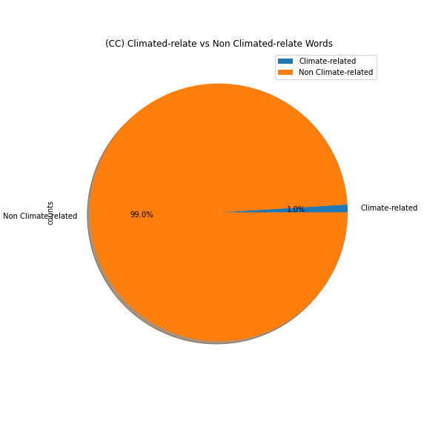

# Climate Related Words Graph: CC words

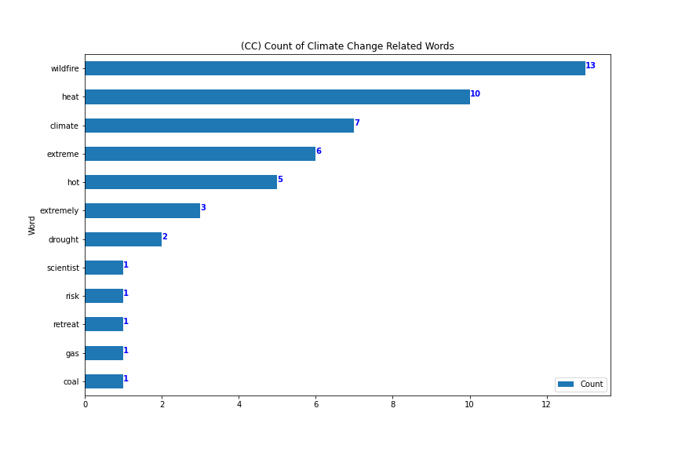

## List of CC Climate Related Words Found

* climate
* coal
* drought
* extreme
* extremely
* gas
* heat
* hot
* retreat
* risk
* scientist
* wildfire

## List of My Climate Related Phrases Found

* weather system
* heat wave
* climate change
* extremely warm

## Potential segments with CC climate related words:

*** row 6 ***

northwest it was sporadic weather patterns connected to climate change that created a once in a millenia heat wave resulting in some of the highest temperatures ever recorded in the region temperatures in portland seattle and parts of canada soaring well above degrees adlibs people dying in washington state and oregon alone electricity went off and so it's quickly getting warmer and warmer kicking off an unprecedented summer of heat

*** row 7 ***

be evacuated because there are several grass fires burning out there this is happening just north of denver about a half hour out of denver you can see the smoke from the fires blowing in the wind a hospital in the area now working to evacuate the patients there and this fire wrapping up a year of extreme catastrophic weather events scientists say climate change contributes to the worsening conditions this year also brought historic levels of funding for climate related projects around the nation nbc's al roker walks us through the severe weather and climate policy efforts of twenty twenty one another blistering year of climate and weather extremes from wildfires and drought to catastrophic flooding hurricanes almost no state escaping unscathed this year seem to pick up where left off with one major exception four years after withdrawing from the paris climate

*** row 8 ***

living with a risk factor they may not know about i am josie sterman for spotlight on america this is really important information you can batch more of her in depth reporting on wjlacom look under the spotlight on america section carl well alison a breaking update on news we brought you a few minutes ago a wildfire

*** row 9 ***

but jeff says too little too late police are searching for a man who robbed a postal worker who was delivering mail in the bronx the robber approached the 43 year old worker on monday threatened to shoot the postal worker then took some of the mail that postal worker suffered no serious injuries a car crashed into a gas

*** row 11 ***

story apartment building collapsing outside miami beach desperate to find survivors time to end america's longest war mayhem in kabul the airport overrun the deadliest attack on us forces in afghanistan in a decade marking the end of america's longest war thousands of diplomats activists and world leaders bringing the global climate crisis to the center stage we are drowning the world has warmed more in the last years than in the past years arctic air power grids failing and millions left to cope with the bitter cold texas getting pummeled with snow like a walk in freezer people freezing to death inside their homes dangerous heat waves hitting both coasts it feels like an armageddon disblmplets record shattering temperatures in the pacific northwest now blamed for dozens of deaths it's like you're on fire nearly two thirds of the west exceptional or extreme drought

*** row 29 -- matches rows: [12, 14, 15, 19, 25, 27, 29, 32, 33, 35, 36, 96]***

it is supposed to start snowing in the morning in colorado but at that point the damage will have been done whit until then still so much concern will thank you let's get right to abc's senior meteorologist rob marciano and rob you're tracking those dangerous fire conditions in colorado when are the winds expected to finally let up reporter we expect the strongest winds whit to retreat

*** row 39 -- matches rows: [38, 39, 40, 42, 44, 45, 47, 54, 58, 62, 64, 97]***

to heed the warning and get out i have a party near the element hotel that's going to be trying to evacuate on foot towards you they are actively running from fire behind them reporter across the area at least six people rushed to the hospital due to the magnitude of this fire intensity of this fire and its presence in such a heavily populated area we would not be surprised if there are injuries or fatalities reporter millions across the country facing dangerous weather conditions in california a slow moving storm dumping torrential rain floodwaters inundating this campground in malibu before dawn everyone okay reporter first responders racing to rescue families and their pets some people in all brought to safety to the south a tree crashing down on the pacific coast highway bringing utility lines with it shutting down the roadway while it's raining here in california it's been a record setting dry season in colorado add in those winds up to miles per hour and you're looking at perfect wildfire

*** row 93 ***

broomfield at because of all of that heat

*** row 101 ***

said he wasn't expecting to evacuate in a residential area the last thing he was expecting tonight he said it so well what so many of us are thinking you get your shot your shot your second shot your second shot a booster a wildfire a shooting another shooting and we all feel a little overwhelmed right now but the only thing i can say is we're all feeling it do reach out and feel that none of us is alone in all of this and we're all going through this together tonight we have a new chapter to add on to this you're seeing a live look on the left side of your screen a fire burning live in superior it's not a wildfire

*** row 105 ***

air over the range because this thing is swirling the winds in we continue to keep the winds going for longer than we normally would see without this type of a big heat

*** row 106 ***

tremendous amount of heat so think of the fire triangle the food oxygen you need the heat and so with that you're creating an upgraft that goes up much like it did with a hot air balloon or a big thunderstorm the air swirls in from all different directions let me go back to the graphic i was working on and i got this pulled together moments ago if you look kind of carefully here this is the area of the fire but look at the win direction coming strong in from the west here blowing in from the south from the denver area and then swirling in like a great big circulation and that's why it's so erratic is because there's so much heat

*** row 107 ***

gusty but we're talking gusty of to miles an hour from the northeast which would mean that it would actually tend to blow a lot of anything that's burned back over areas that have already been burned this was just unprecedented with extremely strong winds in an area that is prone to get the strongest winds along the front range the rocky flats highway blowing across lewisville and superior december has been extremely

*** row 108 ***

the fire mountains will see one to two feet of snow in the short term it's still very very active up there winds will begin to ease and that should be happening in the next hour or two they have eased off a little bit already because but because th is so hot it's created its own weather three to five inches of snow does not arrive until tomorrow afternoon and tomorrow night by the time we get to saturday morning lows will drop to near zero degrees mike if i could keep you on here for another couple of minutes i had a couple of questions this snowstorm that's coming in thank goodness will it i know sometimes when storms come in fronts come in they bring with them a new wind higher winds are we going to see that with this storm nothing is going to be too extreme

*** row 110 ***

fire storms we've been seeing we've been hoping that the atmosphere would start to settle out but we are seeing something similar to a fire storm that you would have seen from bombing missions in world war ii this has become a large concentration here and i just got the graphic up and i haven't worked with it too much the areas in the pink is the fire these are the wind vektctors in the entire fire storm that's why it's continued to be erratic because of the heat

*** row 111 ***

winds are dying down a little bit let's check in with meteorologist mike nelson coal

*** row 119 ***

destroyed so far and the fire is continuing to burn to put this in perspective it's possibly the most deadly wildfire

*** row 122 ***

are under wind and storm warnings unfortunately the snow doesn't come in until tomorrow afternoon as a sharp cold front drops in from the northwest it's going to be our most significant snowfall we've had all season and the most significant moisture we've had all out of the sky since last summer about three to five inches of snow the winds will begin to ease i wish they had about an hour ago because of this fire storm it's taking longer for the atmosphere to start to settle down there's colder weather on the way and some snow coming but that doesn't arrive until tomorrow afternoon conditions will get better but it remains extremely active and unpredictable situation right now due to the size and the heat

*** row 123 ***

area that does show signs of easing backward but because this fire is so big and so hot now it's pulling in air from all around to feed it the oxygen from the fire that's why we're continuing to see strong and erratic winds that may last longer than unfortunately we had hoped this is what it looked like on radar that is not precipitation that is smoke and it is very very thick right through the northern part of the denver area southwestern boulder county along broomfield and extending out miles to the east of us out across the far eastern plains out to akron that's how far to the east the smoke is going at the present time there's not much to see on radar as far as precipitation but there is a little bit of hope coming our way this will fill in slowly because there's so many advisories we have extreme

*** row 124 ***

is a category two ef2 tornado what we've developed is really a fire storm i'm looking at this and thinking about seeing pictures from world war ii some bombings that occurred there this fire has gotten so big it's now creating its own weather and that's part of the reason why we're not seeing these winds die down in this time lapse you can see the smoke is just rolling off the foothills what happens raemeally waves o strong winds come in what we hoped is after sunset this would all start to calm down a little bit but this fire is so big and so hot

*** row 127 ***

would presume possibly hundreds of more once that smoke clears we've been monitoring the traffic here as well because this fire you know has been moving closer to us really the stop and go about an hour ago it's gotten a little better now but everybody can't help but to pull over along the here where we are looking at the rock creek community because how could you not it's absolute devastation it's the kind of wrath that i don't think i've ever seen and i've covered a lot of wildfires coming from california i've never seen anything like this and you know when we talk about the mountain communities with some of the other fires we've seen those folks know hey we can be evacuated these superior residents that we've been talking about they have no idea what in the world is going on they just know that law enforcement came to their home pack your bags there may be a wildfire

*** row 130 ***

who are watching right now watching their homes you know become victims of this devastating and catastrophic wildfire

*** row 137 ***

[inaudible] do you know how many patients you had there governor do you know if the winds died down will the planes will be able to fly tonight are they on standby we do have aircraft that can help fly and they can fly at night to help map the fire and look for other hot

*** row 148 ***

approximately acres we know that approximately homes in the sagmore subdivision which is just west of superior have been lost there's a potential of homes lost in superior target shopping complex in superior is under fire element hotel in superior fully engulfed we had the one officer injured fortunately no other reports of evacuation or damage i want to thank the following agencies who jumped in to assist us today under extreme