# CBS summary

# Word Cloud:

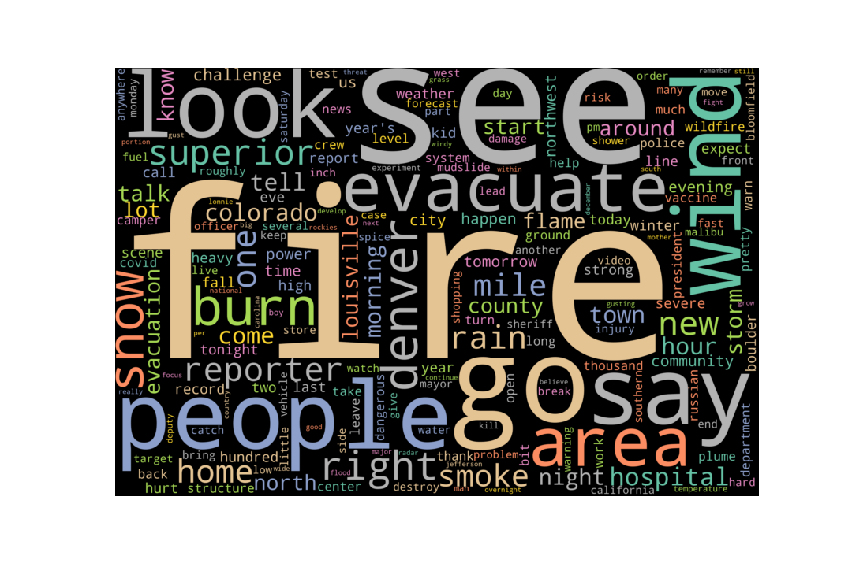

# Word Comparison: My words

|  |  |
| --- | --- |
| Word type | Counts |
| Climate-related | 46 |
| Non Climate-related | 1708 |

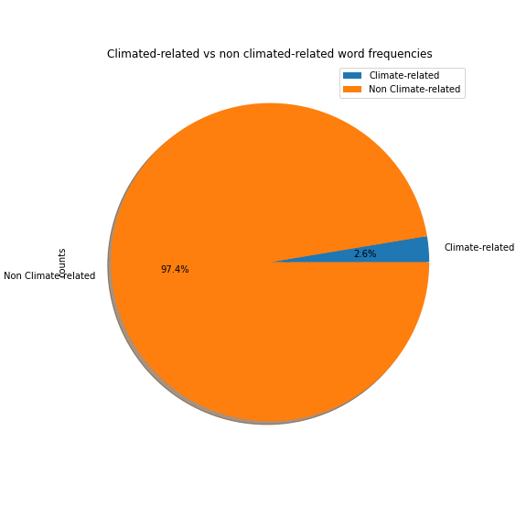

# Climate Related Words Graph: My words

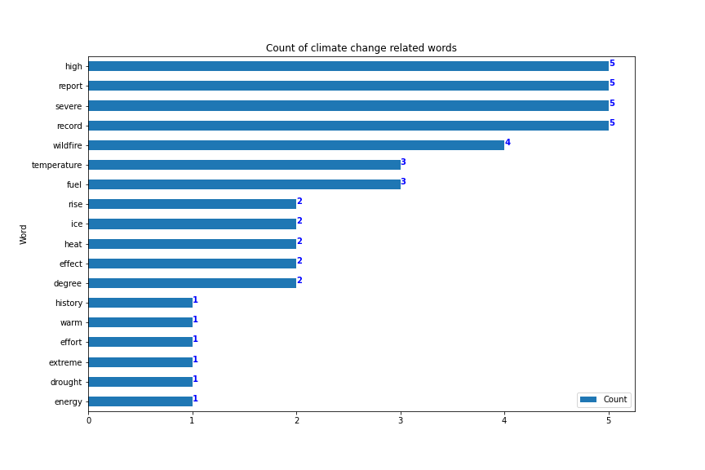

# Word Comparison: CC words

|  |  |
| --- | --- |
| Word type | Counts |
| Climate-related | 16 |
| Non Climate-related | 1738 |

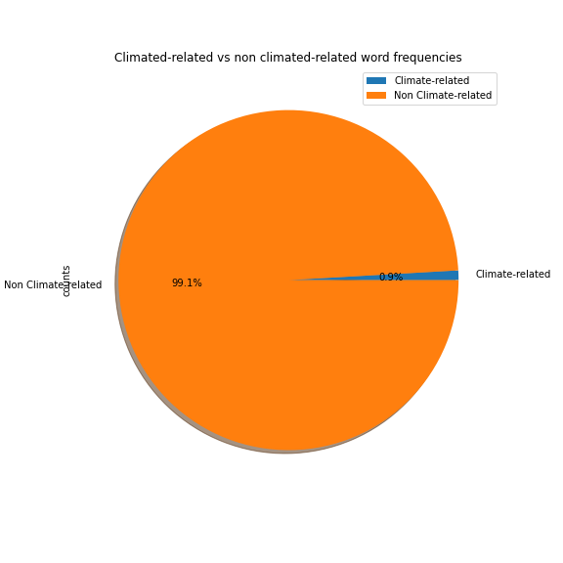

# Climate Related Words Graph: cc words

