Index

S.N. | Title | Remarks
1 | Economic Feasibility Numerical
2 | Gantt Chart
3 | DFD
4 | ER Diagram
5 | Network Diagram

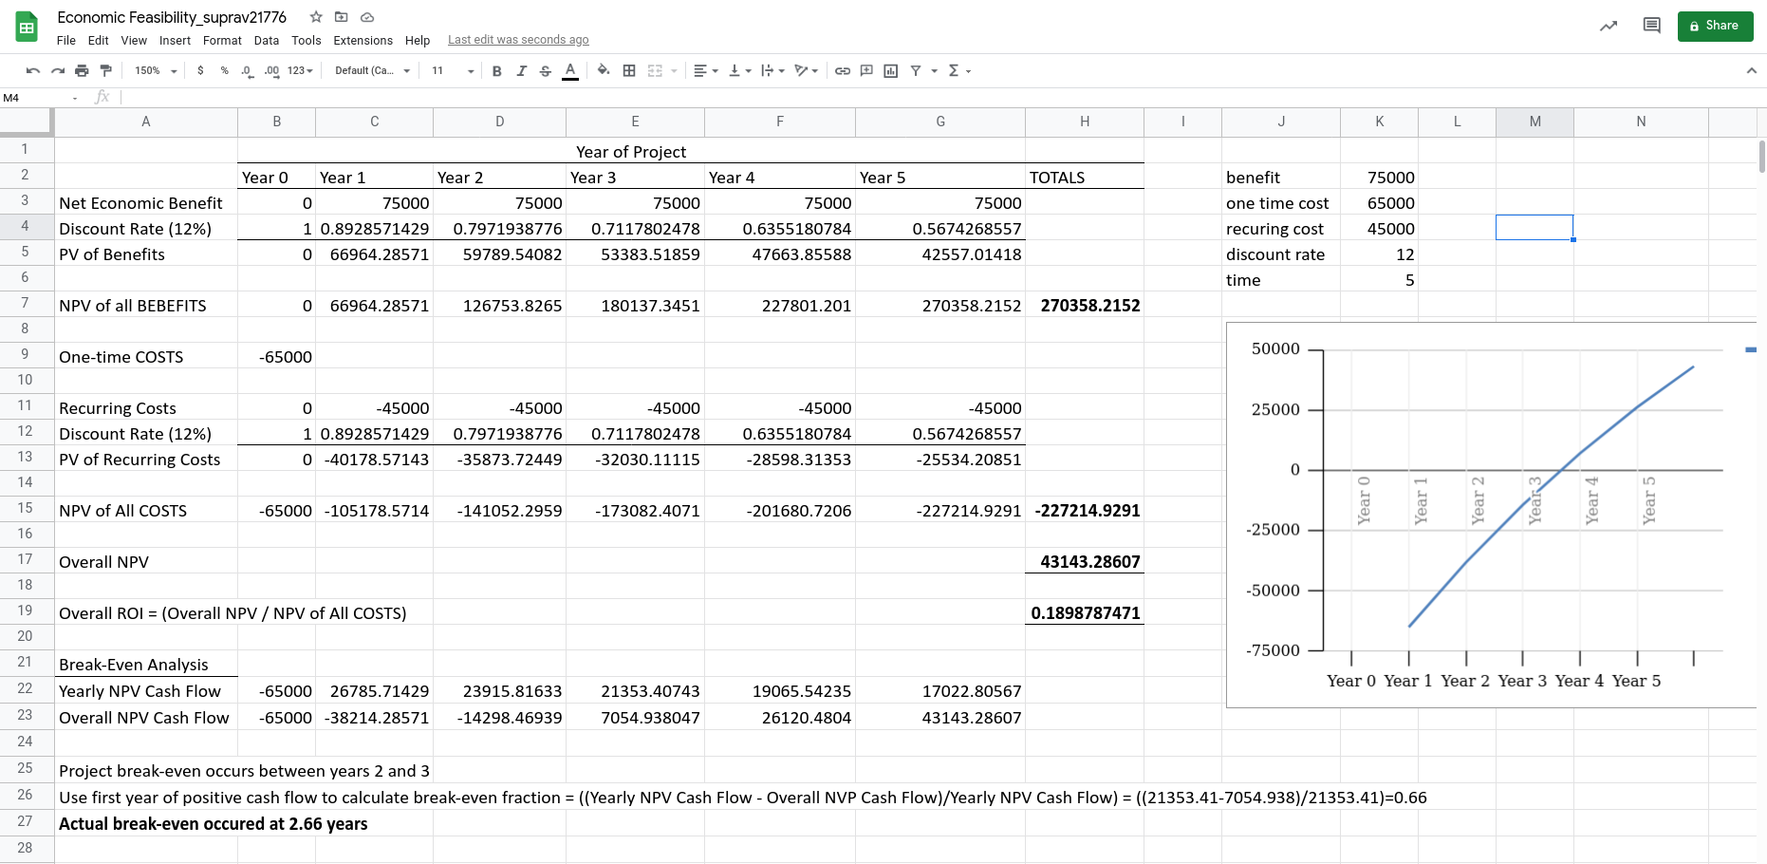
Economic Feasibility

n = nth year

Discount rate =

PV of benefits = Net economic benefit of year n * discount rate of year n

PV of recurring costs = Recurring cost of year n * discount rate of year n

NPV of all benefits = NPV of all benefits of year (n-1) + PV of benefits of year n

NPV of all costs = NPV of all costs of year (n-1) + PV of recurring costs of year n

Overall NPV = NPV of all benefits + NPV of all costs

Overall ROI = (Overall NPV / NPV of All COSTS)

Gantt chart
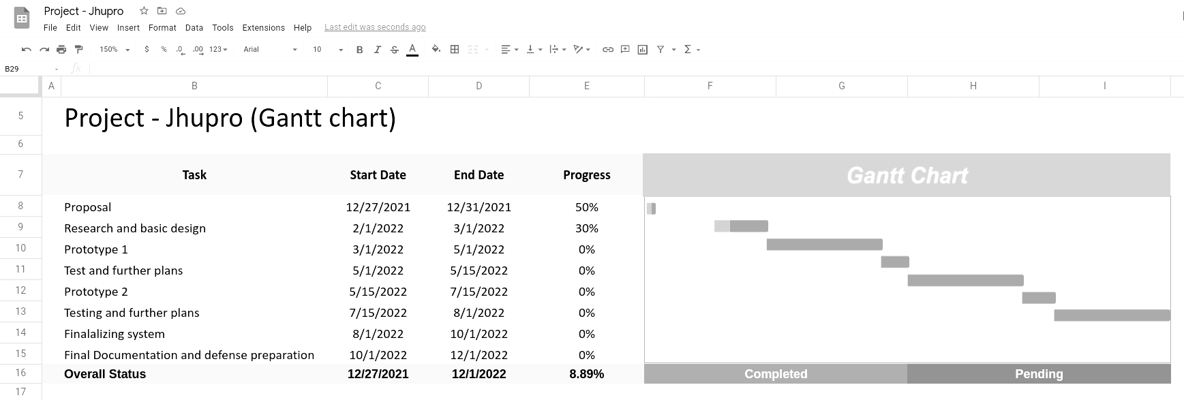

DFD
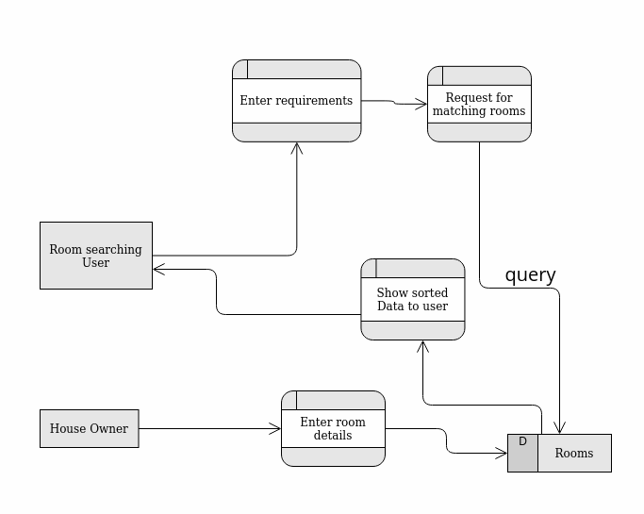

ER diagram
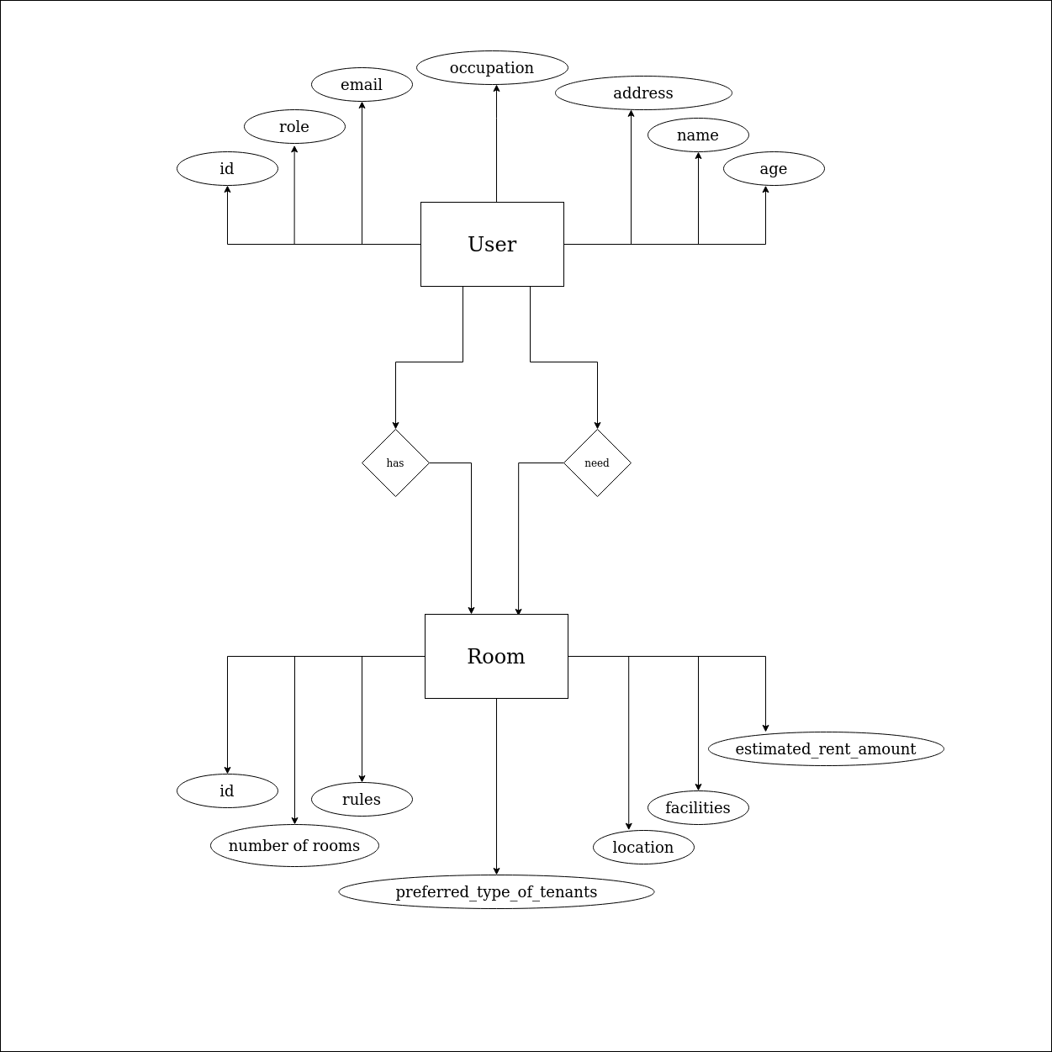

Network diagram
