Language Issue on sapnomads.com Translations
Diagnosis of the “Read more” bug, investigation results, and recommended next steps
July 24, 2026

1. Executive Summary
When a visitor to sapnomads.com selects English and clicks “Read more” on a blog article, the article opens in Dutch instead of English. The root cause has been identified precisely: Weglot's own mechanism for remembering a visitor's chosen language does not reliably work on this site's specific setup — it fails even independently of how the navigation happens.
We built and tested three different client-side JavaScript workarounds against the live site using an automated browser, specifically to avoid touching Weglot's own configuration. All three failed. This is not a timing issue that a smarter script can work around — the fault sits inside Weglot's own initialization logic (or its configuration) for this integration. Two concrete, low-effort next steps are recommended below (Section 5): review the relevant Weglot dashboard settings, and/or report this to Weglot support with the ready-made reproduction steps in Section 6.

2. Problem Description
On the blog listing page (blog-eor-bulgaria), when a visitor has selected English (see Screenshot 1) and clicks the “Read more” button under an article, the same article opens translated into Dutch instead of English (Screenshots 2 and 3). The “English” language selection is lost during the transition between pages.
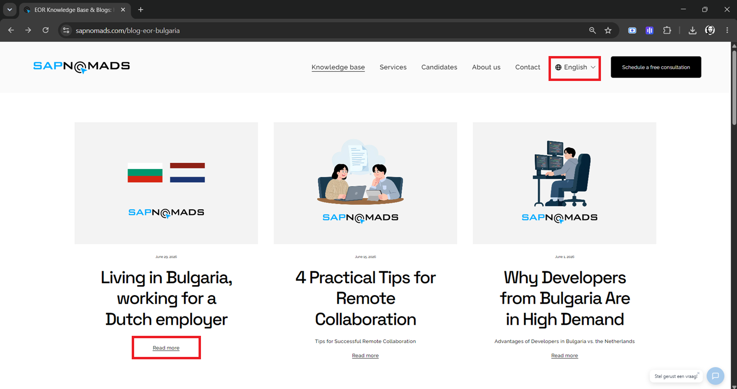
Screenshot 1 — article listing page, language selector set to “English”.
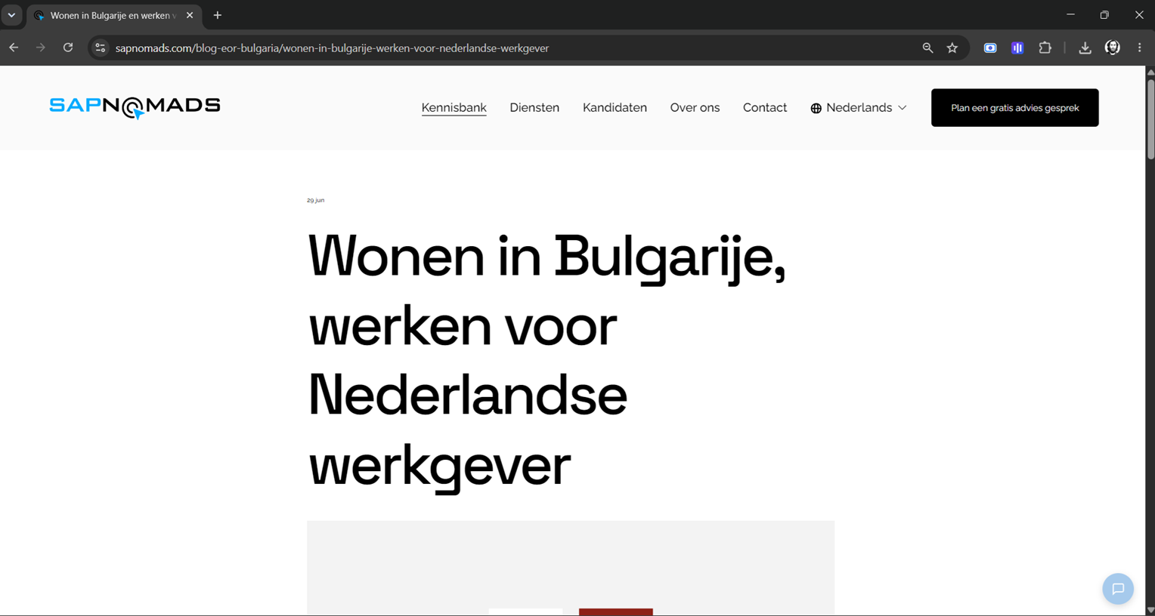
Screenshot 2 — after clicking “Read more”: the title is now in Dutch and the language switcher shows “Nederlands”.
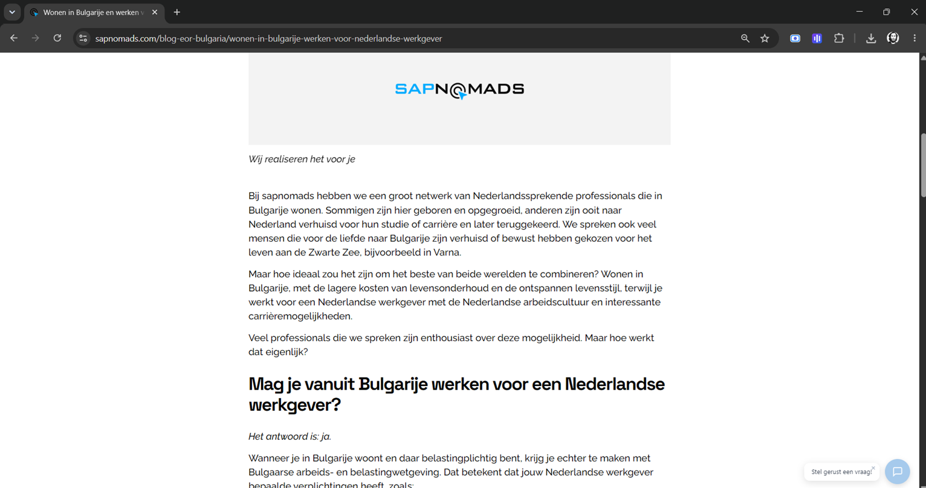
Screenshot 3 — the entire article body is in Dutch.

3. Technical Root Cause
The site uses Weglot for translation, but unlike most Weglot installations, the selected language is NOT reflected in the page URL (there is no /en/, /nl/, etc. in the address). Verified directly: a request to sapnomads.com/en/blog-eor-bulgaria returns a 404 error — the English version is not a separate, real address; it is generated entirely in the browser by Weglot's Squarespace integration script (weglot_squarespace-12.7.0.min.js).
Weglot does store the visitor's chosen language in the browser (in localStorage, under the key “wglang”) so that it can, in principle, be restored on later page loads. Our testing shows this restoration does not reliably happen — including in a scenario with no “Read more” click involved at all (see Section 4). This points to the underlying fault being in Weglot's own initialization/persistence logic or its dashboard configuration for this site, rather than something specific to the “Read more” button.
Separately: the site emits no hreflang tags anywhere in its HTML (the standard mechanism search engines use to understand which pages are translations of each other). This is an independent SEO gap, not the cause of the bug above, but worth addressing at some point.

4. Investigation: Why a Client-Side-Only Fix Was Ruled Out
To avoid any change to Weglot's configuration, we first attempted to solve this purely with an additive script (via Squarespace's Code Injection) that would detect and correct the language after each page load, using only Weglot's official public JavaScript API. Three variants were built and tested end-to-end against the live site with an automated browser (the same click sequence a real visitor performs — select English, click “Read more”):
- Attempt 1: Calling Weglot's own switchTo() function once the page reports itself ready — the call completes without error, but the language does not change.
- Attempt 2: Retrying that same call up to 40 times over 8 seconds, in case of a timing race — still no effect, on any attempt.
- Attempt 3: Simulating a click directly on the visible language-switcher menu item (bypassing the API entirely) — still no effect.
We then tested Weglot's own stored preference in isolation: with the “English” choice already saved in the browser exactly as Weglot itself saves it, we loaded the article page directly (no click, no navigation from another page) — it still came up in Dutch. This confirms the issue is not about how the visitor arrives at the page; Weglot is not correctly restoring its own saved language choice on this site.
Full logs from all four tests are available on request (TEST_FINDINGS.md).

5. Recommended Next Steps

5.1 Review Weglot Dashboard Configuration
Since the fault appears to originate in Weglot's own behavior rather than in the site's markup, the fastest possible resolution is checking the Weglot dashboard for sapnomads.com for the following, in priority order:
- A setting controlling whether Weglot remembers/restores a visitor's previously chosen language across page loads (sometimes phrased as “remember visitor's language” or similar) — confirm it is enabled.
- The site's URL structure setting (Subdirectory / Subdomain / ccTLD vs. the current JavaScript-only mode). Encoding the language in the URL itself (e.g. /en/blog-eor-bulgaria) would make the correct language part of every link and survive any full page reload by construction — this would likely eliminate the bug category entirely, not just this one instance of it.
- Automatic/browser-based language detection settings, in case they are configured to override a visitor's manual selection on new page loads.
This requires access to the Weglot dashboard/account for the site (whoever manages the Weglot subscription).

5.2 Report to Weglot Support
If the dashboard settings above are already correct, this looks like a genuine bug in Weglot's Squarespace integration (version weglot_squarespace-12.7.0) for this account/site. Weglot's support team can be reached through the dashboard's support/chat option or at support@weglot.com. Ready-to-send reproduction steps are provided in Section 6 below so this can be reported with minimal extra effort.

6. Appendix — Reproduction Steps (for a Weglot Support Ticket)
- Go to https://www.sapnomads.com/blog-eor-bulgaria in a fresh/incognito browser window.
- Accept the cookie banner.
- Use the language switcher (top right) to select “English.” The page content and switcher correctly update to English.
- Click “Read more” under any article.
- Expected: the article opens in English. Actual: the article opens in Dutch, and the language switcher itself reverts to “Nederlands.”
- Additional detail for Weglot's engineers: the chosen language is correctly saved to localStorage under the key “wglang” (value “en”) at step 3, but is not restored on the page loaded in step 4 — this reproduces even via a plain direct navigation to the article URL with that value already present, not only via the “Read more” link specifically.

