QA & Security Bug Report
sapnomads.com — HTML Source Code Analysis
Project | sapnomads.com
Test Type | Static HTML Source Code Review
Tester | QA Manual Tester
Report Date | 27 June 2026
Security Findings | 2
QA Bugs | 12

Severity Legend
Critical | High | Medium | Low

Bug Summary
Bug ID | Title | Category | Severity
SECURITY FINDINGS
SEC-001 | Missing rel="noopener noreferrer" on target="_blank" links | Security — Reverse Tabnapping | Critical
SEC-002 | Outdated YUI3 library with no security support | Security — Outdated Dependency | Medium
QA BUGS
BUG-001 | Duplicate HTML IDs across desktop and mobile navigation | HTML Validity | High
BUG-002 | Duplicate alt attribute on <img> elements | HTML Validity | Medium
BUG-003 | Empty <base href> tag causes unpredictable relative URL resolution | HTML Validity | Medium
BUG-004 | Phone numbers linked to /contact page instead of tel: URI | Functional | High
BUG-005 | Language picker dropdown is entirely JavaScript-dependent with no fallback | Functional | Medium
BUG-006 | Contact form is entirely JavaScript-dependent with no fallback | Functional | High
BUG-007 | tabindex="-1" applied to <body> element | Accessibility | Low
BUG-008 | Duplicate navigation landmarks in DOM (desktop + mobile nav both rendered) | Accessibility | Medium
BUG-009 | Missing or inadequate alt text on logo and flag images | Accessibility | Medium
BUG-010 | Conflicting lazy-load strategies: data-load="false" and loading="lazy" | Performance / Conflicts | Low
BUG-011 | Massive inline JSON payload (~30 KB) blocking HTML parse | Performance | Low
BUG-012 | Missing type="button" on <button> elements inside forms | HTML Validity / Functional | Low
Security Findings

SEC-001 — Missing rel="noopener noreferrer" on target="_blank" links
Severity: Critical | Category: Security — Reverse Tabnapping | Environment: All browsers, All OS

Description: Multiple external links use target="_blank" without rel="noopener noreferrer". This exposes the site to reverse-tabnapping attacks: the opened page can access window.opener and redirect the originating tab to a phishing page. Affected links include the Outlook booking link and the LinkedIn company page link.

Code Evidence:
<a href="https://outlook.office.com/book/..." target="_blank">Plan een gratis advies gesprek</a>
<a href="https://www.linkedin.com/company/sapnomads" target="_blank">LinkedIn</a>

Steps to Reproduce
1. Open https://www.sapnomads.com in any browser.
2. Right-click the page and select "View Page Source".
3. Search (Ctrl+F) for target="_blank".
4. Observe that the matching <a> elements do not include rel="noopener noreferrer".
5. Alternatively, open DevTools Console and run: document.querySelectorAll('a[target="_blank"]:not([rel*="noopener"])') — all returned elements are vulnerable.

Expected Result: All links with target="_blank" should include rel="noopener noreferrer" to prevent reverse-tabnapping.
Actual Result: Links open a new tab without the protective rel attribute, leaving window.opener accessible to the target page.

Screenshot: Homepage — CTA button visible in hero section
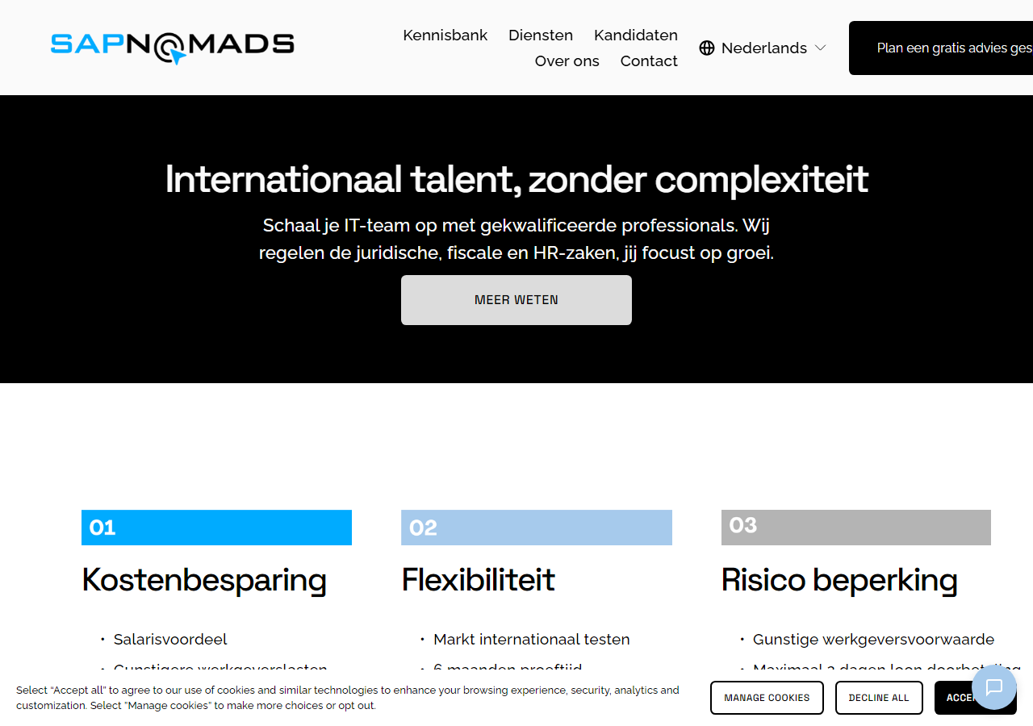

Screenshot: Close-up of the vulnerable CTA anchor element
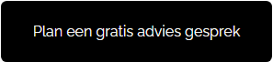

Screenshot: LinkedIn footer link — also missing rel attribute
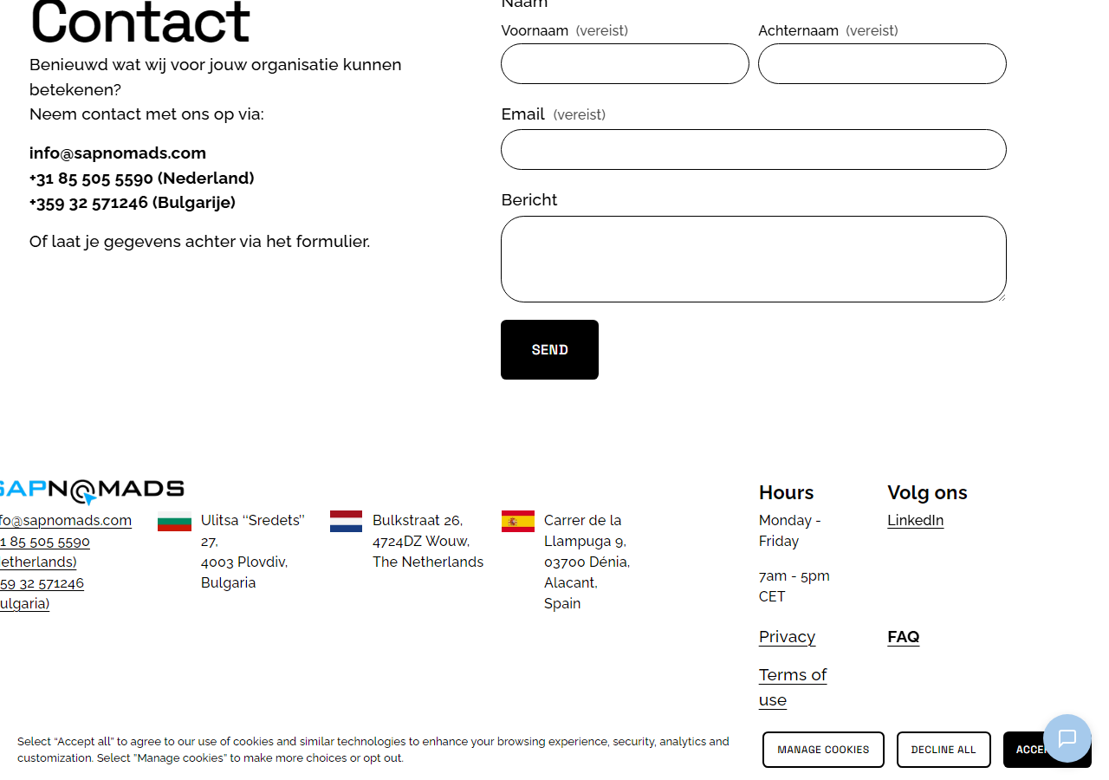

Recommended Fix: Add rel="noopener noreferrer" to every <a target="_blank"> element.

Deep Dive — Technical Explanation
HOW DOES target="_blank" WORK?
When you have:
<a href="https://linkedin.com" target="_blank">LinkedIn</a>
the browser:
• keeps the current site open;
• opens a new tab;
• loads LinkedIn.
Most people assume the two tabs are now completely isolated. In reality, the new tab gains JavaScript access to the original tab via window.opener.
WHAT IS window.opener?
Consider this flow:
sapnomads.com -> user clicks [Book Meeting] -> outlook.office.com opens
From the Outlook page, JavaScript can do:
console.log(window.opener); // reference to the original tab
window.opener.location = "https://fake-sapnomads-login.com";
WHAT IS REVERSE TABNAPPING?
1. The user is on sapnomads.com and clicks the LinkedIn link.
2. linkedin.com opens in a new tab.
3. While the user is reading LinkedIn, JavaScript there executes:
window.opener.location = "https://fake-sapnomads-login.com";
4. The user switches back after 2 minutes and sees a page that looks like
SAP Nomads Login. They enter their email and password.
The credentials are now sent to the attacker.
Note: Outlook and LinkedIn are not malicious themselves. The risk arises if:
• their account gets compromised;
• a malicious JS payload is injected (XSS);
• an external domain is no longer trustworthy.
PROOF OF CONCEPT (PoC):
Open the new tab and run in the Console:
window.opener.location = "https://google.com";
The original tab immediately navigates to google.com — no popup, no warning.
WHAT DOES rel="noopener" DO?
When you add rel="noopener", the browser sets window.opener = null.
No connection. No access.
WHAT DOES rel="noreferrer" DO?
1. Hides the Referer header — the external site cannot see where the user came from.
2. In most modern browsers it also removes window.opener implicitly.
WHY USE BOTH TOGETHER?
rel="noopener noreferrer"
- No reverse tabnapping
- No Referer leak
- Compatible with all modern browsers
HOW TO DETECT IT:
In DevTools Console:
document.querySelectorAll('a[target="_blank"]:not([rel*="noopener"])')
All returned elements are vulnerable and should be reviewed.
HOW SERIOUS IS THIS VULNERABILITY?
Typically classified as Low or Medium severity because it does not allow direct code execution on the originating page and does not cause data leakage on its own. However, it can be exploited for convincing phishing attacks via tab hijacking. The risk is reduced in modern browsers (Chrome 88+, Firefox 79+ treat target="_blank" as equivalent to noopener by default), but adding rel="noopener noreferrer" remains best practice for older browser compatibility and explicit code clarity.
Commonly reported in: Bug Bounty programs, Penetration Testing, OWASP reviews, and Security Code Reviews.

────────────────────────────────────────────────────────────────────────────────

SEC-002 — Outdated YUI3 library with no security support
Severity: Medium | Category: Security — Outdated Dependency | Environment: All browsers

Description: The newsletter subscription form uses YUI3 (Yahoo! User Interface Library version 3), a JavaScript framework discontinued and unmaintained since 2014. It receives no security patches. Its continued use introduces potential future security vulnerabilities and indicates a dependency on legacy Squarespace infrastructure.

Code Evidence:
<!-- YUI3 loader -->
<script src="https://yui.yahooapis.com/3.x.x/build/yui/yui-min.js"></script>
// Newsletter form:
YUI().use('node', 'event', 'io-base', function(Y) { ... });

Steps to Reproduce
1. Open https://www.sapnomads.com in Chrome.
2. Open DevTools > Network tab.
3. Reload the page and filter requests by 'JS'.
4. Look for requests to yui.yahooapis.com or any YUI library file.
5. Alternatively, Ctrl+U > search for 'YUI' in the page source.
6. Confirm the loaded version is a 3.x release with no active security support.

Expected Result: Form submission should use a modern, actively maintained JavaScript approach (native Fetch API or Squarespace's current form API).
Actual Result: The newsletter form relies on the deprecated, unmaintained YUI3 library for its AJAX form submission.

Screenshot (manual): Screenshot: DevTools Network tab showing YUI3 script request; page source showing YUI().use() call.
Recommended Fix: Migrate newsletter form submission to the Fetch API. Remove the YUI3 dependency entirely. Contact Squarespace support if this is platform-managed.

────────────────────────────────────────────────────────────────────────────────

QA Bugs

BUG-001 — Duplicate HTML IDs across desktop and mobile navigation
Severity: High | Category: HTML Validity | Environment: All browsers, All OS

Description: The page renders both a desktop nav and a mobile nav simultaneously in the DOM. Several IDs are repeated across both: id="kennisbank", id="multilingual-language-picker-desktop", and id="language-picker-menu". Duplicate IDs violate the HTML specification and break JavaScript getElementById() calls, which always return only the first match.

Code Evidence:
<!-- In desktop nav -->
<div class="header-nav-folder-content" id="kennisbank">
<div id="multilingual-language-picker-desktop" ...>
<div class="language-picker-content" id="language-picker-menu">
<!-- Same IDs repeated in mobile nav -->
<div class="header-nav-folder-content" id="kennisbank">
<div id="multilingual-language-picker-desktop" ...>
<div class="language-picker-content" id="language-picker-menu">

Steps to Reproduce
1. Open https://www.sapnomads.com in any browser.
2. Open DevTools (F12) > Console.
3. Run: document.querySelectorAll('#kennisbank').length
4. Observe the result is 2 (not 1).
5. Repeat for #multilingual-language-picker-desktop and #language-picker-menu.
6. Alternatively, paste the HTML into validator.w3.org and observe duplicate ID errors.

Expected Result: Each id attribute value must be unique within the entire HTML document.
Actual Result: The IDs kennisbank, multilingual-language-picker-desktop, and language-picker-menu each appear twice in the DOM.

Screenshot: Header section containing both desktop and mobile nav elements

Recommended Fix: Assign unique IDs to each nav variant, e.g. id="kennisbank-desktop" and id="kennisbank-mobile".

────────────────────────────────────────────────────────────────────────────────

BUG-002 — Duplicate alt attribute on <img> elements
Severity: Medium | Category: HTML Validity | Environment: All browsers, All OS

Description: Several <img> elements contain two alt attributes on the same tag. The HTML specification only allows one instance of each attribute per element; browsers silently discard the second occurrence, making it unpredictable which value screen readers will use.

Code Evidence:
<img data-sqsp-image-block-image alt="" data-load="false"
src="..." alt="" sizes="auto ...">

Steps to Reproduce
1. Open https://www.sapnomads.com in any browser.
2. View Page Source (Ctrl+U).
3. Search for alt= and examine img tags for duplicate alt attributes.
4. Paste the HTML into https://validator.w3.org/#validate_by_input and observe attribute duplication warnings.

Expected Result: Each <img> element should have exactly one alt attribute.
Actual Result: Multiple <img> elements contain two alt="" attributes on the same tag.

Screenshot (manual): Screenshot: Page source with both alt attributes highlighted on the same <img> tag; W3C Validator warning output.
Recommended Fix: Remove the duplicate alt attribute. Ensure images that convey meaning have descriptive alt text.

────────────────────────────────────────────────────────────────────────────────

BUG-003 — Empty <base href> tag causes unpredictable relative URL resolution
Severity: Medium | Category: HTML Validity | Environment: All browsers, All OS

Description: The <head> contains <base href="">. An empty href on a <base> element has no useful effect per the HTML specification, but its presence is misleading and can interfere with relative URL resolution in certain edge cases.

Code Evidence:
<base href="">

Steps to Reproduce
1. Open https://www.sapnomads.com in any browser.
2. View Page Source (Ctrl+U).
3. Search for <base and observe the empty href value.
4. Validate the page at https://validator.w3.org/ and note the warning.

Expected Result: The <base> element should be omitted or contain a valid absolute URL.
Actual Result: <base href=""> is present with an empty href, serving no useful purpose.

Screenshot: Page top — the empty <base> tag exists in the <head> of this page
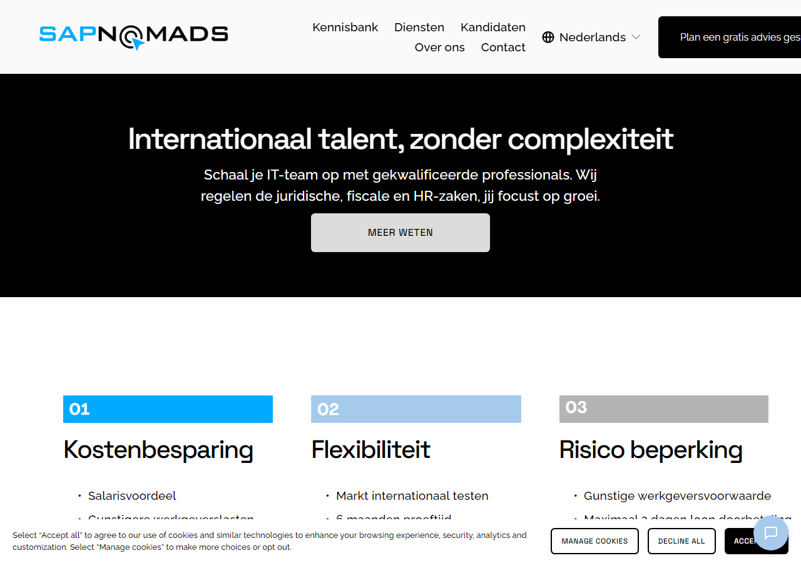

Recommended Fix: Remove the <base href=""> tag entirely, or set it to: <base href="https://www.sapnomads.com/">.

────────────────────────────────────────────────────────────────────────────────

BUG-004 — Phone numbers linked to /contact page instead of tel: URI
Severity: High | Category: Functional | Environment: Mobile browsers (iOS Safari, Android Chrome), Desktop browsers

Description: The Dutch phone number (+31 85 505 5590) is wrapped in an <a href="/contact"> link. Clicking it navigates the user to the contact page instead of initiating a phone call. On mobile devices, users expect a phone number link to open the dialer immediately.

Code Evidence:
<!-- Current (broken) -->
<a href="/contact">+31 85 505 5590 (Netherlands)</a>
<!-- Expected (correct) -->
<a href="tel:+31855055590">+31 85 505 5590 (Netherlands)</a>

Steps to Reproduce
1. Open https://www.sapnomads.com on a mobile device (or use DevTools Device Toolbar, Ctrl+Shift+M).
2. Locate the phone number +31 85 505 5590 on the page.
3. Tap / click the phone number.
4. Observe: the browser navigates to the /contact page instead of launching the phone dialer.

Expected Result: Tapping the phone number should invoke the system phone dialer with the number pre-filled.
Actual Result: The link navigates to the /contact page, ignoring the user's intent to call.

Screenshot: Mobile viewport (390px) — homepage as seen on iPhone


Screenshot: Phone number link visible on mobile — tapping navigates to /contact instead of dialer
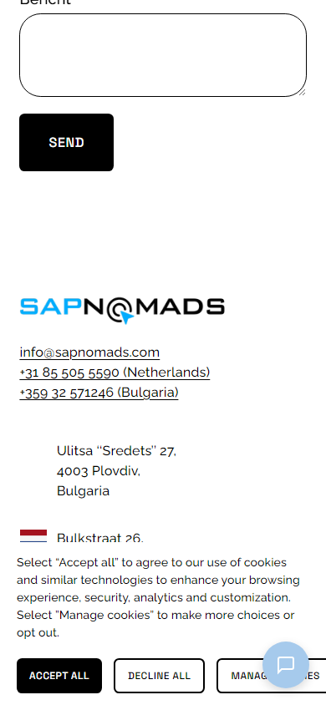
Recommended Fix: Change href="/contact" to href="tel:+31855055590" on the phone number anchor element.

────────────────────────────────────────────────────────────────────────────────

BUG-005 — Language picker dropdown is entirely JavaScript-dependent with no fallback
Severity: Medium | Category: Functional | Environment: All browsers when JavaScript is disabled or fails to load

Description: The language picker (Weglot integration) renders its dropdown options exclusively via JavaScript. The static HTML contains an empty container. When JS is blocked, fails, or is slow to load, users cannot switch languages.

Code Evidence:
<div id="multilingual-language-picker-desktop" data-js-reload="header-language-picker-desktop">
<!-- empty — populated entirely by Weglot JS -->
</div>

Steps to Reproduce
1. Open https://www.sapnomads.com in Chrome.
2. Open DevTools (F12) > Network tab.
3. Block the Weglot script (cdn.weglot.com) using DevTools request blocking.
4. Reload the page.
5. Observe the language picker area is empty or non-functional.

Expected Result: The language picker should degrade gracefully or display available languages without JS.
Actual Result: The language picker container is empty in static HTML; it only works when Weglot JS loads successfully.

Screenshot: Language picker area in the navigation header


Recommended Fix: Provide static fallback language links inside the container, or ensure Weglot loads reliably with error handling.

────────────────────────────────────────────────────────────────────────────────

BUG-006 — Contact form is entirely JavaScript-dependent with no fallback
Severity: High | Category: Functional | Environment: All browsers when JavaScript is disabled or blocked

Description: The contact form configuration is stored as a ~30 KB inline JSON blob and the form fields are rendered entirely by JavaScript at runtime. If JS fails or is disabled, users see no form and cannot contact the company.

Code Evidence:
<div class="form-wrapper" data-form-id="...">
<script type="application/json">{ ...30KB of form config JSON... }</script>
<!-- No static <form> element present -->
</div>

Steps to Reproduce
1. Open https://www.sapnomads.com in Firefox.
2. In the address bar, type about:config and set javascript.enabled to false.
3. Navigate to https://www.sapnomads.com.
4. Scroll to the contact section.
5. Observe no form fields are rendered.

Expected Result: A contact form or at minimum a mailto/tel fallback should be visible without JavaScript.
Actual Result: The contact section shows no form fields when JavaScript is disabled.

Screenshot: Contact form section — rendered via JS; no static HTML form present
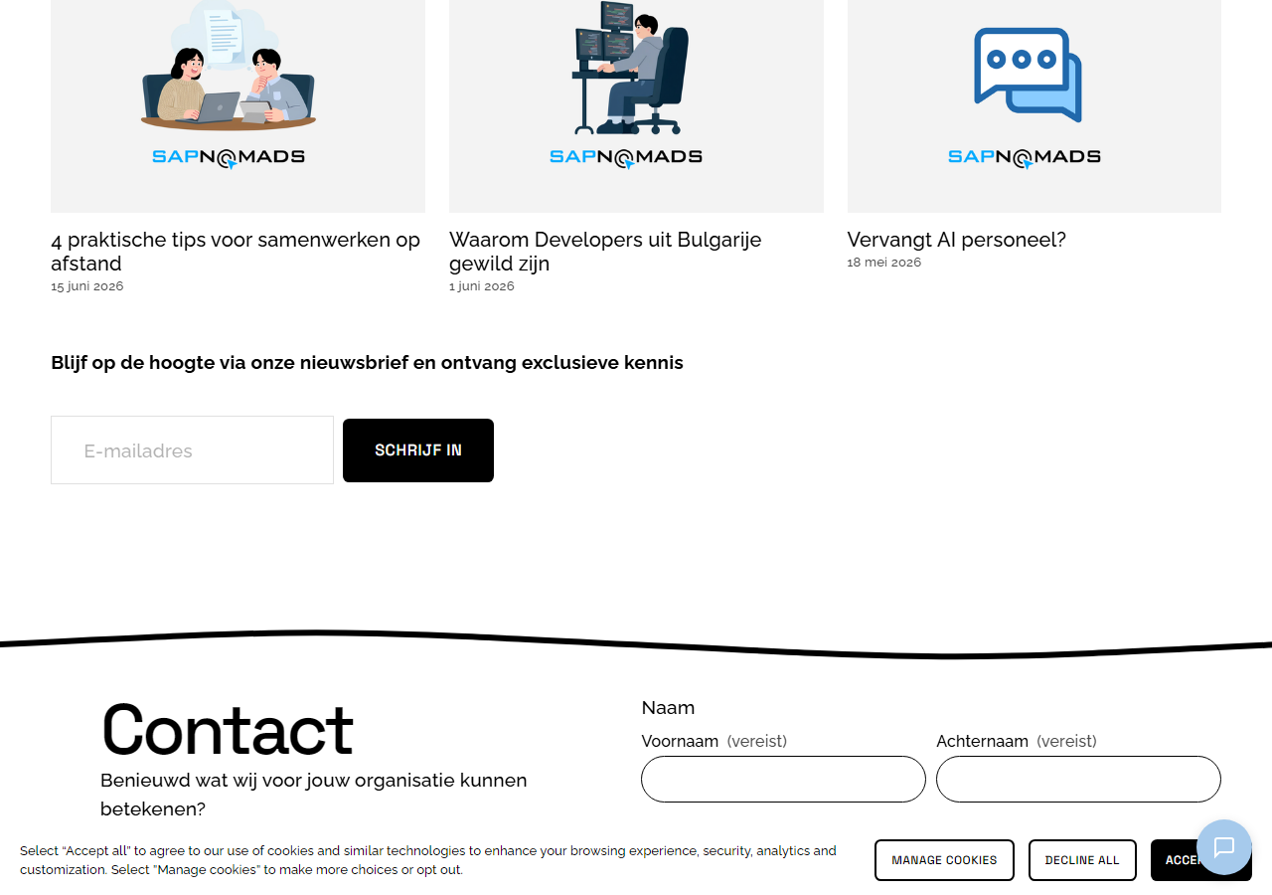

Recommended Fix: Include a static <form> fallback within the container, or provide a direct email/phone contact link as a no-JS fallback.

────────────────────────────────────────────────────────────────────────────────

BUG-007 — tabindex="-1" applied to <body> element
Severity: Low | Category: Accessibility | Environment: All browsers, screen readers

Description: The <body> element has tabindex="-1" applied. While tabindex=-1 makes an element programmatically focusable (via JS .focus()), placing it on <body> is unconventional and can cause confusion for assistive technologies.

Code Evidence:
<body id="collection-69e5d4b7a894de790b2348dd" ... tabindex="-1">

Steps to Reproduce
1. Open https://www.sapnomads.com in any browser.
2. Open DevTools (F12) > Elements.
3. Inspect the <body> tag.
4. Observe the tabindex="-1" attribute.
5. Enable a screen reader (NVDA on Windows, VoiceOver on Mac) and navigate the page to check for unexpected body focus announcements.

Expected Result: The <body> element should not have a tabindex attribute unless there is an explicit reason for programmatic focus management.
Actual Result: tabindex="-1" is present on <body>, potentially confusing screen readers.

Screenshot (manual): Screenshot: DevTools Elements panel with <body tabindex="-1"> highlighted.
Recommended Fix: Remove tabindex="-1" from the <body> element unless a specific focus management pattern explicitly requires it.

────────────────────────────────────────────────────────────────────────────────

BUG-008 — Duplicate navigation landmarks in DOM (desktop + mobile nav both rendered)
Severity: Medium | Category: Accessibility | Environment: All browsers, screen readers (NVDA, VoiceOver, JAWS)

Description: Both the desktop and mobile navigation are simultaneously present in the DOM, each using <nav> elements. Screen reader users encounter two identical navigation regions when navigating by landmarks, causing confusion. WCAG 2.1 SC 1.3.6 recommends uniquely identifiable landmarks.

Code Evidence:
<!-- Both present simultaneously in DOM -->
<nav class="Header-nav Header-nav--primary"> ... </nav> <!-- desktop -->
<nav class="Header-nav Header-nav--secondary"> ... </nav> <!-- mobile -->

Steps to Reproduce
1. Open https://www.sapnomads.com in Chrome.
2. Install the axe DevTools browser extension.
3. Run a full-page accessibility scan.
4. Observe the warning about multiple navigation landmarks without distinguishing labels.
5. Alternatively, enable NVDA and press 'N' to cycle through navigation landmarks — two identical regions are announced.

Expected Result: Each navigation landmark should have a unique aria-label (e.g. aria-label="Main navigation") or the hidden nav should use aria-hidden="true".
Actual Result: Two <nav> elements exist in the DOM without distinguishing ARIA labels; the mobile nav is hidden visually via CSS but still exposed to screen readers.

Screenshot: Header area containing both desktop and mobile <nav> landmarks simultaneously

Recommended Fix: Add aria-label="Main navigation" to the desktop nav and aria-hidden="true" to the mobile nav.

────────────────────────────────────────────────────────────────────────────────

BUG-009 — Missing or inadequate alt text on logo and flag images
Severity: Medium | Category: Accessibility | Environment: All browsers, screen readers

Description: The company logo image and country flag images have empty alt="" attributes. The logo is a functional link (navigates to homepage) and requires descriptive alt text. Flag images used as language selectors also need alt text identifying the language.

Code Evidence:
<!-- Logo as link — needs descriptive alt -->
<a href="/"><img src="logo.png" alt=""></a>
<!-- Flag images — need language alt text -->
<img src="nl-flag.png" alt="">
<img src="en-flag.png" alt="">

Steps to Reproduce
1. Open https://www.sapnomads.com in Chrome.
2. Open DevTools > Lighthouse tab.
3. Run an Accessibility audit.
4. Observe 'Links must have discernible text' violation for the logo link.
5. Enable a screen reader — the logo link is announced only as its URL, not its purpose.

Expected Result: Logo: alt="Sapnomads - Home". Flag images: alt="Nederlands" / alt="English".
Actual Result: Logo and flag images have alt="", making them inaccessible to screen reader users.

Screenshot: Company logo image — functional link with empty alt attribute


Recommended Fix: Set alt="Sapnomads homepage" on the logo. Set alt="Nederlands" / alt="English" on flag images.

────────────────────────────────────────────────────────────────────────────────

BUG-010 — Conflicting lazy-load strategies: data-load="false" and loading="lazy"
Severity: Low | Category: Performance / Conflicts | Environment: All browsers

Description: Image elements use both data-load="false" (Squarespace proprietary JS-based lazy loading) and the native HTML loading="lazy" attribute simultaneously. These can conflict, resulting in double-fetch behavior or images remaining unloaded.

Code Evidence:
<img data-load="false" loading="lazy"
src="https://images.squarespace-cdn.com/..." ...>

Steps to Reproduce
1. Open https://www.sapnomads.com in Chrome.
2. Open DevTools (F12) > Network tab.
3. Filter by 'Img'.
4. Scroll down the page slowly and observe image loading behavior.
5. Look for images fetched twice, or images remaining blank despite being in the viewport.
6. Inspect any image element and confirm both data-load="false" and loading="lazy" are present.

Expected Result: Images should use one consistent lazy loading strategy — either native loading="lazy" or data-load, not both.
Actual Result: Images have both attributes, creating potential for conflicting load behaviors.

Screenshot (manual): Screenshot: DevTools Network tab showing image requests; Elements panel with both lazy-load attributes highlighted.
Recommended Fix: Remove data-load="false" and rely on native loading="lazy", or vice versa.

────────────────────────────────────────────────────────────────────────────────

BUG-011 — Massive inline JSON payload (~30 KB) blocking HTML parse
Severity: Low | Category: Performance | Environment: All browsers, especially on slow connections

Description: The contact form configuration is embedded as a ~30 KB inline JSON blob inside a <script type="application/json"> tag in the HTML body. This increases the page's initial HTML payload size and delays parsing.

Code Evidence:
<script type="application/json" data-form-id="...">
{ /* ~30,000 characters of form field configuration */ }
</script>

Steps to Reproduce
1. Open https://www.sapnomads.com in Chrome.
2. Open DevTools > Network tab > hard reload (Ctrl+Shift+R).
3. Find the main document request (sapnomads.com) in the Network log.
4. Check the Response tab — the HTML will be ~50 KB+ primarily due to this inline JSON.
5. Alternatively, View Source and search for data-form-id — the <script> block spans hundreds of lines.

Expected Result: Form configuration should be loaded asynchronously via a separate JSON endpoint.
Actual Result: ~30 KB of form JSON is inlined directly into the HTML, increasing parse time and payload size.

Screenshot: Contact form section — the inline JSON config bloats the HTML payload of this page


Recommended Fix: Move form configuration to an external JSON file loaded asynchronously.

────────────────────────────────────────────────────────────────────────────────

BUG-012 — Missing type="button" on <button> elements inside forms
Severity: Low | Category: HTML Validity / Functional | Environment: All browsers

Description: Several <button> elements within the newsletter form are missing the type attribute. The HTML specification defines the default type for a <button> inside a <form> as "submit". This can cause unintended form submissions if the button is intended for UI purposes only.

Code Evidence:
<!-- Missing type attribute (defaults to submit) -->
<button class="newsletter-form-button">Subscribe</button>
<!-- Correct -->
<button type="submit" class="newsletter-form-button">Subscribe</button>

Steps to Reproduce
1. Open https://www.sapnomads.com in any browser.
2. View Page Source and search for <button.
3. Observe that <button> elements in the newsletter section lack a type attribute.
4. In DevTools Console, run: document.querySelectorAll('button:not([type])') to list all type-less buttons.

Expected Result: All <button> elements should have an explicit type attribute: type="submit", type="button", or type="reset".
Actual Result: Multiple <button> elements omit the type attribute, defaulting to type="submit".

Screenshot (manual): Screenshot: DevTools Console showing querySelectorAll('button:not([type])') results.
Recommended Fix: Add explicit type attributes to all <button> elements.

────────────────────────────────────────────────────────────────────────────────

