QA BUG REPORT
AGELESS Docuseries — Staging Review
Visual Bugs · Content Errors · Functional Issues · Legal / Terms Review
Staging URL staging.zonia.com/ageless-qa-test · staging.zonia.com/terms_use · staging.zonia.com/privacy_cookie Tester Teodor Kostov

Findings Summary
Page | Total | Critical | High | Medium | Low
AGELESS QA Test Page | 13 | 2 | 5 | 5 | 1
Terms of Use Page | 6 | — | 1 | 3 | 2
Privacy & Cookie Policy | 1 | — | — | — | 1
TOTAL | 20 | 2 | 6 | 8 | 4

Report Details
Prepared by | Teodor Kostov
Date | 2026-03-14
Staging URL | staging.zonia.com/ageless-qa-test
Terms URL | staging.zonia.com/terms_use
Privacy URL | staging.zonia.com/privacy_cookie
Reference | zonia.com/beyond-the-brain/ · zonia.com/terms_use · zonia.com/privacy_cookie
Total bugs | 20 — 2 Critical · 6 High · 8 Medium · 4 Low

● AGELESS QA Test Page — Bugs

● ageless-qa-test · BUG-01 · Functional CRITICAL
Registration CTA Button Links to /404

Section: Multiple registration CTAs throughout the page
Expected  "Register for free now" button navigates to the registration/checkout flow. | Actual  Button href points to /404 — clicking it shows a "Page Not Found" error.

⚑ Impact: All registrations are broken. Users cannot sign up. This is a complete conversion blocker.
Screenshot evidence
 | 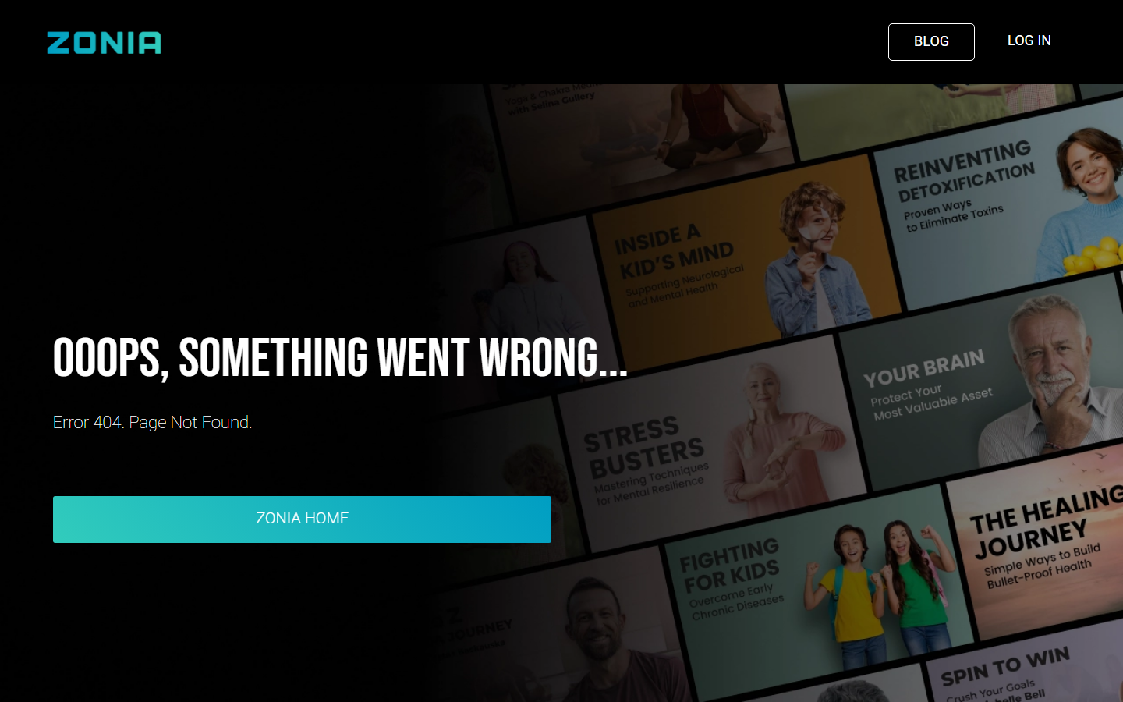

Bug ID | BUG-01 | Severity | CRITICAL | Page | ageless-qa-test | Category | Functional

● ageless-qa-test · BUG-02 · Content CRITICAL
Lorem Ipsum Placeholder Text in Sarah Otto Testimonial

Section: Testimonials section
Expected  Real testimonial quote from Sarah Otto (Nutritionist & Health Docuseries Filmmaker). | Actual  Testimonial body contains lorem ipsum placeholder text followed by unrelated generic copy about Stefan Apostolov. The content was never replaced.

⚑ Impact: Unprofessional appearance; signals an unfinished page to every visitor.
Screenshot evidence

Bug ID | BUG-02 | Severity | CRITICAL | Page | ageless-qa-test | Category | Content

● ageless-qa-test · BUG-03 · Content HIGH
Typo in Hero Heading — "Revealsd" instead of "Reveals"

Section: Hero / main headline
Expected  "This Groundbreaking New Docuseries Reveals How To Go From Prematurely Aged To Looking and Feeling 10-20 Years Younger" | Actual  "Revealsd" — extra "d" appended to the word "Reveals".

⚑ Impact: Immediately visible to all visitors on first page load; directly damages credibility.
Screenshot evidence
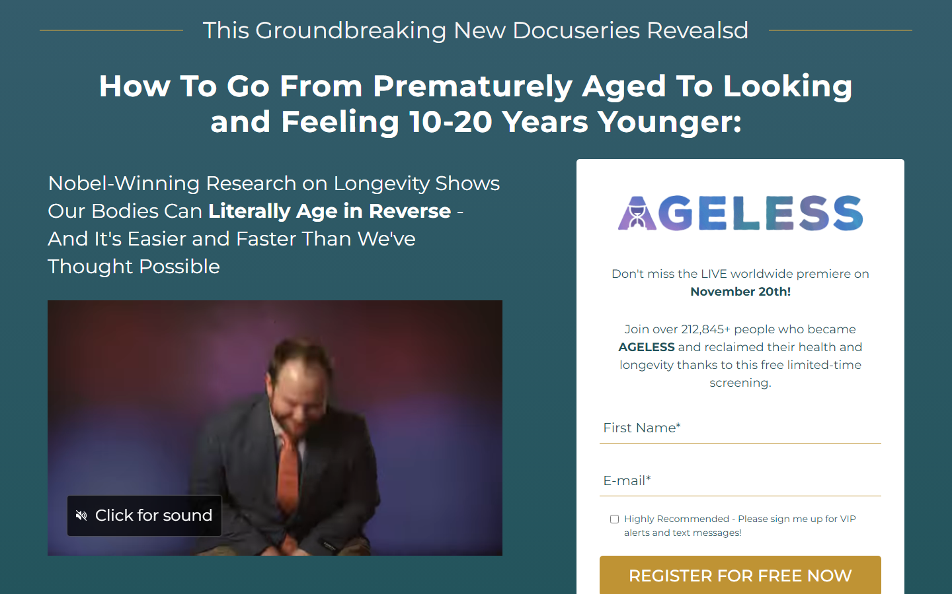
Bug ID | BUG-03 | Severity | HIGH | Page | ageless-qa-test | Category | Content

● ageless-qa-test · BUG-04 · Content HIGH
Cyrillic Character "Т" Used Instead of Latin "T" in CTA Text

Section: Call-to-action button / banner text
Expected  "Register For Free Today To Become Ageless Tomorrow" — all Latin characters. | Actual  "Register For Free Today Тo Become Ageless Tomorrow" — the "T" in "To" is Cyrillic Т (U+0422), not Latin T.

⚑ Impact: Visually identical but technically malformed. Causes issues with screen readers, SEO, copy-paste, and accessibility tools.
Screenshot evidence

Bug ID | BUG-04 | Severity | HIGH | Page | ageless-qa-test | Category | Content

● ageless-qa-test · BUG-05 · Content HIGH
Wrong Quote Attributed to Edward Levitan in Testimonial

Section: Testimonials section
Expected  Edward Levitan's testimonial block contains his personal review of the AGELESS docuseries. | Actual  His block contains "...the most incredible sex of my life" — a quote belonging to Susan Bratton (Intimacy Expert, Episode 7), placed under the wrong person's name.

⚑ Impact: Embarrassing attribution error visible to all visitors.
Screenshot evidence

Bug ID | BUG-05 | Severity | HIGH | Page | ageless-qa-test | Category | Content

● ageless-qa-test · BUG-06 · Content MEDIUM
Expert Count Mismatch — Page Claims 50, Only 48 Listed

Section: Expert roster / social proof section
Expected  If the page states "Our 50 World-Renowned Longevity Doctors and Health Experts", 50 experts should be listed. | Actual  Only 48 expert profiles appear in the featured expert section — a discrepancy of 2.

⚑ Impact: Misleading claim; visitors who count the cards will notice and lose trust.
Screenshot evidence

Bug ID | BUG-06 | Severity | MEDIUM | Page | ageless-qa-test | Category | Content

● ageless-qa-test · BUG-07 · Functional MEDIUM
"Free Download Now" Button Is Non-Functional (href="#")

Section: Free Books / Bonus section
Expected  "Free Download Now" button navigates to a download page or triggers a download. | Actual  Button uses href="#" — a placeholder that scrolls to the top of the page and does nothing.

⚑ Impact: Secondary conversion path is completely broken; users cannot claim the free books bonus.
Screenshot evidence

Bug ID | BUG-07 | Severity | MEDIUM | Page | ageless-qa-test | Category | Functional

● ageless-qa-test · BUG-08 · UI / UX LOW
Countdown Timer Displays an Expired Date

Section: Hero / registration section
Expected  "World Premiere" countdown timer counts down to a future event date. | Actual  Countdown target is set to November 20th (unix timestamp 1763612430) which is in the past. Timer shows zeros or a frozen state.

⚑ Impact: Undermines urgency messaging; makes the page look stale and forgotten.
Screenshot evidence
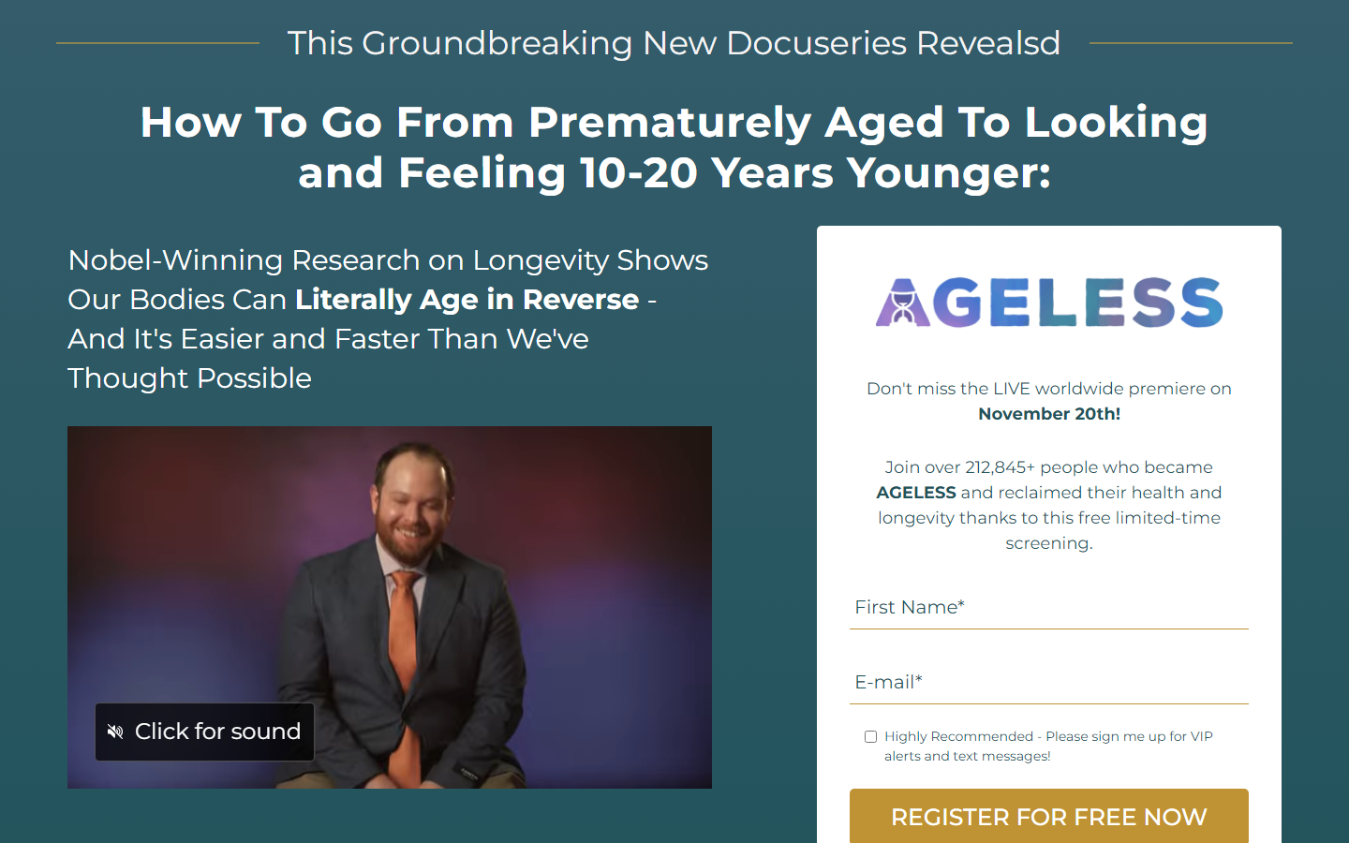
Bug ID | BUG-08 | Severity | LOW | Page | ageless-qa-test | Category | UI / UX

● Terms of Use Page — Staging vs Production Comparison

The following bugs were identified by comparing staging.zonia.com/terms_use against the production reference at zonia.com/terms_use. BUG-09 through BUG-11 also exist on the production page, indicating they were carried over during the staging deployment.
● terms_use · BUG-09 · Legal / Content MEDIUM
Wrong Section Cross-Reference in IMPORTANT Notice

Section: IMPORTANT notice at the top of the Terms of Use page
Expected  "THESE TERMS CONTAIN DISCLAIMERS OF WARRANTIES AND LIMITATIONS OF LIABILITIES (see Sections 15 and 16)." — Section 15 = Disclaimer of Warranties, Section 16 = Disclaimer of Liabilities. | Actual  "(see Sections 14 and 15)" — Section 14 is "Social Media", not a disclaimer section. Users following this reference land on the wrong section.

⚑ Impact: Legal documents require precise cross-references. A user directed to Section 14 looking for liability disclaimers will be confused and may miss critical legal information. Present on both staging and production — was carried over unchanged.
Screenshot evidence
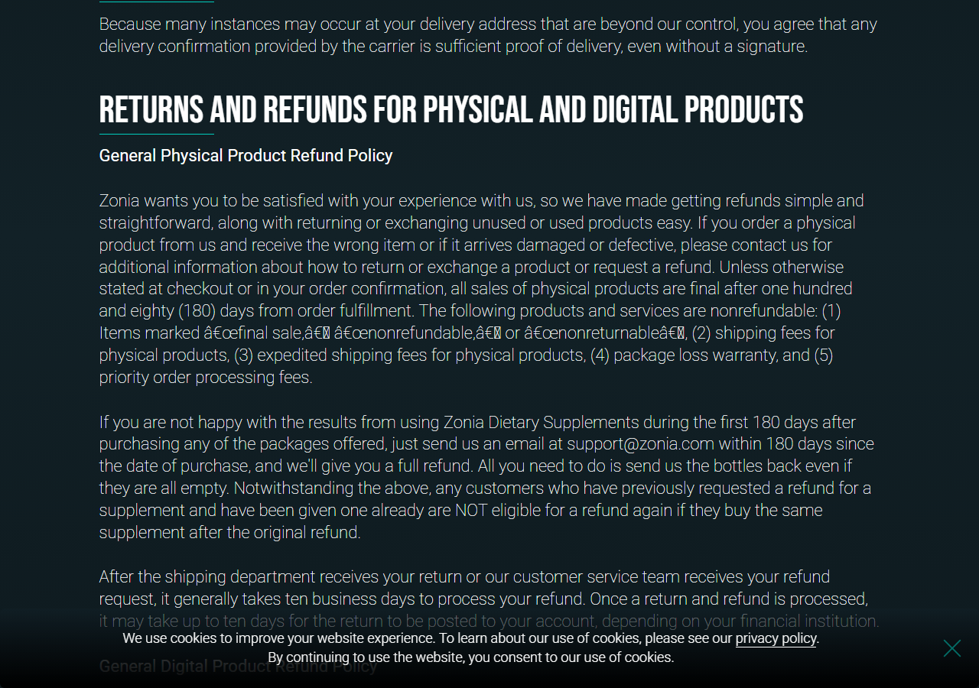
Bug ID | BUG-09 | Severity | MEDIUM | Page | terms_use | Category | Legal / Content

● terms_use · BUG-10 · Legal / Content MEDIUM
Broken Sentence Grammar in Section 9 — Subscriptions

Section: Section 9 — Subscriptions, Automatic Payment, and Cancellation
Expected  "The prices charged for your subscription will be those confirmed to you on the checkout page at the time of your enrollment in Zonia's subscription plans." | Actual  "The prices charged for your subscription will be those confirmed to you at the time you on the checkout page at the time of your enrollment in Zonia's subscription plans." — The phrase "at the time you on the checkout page" is grammatically broken (missing verb/preposition).

⚑ Impact: Unprofessional and confusing language in a legally binding document. Present on both staging and production — was carried over unchanged.
Screenshot evidence

Bug ID | BUG-10 | Severity | MEDIUM | Page | terms_use | Category | Legal / Content

● terms_use · BUG-11 · Content LOW
Section Title Typo — "CUSTOM & IMPORT DUTIES" instead of "CUSTOMS"

Section: Table of Contents item 11 and Section 11 heading
Expected  "CUSTOMS & IMPORT DUTIES" — the standard legal/trade term uses plural "Customs". | Actual  "CUSTOM & IMPORT DUTIES" — missing trailing "S". The word "Customs" in trade law is always plural when referring to customs duties as a category.

⚑ Impact: Minor but incorrect legal terminology in a Terms of Use document. Present on both staging and production.
Screenshot evidence
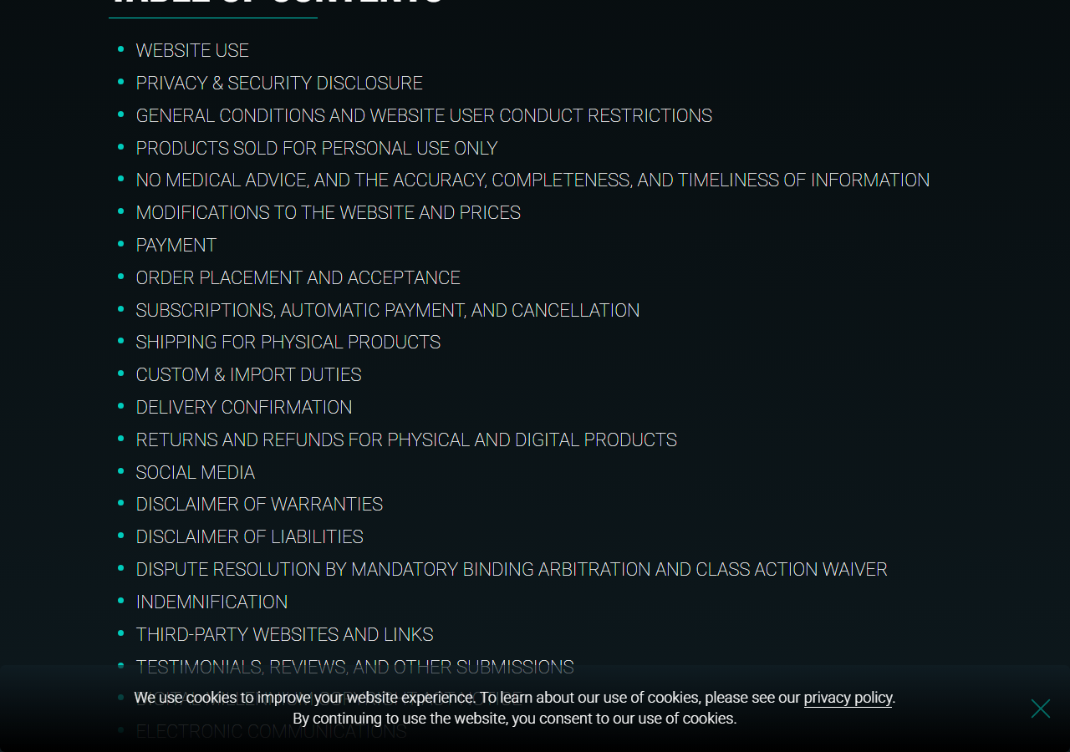
Bug ID | BUG-11 | Severity | LOW | Page | terms_use | Category | Content

● Privacy & Cookie Policy — Staging vs Production Comparison

The following bug was identified by comparing staging.zonia.com/privacy_cookie against the production reference at zonia.com/privacy_cookie. All other page content, sections, and legal text are identical between staging and production.
● privacy_cookie · BUG-12 · Content LOW
Capitalization Inconsistency in Children's Privacy Statement — "do NOT" vs "DO NOT"

Section: Children's Privacy Statement section
Expected  Production uses "DO NOT" (both words fully capitalized for emphasis) in statements about data collection: "we DO NOT knowingly collect", "we also DO NOT knowingly distribute", "We DO NOT knowingly allow". | Actual  Staging uses "do NOT" (only "NOT" is capitalized) across all four bullet points: "we do NOT knowingly collect", "we also do NOT knowingly distribute", "we do NOT knowingly allow", "we do NOT condition". The full emphasis on "do" is lost.

⚑ Impact: Minor formatting inconsistency in a legal section. The weakened capitalization slightly reduces the emphasis on prohibited data practices involving children's data.
Screenshot evidence
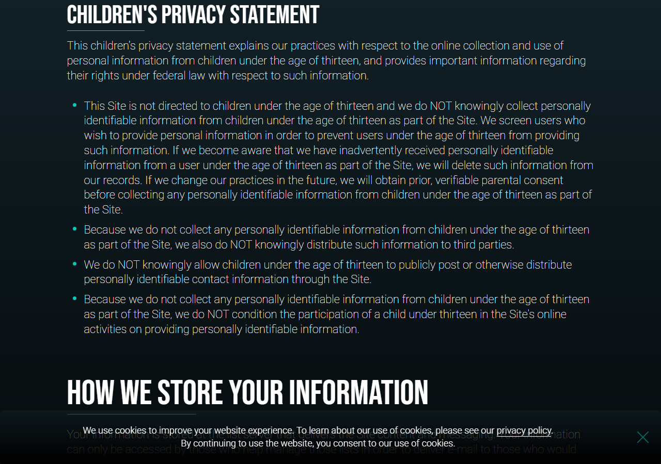
Bug ID | BUG-12 | Severity | LOW | Page | privacy_cookie | Category | Content

● AGELESS QA Test Page — Additional Finding

● ageless-qa-test · BUG-13 · Content HIGH
FREE BONUS Section Completely Missing from Staging Page

Section: FREE BONUS / Ebook offer section (below the hero registration form)
Expected  After the registration form, the page shows a "FREE BONUS" section offering "The Top 3 Aging Accelerators PLUS: How to Test and Avoid Them (Valued at $27)" with a 3D book cover image and three bullet point descriptions, followed by a "REGISTER FOR FREE NOW + GET YOUR FREE GIFT" CTA button. | Actual  The entire FREE BONUS section (segment-ebook) is absent from the staging page. The page jumps directly from the registration form to the "Our 50 World-Renowned Longevity Doctors" section, skipping the ebook offer completely.

⚑ Impact: A key incentive driving registrations is not shown to staging visitors. The bonus offer is a primary conversion lever — its absence makes the staging page significantly less persuasive than production.
Screenshot evidence
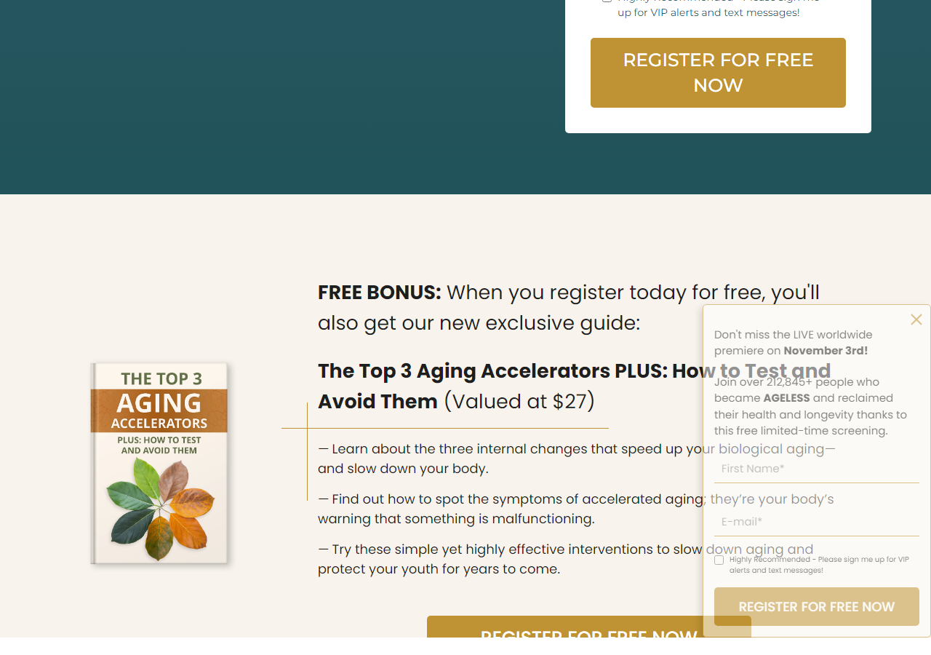 | 

Bug ID | BUG-13 | Severity | HIGH | Page | ageless-qa-test | Category | Content

● ageless-qa-test · BUG-14 · UI / UX HIGH
Text Overlaps Nobel Building Image in "Age Reversal" Section

Section: "Age Reversal Starts With One Prominent Nobel-Winning Discovery" section
Expected  The Nobel building photograph and the body text (cellular "housekeeping" explanation) sit in separate columns — image on the left, text on the right — with no visual overlap. | Actual  The right-column text overflows into the image area, causing paragraphs to visually overlap the Nobel building photograph. The layout breaks because the text column is not properly bounded by the image container.

⚑ Impact: The section becomes visually broken and hard to read. The overlap obscures part of both the supporting image and the body text, undermining the credibility of a key educational section.
Screenshot evidence
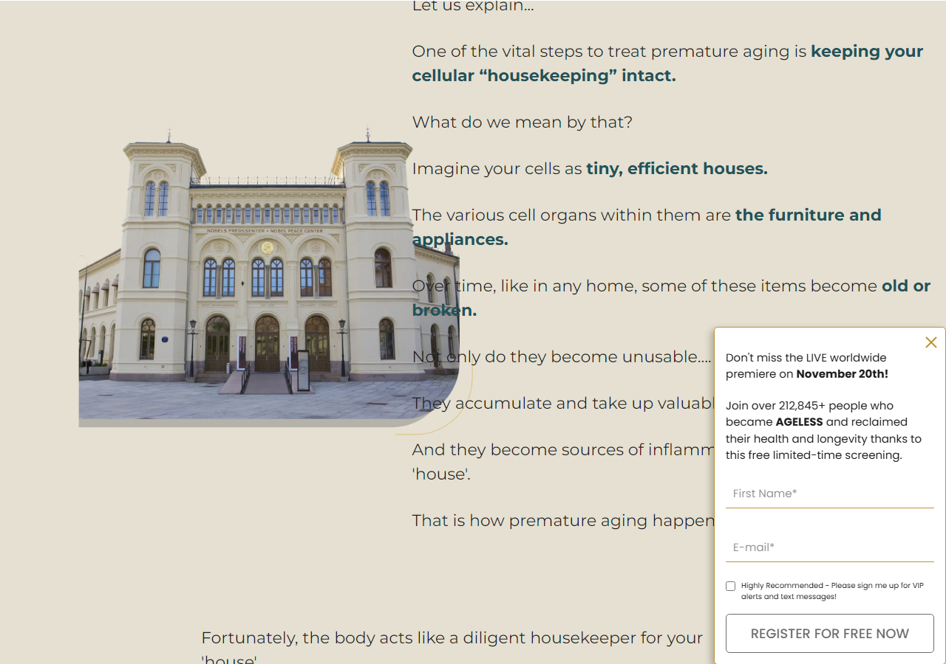 | 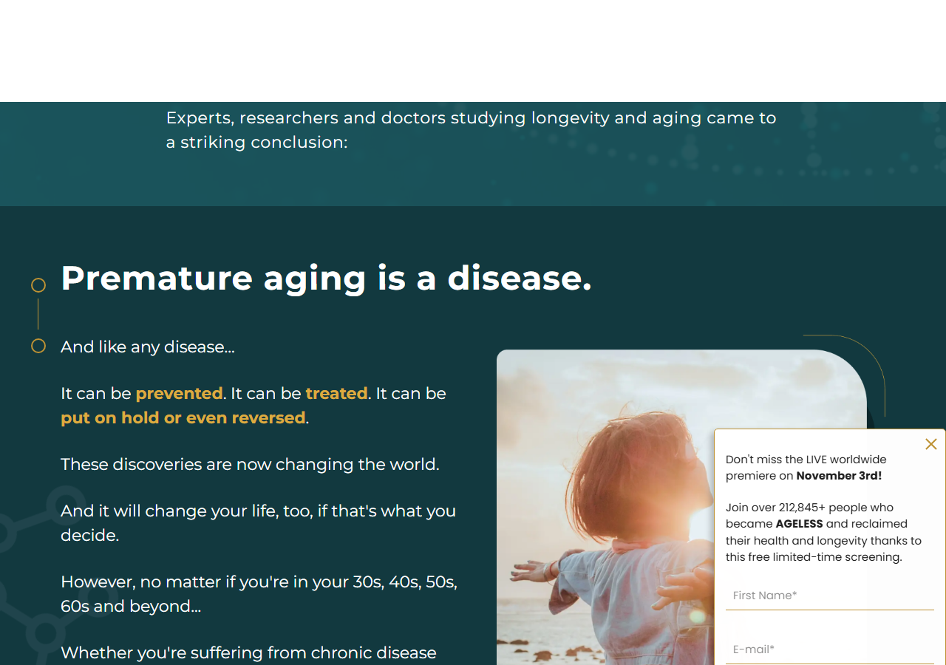

Bug ID | BUG-14 | Severity | HIGH | Page | ageless-qa-test | Category | UI / UX

● ageless-qa-test · BUG-15 · Functional MEDIUM
"Register for Free Now" CTA Button Missing in Meet Your Host Section

Section: Meet Your Host — Stefan Apostolov section
Expected  Production page includes a "Register for Free Now" CTA button within the Meet Your Host section, giving users a direct conversion path after reading the host bio. | Actual  The "Register for Free Now" button is completely absent from the Meet Your Host section on the staging page. The section ends after Stefan's bio with no CTA.

⚑ Impact: Removes a conversion touchpoint at a high-engagement moment. Users who are persuaded by the host's credibility have no immediate action to take.
Screenshot evidence
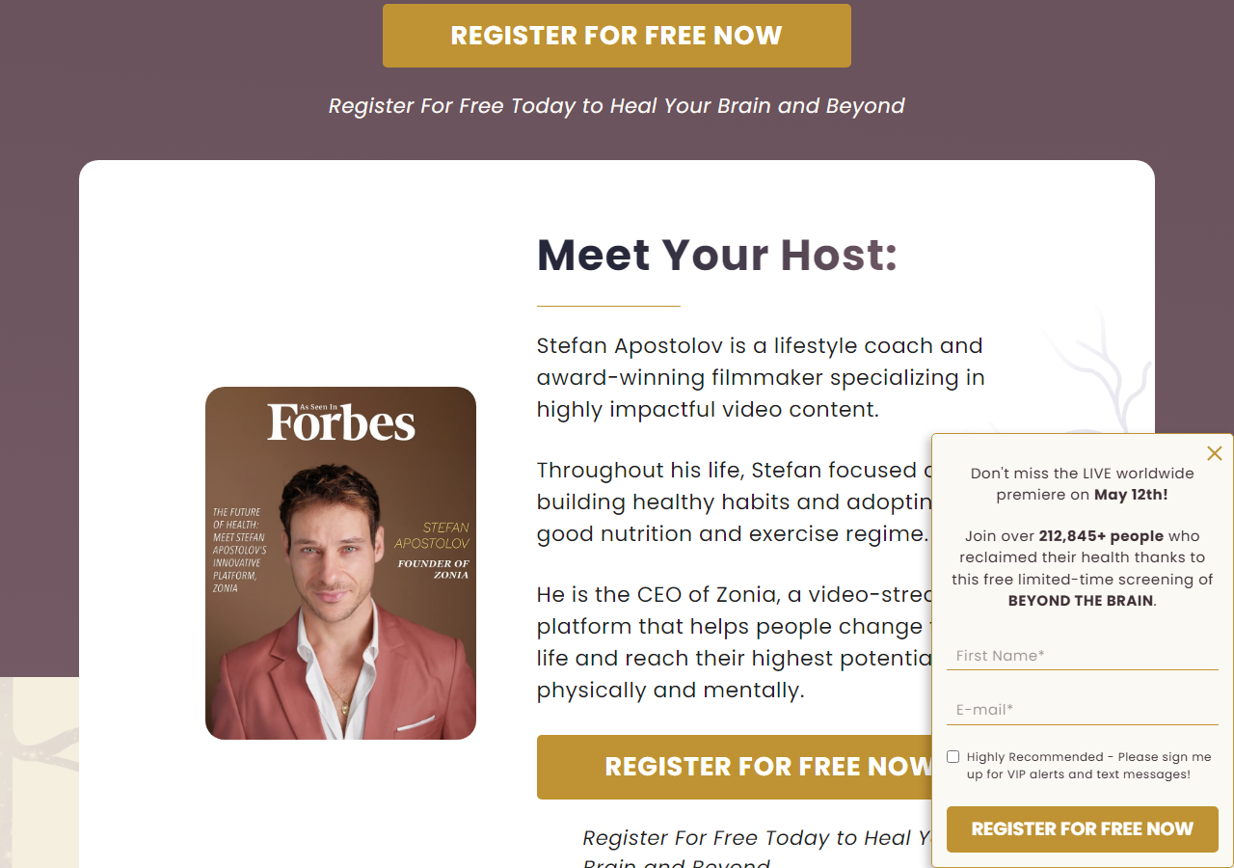 | 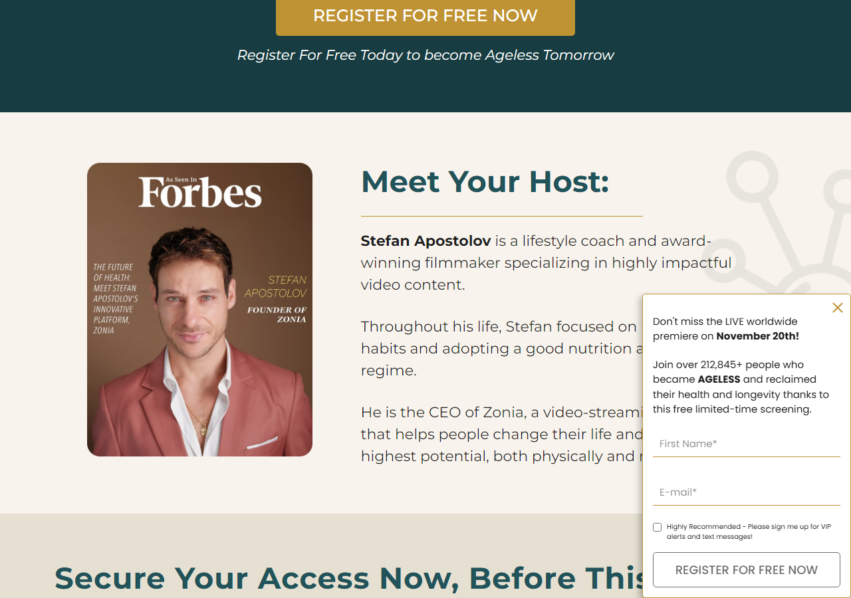

Bug ID | BUG-15 | Severity | MEDIUM | Page | ageless-qa-test | Category | Functional

● ageless-qa-test · BUG-16 · Content MEDIUM
Section Title Shows "10-part" Instead of "9-part" Documentary

Section: "Secure Your Access Now, Before This Groundbreaking Documentary Is Taken Down" section heading
Expected  "Secure Your Access Now, Before This 9-part Groundbreaking Documentary Is Taken Down" — as shown on the reference page (zonia.com/beyond-the-brain). | Actual  "Secure Your Access Now, Before This 10-part Groundbreaking Documentary Is Taken Down" — the episode count is incorrect on the staging page.

⚑ Impact: Factual inconsistency in a prominent section heading. If the docuseries has 9 episodes, stating "10-part" is misleading to visitors and contradicts other page content.
Screenshot evidence
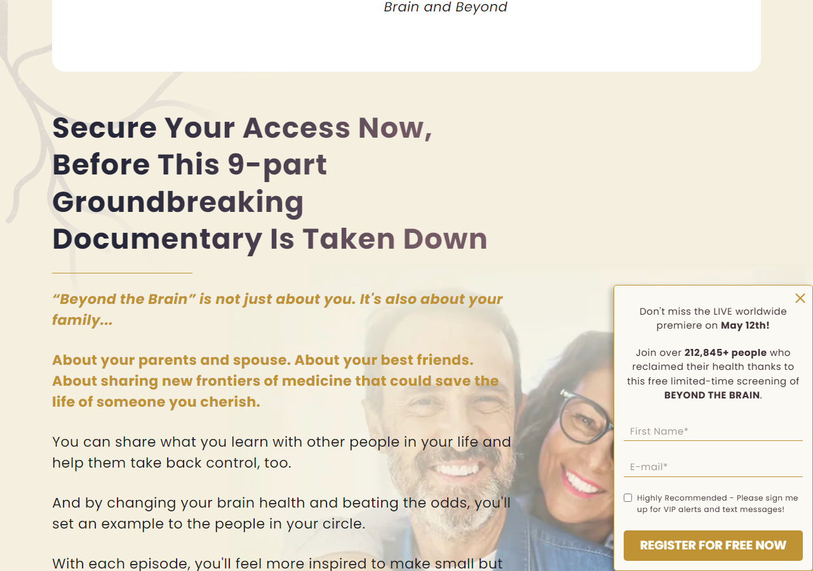 | 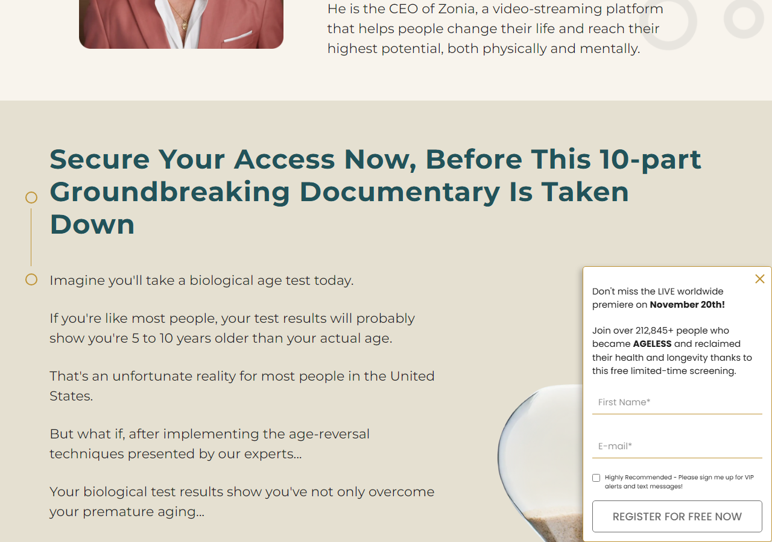

Bug ID | BUG-16 | Severity | MEDIUM | Page | ageless-qa-test | Category | Content

● ageless-qa-test · BUG-17 · UI / UX MEDIUM
Paragraph Indicator Dots Appearing Next to Expert Names / Info in "Meet Our 50 Experts" Section

Section: "Meet Our 50 World-Renowned Longevity and Chronic Disease Doctors and Health Experts Featured in AGELESS" section
Expected  On the production page each expert card displays the additional info lines cleanly with no extra leading characters or markers — only the circle outline bullet (○) and vertical separator line intended by the design. | Actual  On the staging page, small paragraph indicator dots (·) appear at the beginning of each line of additional info text beneath expert names. These markers are not present on the production page and appear to be an unintended CSS list-style or pseudo-element artefact.

⚑ Impact: Visual noise across every expert card in a large, prominent section. Degrades the professional appearance of the page and indicates a CSS styling regression affecting the expert grid component.
Screenshot evidence
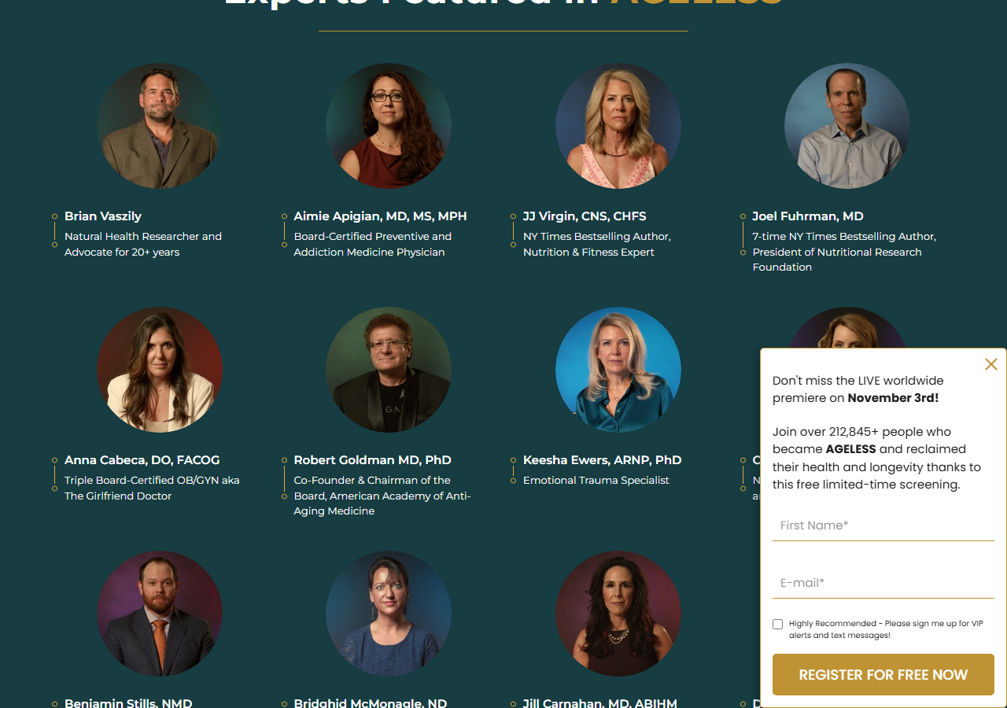 | 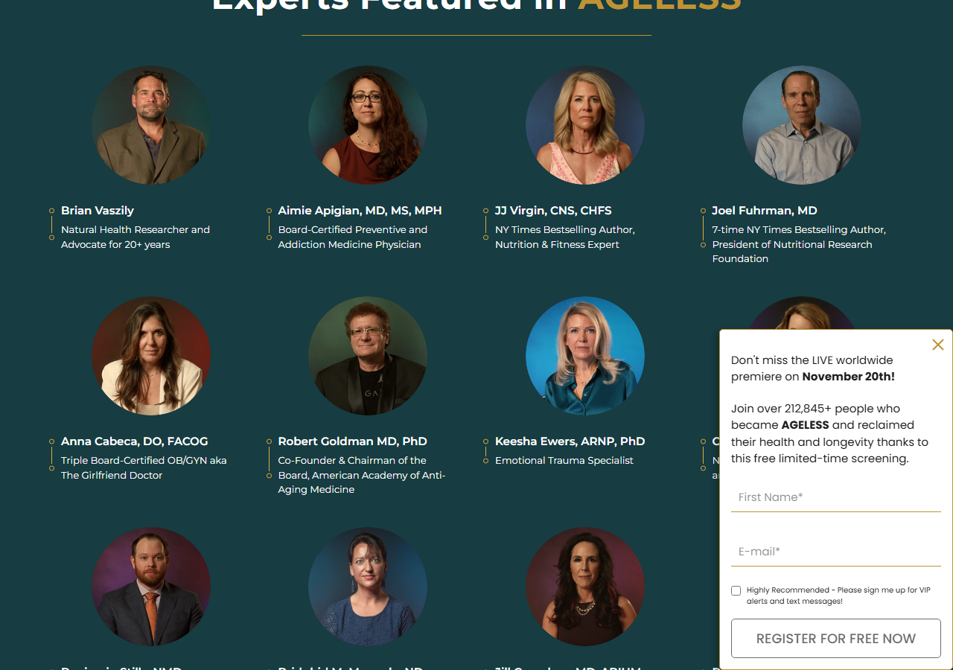

Bug ID | BUG-17 | Severity | MEDIUM | Page | ageless-qa-test | Category | UI / UX

● Terms of Use Page — Additional Bugs Found

The following additional bugs were found on staging.zonia.com/terms_use. BUG-18 (character encoding corruption) is staging-only. BUG-19 and BUG-20 relate to incorrect assets and meta description corruption.
● privacy_cookie · BUG-18 · Content HIGH
Character Encoding Corruption — Curly Quotes Rendered as â€œ / â€ Mojibake in Terms Page Overview

Section: Overview section — "IMPORTANT - PLEASE CAREFULLY READ AND UNDERSTAND THESE TERMS OF SALE…" paragraph
Expected  Curly quotation marks display correctly as " and " (e.g. ("TERMS" OR "AGREEMENT"), (collectively, the "Website"), d/b/a Zonia ("Zonia," "we," "our," "us")) — as seen on the production Terms page. | Actual  On the staging Terms page the same quotation marks are rendered as garbled mojibake sequences: â€œ (opening quote) and â€ (closing quote). This corruption appears throughout the entire Overview section and persists further down the page in multiple paragraphs.

⚑ Impact: Severe readability and professionalism issue in a legal document. The encoding corruption is immediately visible at the very top of the page content and affects multiple paragraphs throughout the Terms of Use, making the document look broken and unprofessional to every visitor.
Screenshot evidence
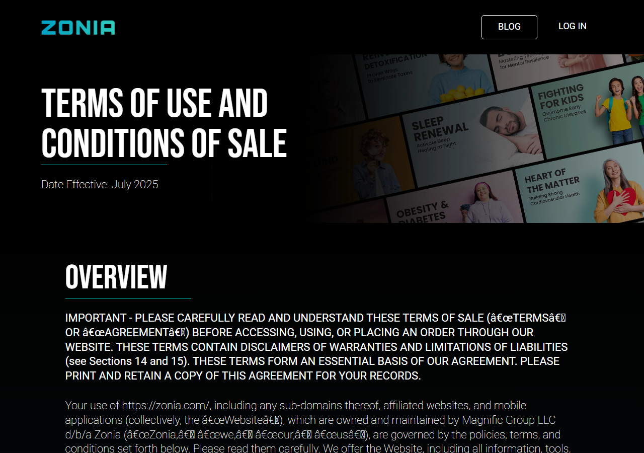 | 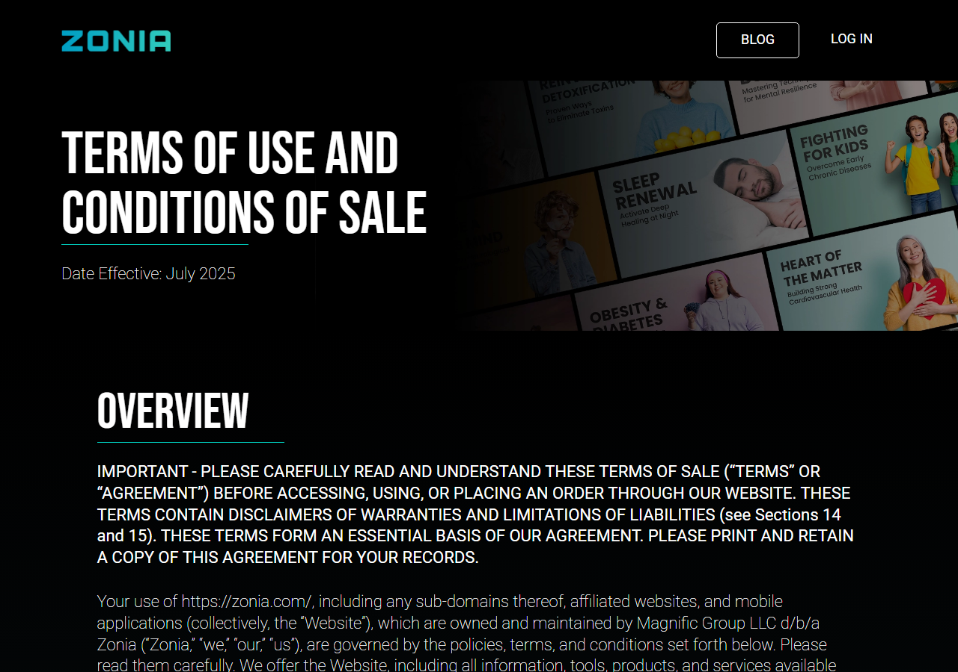

Bug ID | BUG-18 | Severity | HIGH | Page | privacy_cookie | Category | Content

● privacy_cookie · BUG-19 · UI / UX MEDIUM
Footer App Store Icons Are Smaller and Use Wrong Image Assets

Section: Footer — "ZONIA APP" section (App Store, Google Play, Roku, Amazon badges)
Expected  Production uses full-size official app store badge images (138×47 px PNG) sourced from /pages/policy-pages/icons/ — clearly readable badges with standard branding. | Actual  Staging uses smaller SVG files (83×28 px) sourced from /pages/quiz/images/app-icons/ — a different asset path intended for the quiz flow. The badges are noticeably smaller and visually inconsistent with the production footer.

⚑ Impact: Visual regression in the site-wide footer. The undersized app store badges look unprofessional and may reduce click-through on app download links. The wrong asset path suggests the footer component was not updated during the staging deployment.
Screenshot evidence
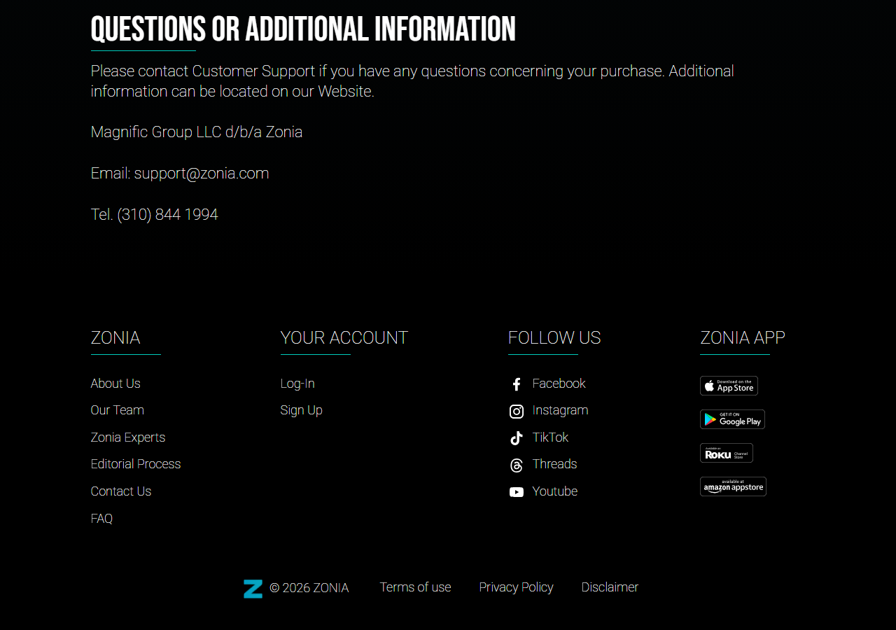 | 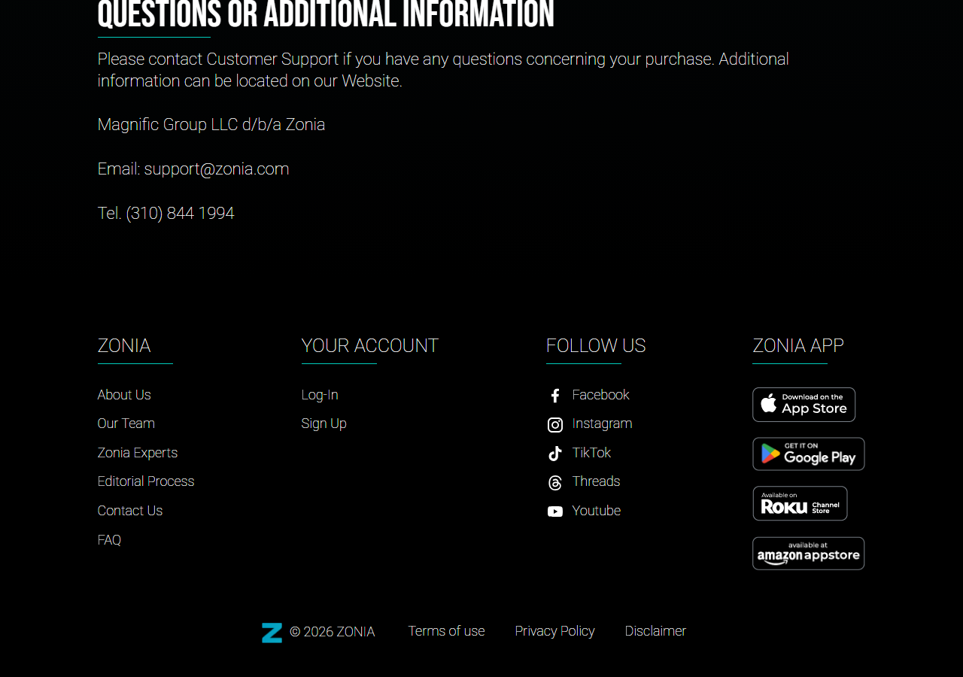

Bug ID | BUG-19 | Severity | MEDIUM | Page | privacy_cookie | Category | UI / UX

● privacy_cookie · BUG-20 · Content LOW
Meta Description Contains UTF-8 Encoding Corruption (Same Root Cause as BUG-18)

Section: Page <meta name="description"> tag (not visible on page — affects Google search snippets and social previews)
Expected  Production meta description: "Read our Terms of Use » See how Zonia provides science-backed content responsibly ✔ Registration ✔ Managing Account ✔ Refund Policy ✔ Website Features" | Actual  Staging meta description: "Read our Terms of Use Â» See how Zonia provides science-backed content responsibly âœ" Registration âœ" ..." — the » (right-pointing angle quote) and ✔ (check mark) characters are double-encoded as mojibake sequences Â» and âœ".

⚑ Impact: While invisible on the rendered page, the corrupted meta description is displayed verbatim in Google search result snippets and social media link previews (Facebook, Slack, etc.), damaging brand credibility in off-site contexts.
Bug ID | BUG-20 | Severity | LOW | Page | privacy_cookie | Category | Content

● Additional Observations

ℹ Video URL Difference — Hero Section
The embedded YouTube video in the hero section differs between production and staging. This may be intentional (e.g. a test/placeholder video) but should be confirmed before launch.
Production (zonia.com/ageless) | https://www.youtube.com/watch?v=T7MTcbqX0jI
Staging (ageless-qa-test) | https://www.youtube.com/watch?v=weC-IDkZx9s

