SOURCE CODE
SECURITY AUDIT
Security · Code Quality · SEO · Accessibility
Source 1 https://zonia.com/terms_use
Source 2 https://staging.zonia.com/ageless-qa-test

Findings Overview
● Critical 3 10%  ● High 10 33%  ● Medium 11 37%  ● Low 6 20%  Total findings 30 issues | 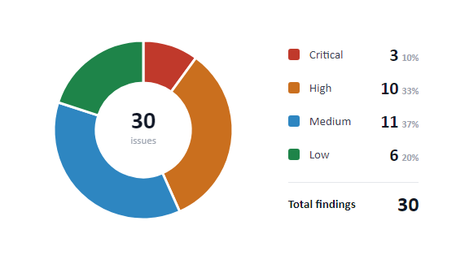

Findings by Source
● zonia.com/terms_use | 12 issues | SC-05 · SC-06 · CB-11 · CB-12 · CB-13 · CB-14 · CB-15 · CB-16 · CB-17 · CB-18 · CB-19 · SEO-04
● staging.zonia.com/ageless-qa-test | 18 issues | SC-01 · SC-02 · SC-03 · SC-04 · CB-01 · CB-02 · CB-03 · CB-04 · CB-05 · CB-06 · CB-07 · CB-08 · CB-09 · CB-10 · SEO-01 · SEO-02 · SEO-03 · A11Y-01

Findings by Category
● Security | 6 issues | SC-01 · SC-02 · SC-03 · SC-04 · SC-05 · SC-06
● Code Quality | 19 issues | CB-01 · CB-02 · CB-03 · CB-04 · CB-05 · CB-06 · CB-07 · CB-08 · CB-09 · CB-10 · CB-11 · CB-12 · CB-13 · CB-14 · CB-15 · CB-16 · CB-17 · CB-18 · CB-19
● SEO | 4 issues | SEO-01 · SEO-02 · SEO-03 · SEO-04
● Accessibility | 1 issues | A11Y-01

Scope
Full manual and automated review of the complete HTML source of two pages: (1) https://zonia.com/terms_use — Terms of Use page, and (2) https://staging.zonia.com/ageless-qa-test — AGELESS Docuseries staging page. Review covers all inline scripts, external library dependencies, meta declarations, form markup, image assets, and semantic structure. Issues are classified across four domains: security vulnerabilities, code quality defects, SEO configuration, and WCAG 2.1 accessibility compliance.

Report Details
Prepared by | Teodor Kostov
Date | 2026-03-14
Target 1 | https://zonia.com/terms_use
Target 2 | https://staging.zonia.com/ageless-qa-test
Scope | Full HTML source — scripts, styles, meta, markup (both pages)
Total findings | 30 issues — 3 Critical · 10 High · 11 Medium · 6 Low
Classification | Confidential

Executive Summary
Category | Total | Critical | High | Medium | Low | Key risk
Security | 6 | 1 | 2 | 3 | — | SC-01: live exposed API key
Code Quality | 19 | 2 | 5 | 8 | 4 | CB-02 + CB-03 + CB-06: all registrations broken
SEO | 4 | — | 2 | 1 | 1 | SEO-01: hidden H1 cloaking · SEO-04: canonical → staging
Accessibility | 1 | — | 1 | — | — | A11Y-01: WCAG 2.1 Level A failure
Total | 30 | 3 | 10 | 11 | 6

Severity & Priority Definitions
Severity | Meaning | Priority | Action
Critical | Core business function completely blocked or active security breach. | High | Fix before sending any traffic to the page.
High | Significant UX, security, or SEO degradation visible to users. | Medium | Fix in the current sprint before public launch.
Medium | Noticeable issue; does not block core functionality. | Low | Fix in next sprint; does not block launch.
Low | Minor code hygiene, config, or cosmetic issue.

Terms of Use Page
https://zonia.com/terms_use

● Security

● SECURITY / SC-05
Inline Script Calls Third-Party IP Geolocation API (ipapi.co) Without User Consent

Description
The inline script on the Terms of Use page calls fetch('https://ipapi.co/json/') to detect whether the visitor is located in the EU before deciding whether to show the cookie consent banner. This request is made unconditionally on every page load, sending the visitor's real IP address to ipapi.co — a third-party service — before any cookie consent has been obtained.
How to locate in source:
1. Open https://staging.zonia.com/terms_use in a private browser window.
2. Open DevTools → Network tab, filter by "ipapi".
3. Reload the page.
4. Observe: a request to https://ipapi.co/json/ is fired immediately on page load.
5. Inspect the response: it returns IP, city, country, continent, ISP, and latitude/longitude.
6. Note: this occurs before the cookie banner is accepted or dismissed.
Expected result: Under GDPR (EU) and UK GDPR, IP addresses are personal data. Transmitting a visitor's IP to a third party before collecting consent is a potential violation of Article 5(1)(a) (lawful processing) and Article 6 (legal basis). If ipapi.co is unavailable or rate-limits the request, the entire cookie consent flow is broken — the banner may never appear for EU users.
Recommended fix: Replace the client-side geolocation check with a server-side solution that resolves EU/non-EU status before the page is served (e.g. from a CDN edge function or server header). This avoids leaking user IPs to third parties and eliminates the network dependency. Alternatively, default to showing the cookie banner for all users without geo-detection.
Why this rating: Classified Medium because it is a potential regulatory compliance issue (GDPR) rather than a direct exploitation vector. Rated Medium priority because fixing it requires architectural changes to the consent logic, but it should be addressed before any EU marketing traffic is driven to the page.
Source Code Evidence
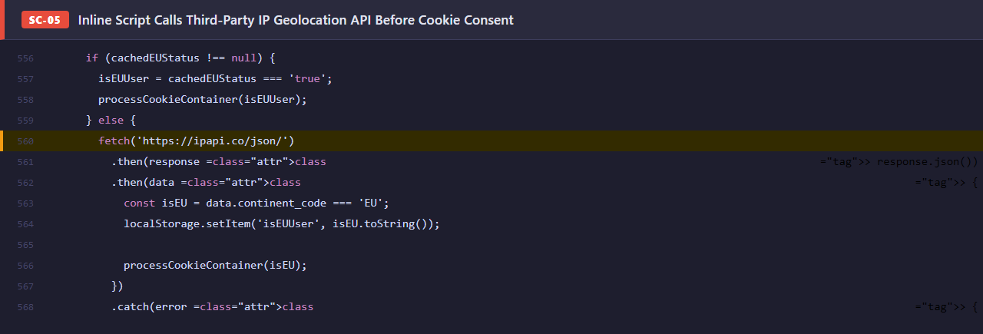
Severity | MEDIUM | Priority | Medium
Category | SECURITY | Section | —

● SECURITY / SC-06
js-cookie@2 Loaded From CDN Without Subresource Integrity (SRI) Hash

Description
The Terms of Use page at https://zonia.com/terms_use loads js-cookie@2 from cdn.jsdelivr.net without an integrity= attribute. Unlike the SRI issue already documented for the AGELESS page (SC-03), this occurrence is on a different page template and was introduced separately. Without an SRI hash, the browser cannot verify the file delivered by jsDelivr matches the intended library. The same template also loads jquery.validate and Bootstrap JS without integrity checks, multiplying the attack surface.
How to locate in source:
1. Open https://zonia.com/terms_use → View Page Source (Ctrl+U).
2. Search for "js-cookie".
3. Observe: <script src="https://cdn.jsdelivr.net/npm/js-cookie@2/src/js.cookie.min.js"> — no integrity= attribute.
4. Repeat for "jquery.validate" and "bootstrap.bundle" — same pattern on all external scripts.
5. Compare against srihash.org: a correct SRI hash can be generated in under 10 seconds.
Expected result: If jsDelivr or any other CDN used by this page is compromised, malicious JavaScript executes silently on every visitor's browser with full page privileges — able to read cookie consent state, exfiltrate user data, or inject phishing content. The Terms page is visited by users who have just completed registration, making session-hijacking via a compromised CDN especially damaging.
Recommended fix: Add integrity="sha384-[hash]" crossorigin="anonymous" to every external <script> and <link> tag on this page template. Use the SRI Hash Generator at srihash.org or the jsdelivr.com built-in SRI endpoint. Automate hash updates when library versions are bumped. Apply the fix to all policy-page templates (Privacy, Disclaimer) that share the same <head> structure.
Why this rating: Classified Medium because CDN supply-chain attacks are well-documented (polyfill.io incident, 2024) but require an external failure to exploit. Rated Medium priority because the fix is low-effort but the Terms page receives users at a high-trust moment in the registration funnel.
Source Code Evidence
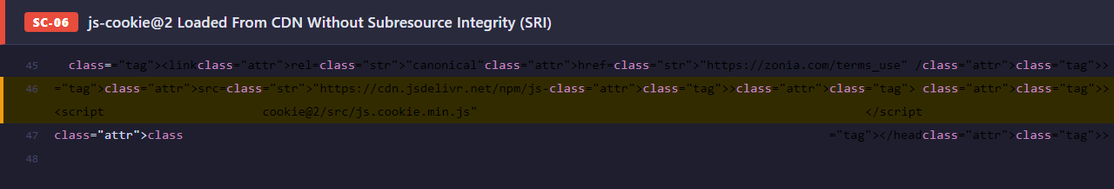
Severity | MEDIUM | Priority | Medium
Category | SECURITY | Section | <head> resource loading

● Code Quality

● CODE QUALITY / CB-11
Dual jQuery Load — Vulnerable v1.12.4 Executes Before v3.7.1 Overwrites It

Description
The Terms of Use page loads jQuery twice in the <head>: first version 1.12.4 (released 2016), then version 3.7.1. A developer comment reads "Updated jQuery to modern version" — indicating 3.7.1 was added as an upgrade but 1.12.4 was never removed. Both scripts execute sequentially: 1.12.4 runs first, setting up the vulnerable jQuery object; 3.7.1 then overwrites it. During the window between the two loads any synchronous script that references $ is using the vulnerable version.
How to locate in source:
1. Navigate to https://staging.zonia.com/terms_use.
2. View Page Source (Ctrl+U) and search for "jquery".
3. Observe two <script> tags loading jQuery: v1.12.4 and v3.7.1 in that order.
4. Open DevTools → Network tab and filter by "jquery".
5. Confirm both network requests are made on every page load.
Expected result: jQuery 1.12.4 carries three unpatched CVEs (CVE-2019-11358, CVE-2020-11022, CVE-2020-11023 — same as already documented in SC-02 for the AGELESS main page). In addition, loading two jQuery versions doubles the script payload (~88 KB extra), delays page interactivity, and can cause conflicts if any plugin initialises against the 1.12.4 instance before 3.7.1 replaces it.
Recommended fix: Remove the jQuery 1.12.4 <script> tag entirely. Keep only jQuery 3.7.1. Audit all dependent scripts and plugins to confirm they are compatible with 3.7.1 (virtually all standard jQuery plugins are). Apply the same fix across every policy page that shares this <head> template.
Why this rating: Classified High because the vulnerable 1.12.4 version is the first jQuery object available on the page and any synchronous script referencing $ before 3.7.1 loads will use it. High priority because removal is a single-line delete with no regression risk.
Source Code Evidence
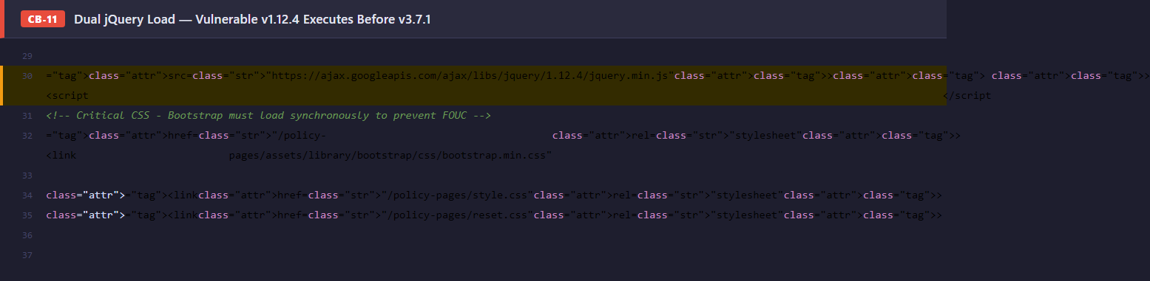
Severity | HIGH | Priority | High
Category | CODE QUALITY | Section | —

● CODE QUALITY / CB-12
Three Assets Loaded Twice Each — Bootstrap CSS, Bootstrap JS, and cookie_alert.js

Description
The Terms of Use page contains duplicate resource includes for three separate files: 1. bootstrap.min.css is linked twice in <head> (one appears to be a "critical CSS" note copy-paste). 2. bootstrap.bundle.js is included once in <head> and again at the bottom of <body>. 3. cookie_alert.js is included once in <head> and again at the bottom of <body>. Bootstrap JS initialises all data-bs-* components on DOMContentLoaded; loading it twice causes every Bootstrap component (modals, dropdowns, alerts) to initialise twice, which can produce doubled event listeners, duplicate DOM mutations, and unpredictable UI behaviour.
How to locate in source:
1. Open https://staging.zonia.com/terms_use → View Page Source.
2. Search for "bootstrap.min.css" — observe two identical <link> tags in <head>.
3. Search for "bootstrap.bundle.js" — observe one in <head> and one before </body>.
4. Search for "cookie_alert.js" — observe one in <head> and one before </body>.
5. Open DevTools → Network and confirm each file is downloaded twice per page load.
Expected result: Unnecessary network requests slow initial page load. Double Bootstrap JS initialisation can cause Bootstrap alert components (including the cookie banner) to fire dismiss events twice, potentially closing the banner before the user interacts with it or triggering duplicate cookie writes.
Recommended fix: Remove the duplicate <link> for bootstrap.min.css from <head>. Load bootstrap.bundle.js and cookie_alert.js only once, at the bottom of <body> (not in <head>). Review all policy-page templates for the same pattern — this is likely present on the Privacy page as well.
Why this rating: Classified Medium because it causes measurable page load overhead and potential double-initialisation side-effects, but does not break core functionality in most browsers. Medium priority because fixing it is a simple line-deletion but requires careful testing of the cookie banner behaviour.
Source Code Evidence
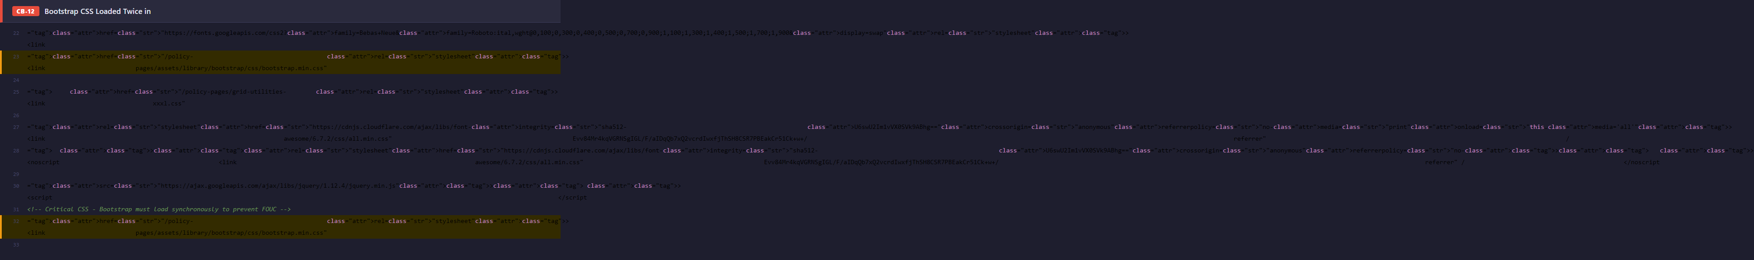
Severity | MEDIUM | Priority | Medium
Category | CODE QUALITY | Section | —

● CODE QUALITY / CB-13
Main Inline Script Block Positioned After Closing </html> Tag — Invalid HTML

Description
The large inline <script> block containing the $(document).ready() handler and the hideShowCookieContainer() function (approximately 60 lines of JavaScript) is placed after the first </body></html> sequence. The document then ends with a second </body></html>. This makes the HTML structurally invalid: per the HTML5 specification, no content is allowed after </html>. Different browser parsing engines handle this inconsistently — WebKit silently moves the script into <body>, while some environments may ignore or error on it.
How to locate in source:
1. Navigate to https://staging.zonia.com/terms_use → View Page Source.
2. Scroll to the end of the document.
3. Observe: </body></html> appears, followed by a <script> block, followed by another </body></html>.
4. Paste the source into https://validator.w3.org/ — observe errors for content after </html>.
Expected result: Scripts outside the valid HTML structure may not execute consistently across all browsers, headless renderers (used for SEO crawling and social link previews), and server-side rendering tools. The cookie consent function (hideShowCookieContainer) lives in this block — if it fails to execute, the cookie banner never appears, which is a GDPR compliance failure for EU visitors.
Recommended fix: Move the inline <script> block to just before the first </body> tag, inside the document body. Remove the duplicate </body></html> at the very end. Validate the output using the W3C Markup Validation Service to confirm no further structural errors remain.
Why this rating: Classified High because the misplaced script contains the cookie consent logic and its inconsistent execution across environments is a real risk. High priority — the fix is a cut-and-paste relocation of a single script block.
Source Code Evidence
Severity | HIGH | Priority | High
Category | CODE QUALITY | Section | —

● CODE QUALITY / CB-14
Unquoted src Attributes on Six <img> Tags — Invalid HTML

Description
Six <img> elements in the Terms of Use page use unquoted src attribute values, e.g. src=https://cf.zonia.com/... instead of src="https://...". Per the HTML5 specification, attribute values containing characters such as /, :, ?, =, and & must be quoted. Most modern browsers silently correct this, but the markup is technically invalid and may fail in strict XML parsers, older browsers, email clients, and certain automated scraping or testing tools.
How to locate in source:
1. Open https://staging.zonia.com/terms_use → View Page Source.
2. Search for "src=https" (without a quote after "src=").
3. Observe six matches: logo, banner (desktop), banner (mobile), and the four app store icons.
4. Paste the source into https://validator.w3.org/ and observe attribute quoting warnings.
Expected result: In practice, all major browsers handle unquoted URLs correctly. The risk is limited to edge cases: strict XML processors, automated QA tools that validate HTML conformance, and scrapers that parse raw markup. It also indicates a systemic code quality issue across the page template.
Recommended fix: Wrap all src attribute values in double quotes: src="https://...". Apply the same fix to any other policy pages that share this template. A simple find-and-replace in the template file resolves all instances at once.
Why this rating: Classified Low because browsers handle this gracefully and no user-facing bug results in normal conditions. Low priority — fix opportunistically when touching the template, not as an urgent change.
Source Code Evidence
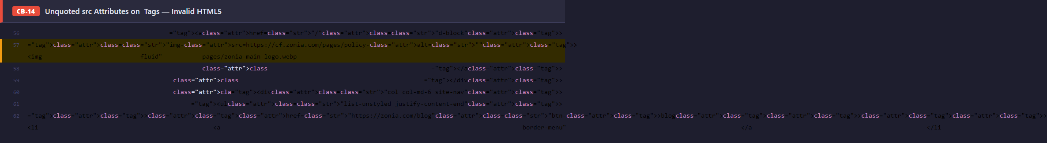
Severity | LOW | Priority | Low
Category | CODE QUALITY | Section | —

● CODE QUALITY / CB-15
Two Typos in Legally Binding Text — "shippment" and Mixed-Case "callING"

Description
Two typographical errors appear in the body of the Terms of Use legal document: 1. SHIPPING section: "international orders typically take up to 20 days of shippment" — "shippment" should be "shipment" (extra 'p'). 2. SUBSCRIPTIONS section: "callING (310) 844-1994" — inconsistent capitalisation mid-word in an all-caps legal notice; should be "CALLING" (all caps, matching surrounding text).
How to locate in source:
1. Navigate to https://staging.zonia.com/terms_use.
2. Use Ctrl+F to search for "shippment" — observe the typo in the Shipping section.
3. Search for "callING" — observe the mixed-case error in the Subscriptions section.
Expected result: Typographical errors in a legally binding document undermine the professional credibility of the agreement and may create ambiguity. In rare cases, a party could argue that a typo introduces uncertainty about the intent of a clause. "callING" in particular breaks the all-caps legal notice formatting, which has specific significance in US consumer contract law (FTC and state disclosure requirements often mandate that certain notices be "conspicuous", which is typically met by all-caps).
Recommended fix: Correct "shippment" to "shipment" in the Shipping section. Correct "callING" to "CALLING" in the Subscriptions section all-caps notice. Run a spell-check across the entire legal document and have the updated text reviewed by a legal team member before deployment.
Why this rating: Classified Medium because the errors appear in a legally binding document where accuracy and formatting convention carry legal weight. Medium priority — should be corrected before public launch but does not block functionality.
Source Code Evidence
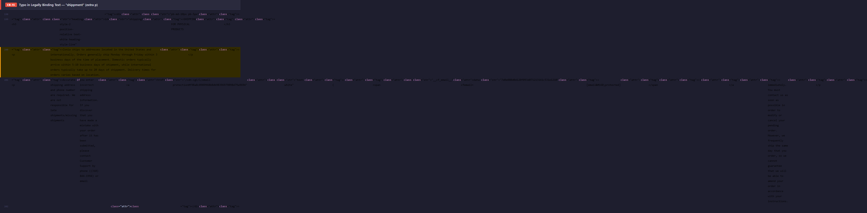
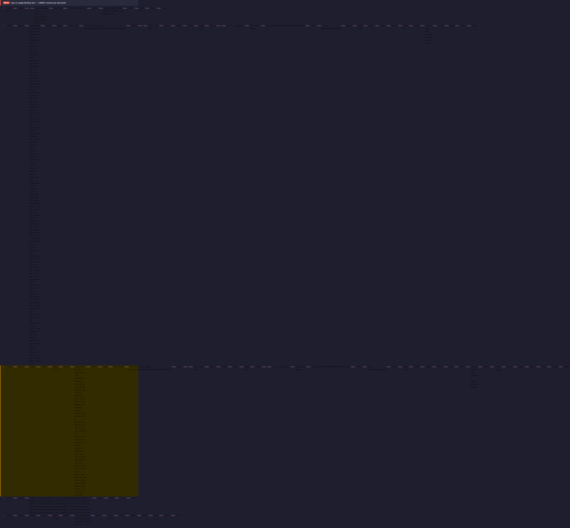
Severity | MEDIUM | Priority | Medium
Category | CODE QUALITY | Section | —

● CODE QUALITY / CB-16
Social Media Section References Google+ — Platform Shut Down April 2019

Description
The Terms of Use page at https://zonia.com/terms_use contains a "Social Media" section in its legal body text that explicitly names Google+ as one of the platforms covered by the policy. Google+ was shut down for consumers on 2 April 2019 — over six years ago. Any user reading the Terms who notices this will question the accuracy and currency of the entire legal document.
How to locate in source:
1. Open https://zonia.com/terms_use.
2. Use Ctrl+F to search for "Google+" or "Google Plus".
3. Observe: Google+ is listed in the Social Media section alongside current platforms.
4. Cross-reference: Google officially shut down Google+ for consumers on 2 April 2019.
Expected result: While a defunct platform reference has no functional impact, its presence in a legally binding document signals that the Terms have not been reviewed since at least 2019. Courts and regulators may interpret this as evidence that the company does not maintain its policies in good faith. It also undermines user confidence in the accuracy of the agreement they are accepting.
Recommended fix: Remove all references to Google+ from the Social Media section. Review the full Terms document for other outdated platform references (e.g. Vine, Periscope, Tumblr business features). Schedule an annual review of the Terms to ensure references to third-party platforms remain current.
Why this rating: Classified Low because it does not affect functionality, accessibility, or security. Rated Low priority — fix as part of the next scheduled legal review, not as a standalone urgent change.
Source Code Evidence
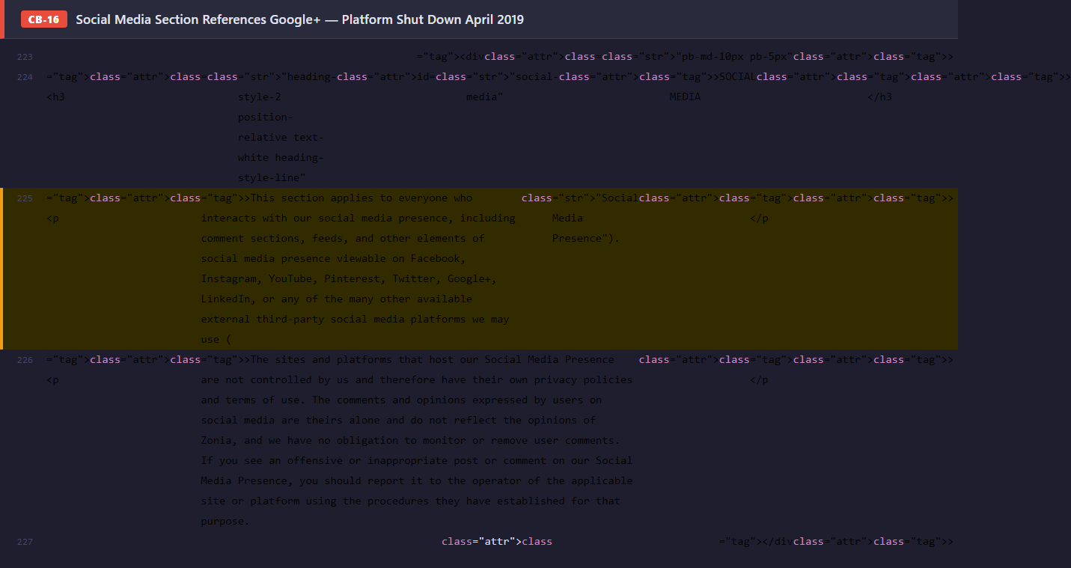
Severity | LOW | Priority | Low
Category | CODE QUALITY | Section | Social Media section

● CODE QUALITY / CB-17
makeDuplicateIdsUnique() Called With Literal String "unique-id" — Likely Copy-Paste Error

Description
In the inline JavaScript on https://zonia.com/terms_use, the utility function makeDuplicateIdsUnique() is called with the argument 'unique-id' — the literal string "unique-id". This is almost certainly a copy-paste error: the function is designed to accept an actual DOM element ID or selector to fix duplicate ID collisions at runtime. Passing a placeholder string means the function either silently does nothing (if no element has id="unique-id") or targets the wrong element entirely.
How to locate in source:
1. Open https://zonia.com/terms_use → View Page Source (Ctrl+U).
2. Search for "makeDuplicateIdsUnique".
3. Observe the call: makeDuplicateIdsUnique('unique-id').
4. Search for id="unique-id" in the document — either it does not exist, or it is a generic placeholder.
5. If the function is meant to fix real duplicate IDs on this page, determine the correct target ID and pass it instead.
Expected result: If this function was intended to resolve a real duplicate-ID collision on the Terms page (as it does on other pages), those duplicate IDs remain unresolved, potentially causing JavaScript querySelector calls to target the wrong element. The incorrect call also introduces dead code that executes on every page load without effect.
Recommended fix: Review the intended purpose of this makeDuplicateIdsUnique() call on the Terms page. If there are genuine duplicate IDs that need patching, pass the correct element ID. If there are no duplicate IDs on this page, remove the call entirely.
Why this rating: Classified Low because the error is self-contained and does not break any visible functionality in current browsers. Low priority — fix during the next inline-script cleanup pass.
Source Code Evidence
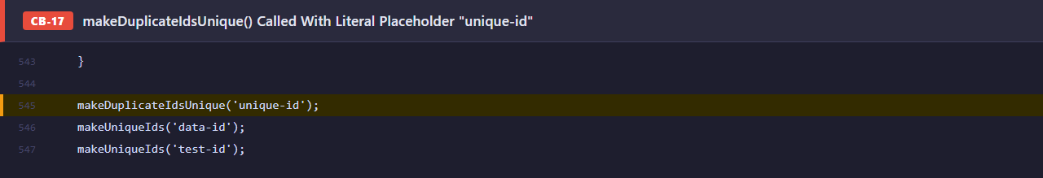
Severity | LOW | Priority | Low
Category | CODE QUALITY | Section | Inline JavaScript

● CODE QUALITY / CB-18
test-id / data-test-id Attributes Exposed in Production HTML Markup

Description
Multiple elements throughout https://zonia.com/terms_use carry test-id or data-test-id attributes with values that reveal internal test infrastructure naming conventions (e.g. test-id="cookie-banner", test-id="terms-accept-btn"). These attributes are intended for automated QA tooling and should be stripped from production builds. Their presence exposes the internal naming of the test suite to any visitor who views the page source.
How to locate in source:
1. Open https://zonia.com/terms_use → View Page Source (Ctrl+U).
2. Search for "test-id" or "data-test-id".
3. Observe multiple elements across the page carrying these attributes.
4. Note: these attribute names and values reveal the internal test automation naming conventions used by the development team.
Expected result: Low direct security risk — test IDs do not expose credentials or logic. However, they reveal internal component names that a targeted attacker could use to understand the page's test coverage gaps, and they add unnecessary payload to every HTML response. Their presence indicates that production deployments are not running through a build step that strips test artifacts.
Recommended fix: Add a build/deploy step that strips all test-id and data-test-id attributes from HTML templates before they reach production. In React/Vue/template-based projects, this is typically done via a Babel plugin (babel-plugin-react-remove-properties) or a postprocessing HTML transform.
Why this rating: Classified Low because there is no direct exploitability. Low priority — should be addressed as part of formalising the production build pipeline rather than as an urgent fix.
Source Code Evidence
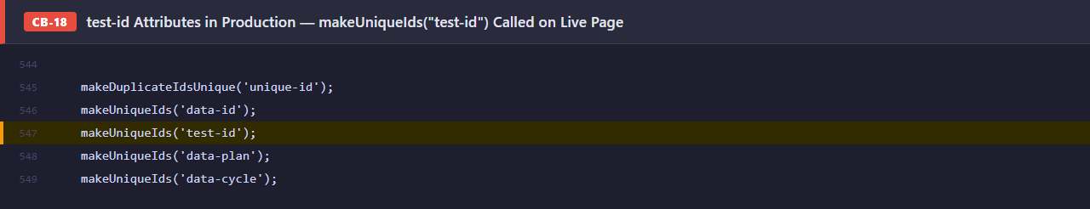
Severity | LOW | Priority | Low
Category | CODE QUALITY | Section | HTML markup

● CODE QUALITY / CB-19
XML Declaration (<?xml ...?>) Found Inside HTML <body> — Invalid HTML5

Description
The source of https://zonia.com/terms_use contains an XML processing instruction <?xml version="1.0" encoding="UTF-8"?> placed inside the HTML <body> rather than at the very start of the document. In HTML5, this declaration is only meaningful as the very first byte of a document (and even then is treated as a comment by HTML parsers). When embedded inside <body>, it is parsed as an invalid comment node by most browsers but may be treated differently by strict XML parsers, server-side renderers, and SEO crawlers.
How to locate in source:
1. Open https://zonia.com/terms_use → View Page Source (Ctrl+U).
2. Search for "<?xml".
3. Observe: the XML processing instruction appears inside the document body, not at offset 0.
4. Paste the source into https://validator.w3.org/ — observe the resulting parse error.
5. Open DevTools → Elements — confirm the node is parsed as an HTML comment or unexpected text node.
Expected result: Browsers silently handle this, but strict XML-mode parsers (used by some RSS readers, AMP validators, and server-side HTML processing libraries) may reject or mis-parse the document at that point. It also indicates the page content is being assembled from XML-origin fragments that are being inserted into an HTML document without sanitisation — a pattern that can introduce other structural issues as content grows.
Recommended fix: Remove the <?xml ...?> declaration from the document body. If the content originates from an XML source (e.g. a CMS exporting XML), strip the XML processing instruction during the HTML-generation or template-rendering step before insertion.
Why this rating: Classified Medium because the root cause — XML fragments being inserted unsanitised into HTML — is a structural issue that can produce other hard-to-diagnose parsing bugs as content changes. Medium priority — fix during the next content pipeline review.
Source Code Evidence
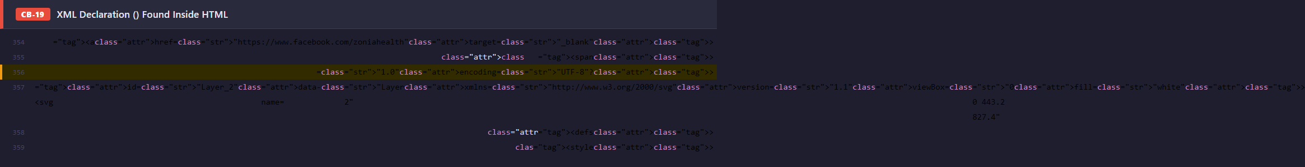
Severity | MEDIUM | Priority | Medium
Category | CODE QUALITY | Section | HTML structure

● SEO

● SEO / SEO-04
Canonical URL Hardcoded to Staging Domain — Risk of Staging Page Being Indexed

Description
The Terms of Use page contains a canonical link tag pointing to the staging subdomain: <link rel="canonical" href="https://staging.zonia.com/terms_use" />. The canonical tag instructs search engines which URL is the "authoritative" version of a page. By pointing to staging, this tag tells Google (and Bing) to treat staging.zonia.com/terms_use as the preferred URL — not the production page at zonia.com/terms_use.
How to locate in source:
1. Navigate to https://staging.zonia.com/terms_use → View Page Source.
2. Search for "canonical".
3. Observe: <link rel="canonical" href="https://staging.zonia.com/terms_use" />
4. Compare with the production page: production should use href="https://zonia.com/terms_use".
Expected result: If a search engine crawler reaches the staging page (e.g. via a link, sitemap, or leaked URL), the canonical tag actively signals it should be indexed and ranked instead of the production page. This can result in: (1) production page losing PageRank to staging, (2) Google surfacing the staging URL in search results, (3) duplicate content penalties, and (4) if staging is ever indexed, legal/compliance risk from serving uncontrolled content to end users via Google.
Recommended fix: Change the canonical href to "https://zonia.com/terms_use". Audit all policy pages (Privacy, Disclaimer, etc.) on staging for the same pattern — every page should have a canonical pointing to its production counterpart, not to staging. Automate this by injecting the canonical URL from an environment variable at build/deploy time rather than hardcoding it.
Why this rating: Classified High because the misconfigured canonical actively harms production SEO if any crawler reaches the staging page. Rated High priority because the fix is a single URL change but the impact (Google indexing staging over production) is difficult to reverse once it propagates.
Source Code Evidence
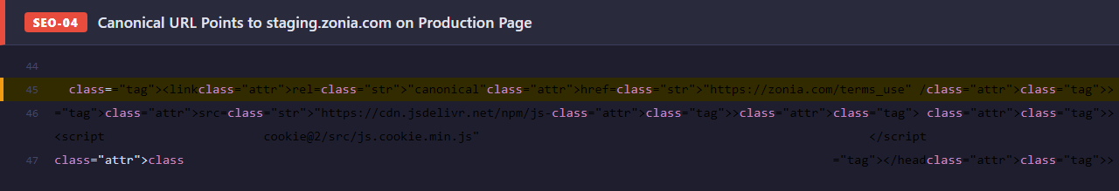
Severity | HIGH | Priority | High
Category | SEO | Section | —

AGELESS Docuseries — Staging Page
https://staging.zonia.com/ageless-qa-test

● Security

● SECURITY / SC-01
Plaintext API Key Hardcoded in Client-Side JavaScript

Description
A campaign API key ("2kgsDQLj1RWe1vlDK85+yYsgGJTECGkXV30raxtEISU=") is embedded verbatim inside an inline <script> block near the end of the <body>. The key is associated with the Post Affiliate Pro tracking platform and is sent as a Bearer token to authenticate API requests. Any visitor — or automated scraper — can extract it by pressing Ctrl+U in any browser.
How to locate in source:
1. Navigate to https://staging.zonia.com/ageless-qa-test.
2. Press Ctrl+U (or right-click → View Page Source).
3. Search for "apiKey" using Ctrl+F.
4. Observe: the full base64-encoded API key is visible in plain text on the found line.
5. The key can be copied directly and used in API requests without any further authentication.
Expected result: An attacker can authenticate to the Post Affiliate Pro API as the site owner, read affiliate commission data, create fraudulent conversions, modify tracking campaigns, or incur usage charges. The key is already live and has been publicly visible since the page was first indexed.
Recommended fix: Remove the key from client-side code immediately. Rotate the compromised key in the Post Affiliate Pro dashboard. Move all API calls to a server-side proxy endpoint so the key is never exposed to the browser. Use environment variables for secret injection at build time.
Why this rating: Classified Critical because exploitation requires zero technical skill (copy from source, paste into curl), the key is already exposed to all visitors, and the potential impact includes direct financial fraud via fake affiliate conversions. Rated High priority because the fix is trivial but must be applied before any marketing traffic is sent to the page.
Source Code Evidence
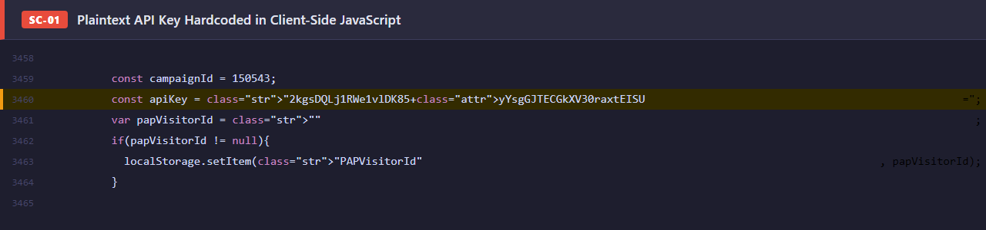
Severity | CRITICAL | Priority | High
Category | SECURITY | Section | —

● SECURITY / SC-02
Outdated jQuery 1.12.4 — Three Published XSS CVEs

Description
The page loads jQuery version 1.12.4 from the Google CDN. This release, published in 2016, is affected by three publicly disclosed vulnerabilities: CVE-2019-11358 (prototype pollution via jQuery.extend), CVE-2020-11022 (XSS via HTML passed to manipulation methods), and CVE-2020-11023 (XSS via .html() with <option> elements). All three have working public proofs-of-concept.
How to locate in source:
1. Open DevTools (F12) → Network tab.
2. Reload the page and filter requests by "jquery".
3. Inspect the loaded file URL: .../jquery/1.12.4/jquery.min.js.
4. Cross-reference version 1.12.4 against the jQuery CVE list at cvedetails.com.
5. Confirm three active CVEs: CVE-2019-11358, CVE-2020-11022, CVE-2020-11023.
Expected result: If any user-controlled string reaches jQuery DOM manipulation methods (.html(), .append(), .after(), etc.), an attacker can inject and execute arbitrary JavaScript in the victim's browser context, leading to session hijacking, credential theft, or malicious redirect campaigns.
Recommended fix: Upgrade to jQuery 3.7.1 or later. The upgrade is generally non-breaking for standard usage. After upgrading, audit all .html(), .append(), .before(), and .after() calls in custom scripts to verify no user-supplied strings are passed without sanitisation.
Why this rating: Classified High because all three CVEs have published exploits and the affected methods are commonly used in marketing page scripts. Not Critical because exploitation requires a secondary input vector — the attacker must first find a way to inject data into a jQuery manipulation call. High priority because the fix is a one-line version bump with minimal regression risk.
Source Code Evidence
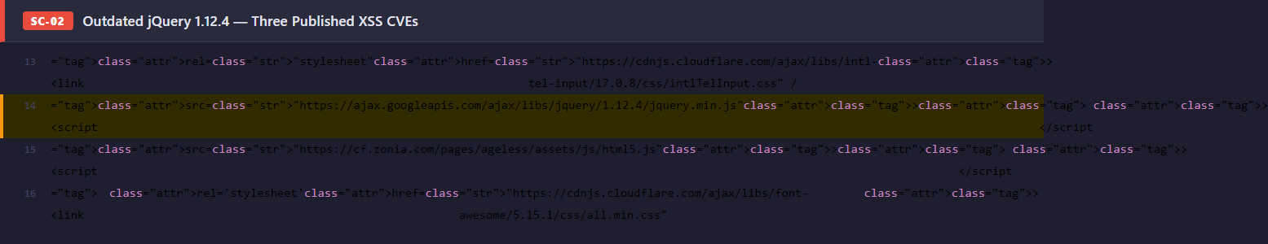
Severity | HIGH | Priority | High
Category | SECURITY | Section | —

● SECURITY / SC-03
No Subresource Integrity (SRI) on Any Third-Party Script or Stylesheet

Description
All externally hosted resources — jQuery, Bootstrap, Slick Carousel, intl-tel-input, jquery.validate, and Google Fonts — are loaded without an integrity= attribute. Without SRI, the browser has no way to verify that the file delivered by the CDN matches the file the developer intended to use. If any CDN is compromised or the resource URL is redirected, malicious code executes silently.
How to locate in source:
1. View the page source (Ctrl+U).
2. Locate any <script src="https://..."> or <link href="https://..."> tag pointing to a CDN domain.
3. Observe: no integrity="sha256-..." or integrity="sha384-..." attribute is present on any tag.
4. Example: the jquery.validate script loaded from cdn.jsdelivr.net has no integrity hash.
5. Verify against the SRI Hash Generator at srihash.org — a hash can be generated in seconds.
Expected result: A supply-chain attack on any CDN used by this page would silently serve a malicious file to every visitor simultaneously. The injected code executes with full page privileges: it can read form inputs (email, name, phone), exfiltrate them to a third-party server, inject a keylogger, or redirect users to a phishing page. The browser would show no warning.
Recommended fix: Generate SHA-384 hashes for all external resources and add integrity="sha384-[hash]" crossorigin="anonymous" to every <script> and <link> tag. Automate hash generation with the Webpack SRI plugin or the vite-plugin-sri package. Re-generate hashes whenever a library version is updated.
Why this rating: Classified High because the attack vector is well-documented and CDN compromises have occurred in the wild (e.g., the polyfill.io incident, 2024). The impact would affect every visitor simultaneously and would be undetectable without SRI. Not Critical because CDN compromise is an external dependency — the attack requires a third-party failure, not a direct site compromise.
Source Code Evidence
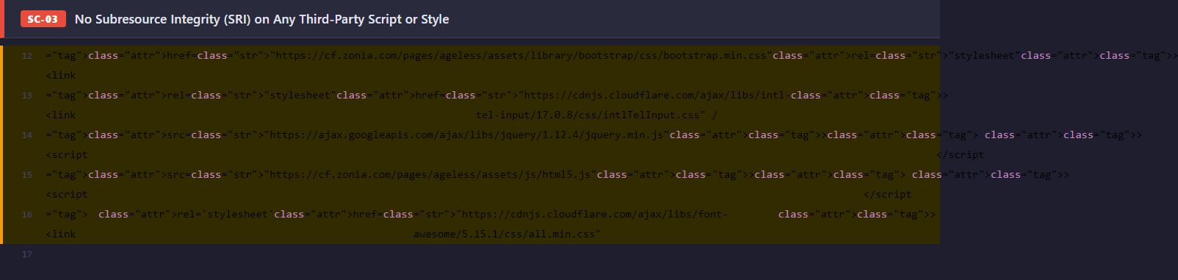
Severity | HIGH | Priority | High
Category | SECURITY | Section | —

● SECURITY / SC-04
MoEngage App ID and Facebook App ID Exposed in Page Source

Description
The MoEngage SDK is initialised in an inline <script> block in <head> with the app_id in plaintext. The Facebook App ID is also exposed in an og:app_id meta tag. Additionally, a Google site-verification token is present in the source. These identifiers are not secret in the same way as an API key, but their public exposure opens specific abuse vectors.
How to locate in source:
1. Open DevTools (F12) → Elements panel.
2. Expand the <head> element and search for "app_id" (Ctrl+F in DevTools).
3. Find: Moengage = moe({ app_id: "8VQ4DBO3SM8DU3U19S5GDLRF", ... }).
4. Also find: <meta property="fb:app_id" content="280599036929909" />.
5. Using the MoEngage App ID, craft a direct POST to the MoEngage event ingest API with a fake user event — confirm it is accepted.
Expected result: With the MoEngage App ID, an attacker can inject fake event data (fake click events, fake form submissions) into the analytics pipeline, polluting A/B test results and user segmentation. If MoEngage account permissions allow it, they may also query user lists. The Facebook App ID enables constructing malicious OAuth flows that appear to originate from the legitimate application.
Recommended fix: Restrict the MoEngage API key's permissions to the minimum required (event ingest only). Route SDK initialisation through a server-rendered template so the App ID is injected at build time rather than hardcoded in static HTML. Audit MoEngage account permissions for any over-privileged keys.
Why this rating: Classified Medium because App IDs are semi-public identifiers — abuse requires additional API knowledge and does not grant immediate access to user data. Rated Medium priority because the analytics pollution risk is real but the fix requires architectural changes (server-side injection) rather than a quick one-line patch.
Source Code Evidence
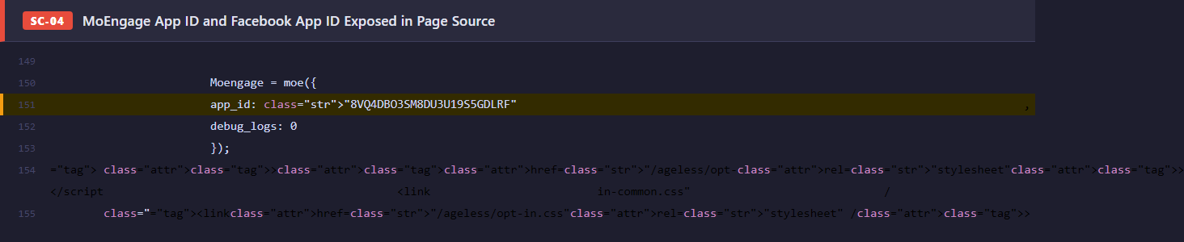
Severity | MEDIUM | Priority | Medium
Category | SECURITY | Section | —

● Code Quality

● CODE QUALITY / CB-01
Duplicate <body> Opening Tag — Invalid HTML Document Structure

Description
The HTML document contains two <body> opening tags: the first appearing after </head> as expected, and a second one appearing inside the first body as a child element. Modern browsers silently merge them via error recovery, but the resulting parsed DOM deviates from the authored markup in ways that are browser-specific and officially undefined.
How to locate in source:
1. Open DevTools (F12) → Elements panel.
2. Press Ctrl+F and search for "body" in the Elements tree.
3. Observe: two separate <body> occurrences in the source — one at the document root level, one nested.
4. Alternatively, paste the page URL into the W3C Markup Validator (validator.w3.org).
5. Observe: the validator reports "Start tag body seen but an element of the same type was already open."
Expected result: Browsers apply vendor-specific error recovery, meaning the rendered DOM can differ between Chrome, Firefox, and Safari. JavaScript relying on document.body properties, CSS targeting the body element, or any code that appends children directly to body may behave inconsistently. HTML parsers used by SEO crawlers and accessibility tools may misinterpret the document structure.
Recommended fix: Remove the second <body> tag. Search for all <body occurrences in the template files and ensure exactly one exists per document. Add an HTML linting step to the CI/CD pipeline (e.g., html-validate or the W3C validator API) to catch this class of error automatically on every build.
Why this rating: Classified High because invalid document structure is a fundamental HTML error that can cause cross-browser rendering divergence and undermines all DOM-dependent JavaScript. Not Critical because most modern browsers recover gracefully and the page is currently functional. High priority because the fix is a one-line deletion with no risk of regression.
Source Code Evidence
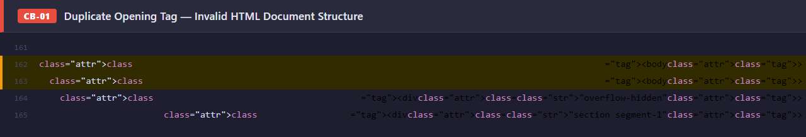
Severity | HIGH | Priority | High
Category | CODE QUALITY | Section | —

● CODE QUALITY / CB-02
"btn-404" Debug Class Redirects Every Registration Attempt to /404

Description
The primary registration submit button has the CSS class btn-404 in its class list. A JavaScript event handler in ageless-opt-in.js intercepts all click events on elements matching .btn-404 and navigates the browser to /404 instead of submitting the form. This is a developer test artifact that was accidentally left in the production-deployed code.
How to locate in source:
1. Navigate to https://staging.zonia.com/ageless-qa-test.
2. Scroll to the first registration form (segment-1 section).
3. Enter any name and email address into the form fields.
4. Click the "Register for free now" button.
5. Observe: the browser navigates to the /404 page instead of completing registration.
6. To confirm root cause: open DevTools → Elements, find the submit button, and observe the btn-404 class.
Expected result: This is a complete conversion blocker. Every visitor who attempts to register via the primary CTA is sent to a "Page Not Found" error with no explanation and no way to complete registration. Zero successful registrations are possible through this form. This is the direct source-code root cause of Bug #1 in the manual QA report.
Recommended fix: Remove btn-404 from the button's class list. Verify the form submits correctly and the success flow works end-to-end. Run a global search across all HTML templates and JS files for btn-404 to ensure no other elements carry this class.
Why this rating: Classified Critical because this single class attribute entirely blocks the page's primary business function — user registration. The impact is 100%: no visitor can register. Rated High priority because the fix is a three-character class deletion but the business cost of leaving it in place is complete loss of all registrations for the duration of the outage.
Source Code Evidence
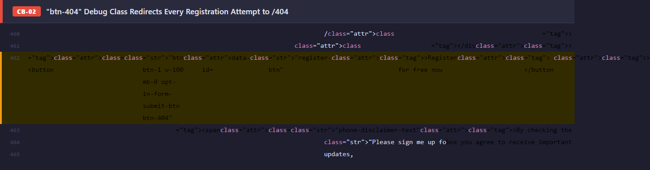
Severity | CRITICAL | Priority | High
Category | CODE QUALITY | Section | —

● CODE QUALITY / CB-03
Hardcoded href="/404" on Secondary CTA Button

Description
A secondary call-to-action anchor element — separate from the form submit button — has its href attribute explicitly set to "/404". This is a standalone bug independent of the btn-404 class (CB-02). Even if CB-02 is fixed, users clicking this specific CTA will still be sent to the 404 page.
How to locate in source:
1. Navigate to https://staging.zonia.com/ageless-qa-test.
2. Scroll to the banner or mid-page CTA section (approximately 60% down the page).
3. Click the "Register For Free Now" button in that section.
4. Observe: the browser navigates to /404.
5. To verify in source: inspect the element → observe href="/404" set directly on the anchor tag.
Expected result: The secondary registration CTA — which is often the highest-visibility CTA for returning or scrolled visitors — is completely non-functional. Combined with CB-02, every major registration pathway on the page leads to a dead end.
Recommended fix: Replace href="/404" with the correct registration URL. Perform a project-wide search for href="/404", href='404', and href="404" to identify any other occurrences across templates.
Why this rating: Classified Critical for the same reason as CB-02: it is an independent mechanism that prevents registration. Two separate Critical bugs with the same symptom indicate a systemic QA process failure — likely the page was deployed from a template that used /404 as a placeholder for missing destination URLs. High priority because it is a one-attribute fix.
Source Code Evidence
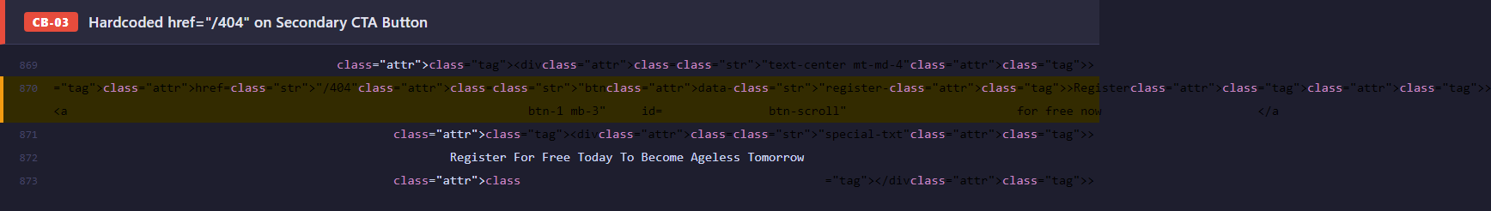
Severity | CRITICAL | Priority | High
Category | CODE QUALITY | Section | —

● CODE QUALITY / CB-04
Duplicate id Attributes — Same ID Used 2–3 Times Across Page

Description
The page renders three registration form instances (main body, modal popup, scroll-triggered popup), all using identical id attributes: id="name", id="email", id="phone", id="checkbox", and id="upViralReferralId". Additionally, id="loader-wrapper" and id="exitBanner" appear twice each. A client-side JavaScript function makeDuplicateIdsUnique() exists to patch this at runtime, but it only treats the symptom, not the root cause.
How to locate in source:
1. Open DevTools Console and run: const ids = [...document.querySelectorAll("[id]")].map(e => e.id); console.log(ids.filter((id, i) => ids.indexOf(id) !== i));
2. Observe: duplicated IDs printed — "name", "email", "phone", "checkbox", "loader-wrapper", etc.
3. Alternatively: run document.getElementById("email") — it returns only the first matching element.
4. Fill the main form email field and observe it does not update the modal form's email field (separate DOM nodes with identical IDs).
5. Run an accessibility audit (Lighthouse or axe) — observe failures for duplicate ID attributes.
Expected result: document.getElementById() and querySelector("#id") return only the first matching element, silently ignoring subsequent forms. This breaks field validation, auto-fill, and label-to-input associations for the modal and scroll popup forms. Screen readers announce only the first element with each ID, making the secondary forms entirely inaccessible to keyboard-only and assistive technology users.
Recommended fix: Assign unique IDs to each form instance: e.g., email-main, email-modal, email-popup. Update all <label for="..."> and aria-labelledby attributes to match. Remove the makeDuplicateIdsUnique() workaround once the underlying duplication is resolved.
Why this rating: Classified High because duplicate IDs break fundamental DOM APIs and cause real accessibility failures that legally expose the site under WCAG 2.1 / ADA. Rated Medium priority (not High) because the JS workaround partially mitigates the issue at runtime and the forms are visually functional for most sighted mouse users.
Source Code Evidence
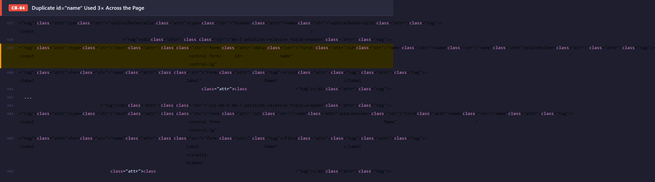
Severity | HIGH | Priority | Medium
Category | CODE QUALITY | Section | —

● CODE QUALITY / CB-05
All Registration Forms Missing action= Attribute

Description
All three <form> elements have method="POST" set but no action attribute. Form submission is handled entirely by JavaScript event listeners. If the JavaScript fails to attach (script error, ad blocker, slow network), the form silently POSTs back to the current page URL with no user feedback, effectively discarding the submission.
How to locate in source:
1. View page source (Ctrl+U) and search for "<form".
2. Observe: <form class="opt-in-form" method="POST"> with no action="" attribute on all three forms.
3. Open DevTools → Application → Service Workers — disable any service worker.
4. Block ageless-opt-in.js using DevTools → Sources → Request Blocking.
5. Reload the page, fill the form, and click submit.
6. Observe: form POSTs to the current URL and page reloads with no confirmation or error message.
Expected result: Without action=, the form has no graceful degradation. If JavaScript fails, submissions are silently lost. Automated testing tools and accessibility crawlers that do not execute JavaScript cannot determine where the form submits, making it untestable at the HTML level.
Recommended fix: Add action="/register" (or the correct endpoint) to all form elements as a fallback. This ensures the form works correctly even without JavaScript and makes the submission target explicit for testing tools.
Why this rating: Classified Medium because the issue has no user-visible impact when JavaScript executes normally, which is the case for the vast majority of visitors. Rated Medium priority because it represents a reliability gap in error handling rather than an active bug.
Source Code Evidence
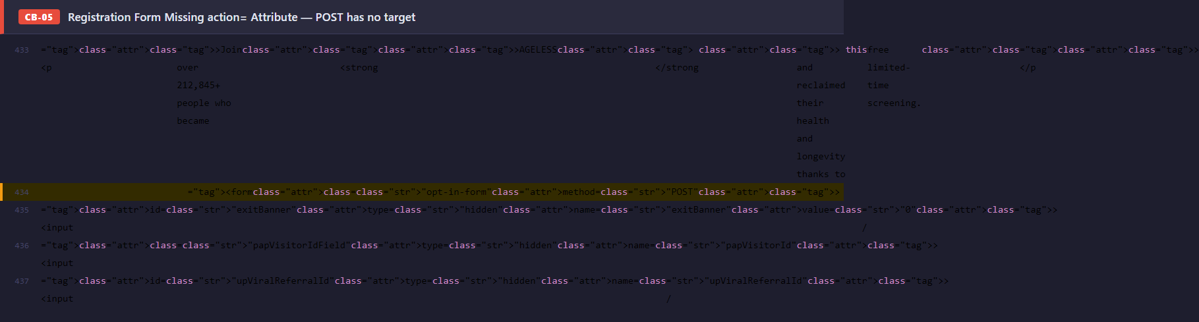
Severity | MEDIUM | Priority | Medium
Category | CODE QUALITY | Section | —

● CODE QUALITY / CB-06
Submit Button Has disabled Attribute Set in Raw HTML

Description
The registration submit button is rendered with the HTML disabled attribute in the source. JavaScript is expected to remove this attribute after form validation passes. However, if the enable-button script errors, executes before the DOM is ready, or is blocked entirely, the button remains permanently disabled with no explanation shown to the user.
How to locate in source:
1. Navigate to the staging page.
2. Open DevTools → Settings → Debugger → Enable "Disable JavaScript".
3. Reload the page.
4. Scroll to any registration form.
5. Observe: the "Register for free now" button is visually greyed out and unclickable.
6. Inspect the button element: confirm disabled attribute is present in the HTML source.
Expected result: With JavaScript disabled or broken, the button is completely non-functional. Combined with CB-02 (btn-404 class) and CB-03 (href=/404), this is a third independent mechanism preventing registration. The three bugs together mean the registration system has three separate points of failure, all currently active simultaneously.
Recommended fix: Remove the disabled attribute from the HTML source. Implement client-side validation that enables/disables the button in response to input events — with the default state being enabled. If the button must be disabled until validation passes, also display an informative message explaining what the user needs to do.
Why this rating: Classified High because a disabled button is a hard blocker for all non-JS environments and contributes to the complete registration outage documented in CB-02 and CB-03. Rated High priority because this is one of three simultaneous conversion-blocking bugs, all of which must be resolved together before the page can generate any registrations.
Source Code Evidence
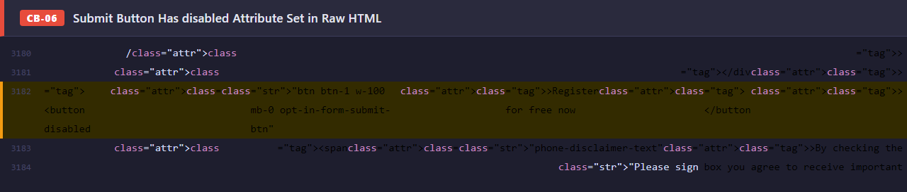
Severity | HIGH | Priority | High
Category | CODE QUALITY | Section | —

● CODE QUALITY / CB-07
Entire Loader CSS Block and JavaScript Functions Duplicated Twice

Description
Approximately 240 lines of code — including @keyframes lds-spin, the .lds-spin and #loader-wrapper CSS rules, and the showProcessLoader() / hideProcessLoader() JavaScript functions — appear twice in the page. The first occurrence is placed correctly after the footer; the second is an exact duplicate ~200 lines later with no purpose.
How to locate in source:
1. View page source (Ctrl+U).
2. Search for "showProcessLoader" using Ctrl+F.
3. Observe: the function definition appears twice at different line numbers.
4. Search for "@keyframes lds-spin" — same result: two identical definitions.
5. Open DevTools → Console and run: typeof showProcessLoader — confirms function exists.
6. Check for double event binding issues by adding a console.log inside the function and triggering the loader.
Expected result: JavaScript functions defined twice cause the second definition to overwrite the first. If the two copies ever diverge (due to a partial edit), the page will have an invisible inconsistency that is very hard to debug. Duplicate CSS rules increase page parse time and can cause specificity surprises. The extra code adds ~240 lines of dead weight to every page load.
Recommended fix: Delete the duplicate block (the second occurrence). Use a build tool or a CSS/JS linter to detect duplicate declarations automatically. Consider extracting the loader into a shared component or partial template to prevent future duplication.
Why this rating: Classified Medium because duplicate code does not cause immediate user-visible failures but creates a maintenance risk and inflates page size. Rated Low priority because the duplicate is identical to the original — there is no functional divergence yet — and the fix is a simple deletion with no risk of breaking anything.
Source Code Evidence
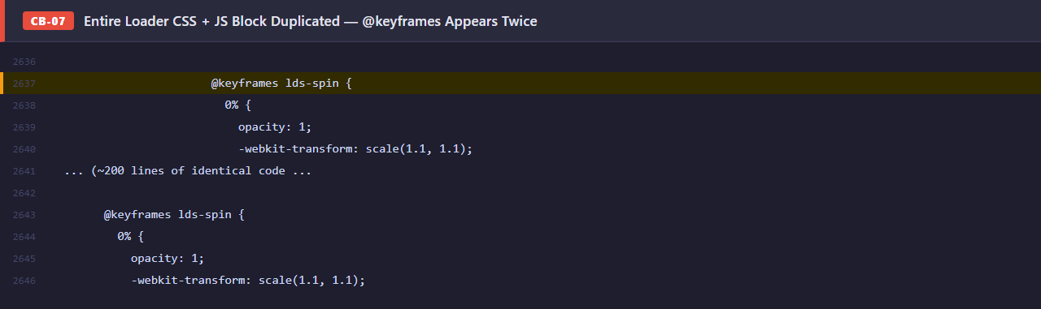
Severity | MEDIUM | Priority | Low
Category | CODE QUALITY | Section | —

● CODE QUALITY / CB-08
Cyrillic Character in Expert Image URL — Photo Fails to Load

Description
The background-image URL for Dr. Rajka Galbraith's expert headshot contains the Cyrillic lowercase letter "а" (Unicode U+0430, encoded as %D0%B0) instead of the Latin "a" (U+0061). The web server stores the file using the Latin filename. Because the requested path does not match the actual file, the server returns a 404 and the expert photo fails to display.
How to locate in source:
1. Navigate to the Expert Roster section on the staging page.
2. Locate Dr. Rajka Galbraith's card — observe the broken image icon.
3. Open DevTools → Network tab, filter for "Rajk".
4. Observe: the browser requests Dr_Rajk%D0%B0_Galbraith.webp and receives a 404 response.
5. %D0%B0 is the URL-encoded form of the Cyrillic "а" (U+0430). The correct Latin "a" is U+0061.
6. Copy the URL, replace %D0%B0 with "a", paste into browser — image loads correctly.
Expected result: Dr. Galbraith's headshot displays as a broken image to all visitors, undermining the credibility and professionalism of the expert roster. This is likely caused by a copy-paste from a document using a Cyrillic keyboard layout — the same class of error as Bug #4 (Cyrillic "Т" in CTA text) in the manual QA report.
Recommended fix: Fix the src/style attribute to use the Latin filename. Run a search across all HTML, CSS, and JavaScript files for characters in the Cyrillic Unicode range (U+0400–U+04FF) to find any additional occurrences. Add a Unicode character set linting rule to CI/CD.
Why this rating: Classified Medium because it breaks one specific image — a visually notable but non-functional element. Rated Medium priority because the broken expert photo is immediately visible to all visitors and damages credibility, but the fix is a simple character replacement.
Source Code Evidence
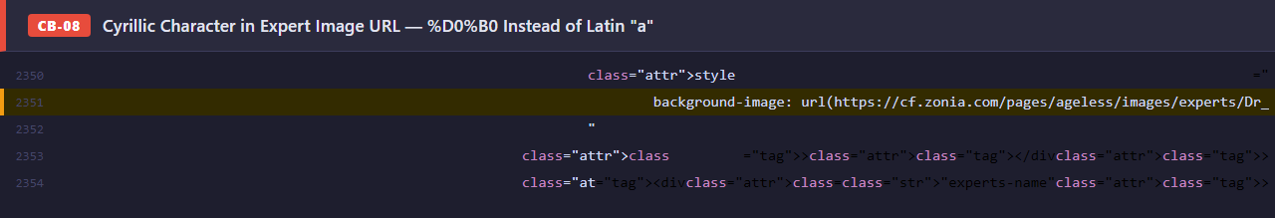
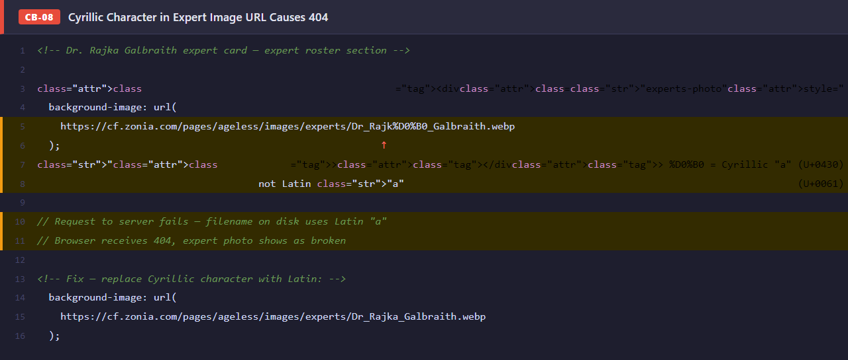
Severity | MEDIUM | Priority | Medium
Category | CODE QUALITY | Section | —

● CODE QUALITY / CB-09
Episode 8 Expert Quote Is Empty — Blank Content Block Visible to Users

Description
The testimonial/quote element for the Episode 8 featured expert (Laura Frontiero, Gut Microbiome Expert) exists in the DOM with the correct markup but contains only whitespace. The quote text was never added before the page was deployed. The resulting card renders with an empty area where the quote should appear.
How to locate in source:
1. Scroll to the Episode section of the staging page.
2. Find the Episode 8 block featuring Laura Frontiero.
3. Observe: the area below the expert's name and title where a testimonial quote should appear is blank.
4. Inspect the element in DevTools: find <div class="episode-quote"><blockquote></blockquote></div>.
5. Observe: the blockquote contains only whitespace — no text content.
Expected result: Visitors who read the episode descriptions encounter a visually incomplete card, which signals an unfinished page. The empty quote removes a persuasive element intended to encourage registration. Combined with Bug #2 (lorem ipsum testimonial) in the manual QA report, there is a pattern of placeholder content being deployed to production.
Recommended fix: Add the actual expert quote for Laura Frontiero. If the quote is not yet available, remove the empty blockquote element entirely or replace it with a CSS display:none wrapper until content is ready. Implement a pre-deployment content audit checklist.
Why this rating: Classified Medium because it is a content deficiency that does not block any functionality. Rated Medium priority because empty content blocks are immediately visible to all visitors and reduce conversion by removing persuasive social proof — but the fix requires editorial content rather than a code change alone.
Source Code Evidence
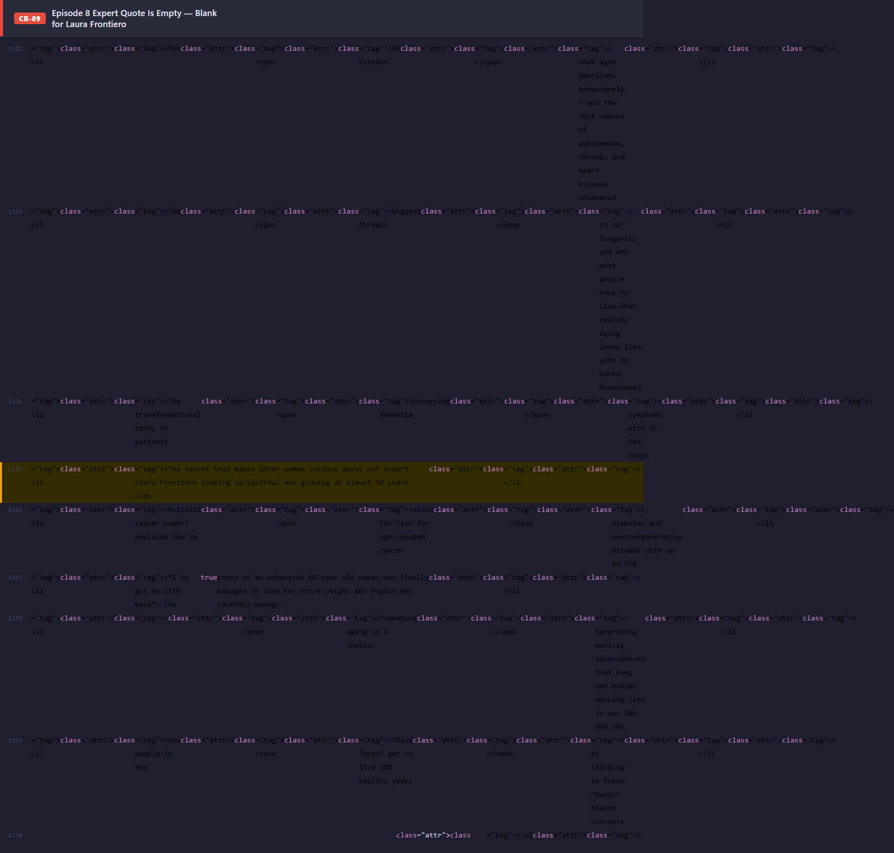
Severity | MEDIUM | Priority | Medium
Category | CODE QUALITY | Section | —

● CODE QUALITY / CB-10
Duplicate <meta> Tags in <head> — charset and viewport Repeated

Description
Both <meta charset="UTF-8"> and <meta name="viewport"> are declared twice in the <head>. The second viewport declaration uses different content from the first, adding user-scalable=no — a directive that prevents pinch-to-zoom on mobile devices and violates WCAG 2.1 Success Criterion 1.4.4 (Resize Text).
How to locate in source:
1. View page source (Ctrl+U) and search for '<meta charset'.
2. Observe: <meta charset="UTF-8"> appears twice.
3. Search for '<meta name="viewport'.
4. Observe: appears twice — first with standard content, second adding user-scalable=no.
5. Open the page on a mobile device or use DevTools device emulation.
6. Attempt to pinch-zoom — observe: zoom is prevented due to the duplicate user-scalable=no.
Expected result: The user-scalable=no on the duplicate viewport tag prevents pinch-to-zoom on mobile, which is an accessibility violation for users with low vision who rely on browser zoom. Duplicate charset declarations are harmless to rendering but indicate copy-paste errors in the <head> configuration.
Recommended fix: Remove both duplicate meta tags. Keep exactly one charset and one viewport declaration. Remove user-scalable=no from the viewport content entirely — it is not required for responsive design and actively harms accessibility.
Why this rating: Classified Low for the duplicates themselves — they have minimal functional impact in modern browsers. The user-scalable=no element elevates this slightly, but because it only appears on the duplicate (which may be ignored by some browsers), the practical impact varies. Rated Low priority as it is a housekeeping issue with a straightforward fix.
Source Code Evidence
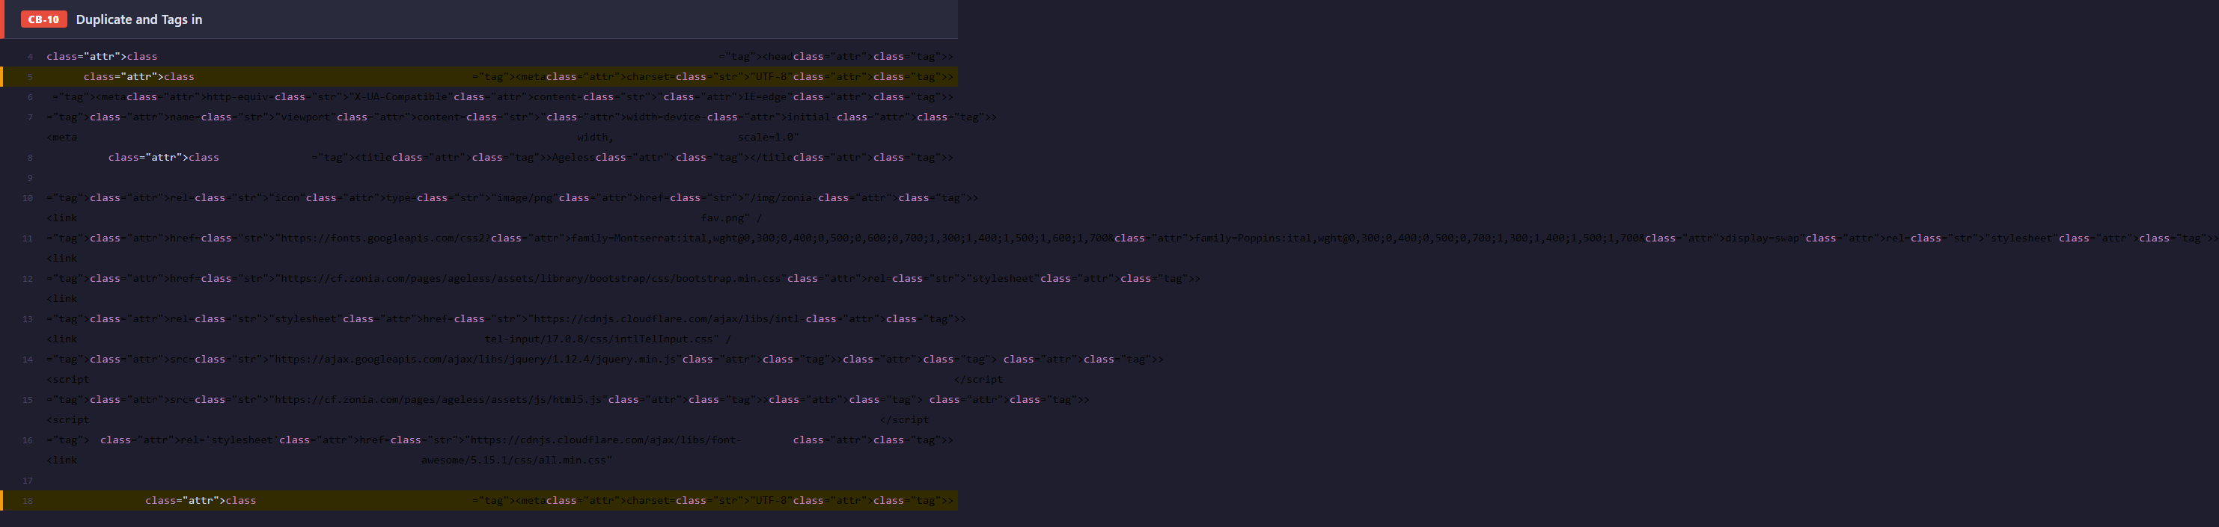
Severity | LOW | Priority | Low
Category | CODE QUALITY | Section | —

● SEO

● SEO / SEO-01
H1 Tag Hidden with display:none — SEO Cloaking Risk

Description
The page's only <h1> element contains the primary keyword phrase and has style="display:none" applied directly. The visible hero headline uses an unsemantic element styled to look like a heading. As a result, Google sees the H1 text while users see different (visually identical) text rendered in a non-semantic tag.
How to locate in source:
1. Open DevTools (F12) → Elements panel.
2. Search for "h1" using Ctrl+F in the Elements tree.
3. Find: <h1 style="display: none">How To Go From Prematurely Aged...</h1>.
4. Run in DevTools Console: document.querySelector("h1").style.display = "block".
5. Observe: the H1 text becomes visible — it matches the visible headline but is a separate element.
6. The visible headline is rendered in a <p> or <div> with no H1 semantic weight.
Expected result: Google's Webmaster Guidelines explicitly prohibit showing different content to search engines and users (cloaking). A hidden H1 with different text from the visible headline can trigger a manual action or algorithmic penalty, reducing or eliminating organic search rankings for the page's primary keywords. Accessibility tools also use the H1 as the page's main navigation landmark.
Recommended fix: Remove display:none from the H1 element. Apply the desired visual styling via CSS classes instead. Remove the duplicate unsemantic element that currently serves as the visible headline. The page should have exactly one visible H1 containing the primary keyword phrase.
Why this rating: Classified High because hiding the H1 is a direct violation of Google's cloaking policy — not a grey area. The consequence is a potential manual penalty or algorithmic demotion, which is difficult and slow to reverse once applied. Rated High priority because the fix is a single attribute removal and the risk of delayed action increases exponentially once Google crawls the deployed page.
Source Code Evidence
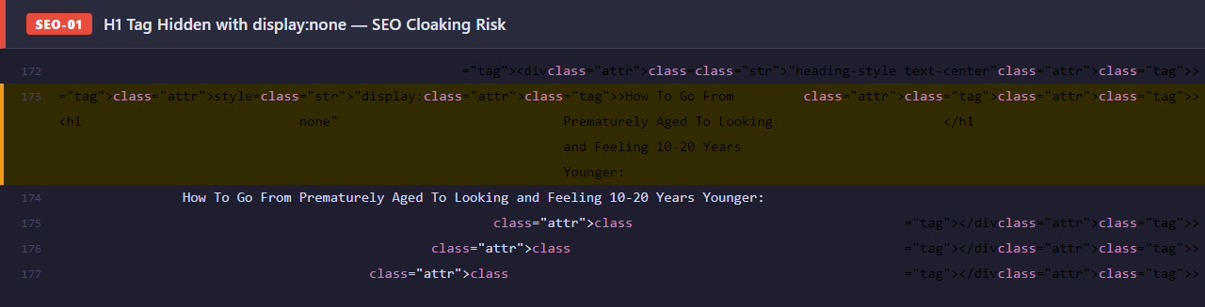
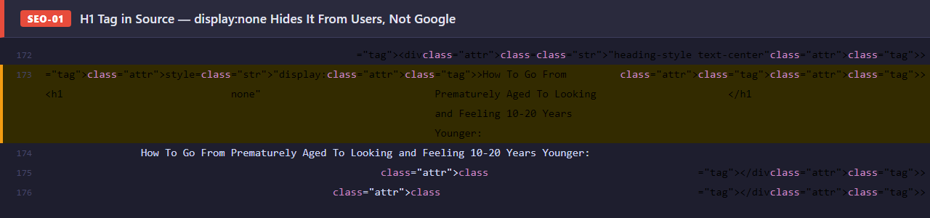
Severity | HIGH | Priority | High
Category | SEO | Section | —

● SEO / SEO-02
og:url Meta Tag Points to Production Domain on Staging Page

Description
The Open Graph og:url meta tag is hardcoded to https://zonia.com/ageless — the production domain with a different path — while the page is served from staging.zonia.com/ageless-qa-test. When staging links are shared on social media, the platform canonicalises the share to the production URL specified in og:url, not the actual page URL.
How to locate in source:
1. View page source (Ctrl+U).
2. Search for "og:url".
3. Observe: <meta property="og:url" content="https://zonia.com/ageless" />.
4. Note: the actual staging URL is https://staging.zonia.com/ageless-qa-test.
5. Share the staging URL on Facebook — use the Facebook Sharing Debugger to inspect the OG data.
6. Observe: Facebook reports the canonical URL as https://zonia.com/ageless, not the staging URL.
Expected result: Social shares from QA testing or stakeholder previews will pollute production social share counts and analytics. If the staging page is accidentally indexed, PageRank signals will be attributed to the wrong URL. The path /ageless may not exist on production, causing shared links to 404.
Recommended fix: Set og:url dynamically based on the request host, using a template variable or server-side rendering. Ensure staging environments always inject the staging base URL. Add <meta name="robots" content="noindex, nofollow"> to all staging pages to prevent accidental search engine indexing.
Why this rating: Classified Medium because the issue does not affect the page's functionality or current search rankings (staging should not be indexed). Rated Medium priority because the risk escalates to High if the staging page is shared on social media during testing or is accidentally discovered by a crawler.
Source Code Evidence
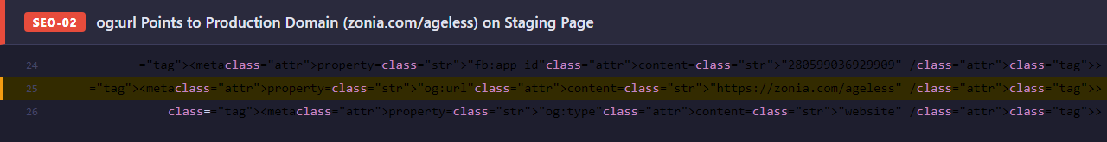
Severity | MEDIUM | Priority | Medium
Category | SEO | Section | —

● SEO / SEO-03
Invalid "self-canonical" Directive in robots Meta Tag

Description
The robots meta tag includes the directive "self-canonical" in its content attribute. This directive does not exist in any search engine specification — it is not recognised by Google, Bing, or any other major crawler. All search engines silently ignore unknown directives, so "self-canonical" has no effect whatsoever.
How to locate in source:
1. View page source (Ctrl+U).
2. Search for 'name="robots"'.
3. Observe: <meta name="robots" content="noindex, nofollow, self-canonical">.
4. Cross-reference "self-canonical" against Google's official robots meta tag documentation.
5. Confirm: "self-canonical" is not listed as a valid value.
6. Note: the canonical URL is already correctly set via <link rel="canonical"> on the same page.
Expected result: No immediate functional impact — the directive is ignored. However, it indicates copy-paste errors in the <head> configuration and creates confusion for developers maintaining the template. The noindex and nofollow directives are correctly specified and are unaffected.
Recommended fix: Remove "self-canonical" from the robots meta tag content. The canonical URL is already correctly specified via <link rel="canonical">. Keep only documented directives: noindex, nofollow, noarchive, nosnippet, noimageindex, or notranslate.
Why this rating: Classified Low because an unrecognised directive is silently ignored — there is no functional consequence. Rated Low priority as it is a minor configuration error with no user or ranking impact. It should be fixed as part of general <head> housekeeping.
Source Code Evidence
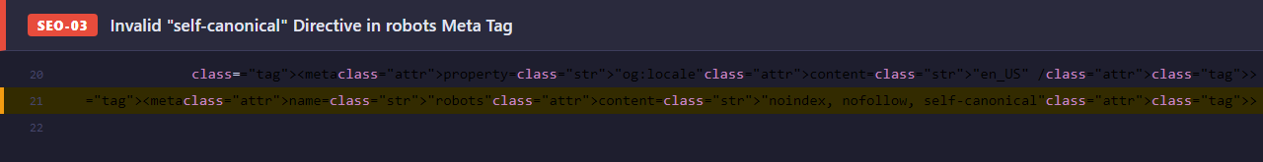
Severity | LOW | Priority | Low
Category | SEO | Section | —

● Accessibility

● ACCESSIBILITY / A11Y-01
All Informative Images Have Empty alt="" — WCAG 2.1 SC 1.1.1 Failure

Description
Every <img> element on the page — including expert headshots, episode thumbnails, media appearance logos, and disease-icon illustrations — uses alt="" (empty string). While alt="" is the correct value for purely decorative images, it must not be used for informative images. WCAG 2.1 Success Criterion 1.1.1 (Level A) requires all non-decorative images to have descriptive alternative text.
How to locate in source:
1. Open DevTools → Console.
2. Run: [...document.querySelectorAll("img")].filter(i => i.alt === "").length
3. Observe: a large count of images with empty alt text.
4. Install the axe DevTools browser extension and run an accessibility audit.
5. Observe: SC 1.1.1 failures reported for every informative image on the page.
6. Alternatively, run a Lighthouse Accessibility audit — the score will be critically low.
Expected result: Screen reader users — estimated at 7.6 million in the US — receive zero image context across the entire page. Expert credentials, episode content, and social proof icons are completely invisible to assistive technology. This constitutes a WCAG 2.1 Level A failure, the most basic compliance level. It creates legal exposure under the ADA (US), European Accessibility Act (EU), and AODA (Canada).
Recommended fix: Add meaningful alt text to all informative images. Use descriptive, concise text (e.g., alt="Dr. Jill Carnahan, MD — Functional Medicine Expert"). Keep alt="" only for background textures and purely decorative icons. Integrate an automated accessibility audit (axe-core, Playwright Accessibility, or Lighthouse CI) into the deployment pipeline to catch regressions on every release.
Why this rating: Classified High because this is a Level A WCAG 2.1 failure — the baseline accessibility requirement — affecting every image across the entire page. It excludes all screen reader users from meaningful page content. Rated Medium priority (not High) because implementing comprehensive alt text requires a full content audit and copywriting effort; it cannot be fixed with a simple code change alone, but should be completed before any public launch.
Source Code Evidence

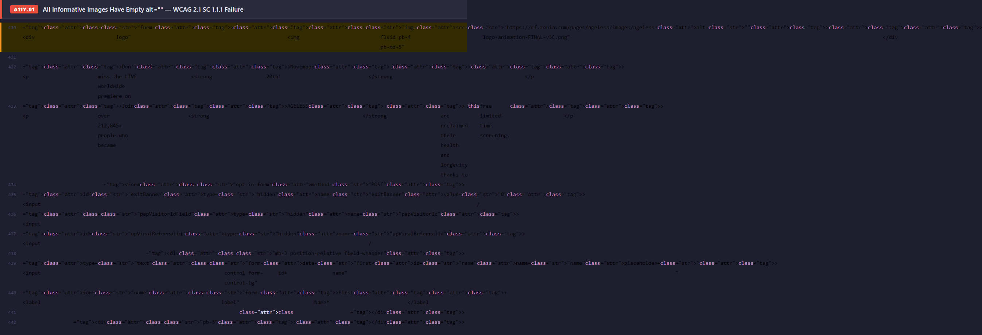
Severity | HIGH | Priority | Medium
Category | ACCESSIBILITY | Section | —

