# Lab: Unit Testing Lists

Submit your solutions here: <https://judge.softuni.org/Contests/5197/Unit-Testing-Lists-Lab>

## Unit Test List: Gauss Trick

For the first **list problem**, test a method which takes in a **list** **of integers** and sums each **pair of numbers** from the beginning and end.

The method is found in the GaussTrick.cs file:

Example: If we have the numbers 1 2 3 4 5, the method will first **sum 1 and 5**, then **2 and 4**, and finally because the list is **odd** it will **append** **3** to the result. The final list will be 6 6 3.

In the **test** **file** GaussTrickTests.cs you are given **6 tests**. One is **finished**, two are **unfinished** and three are **empty**:

Hint: Use CollectionAssert to assert **correctness** when using **lists**. **The first test is an example of it**.

Don't forget to also **assert** if your **tests** **run**:

## Unit Test List: Max Number

For the second **list problem**, test a method which takes in a **list** **of integers** and returns the **largest number in the list**.

The method is found in the MaxNumber.cs file:

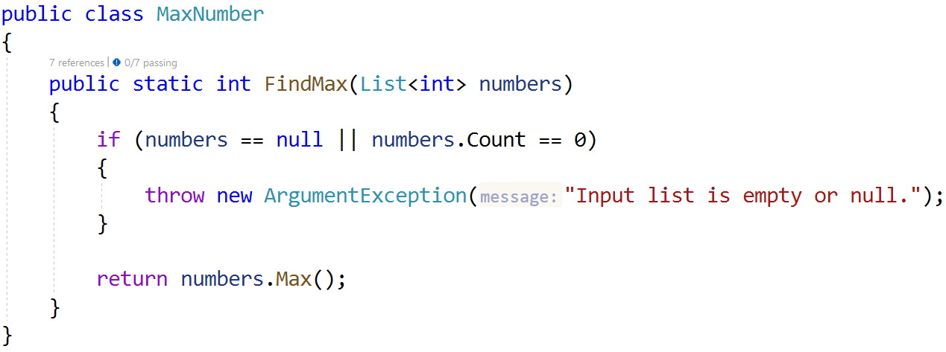

In the **test** **file** MaxNumberTests.cs you are given **5 tests**:

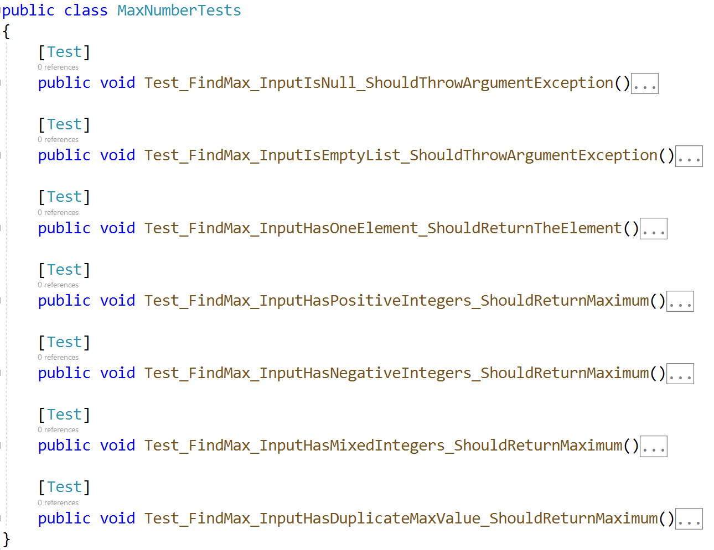

As usual check if your tests run correctly:

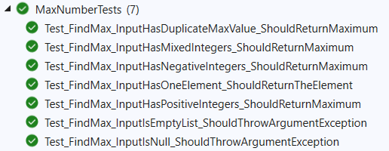

## Unit Test List: Adjacent Equal

Test a method which takes in a **list** **of integers** and **sums each adjacent number if they are equal** and returns the **list as a string**.

The method is found in the AdjacentEqual.cs file:

In the **test** **file** AdjacentEqualTests.cs you are given **7 tests**:

As usual check if your tests run correctly:

## Unit Test List: List Analyzer

Test a given method which takes in a **list of integers** and **returns string** with **information for elements number, mix, max and average values** of the list in following format: **"Element count: {list.length}, Min value: {list.Min()}, Max value: {list.Max()}, Avg: {list.Average():F2}."**

The method is found in the **ListAnalyzer.cs** file:

Картина, която съдържа текст, линия, Шрифт, екранна снимка

Описанието е генерирано автоматично

You are given a test file **ListAnalyzerTests.cs** containing **5 empty tests**

Картина, която съдържа текст, екранна снимка, Шрифт, номер

Описанието е генерирано автоматично

When you are ready make sure your **tests run:**

Картина, която съдържа текст, Шрифт, екранна снимка

Описанието е генерирано автоматично

## Unit Test List: Ignore The Chars

Test a given method that **takes a string and a list of characters as input**. The **first parameter is a sentence**, and the **second parameter is a list of characters to ignore**. The method **returns the sentence without the ignored characters**.

The method is found in the **IgnoreTheChars.cs** file:

Картина, която съдържа текст, екранна снимка, Шрифт

Описанието е генерирано автоматично

You are given a test file **IgnoreTheCharsTests.cs** containing **4 empty tests:**

Картина, която съдържа текст, екранна снимка, Шрифт, линия

Описанието е генерирано автоматично

When you are ready make sure your **tests run:**

Картина, която съдържа текст, екранна снимка, Шрифт, линия

Описанието е генерирано автоматично

## Unit Test List: Remove Negatives and Reverse

Test a given method that takes a **list of integers**, **remove all negative numbers from it, reversed order** and **returns the result as a list.**

The method is found in the **ListManipulation.cs** file:

**Картина, която съдържа текст, Шрифт, линия, екранна снимка

Описанието е генерирано автоматично**

You are given a test file **IgnoreTheCharsTests.cs** containing **5 empty tests**

**Картина, която съдържа текст, екранна снимка, Шрифт

Описанието е генерирано автоматично**

When you are ready make sure your **tests run:**

**Картина, която съдържа текст, екранна снимка, Шрифт, линия

Описанието е генерирано автоматично**