Udacity

AWS Cloud Developer Nanodegree

--------------------

Cloud Capstone Project

Whatever You Want

Serverless Application

--------------------

Richard EB Hartell

August 2021

https://github.com/rebhartell/udacity-aws-cloud-developer-project-5
Table of Contents
Overview 4
Suggested Applications 4
Instructions 5
Step 1: Propose and Scope the Project 5
Step 2: Choose either microservices or serverless design 6
Serverless Design 6
Application Design 8
Data Model and React JSON-Schema Form (RJSF) 9
Data Model 10
RJSF 11
API 12
Step 3: Build your application 13
Project Source Repository 13
README.md 14
Known Warnings with the backend packaging 15
Known Warnings with the frontend packaging 16
NPM List for the backend 17
NPM List for the frontend 18
NPM List for global 19
Serverless Verbose output 20
Issues with the initial submission (v3.0.0) 27
Response 29
Step 4: Test your application 32
API Integration and Regression Testing using Postman 32
Frontend – User-based Testing 34
Connect to webserver - http://localhost:3000/ 35
Auth0 Login 35
Categories Page 36
Create New Category – Recipe Cards 36
Edit New Category – Recipe Cards 37
Populate New Category – Recipe Cards 37
Save New Category – Recipe Cards 38
Create New Item – Recipe Cards - Shortbread 38
Add Image to New Item – Recipe Cards - Shortbread 39
Choose and Upload Image forn New Item – Recipe Cards - Shortbread 39
Create New Item – Recipe Cards - Shortbread 40
Edit New Whatever Item – Recipe Cards - Shortbread 40
Populate New Whatever Item – Recipe Cards – Shortbread (1) 41
Populate New Whatever Item – Recipe Cards – Shortbread (2) 41
Submit New Whatever Item – Recipe Cards – Shortbread 42
Return to Categories and Select Existing Category – Address Book 42
Select Existing Item - Address Book – Batman 43
Scroll to the bottom of Existing Item - Address Book – Batman 43
Return to Categories and Select Existing Category – Diary 44
Select Existing Item – Diary - 2021-01-04 44
Return to Categories and Select Existing Category – Film Collection 45
Scroll to the Bottom of the Category – Film Collection 45
Select Existing Item – FilmCollection - Zack Snyder's Justice League 46
Deployed Services 47
Serverless.com Dashboard 47
AWS CloudFormation 51
AWS IAM 51
AWS API Gateway 52
AWS Lambda (1) 52
AWS Lambda (2) 53
AWS S3 – serverless application 53
AWS S3 - attachments 54
AWS DynamoDB – Category table 54
AWS DynamoDB – Whatever table 55
AWS CloudWatch 55
AWS Xray – service map 56
AWS Xray - traces 56
Appendix A – Example JSON Schema, UI Schema, and FormData 57
Diary 57
Address Book 59
Film Collection 62
Recipe Card 64

Overview
The purpose of the cloud developer capstone project is to give you a chance to combine what you've learned throughout the program. This project will be an important part of your portfolio that will help you achieve your Cloud-related career goals.

In this project, you will build a cloud-based application, and follow the principles of either the Microservices course (course 3) or the Serverless course (course 4). This will help you demonstrate to potential employers and colleagues that you can independently create and deploy applications using these principles.

Suggested Applications
Possible application ideas would be miniature versions of existing social media or video sharing applications -- any app that can take user input, store it, and allow for user retrieval. The app would also allow for users to log in to access data specific to each user.

Instructions

Step 1: Propose and Scope the Project

“Identify the use case for your app. We recommend keeping the functionality as simple as possible to start with.”

The proposal for the project is to take the existing pre-determined, single-purpose application that facilitates the collection and management of To Do items (Project 4) and extend it such that the user can collect and manage (if applicable) Whatever You Want items – such as:
- a Diary
- an Address Book
- a Film Collection
- a deck of Recipe Cards
- Whatever You Want

And instead of attempting to define a single data model and data entry form to ill-fit all category of user items, React JSON-Schema Form (RJSF) will be used to allow the user to both define the data model and data entry form specific to each category of Whatever You Want items without any need to change and rebuild the project application.

The application will have set of mainly prescribed web pages, API, data models, and storage, but with the addition of a flexible embedded payload to support the generic, user defined data items.

Step 2: Choose either microservices or serverless design

“It’s fine to re-use code from your course 3 or course 4 project as a starting point. Review the rubric for each option, to ensure that the application you build satisfies at least 3 of the rubric requirements. Not all rubric items need to be satisfied in order to pass the project. We hope that you’ll feel that you have enough flexibility to focus on the aspects of your application that you are most interested in.”

Serverless Design
My Serverless Framework of Project 4 will be used as the starting point for this project and a Strangler Pattern approach will be used to progressively change my Project 4 into my Capstone Project delivery.

The high level serverless infrastructure design is:
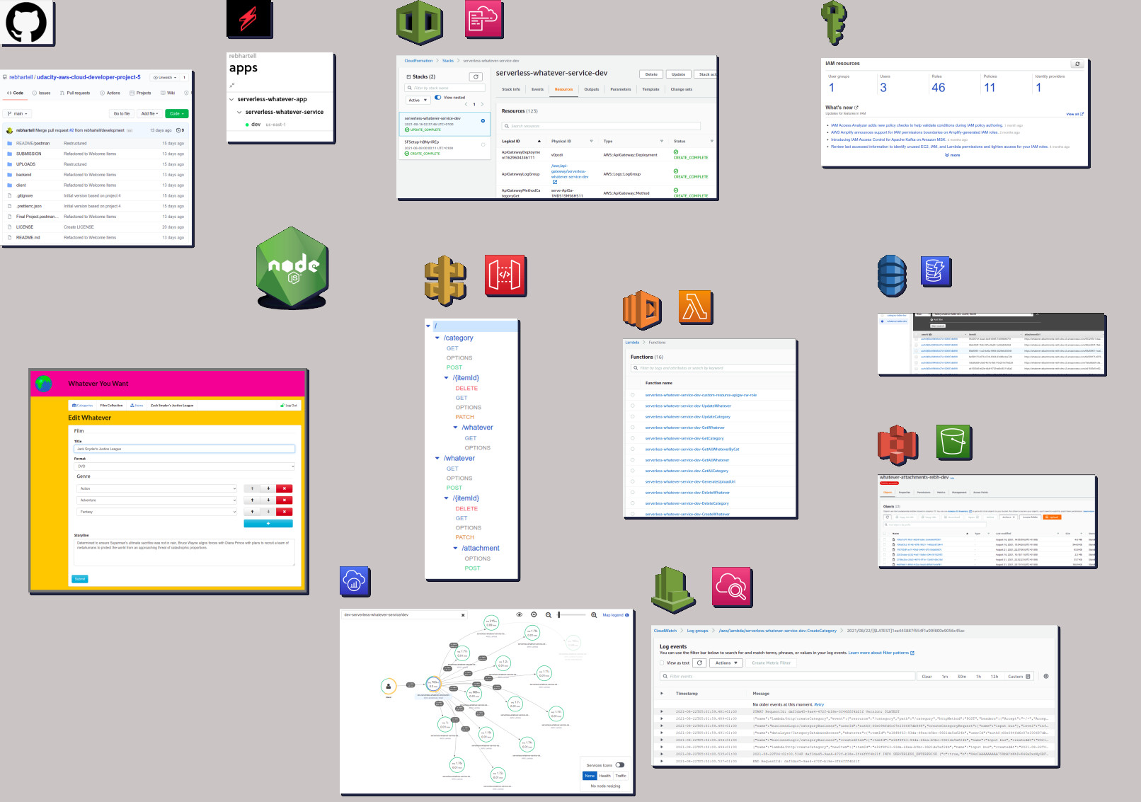
See “Whatever You Want - AWS – Serverless” (jpg, svg, and draw.io)

The application uses the following technologies:
- Visual Studio Code IDE
- Node Javascript server
- Node Package Manager
- React
- Semantic UI
- RJSF (themed with Bootstrap-3)
- Serverless Framework
- GitHub
- AWS:
  - IAM
  - CloudFormation
  - API Gateway
  - Lambda
  - DynamoDB
  - S3
  - CloudWatch
  - Xray
  - SDK
  - Command Line

Along the way, I will be pushing the existing boundaries of my knowledge across these technologies:
- Numerous AWS Cloud Computing services
- Modern Javascript and Node JS
- Typescript
- React
- Semantic UI
- React JSON-Schema Form
- the Serverless Framework

Application Design
The actual application design, extends the concepts of the Project 4 – To Do application.

Instead of providing a UI and API allowing a user to manage a single collection of To Do items with a hard-coded data entry form, this application provides a UI and API allowing a user to manage multiple collections (categories) of Whatever items with a user defined data-driven data entry form specific to each category.

The UI and API support CRUD at both the Category and the Whatever level.

Data Model and React JSON-Schema Form (RJSF)

The under-pinning data model is a collection of Category items which has a 1-to-many relationship to Whatever items which make up the member instances within that category.

The data model is aligned with the principles behind React JSON-Schema Form (see https://github.com/rjsf-team/react-jsonschema-form) which includes:
- a data-driven data model (JSON Schema)
- a data-driven UI form (JSON Schema)
- an instance of form data (JSON)

The following depiction illustrates the relationships within the Data Model and within RJSF and between the two of them:
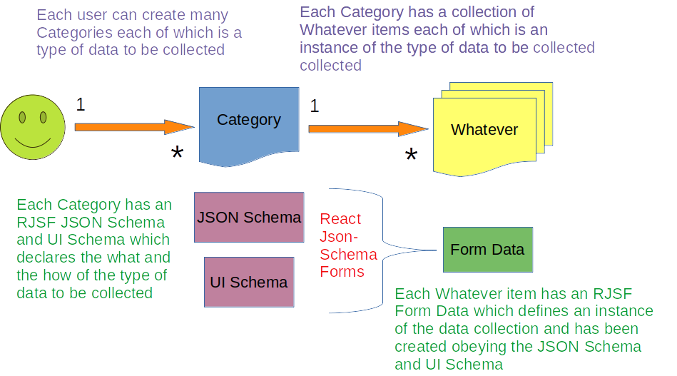
See “Data Model and RJSF” (odp)

Data Model

Category
Name | Type | Example | Primary Key | Index
userId | String | auth0|60e094fd6c07e10123000000 | HASH | HASH
itemId | String | c6723aef-24f3-442e-99db-d7dac0000000 | RANGE
name | String | diary  - other examples include recipe, music, address, etc |  | RANGE
jsonSchema | String | See Appendix A
uiSchema | String | See Appendix A
createdAt | String | 2021-08-08T09:57:47.954Z

Whatever
Name | Type | Example | Primary Key | Index
userId | String | auth0|60e094fd6c07e10123000000 | HASH | HASH
itemId | String | c6723aef-24f3-442e-99db-d7dac0999999 | RANGE
categoryId | String | c6723aef-24f3-442e-99db-d7dac0000000 |  | RANGE
name | String | 2021-01-01
formData | Map | See Appendix A
attachmentUrl | String | https://serverless-attachments-rebh-dev.s3.amazonaws.com/c6723aef-24f3-442e-99db-d7dac0273958
createdAt | String | 2021-08-08T09:57:47.954Z

All entries are ‘owned’ by the user identified by the Auth0 id (userId).
The one-to-many relationship between Category and Whatever items is managed by matching the Category.itemId and the Whatever.categoryId.

RJSF

Use the RJSF playground (https://rjsf-team.github.io/react-jsonschema-form/) to learn about and develop the JSON schema required to collect instances of Whatever You Want.

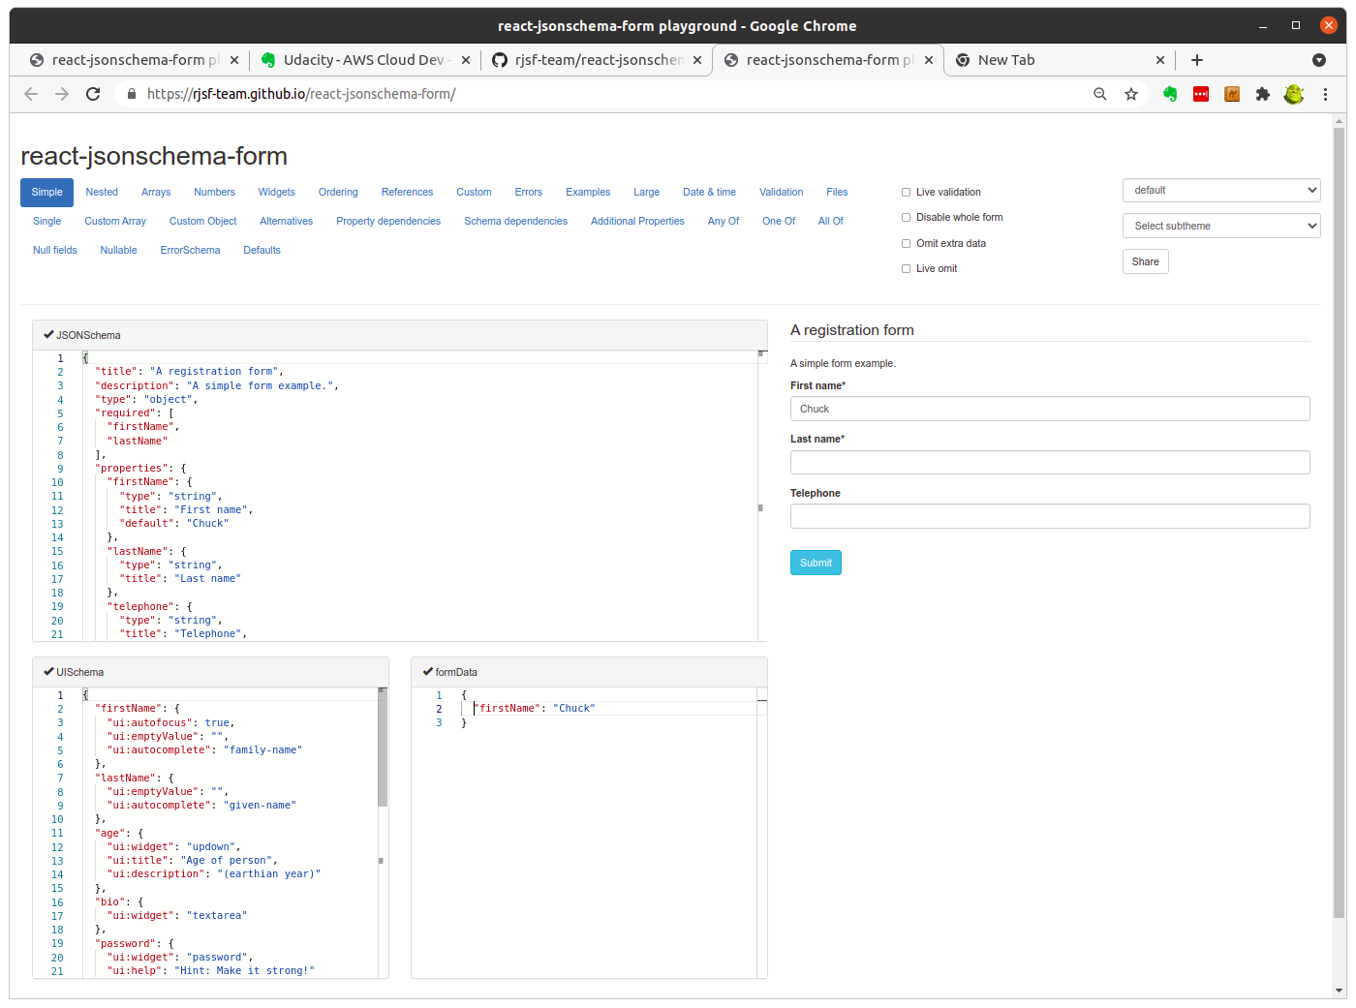

See Appendix A for examples of RJSF schema and data representing collections of:
- a Diary
- an Address Book
- a Movie Collection
- a Recipe Card deck

API

The API is fully defined in the Severless deployment (serverless.yaml) and fully tested by the Postman Collection (Final Project.postman_collection.json) which details:
- URL endpoints
- Authorization
- Request Body
- Path Variables
- Expected Response

The API is summarised by the AWS API Gateway dashboard:
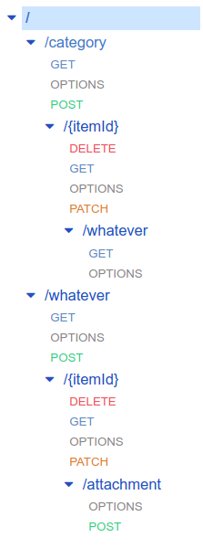

Step 3: Build your application

“Build either a containerized microservices app, or a serverless app.”

Project Source Repository
( https://github.com/rebhartell/udacity-aws-cloud-developer-project-5 )
The project source repository is divided across:
- backend server
- user interface
- Postman testing
- documentation
- upload files – images and schema

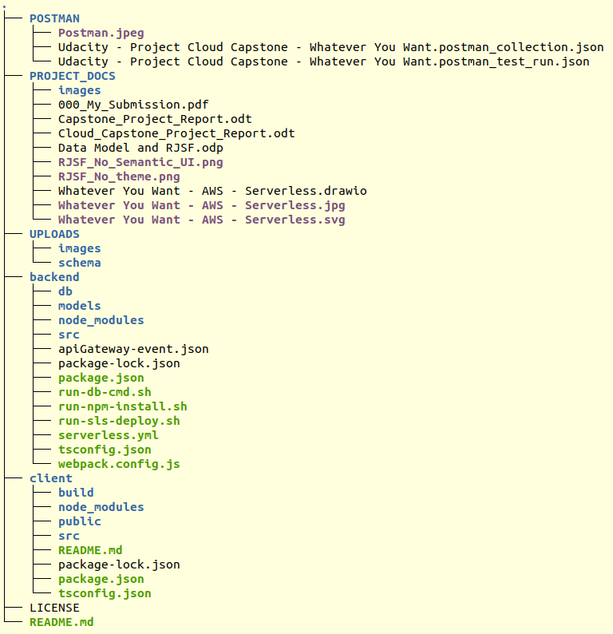

README.md

See the main README.md in the project home directory.

Known Warnings with the backend packaging

cd backend

rm -rf node_modules/

rm -rf package-lock.json

npm install

npm WARN deprecated request-promise-native@1.0.9: request-promise-native has been deprecated because it extends the now deprecated request package, see https://github.com/request/request/issues/3142
npm WARN deprecated urix@0.1.0: Please see https://github.com/lydell/urix#deprecated
npm WARN deprecated har-validator@5.1.5: this library is no longer supported
npm WARN deprecated resolve-url@0.2.1: https://github.com/lydell/resolve-url#deprecated
npm WARN deprecated querystring@0.2.1: The querystring API is considered Legacy. new code should use the URLSearchParams API instead.
npm WARN deprecated querystring@0.2.0: The querystring API is considered Legacy. new code should use the URLSearchParams API instead.
npm WARN deprecated uuid@3.4.0: Please upgrade to version 7 or higher. Older versions may use Math.random() in certain circumstances, which is known to be problematic. See https://v8.dev/blog/math-random for details.
npm WARN deprecated uuid@3.4.0: Please upgrade to version 7 or higher. Older versions may use Math.random() in certain circumstances, which is known to be problematic. See https://v8.dev/blog/math-random for details.
npm WARN deprecated uuid@3.4.0: Please upgrade to version 7 or higher. Older versions may use Math.random() in certain circumstances, which is known to be problematic. See https://v8.dev/blog/math-random for details.
npm WARN deprecated uuid@3.3.2: Please upgrade to version 7 or higher. Older versions may use Math.random() in certain circumstances, which is known to be problematic. See https://v8.dev/blog/math-random for details.
npm WARN deprecated request@2.88.2: request has been deprecated, see https://github.com/request/request/issues/3142

added 936 packages, and audited 937 packages in 39s

60 packages are looking for funding
run `npm fund` for details

found 0 vulnerabilities

The presence of these warnings does not appear to impair the execution of the backend services.

Known Warnings with the frontend packaging

rm -rf node_modules/

rm -rf package-lock.json

npm install

npm WARN ERESOLVE overriding peer dependency
npm WARN ERESOLVE overriding peer dependency
npm WARN deprecated flatten@1.0.3: flatten is deprecated in favor of utility frameworks such as lodash.
npm WARN deprecated @hapi/topo@3.1.6: This version has been deprecated and is no longer supported or maintained
npm WARN deprecated @hapi/bourne@1.3.2: This version has been deprecated and is no longer supported or maintained
npm WARN deprecated urix@0.1.0: Please see https://github.com/lydell/urix#deprecated
npm WARN deprecated resolve-url@0.2.1: https://github.com/lydell/resolve-url#deprecated
npm WARN deprecated querystring@0.2.1: The querystring API is considered Legacy. new code should use the URLSearchParams API instead.
npm WARN deprecated sane@4.1.0: some dependency vulnerabilities fixed, support for node < 10 dropped, and newer ECMAScript syntax/features added
npm WARN deprecated chokidar@2.1.8: Chokidar 2 will break on node v14+. Upgrade to chokidar 3 with 15x less dependencies.
npm WARN deprecated chokidar@2.1.8: Chokidar 2 will break on node v14+. Upgrade to chokidar 3 with 15x less dependencies.
npm WARN deprecated querystring@0.2.0: The querystring API is considered Legacy. new code should use the URLSearchParams API instead.
npm WARN deprecated babel-eslint@10.1.0: babel-eslint is now @babel/eslint-parser. This package will no longer receive updates.
npm WARN deprecated @hapi/address@2.1.4: Moved to 'npm install @sideway/address'
npm WARN deprecated rollup-plugin-babel@4.4.0: This package has been deprecated and is no longer maintained. Please use @rollup/plugin-babel.
npm WARN deprecated uuid@3.4.0: Please upgrade to version 7 or higher. Older versions may use Math.random() in certain circumstances, which is known to be problematic. See https://v8.dev/blog/math-random for details.
npm WARN deprecated uuid@3.4.0: Please upgrade to version 7 or higher. Older versions may use Math.random() in certain circumstances, which is known to be problematic. See https://v8.dev/blog/math-random for details.
npm WARN deprecated @hapi/hoek@8.5.1: This version has been deprecated and is no longer supported or maintained
npm WARN deprecated @hapi/joi@15.1.1: Switch to 'npm install joi'
npm WARN deprecated popper.js@1.16.1: You can find the new Popper v2 at @popperjs/core, this package is dedicated to the legacy v1
npm WARN deprecated core-js@2.6.12: core-js@<3.3 is no longer maintained and not recommended for usage due to the number of issues. Because of the V8 engine whims, feature detection in old core-js versions could cause a slowdown up to 100x even if nothing is polyfilled. Please, upgrade your dependencies to the actual version of core-js.

added 2061 packages, and audited 2062 packages in 59s

151 packages are looking for funding
run `npm fund` for details

10 moderate severity vulnerabilities

To address issues that do not require attention, run:
npm audit fix

To address all issues (including breaking changes), run:
npm audit fix --force

Run `npm audit` for details.

The presence of these warnings does not appear to impair the execution of the frontend services.

NPM List for the backend

npm list

serverless-whatever-app@1.0.0 /home/rebh/Development/udacity-aws-cloud-developer-project-5/backend
├── @types/aws-lambda@8.10.83
├── @types/jsonwebtoken@8.5.5
├── @types/uuid@8.3.1
├── aws-lambda@1.0.6
├── aws-sdk@2.973.0
├── aws-xray-sdk@3.3.3
├── axios@0.21.1
├── debug@4.3.2
├── jsonwebtoken@8.5.1
├── serverless-iam-roles-per-function@3.2.0
├── serverless-jetpack@0.11.1
├── serverless-plugin-tracing@2.0.0
├── serverless-prune-plugin@1.5.1
├── serverless-webpack@5.5.1
├── serverless@2.55.0
├── source-map-support@0.5.19
├── ts-loader@9.2.5
├── uuid@8.3.2
├── webpack@5.51.1
└── winston@3.3.3

NPM List for the frontend

npm list

typescript-app@0.1.0 /home/rebh/Development/udacity-aws-cloud-developer-project-5/client
├── @popperjs/core@2.9.3
├── @rjsf/core@3.1.0
├── @rjsf/semantic-ui@3.1.0
├── @types/dateformat@3.0.1
├── @types/json-schema@7.0.9
├── @types/react-dom@17.0.9
├── @types/react-jsonschema-form@1.7.6
├── @types/react-router-dom@5.1.8
├── @types/react@17.0.19
├── auth0-js@9.16.2
├── axios@0.21.1
├── bindings@1.5.0 extraneous
├── bootstrap@3.4.1
├── dateformat@4.5.1
├── file-uri-to-path@1.0.0 extraneous
├── immutability-helper@3.1.1
├── jquery@3.6.0
├── nan@2.15.0 extraneous
├── react-dom@17.0.2
├── react-jsonschema-form@1.8.1
├── react-router-dom@5.2.0
├── react-scripts@4.0.3
├── semantic-ui-css@2.4.1
├── semantic-ui-react@2.0.3
├── typescript@4.3.5
└── winston@3.3.3

NPM List for global

npm list -g

/home/rebh/.nvm/versions/node/v14.16.0/lib
└── npm@7.20.5

Serverless Verbose output

Here is the output when re-deploying the serverless.yml configuration:
Serverless: Running "serverless" installed locally (in service node_modules)
Serverless: Using provider credentials, configured via dashboard: https://app.serverless.com/rebhartell/apps/serverless-whatever-app/serverless-whatever-service/dev/us-east-1/providers
Serverless: Using configuration:
{
"concurrency": 2,
"serializedCompile": false,
"webpackConfig": "webpack.config.js",
"includeModules": false,
"packager": "npm",
"packagerOptions": {},
"keepOutputDirectory": false
}
Serverless: Removing /home/rebh/Development/udacity-aws-cloud-developer-project-5/backend/.webpack
Serverless: Individually packaging with concurrency at 2 entries a time.
Serverless: Bundling with Webpack...
asset src/lambda/auth/auth0Authorizer.js 255 KiB [emitted] [minimized] (name: src/lambda/auth/auth0Authorizer) 2 related assets
runtime modules 1.04 KiB 5 modules
orphan modules 497 bytes [orphan] 1 module
cacheable modules 762 KiB
javascript modules 759 KiB 176 modules
json modules 3.51 KiB
./node_modules/winston/package.json 1.51 KiB [built] [code generated]
./node_modules/axios/package.json 1.99 KiB [built] [code generated]
17 modules
webpack 5.50.0 compiled successfully in 24412 ms
asset src/lambda/http/getAllWhatever.js 6.53 MiB [emitted] [minimized] (name: src/lambda/http/getAllWhatever) 2 related assets
1350 modules
webpack 5.50.0 compiled successfully in 38596 ms
asset src/lambda/http/deleteCategory.js 6.53 MiB [emitted] [minimized] (name: src/lambda/http/deleteCategory) 2 related assets
1349 modules
webpack 5.50.0 compiled successfully in 30848 ms
asset src/lambda/http/updateCategory.js 6.53 MiB [emitted] [minimized] (name: src/lambda/http/updateCategory) 2 related assets
1349 modules
webpack 5.50.0 compiled successfully in 32976 ms
asset src/lambda/http/createCategory.js 6.53 MiB [emitted] [minimized] (name: src/lambda/http/createCategory) 2 related assets
1350 modules
webpack 5.50.0 compiled successfully in 32665 ms
asset src/lambda/http/getCategory.js 6.53 MiB [emitted] [minimized] (name: src/lambda/http/getCategory) 2 related assets
1349 modules
webpack 5.50.0 compiled successfully in 31375 ms
asset src/lambda/http/getAllCategory.js 6.53 MiB [emitted] [minimized] (name: src/lambda/http/getAllCategory) 2 related assets
1349 modules
webpack 5.50.0 compiled successfully in 32061 ms
asset src/lambda/http/generateUploadUrl.js 6.53 MiB [emitted] [minimized] (name: src/lambda/http/generateUploadUrl) 2 related assets
1350 modules
webpack 5.50.0 compiled successfully in 34885 ms
asset src/lambda/http/deleteWhatever.js 6.53 MiB [emitted] [minimized] (name: src/lambda/http/deleteWhatever) 2 related assets
1350 modules
webpack 5.50.0 compiled successfully in 35062 ms
asset src/lambda/http/updateWhatever.js 6.53 MiB [emitted] [minimized] (name: src/lambda/http/updateWhatever) 2 related assets
1350 modules
webpack 5.50.0 compiled successfully in 33083 ms
asset src/lambda/http/createWhatever.js 6.54 MiB [emitted] [minimized] (name: src/lambda/http/createWhatever) 2 related assets
1351 modules
webpack 5.50.0 compiled successfully in 33151 ms
asset src/lambda/http/getWhatever.js 6.53 MiB [emitted] [minimized] (name: src/lambda/http/getWhatever) 2 related assets
1350 modules
webpack 5.50.0 compiled successfully in 32761 ms
asset src/lambda/http/getAllWhateverByCategory.js 6.53 MiB [emitted] [minimized] (name: src/lambda/http/getAllWhateverByCategory) 2 related assets
1350 modules
webpack 5.50.0 compiled successfully in 28153 ms
Serverless: Zip method used: native
Serverless: Zip function: /home/rebh/Development/udacity-aws-cloud-developer-project-5/backend/.webpack/Auth [274 ms]
Serverless: Zip method used: native
Serverless: Zip function: /home/rebh/Development/udacity-aws-cloud-developer-project-5/backend/.webpack/GetAllWhatever [485 ms]
Serverless: Zip method used: native
Serverless: Zip function: /home/rebh/Development/udacity-aws-cloud-developer-project-5/backend/.webpack/GetAllWhateverByCat [515 ms]
Serverless: Zip method used: native
Serverless: Zip function: /home/rebh/Development/udacity-aws-cloud-developer-project-5/backend/.webpack/GetWhatever [485 ms]
Serverless: Zip method used: native
Serverless: Zip function: /home/rebh/Development/udacity-aws-cloud-developer-project-5/backend/.webpack/CreateWhatever [487 ms]
Serverless: Zip method used: native
Serverless: Zip function: /home/rebh/Development/udacity-aws-cloud-developer-project-5/backend/.webpack/UpdateWhatever [556 ms]
Serverless: Zip method used: native
Serverless: Zip function: /home/rebh/Development/udacity-aws-cloud-developer-project-5/backend/.webpack/DeleteWhatever [484 ms]
Serverless: Zip method used: native
Serverless: Zip function: /home/rebh/Development/udacity-aws-cloud-developer-project-5/backend/.webpack/GenerateUploadUrl [496 ms]
Serverless: Zip method used: native
Serverless: Zip function: /home/rebh/Development/udacity-aws-cloud-developer-project-5/backend/.webpack/GetAllCategory [490 ms]
Serverless: Zip method used: native
Serverless: Zip function: /home/rebh/Development/udacity-aws-cloud-developer-project-5/backend/.webpack/GetCategory [503 ms]
Serverless: Zip method used: native
Serverless: Zip function: /home/rebh/Development/udacity-aws-cloud-developer-project-5/backend/.webpack/CreateCategory [543 ms]
Serverless: Zip method used: native
Serverless: Zip function: /home/rebh/Development/udacity-aws-cloud-developer-project-5/backend/.webpack/UpdateCategory [502 ms]
Serverless: Zip method used: native
Serverless: Zip function: /home/rebh/Development/udacity-aws-cloud-developer-project-5/backend/.webpack/DeleteCategory [484 ms]
Serverless: Copying existing artifacts...
Serverless: Setting artifact for function 'Auth' to '.serverless/Auth.zip'
Serverless: Setting artifact for function 'GetAllWhatever' to '.serverless/GetAllWhatever.zip'
Serverless: Setting artifact for function 'GetAllWhateverByCat' to '.serverless/GetAllWhateverByCat.zip'
Serverless: Setting artifact for function 'GetWhatever' to '.serverless/GetWhatever.zip'
Serverless: Setting artifact for function 'CreateWhatever' to '.serverless/CreateWhatever.zip'
Serverless: Setting artifact for function 'UpdateWhatever' to '.serverless/UpdateWhatever.zip'
Serverless: Setting artifact for function 'DeleteWhatever' to '.serverless/DeleteWhatever.zip'
Serverless: Setting artifact for function 'GenerateUploadUrl' to '.serverless/GenerateUploadUrl.zip'
Serverless: Setting artifact for function 'GetAllCategory' to '.serverless/GetAllCategory.zip'
Serverless: Setting artifact for function 'GetCategory' to '.serverless/GetCategory.zip'
Serverless: Setting artifact for function 'CreateCategory' to '.serverless/CreateCategory.zip'
Serverless: Setting artifact for function 'UpdateCategory' to '.serverless/UpdateCategory.zip'
Serverless: Setting artifact for function 'DeleteCategory' to '.serverless/DeleteCategory.zip'
Serverless: Setting artifact for function 'Auth' to '.serverless/Auth.zip'
Serverless: Setting artifact for function 'GetAllWhatever' to '.serverless/GetAllWhatever.zip'
Serverless: Setting artifact for function 'GetAllWhateverByCat' to '.serverless/GetAllWhateverByCat.zip'
Serverless: Setting artifact for function 'GetWhatever' to '.serverless/GetWhatever.zip'
Serverless: Setting artifact for function 'CreateWhatever' to '.serverless/CreateWhatever.zip'
Serverless: Setting artifact for function 'UpdateWhatever' to '.serverless/UpdateWhatever.zip'
Serverless: Setting artifact for function 'DeleteWhatever' to '.serverless/DeleteWhatever.zip'
Serverless: Setting artifact for function 'GenerateUploadUrl' to '.serverless/GenerateUploadUrl.zip'
Serverless: Setting artifact for function 'GetAllCategory' to '.serverless/GetAllCategory.zip'
Serverless: Setting artifact for function 'GetCategory' to '.serverless/GetCategory.zip'
Serverless: Setting artifact for function 'CreateCategory' to '.serverless/CreateCategory.zip'
Serverless: Setting artifact for function 'UpdateCategory' to '.serverless/UpdateCategory.zip'
Serverless: Setting artifact for function 'DeleteCategory' to '.serverless/DeleteCategory.zip'
Serverless: [serverless-jetpack] Skipping individual packaging for 13 functions
Serverless: [serverless-jetpack] Packaging 0 functions, 0 services, and 0 layers with concurrency 1
Serverless: Packaging service...
Serverless: Remove /home/rebh/Development/udacity-aws-cloud-developer-project-5/backend/.webpack
Serverless: Removing /home/rebh/Development/udacity-aws-cloud-developer-project-5/backend/.webpack done
Serverless: Installing dependencies for custom CloudFormation resources...
Serverless: Tracing DISABLED for function "serverless-whatever-service-dev-Auth"
Serverless: Tracing DISABLED for function "serverless-whatever-service-dev-GetAllWhatever"
Serverless: Tracing DISABLED for function "serverless-whatever-service-dev-GetAllWhateverByCat"
Serverless: Tracing DISABLED for function "serverless-whatever-service-dev-GetWhatever"
Serverless: Tracing DISABLED for function "serverless-whatever-service-dev-CreateWhatever"
Serverless: Tracing DISABLED for function "serverless-whatever-service-dev-UpdateWhatever"
Serverless: Tracing DISABLED for function "serverless-whatever-service-dev-DeleteWhatever"
Serverless: Tracing DISABLED for function "serverless-whatever-service-dev-GenerateUploadUrl"
Serverless: Tracing DISABLED for function "serverless-whatever-service-dev-GetAllCategory"
Serverless: Tracing DISABLED for function "serverless-whatever-service-dev-GetCategory"
Serverless: Tracing DISABLED for function "serverless-whatever-service-dev-CreateCategory"
Serverless: Tracing DISABLED for function "serverless-whatever-service-dev-UpdateCategory"
Serverless: Tracing DISABLED for function "serverless-whatever-service-dev-DeleteCategory"
Serverless: Uploading CloudFormation file to S3...
Serverless: Uploading artifacts...
Serverless: Uploading service Auth.zip file to S3 (563.13 KB)...
Serverless: Uploading service GetAllWhatever.zip file to S3 (1.62 MB)...
Serverless: Uploading service GetAllWhateverByCat.zip file to S3 (1.62 MB)...
Serverless: Uploading service DeleteCategory.zip file to S3 (1.62 MB)...
Serverless: Uploading service UpdateCategory.zip file to S3 (1.62 MB)...
Serverless: Uploading service CreateCategory.zip file to S3 (1.62 MB)...
Serverless: Uploading service GetCategory.zip file to S3 (1.62 MB)...
Serverless: Uploading service GetAllCategory.zip file to S3 (1.62 MB)...
Serverless: Uploading service GenerateUploadUrl.zip file to S3 (1.62 MB)...
Serverless: Uploading service DeleteWhatever.zip file to S3 (1.62 MB)...
Serverless: Uploading service UpdateWhatever.zip file to S3 (1.62 MB)...
Serverless: Uploading service CreateWhatever.zip file to S3 (1.62 MB)...
Serverless: Uploading service GetWhatever.zip file to S3 (1.62 MB)...
Serverless: Uploading custom CloudFormation resources...
Serverless: Validating template...
Serverless: Updating Stack...
Serverless: Checking Stack update progress...
CloudFormation - UPDATE_IN_PROGRESS - AWS::CloudFormation::Stack - serverless-whatever-service-dev
CloudFormation - UPDATE_IN_PROGRESS - AWS::Lambda::Function - GenerateUploadUrlLambdaFunction
CloudFormation - UPDATE_IN_PROGRESS - AWS::Lambda::Function - UpdateCategoryLambdaFunction
CloudFormation - UPDATE_IN_PROGRESS - AWS::Lambda::Function - GetAllCategoryLambdaFunction
CloudFormation - UPDATE_IN_PROGRESS - AWS::Lambda::Function - GetAllWhateverLambdaFunction
CloudFormation - UPDATE_IN_PROGRESS - AWS::Lambda::Function - AuthLambdaFunction
CloudFormation - UPDATE_IN_PROGRESS - AWS::Lambda::Function - UpdateWhateverLambdaFunction
CloudFormation - UPDATE_IN_PROGRESS - AWS::Lambda::Function - CreateCategoryLambdaFunction
CloudFormation - UPDATE_IN_PROGRESS - AWS::Lambda::Function - GetAllWhateverByCatLambdaFunction
CloudFormation - UPDATE_IN_PROGRESS - AWS::Lambda::Function - GetCategoryLambdaFunction
CloudFormation - UPDATE_IN_PROGRESS - AWS::Lambda::Function - DeleteWhateverLambdaFunction
CloudFormation - UPDATE_IN_PROGRESS - AWS::Lambda::Function - GetWhateverLambdaFunction
CloudFormation - UPDATE_IN_PROGRESS - AWS::Lambda::Function - CustomDashresourceDashapigwDashcwDashroleLambdaFunction
CloudFormation - UPDATE_IN_PROGRESS - AWS::Lambda::Function - DeleteCategoryLambdaFunction
CloudFormation - UPDATE_IN_PROGRESS - AWS::Lambda::Function - CreateWhateverLambdaFunction
CloudFormation - UPDATE_COMPLETE - AWS::Lambda::Function - GenerateUploadUrlLambdaFunction
CloudFormation - UPDATE_COMPLETE - AWS::Lambda::Function - GetAllWhateverLambdaFunction
CloudFormation - UPDATE_COMPLETE - AWS::Lambda::Function - UpdateCategoryLambdaFunction
CloudFormation - UPDATE_COMPLETE - AWS::Lambda::Function - GetCategoryLambdaFunction
CloudFormation - UPDATE_COMPLETE - AWS::Lambda::Function - AuthLambdaFunction
CloudFormation - UPDATE_COMPLETE - AWS::Lambda::Function - GetAllCategoryLambdaFunction
CloudFormation - UPDATE_COMPLETE - AWS::Lambda::Function - DeleteWhateverLambdaFunction
CloudFormation - UPDATE_COMPLETE - AWS::Lambda::Function - CustomDashresourceDashapigwDashcwDashroleLambdaFunction
CloudFormation - UPDATE_COMPLETE - AWS::Lambda::Function - GetAllWhateverByCatLambdaFunction
CloudFormation - UPDATE_COMPLETE - AWS::Lambda::Function - UpdateWhateverLambdaFunction
CloudFormation - UPDATE_COMPLETE - AWS::Lambda::Function - DeleteCategoryLambdaFunction
CloudFormation - UPDATE_COMPLETE - AWS::Lambda::Function - GetWhateverLambdaFunction
CloudFormation - UPDATE_COMPLETE - AWS::Lambda::Function - CreateCategoryLambdaFunction
CloudFormation - UPDATE_COMPLETE - AWS::Lambda::Function - CreateWhateverLambdaFunction
CloudFormation - CREATE_IN_PROGRESS - AWS::Lambda::Version - GetAllWhateverLambdaVersionpgUOeIhERW4xr92nXAEvouEN5nrK61eO36GgIwn4
CloudFormation - CREATE_IN_PROGRESS - AWS::Lambda::Version - GenerateUploadUrlLambdaVersionroXGNvAiB5in7RSIY9E0PDamb5FsFiEOa2beY6OULCI
CloudFormation - CREATE_IN_PROGRESS - AWS::Lambda::Version - GetAllCategoryLambdaVersionZBXwrBj88gKfSjvpDHdhky6rInMStUissKEIo8KDFw
CloudFormation - CREATE_IN_PROGRESS - AWS::Lambda::Version - UpdateCategoryLambdaVersionLMqwtwEeAIgSV5m3qPHX6tme4dpHsWnks5NMFrHo
CloudFormation - CREATE_IN_PROGRESS - AWS::Lambda::Version - GetAllWhateverLambdaVersionpgUOeIhERW4xr92nXAEvouEN5nrK61eO36GgIwn4
CloudFormation - CREATE_IN_PROGRESS - AWS::Lambda::Version - DeleteWhateverLambdaVersion8rLW4Ur9nl39O2F4NhVjcTU3wlBkaZYYMBQoLdu81c
CloudFormation - CREATE_IN_PROGRESS - AWS::Lambda::Version - CreateCategoryLambdaVersionKIz4JK71QYZqa6Q1f4YcV829GZH9rcqETeuXGfh4GNU
CloudFormation - CREATE_IN_PROGRESS - AWS::Lambda::Version - GetCategoryLambdaVersionTQvVYgg6ibYGIbyX39rsSHf8a5zuinDg7FR1jEqizc
CloudFormation - CREATE_IN_PROGRESS - AWS::Lambda::Version - GenerateUploadUrlLambdaVersionroXGNvAiB5in7RSIY9E0PDamb5FsFiEOa2beY6OULCI
CloudFormation - CREATE_IN_PROGRESS - AWS::Lambda::Version - GetWhateverLambdaVersionWPHiqUr2KCrP1sUh6pDbdVe3PQt6WfaQ0pMaNnIOf4Q
CloudFormation - CREATE_IN_PROGRESS - AWS::Lambda::Version - AuthLambdaVersion4r8uMWqouRIk1RFfhe5XWMXIJuM0bHoukQTNqdFCuA
CloudFormation - CREATE_COMPLETE - AWS::Lambda::Version - GenerateUploadUrlLambdaVersionroXGNvAiB5in7RSIY9E0PDamb5FsFiEOa2beY6OULCI
CloudFormation - CREATE_IN_PROGRESS - AWS::Lambda::Version - GetAllCategoryLambdaVersionZBXwrBj88gKfSjvpDHdhky6rInMStUissKEIo8KDFw
CloudFormation - CREATE_IN_PROGRESS - AWS::Lambda::Version - DeleteCategoryLambdaVersionAxrXPHpWUCxKxRrj5jxAEQme1U61ZsusOApoVZsrvsI
CloudFormation - CREATE_IN_PROGRESS - AWS::Lambda::Version - UpdateWhateverLambdaVersionYHwZpViz7O3NwSrtjBLT9CScA54UXGivrnu5kSI
CloudFormation - CREATE_COMPLETE - AWS::Lambda::Version - GetAllWhateverLambdaVersionpgUOeIhERW4xr92nXAEvouEN5nrK61eO36GgIwn4
CloudFormation - CREATE_IN_PROGRESS - AWS::Lambda::Version - DeleteWhateverLambdaVersion8rLW4Ur9nl39O2F4NhVjcTU3wlBkaZYYMBQoLdu81c
CloudFormation - CREATE_IN_PROGRESS - AWS::Lambda::Version - CreateCategoryLambdaVersionKIz4JK71QYZqa6Q1f4YcV829GZH9rcqETeuXGfh4GNU
CloudFormation - CREATE_IN_PROGRESS - AWS::Lambda::Version - GetCategoryLambdaVersionTQvVYgg6ibYGIbyX39rsSHf8a5zuinDg7FR1jEqizc
CloudFormation - CREATE_IN_PROGRESS - AWS::Lambda::Version - UpdateCategoryLambdaVersionLMqwtwEeAIgSV5m3qPHX6tme4dpHsWnks5NMFrHo
CloudFormation - CREATE_COMPLETE - AWS::Lambda::Version - GetAllCategoryLambdaVersionZBXwrBj88gKfSjvpDHdhky6rInMStUissKEIo8KDFw
CloudFormation - CREATE_COMPLETE - AWS::Lambda::Version - DeleteWhateverLambdaVersion8rLW4Ur9nl39O2F4NhVjcTU3wlBkaZYYMBQoLdu81c
CloudFormation - CREATE_IN_PROGRESS - AWS::Lambda::Version - GetWhateverLambdaVersionWPHiqUr2KCrP1sUh6pDbdVe3PQt6WfaQ0pMaNnIOf4Q
CloudFormation - CREATE_IN_PROGRESS - AWS::Lambda::Version - AuthLambdaVersion4r8uMWqouRIk1RFfhe5XWMXIJuM0bHoukQTNqdFCuA
CloudFormation - CREATE_IN_PROGRESS - AWS::Lambda::Version - CreateWhateverLambdaVersionQqc85s8Nq0SWiNyJ5LXnPvorxDIGRQNsUt1W3liobYA
CloudFormation - CREATE_COMPLETE - AWS::Lambda::Version - GetCategoryLambdaVersionTQvVYgg6ibYGIbyX39rsSHf8a5zuinDg7FR1jEqizc
CloudFormation - CREATE_COMPLETE - AWS::Lambda::Version - CreateCategoryLambdaVersionKIz4JK71QYZqa6Q1f4YcV829GZH9rcqETeuXGfh4GNU
CloudFormation - CREATE_IN_PROGRESS - AWS::Lambda::Version - UpdateWhateverLambdaVersionYHwZpViz7O3NwSrtjBLT9CScA54UXGivrnu5kSI
CloudFormation - CREATE_COMPLETE - AWS::Lambda::Version - GetWhateverLambdaVersionWPHiqUr2KCrP1sUh6pDbdVe3PQt6WfaQ0pMaNnIOf4Q
CloudFormation - CREATE_IN_PROGRESS - AWS::Lambda::Version - GetAllWhateverByCatLambdaVersioni1My2f0iPcmPSO8djtHDkiU2UQRB2Pj4n0P5oLyk
CloudFormation - CREATE_COMPLETE - AWS::Lambda::Version - UpdateCategoryLambdaVersionLMqwtwEeAIgSV5m3qPHX6tme4dpHsWnks5NMFrHo
CloudFormation - CREATE_COMPLETE - AWS::Lambda::Version - AuthLambdaVersion4r8uMWqouRIk1RFfhe5XWMXIJuM0bHoukQTNqdFCuA
CloudFormation - CREATE_IN_PROGRESS - AWS::Lambda::Version - DeleteCategoryLambdaVersionAxrXPHpWUCxKxRrj5jxAEQme1U61ZsusOApoVZsrvsI
CloudFormation - CREATE_COMPLETE - AWS::Lambda::Version - UpdateWhateverLambdaVersionYHwZpViz7O3NwSrtjBLT9CScA54UXGivrnu5kSI
CloudFormation - CREATE_COMPLETE - AWS::Lambda::Version - DeleteCategoryLambdaVersionAxrXPHpWUCxKxRrj5jxAEQme1U61ZsusOApoVZsrvsI
CloudFormation - CREATE_IN_PROGRESS - AWS::Lambda::Version - CreateWhateverLambdaVersionQqc85s8Nq0SWiNyJ5LXnPvorxDIGRQNsUt1W3liobYA
CloudFormation - CREATE_IN_PROGRESS - AWS::Lambda::Version - GetAllWhateverByCatLambdaVersioni1My2f0iPcmPSO8djtHDkiU2UQRB2Pj4n0P5oLyk
CloudFormation - CREATE_COMPLETE - AWS::Lambda::Version - CreateWhateverLambdaVersionQqc85s8Nq0SWiNyJ5LXnPvorxDIGRQNsUt1W3liobYA
CloudFormation - CREATE_COMPLETE - AWS::Lambda::Version - GetAllWhateverByCatLambdaVersioni1My2f0iPcmPSO8djtHDkiU2UQRB2Pj4n0P5oLyk
CloudFormation - CREATE_IN_PROGRESS - AWS::ApiGateway::Deployment - ApiGatewayDeployment1629687270178
CloudFormation - CREATE_IN_PROGRESS - AWS::ApiGateway::Deployment - ApiGatewayDeployment1629687270178
CloudFormation - CREATE_COMPLETE - AWS::ApiGateway::Deployment - ApiGatewayDeployment1629687270178
CloudFormation - UPDATE_COMPLETE_CLEANUP_IN_PROGRESS - AWS::CloudFormation::Stack - serverless-whatever-service-dev
CloudFormation - DELETE_SKIPPED - AWS::Lambda::Version - CreateCategoryLambdaVersiongdJSTOIJg2dSafsdsFFnEDQSFWEHV2awFrluCSjOM
CloudFormation - DELETE_SKIPPED - AWS::Lambda::Version - GetAllWhateverLambdaVersion57eMvNPhGXNBTNUftpuKvKcbUNZv8NpSotCn12tcxc
CloudFormation - DELETE_SKIPPED - AWS::Lambda::Version - GetAllCategoryLambdaVersionpum17xc4HXYgth6kRGLhBdmgJjmwac54ji0oGsew0E
CloudFormation - DELETE_SKIPPED - AWS::Lambda::Version - DeleteWhateverLambdaVersionEV6zmgjnsk4PUpjQxOwmFfPT0o7iG4qAJOMPVE2tPnk
CloudFormation - DELETE_SKIPPED - AWS::Lambda::Version - GetAllWhateverByCatLambdaVersionbxSoYhtPCdf0S359b4e62FysiPqnWRfHrS4e6jkdjo
CloudFormation - DELETE_IN_PROGRESS - AWS::ApiGateway::Deployment - ApiGatewayDeployment1629604246111
CloudFormation - DELETE_SKIPPED - AWS::Lambda::Version - UpdateCategoryLambdaVersionR0FtHk4I3ZduojgovnWtOqO56g9r48VA1aSw77yAYto
CloudFormation - DELETE_SKIPPED - AWS::Lambda::Version - DeleteCategoryLambdaVersion094vkuE4hE1ofcpbFH8Lf9fwzIZR8el9uApGNamZQ
CloudFormation - DELETE_SKIPPED - AWS::Lambda::Version - GenerateUploadUrlLambdaVersionDTjdMMJwzZFKPri9X4ZttfS8lhqxKbAp8IZE4Aidcw
CloudFormation - DELETE_SKIPPED - AWS::Lambda::Version - GetWhateverLambdaVersionjl9YhPd0AMGZJejxbh5eoZPT3tSGDpqYgYsYlx4
CloudFormation - DELETE_SKIPPED - AWS::Lambda::Version - UpdateWhateverLambdaVersionWHMQaKlN9ila5YeD5CeU05H6tKKOF6732fdncm0hc
CloudFormation - DELETE_SKIPPED - AWS::Lambda::Version - GetCategoryLambdaVersionguFfvIxKPdiCN355QJaHy8VxNBksaqh8mgjW3eg
CloudFormation - DELETE_SKIPPED - AWS::Lambda::Version - AuthLambdaVersion8Mn14aRyoZ7PMsDS9F8WXTxEEUgDPPCYtpFAF9ot7w
CloudFormation - DELETE_SKIPPED - AWS::Lambda::Version - CreateWhateverLambdaVersionvR5ScOFtzAOxqQGcp3fJlaeY861iKJ7bAWsU3942e0k
CloudFormation - DELETE_COMPLETE - AWS::ApiGateway::Deployment - ApiGatewayDeployment1629604246111
CloudFormation - UPDATE_COMPLETE - AWS::CloudFormation::Stack - serverless-whatever-service-dev
Serverless: Stack update finished...
Service Information
service: serverless-whatever-service
stage: dev
region: us-east-1
stack: serverless-whatever-service-dev
resources: 123
api keys:
None
endpoints:
GET - https://wdjq4nvsa6.execute-api.us-east-1.amazonaws.com/dev/whatever
GET - https://wdjq4nvsa6.execute-api.us-east-1.amazonaws.com/dev/category/{itemId}/whatever
GET - https://wdjq4nvsa6.execute-api.us-east-1.amazonaws.com/dev/whatever/{itemId}
POST - https://wdjq4nvsa6.execute-api.us-east-1.amazonaws.com/dev/whatever
PATCH - https://wdjq4nvsa6.execute-api.us-east-1.amazonaws.com/dev/whatever/{itemId}
DELETE - https://wdjq4nvsa6.execute-api.us-east-1.amazonaws.com/dev/whatever/{itemId}
POST - https://wdjq4nvsa6.execute-api.us-east-1.amazonaws.com/dev/whatever/{itemId}/attachment
GET - https://wdjq4nvsa6.execute-api.us-east-1.amazonaws.com/dev/category
GET - https://wdjq4nvsa6.execute-api.us-east-1.amazonaws.com/dev/category/{itemId}
POST - https://wdjq4nvsa6.execute-api.us-east-1.amazonaws.com/dev/category
PATCH - https://wdjq4nvsa6.execute-api.us-east-1.amazonaws.com/dev/category/{itemId}
DELETE - https://wdjq4nvsa6.execute-api.us-east-1.amazonaws.com/dev/category/{itemId}
functions:
Auth: serverless-whatever-service-dev-Auth
GetAllWhatever: serverless-whatever-service-dev-GetAllWhatever
GetAllWhateverByCat: serverless-whatever-service-dev-GetAllWhateverByCat
GetWhatever: serverless-whatever-service-dev-GetWhatever
CreateWhatever: serverless-whatever-service-dev-CreateWhatever
UpdateWhatever: serverless-whatever-service-dev-UpdateWhatever
DeleteWhatever: serverless-whatever-service-dev-DeleteWhatever
GenerateUploadUrl: serverless-whatever-service-dev-GenerateUploadUrl
GetAllCategory: serverless-whatever-service-dev-GetAllCategory
GetCategory: serverless-whatever-service-dev-GetCategory
CreateCategory: serverless-whatever-service-dev-CreateCategory
UpdateCategory: serverless-whatever-service-dev-UpdateCategory
DeleteCategory: serverless-whatever-service-dev-DeleteCategory
layers:
None

Stack Outputs
AuthLambdaFunctionQualifiedArn: arn:aws:lambda:us-east-1:016523083343:function:serverless-whatever-service-dev-Auth:20
DeleteWhateverLambdaFunctionQualifiedArn: arn:aws:lambda:us-east-1:016523083343:function:serverless-whatever-service-dev-DeleteWhatever:20
GenerateUploadUrlLambdaFunctionQualifiedArn: arn:aws:lambda:us-east-1:016523083343:function:serverless-whatever-service-dev-GenerateUploadUrl:20
CreateWhateverLambdaFunctionQualifiedArn: arn:aws:lambda:us-east-1:016523083343:function:serverless-whatever-service-dev-CreateWhatever:20
UpdateCategoryLambdaFunctionQualifiedArn: arn:aws:lambda:us-east-1:016523083343:function:serverless-whatever-service-dev-UpdateCategory:9
GetWhateverLambdaFunctionQualifiedArn: arn:aws:lambda:us-east-1:016523083343:function:serverless-whatever-service-dev-GetWhatever:20
UpdateWhateverLambdaFunctionQualifiedArn: arn:aws:lambda:us-east-1:016523083343:function:serverless-whatever-service-dev-UpdateWhatever:20
GetAllCategoryLambdaFunctionQualifiedArn: arn:aws:lambda:us-east-1:016523083343:function:serverless-whatever-service-dev-GetAllCategory:8
ServerlessDeploymentBucketName: serverless-whatever-serv-serverlessdeploymentbuck-1wo7mf9horr3z
CreateCategoryLambdaFunctionQualifiedArn: arn:aws:lambda:us-east-1:016523083343:function:serverless-whatever-service-dev-CreateCategory:9
GetCategoryLambdaFunctionQualifiedArn: arn:aws:lambda:us-east-1:016523083343:function:serverless-whatever-service-dev-GetCategory:9
DeleteCategoryLambdaFunctionQualifiedArn: arn:aws:lambda:us-east-1:016523083343:function:serverless-whatever-service-dev-DeleteCategory:9
EnterpriseLogAccessIamRole: arn:aws:iam::016523083343:role/serverless-whatever-servi-EnterpriseLogAccessIamRo-1FP5J135LTY4U
GetAllWhateverByCatLambdaFunctionQualifiedArn: arn:aws:lambda:us-east-1:016523083343:function:serverless-whatever-service-dev-GetAllWhateverByCat:7
GetAllWhateverLambdaFunctionQualifiedArn: arn:aws:lambda:us-east-1:016523083343:function:serverless-whatever-service-dev-GetAllWhatever:13
ServiceEndpoint: https://wdjq4nvsa6.execute-api.us-east-1.amazonaws.com/dev

Serverless: Prune: Running post-deployment pruning
Serverless: Prune: Querying for deployed function versions
Serverless: Prune: serverless-whatever-service-dev-Auth has 3 additional versions published and 0 aliases, 1 version selected for deletion
Serverless: Prune: Deleting Function serverless-whatever-service-dev-Auth v18...
Serverless: Prune: serverless-whatever-service-dev-GetAllWhatever has 3 additional versions published and 0 aliases, 1 version selected for deletion
Serverless: Prune: Deleting Function serverless-whatever-service-dev-GetAllWhatever v11...
Serverless: Prune: serverless-whatever-service-dev-GetAllWhateverByCat has 3 additional versions published and 0 aliases, 1 version selected for deletion
Serverless: Prune: Deleting Function serverless-whatever-service-dev-GetAllWhateverByCat v5...
Serverless: Prune: serverless-whatever-service-dev-GetWhatever has 3 additional versions published and 0 aliases, 1 version selected for deletion
Serverless: Prune: Deleting Function serverless-whatever-service-dev-GetWhatever v18...
Serverless: Prune: serverless-whatever-service-dev-CreateWhatever has 3 additional versions published and 0 aliases, 1 version selected for deletion
Serverless: Prune: Deleting Function serverless-whatever-service-dev-CreateWhatever v18...
Serverless: Prune: serverless-whatever-service-dev-UpdateWhatever has 3 additional versions published and 0 aliases, 1 version selected for deletion
Serverless: Prune: Deleting Function serverless-whatever-service-dev-UpdateWhatever v18...
Serverless: Prune: serverless-whatever-service-dev-DeleteWhatever has 3 additional versions published and 0 aliases, 1 version selected for deletion
Serverless: Prune: Deleting Function serverless-whatever-service-dev-DeleteWhatever v18...
Serverless: Prune: serverless-whatever-service-dev-GenerateUploadUrl has 3 additional versions published and 0 aliases, 1 version selected for deletion
Serverless: Prune: Deleting Function serverless-whatever-service-dev-GenerateUploadUrl v18...
Serverless: Prune: serverless-whatever-service-dev-GetAllCategory has 3 additional versions published and 0 aliases, 1 version selected for deletion
Serverless: Prune: Deleting Function serverless-whatever-service-dev-GetAllCategory v6...
Serverless: Prune: serverless-whatever-service-dev-GetCategory has 3 additional versions published and 0 aliases, 1 version selected for deletion
Serverless: Prune: Deleting Function serverless-whatever-service-dev-GetCategory v7...
Serverless: Prune: serverless-whatever-service-dev-CreateCategory has 3 additional versions published and 0 aliases, 1 version selected for deletion
Serverless: Prune: Deleting Function serverless-whatever-service-dev-CreateCategory v7...
Serverless: Prune: serverless-whatever-service-dev-UpdateCategory has 3 additional versions published and 0 aliases, 1 version selected for deletion
Serverless: Prune: Deleting Function serverless-whatever-service-dev-UpdateCategory v7...
Serverless: Prune: serverless-whatever-service-dev-DeleteCategory has 3 additional versions published and 0 aliases, 1 version selected for deletion
Serverless: Prune: Deleting Function serverless-whatever-service-dev-DeleteCategory v7...
Serverless: Prune: Pruning complete.
Serverless: Removing old service artifacts from S3...
Serverless: Publishing service to the Serverless Dashboard...
Serverless: Successfully published your service to the Serverless Dashboard: https://app.serverless.com/rebhartell/apps/serverless-whatever-app/serverless-whatever-service/dev/us-east-1

Issues with the initial submission (v3.0.0)

Unable to review
Your project could not be reviewed. Please resubmit after you address the issue noted below by the reviewer.
Hi There !!
Your project couldn't be reviewed as it gave the following error on running the client module. 
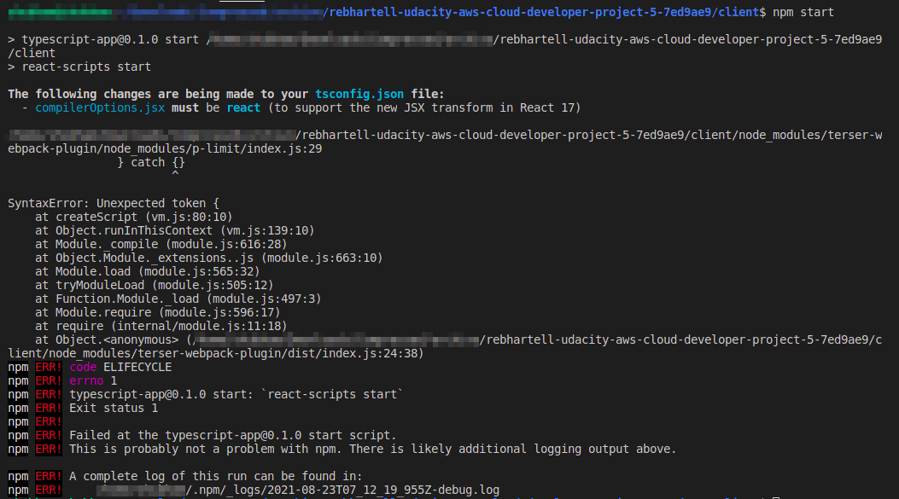
Please ensure that you send a fully working project or update the README instruction for successful build
Hope you make the required changes soon. We look forward to receiving your future project submissions soon .
Have a Good Day and Stay Safe ✌
Keep Learning and Stay Udacious
Review #1 (this review)
Reviewed 8h ago
STUDENT NOTES
https://github.com/rebhartell/udacity-aws-cloud-developer-project-5/tree/v3.0.0
All documentation and images are in https://github.com/rebhartell/udacity-aws-cloud-developer-project-5/blob/v3.0.0/PROJECT_DOCS/Cloud_Capstone_Project_Report.pdf

Response
Downloaded the exact same source code https://github.com/rebhartell/udacity-aws-cloud-developer-project-5/tree/v3.0.0

Builds and runs OK on my computer !!!

Possible Source of Issue | Possible Solution | Comment
The module versions are not specific enough and slightly different versions are being brought in | Use npm ci (rather than npm I) for a deterministic, repeatable build | Updated README.md to use npm ci
Different versions of build tools | Specify the tool versions and check during the build | Configured package.json and .npmrc
Potentially different versions of Typescript when building from VS Code as opposed to the commandline | Build from the commandline and not in VS Code
Pre-installed Global modules are different | Be specific about the global modules required – none  Prefer local modules (--save-dev) over global modules (-g) | Removed all global modules – except npm  serverless now needs to be run using npx
Other differences due to the platform – e.g. Ubuntu vs MacOS vs Windows | I have specified the known working environment
Known warnings are harmless in one environment but are significannt in another environment | Eliminate the warnings  Have attempted to do this before but ended up with breaking changes | NOT DONE YET – MAY INTRODUCE OTHER ISSUES
Other config files in the project | NOT INVESTIGATED YET
Other config files in the host environment | NOT INVESTIGATED YET
Check the error message | Error message – “p-limit unexpected token”  https://github.com/googleapis/nodejs-storage/issues/1223  “This looks to be because that library is using try {} catch {} as opposed to try {} catch (e) {}. This is not an issue in our supported range of Node versions (>= 10), but is back in 8.” | This was the problem – see investigation below
Other possibilities?

Is the version of Node revealing / resilient to the underlying issue?
The following shows that the error is revealed when switched to Node v8:
nvm install 8.17.0

nvm use 8.17.0

Now using node v8.17.0 (npm v6.13.4)

npm start

> typescript-app@0.1.0 start /home/rebh/Development/udacity-aws-cloud-developer-project-5/client
> react-scripts start

/home/rebh/Development/udacity-aws-cloud-developer-project-5/client/node_modules/terser-webpack-plugin/node_modules/p-limit/index.js:29
} catch {}
^

SyntaxError: Unexpected token {
at createScript (vm.js:80:10)
at Object.runInThisContext (vm.js:139:10)
at Module._compile (module.js:617:28)
at Object.Module._extensions..js (module.js:664:10)
at Module.load (module.js:566:32)
at tryModuleLoad (module.js:506:12)
at Function.Module._load (module.js:498:3)
at Module.require (module.js:597:17)
at require (internal/module.js:11:18)
at Object.<anonymous> (/home/rebh/Development/udacity-aws-cloud-developer-project-5/client/node_modules/terser-webpack-plugin/dist/index.js:24:38)
npm ERR! code ELIFECYCLE
npm ERR! errno 1
npm ERR! typescript-app@0.1.0 start: `react-scripts start`
npm ERR! Exit status 1
npm ERR!
npm ERR! Failed at the typescript-app@0.1.0 start script.
npm ERR! This is probably not a problem with npm. There is likely additional logging output above.

npm ERR! A complete log of this run can be found in:
npm ERR! /home/rebh/.npm/_logs/2021-08-23T21_28_00_602Z-debug.log

The following shows that the configuration in package.json and .npmrc throws an error when Node and npm are not at the required versions.
npm install

npm ERR! code ENOTSUP
npm ERR! notsup Unsupported engine for typescript-app@0.1.0: wanted: {"node":">=14.16.0 <15","npm":">=7.20.5 <8","vscode":"^1.59.0"} (current: {"node":"8.17.0","npm":"6.13.4"})
npm ERR! notsup Not compatible with your version of node/npm: typescript-app@0.1.0
npm ERR! notsup Not compatible with your version of node/npm: typescript-app@0.1.0
npm ERR! notsup Required: {"node":">=14.16.0 <15","npm":">=7.20.5 <8","vscode":"^1.59.0"}
npm ERR! notsup Actual: {"npm":"6.13.4","node":"8.17.0"}

npm ERR! A complete log of this run can be found in:
npm ERR! /home/rebh/.npm/_logs/2021-08-23T21_29_00_031Z-debug.log

Switch back to the normal verson of Node and npm.
nvm use v14.16.0

Now using node v14.16.0 (npm v7.20.5)

Step 4: Test your application

“Write unit tests and perform integration tests or user based testing.”

API Integration and Regression Testing using Postman
The Postman scripts are collected together in:

POSTMAN/Udacity - Project Cloud Capstone - Whatever You Want.postman_collection.json

The tests are split across positive testing, negative testing, and unauthorised testing:
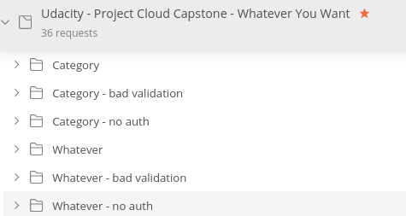

The tests rely on initial configuration including the AWS API Id needed to connect to the API endpoints and an uptodate authorisation token (as it has a limited time-to-live).
Other variables are declared that are dynamic and calculated – or extracted – as the tests progress in order.
Many of the tests rely on being executed in the correct order – for example, the category item created at the beginning is used in a number of tests including update and delete.
Quite often, random appropriate data is used in a request body to provide variety and further test the API.
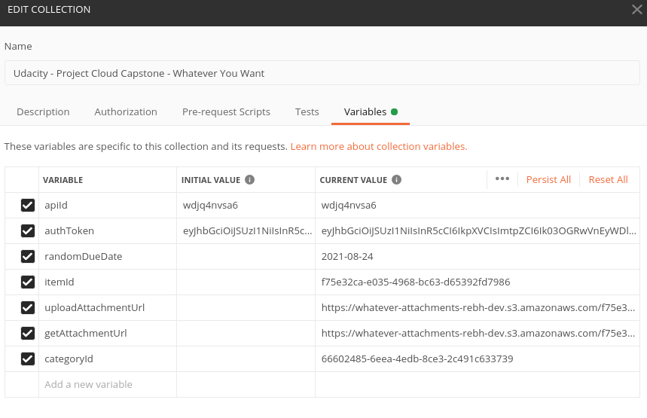

Use the Postman Collection Runner to run all tests – obviously, the target serverless backend must be running first and the aforementioned variables configured.

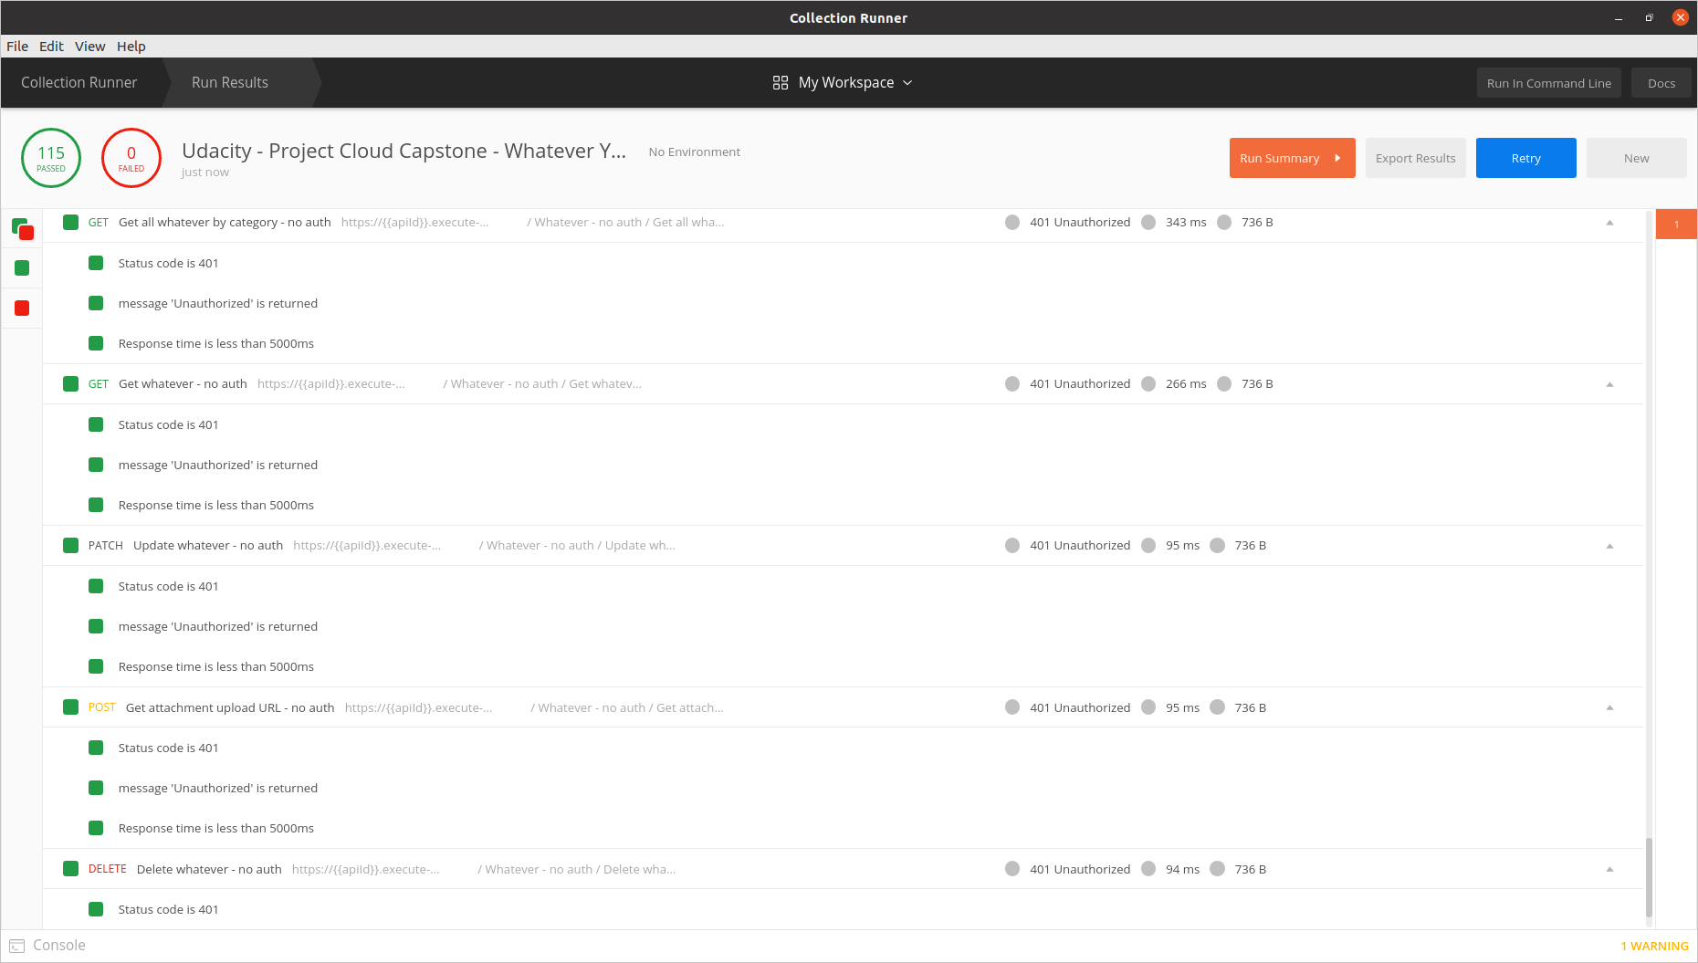

Frontend – User-based Testing
Currently there is no automated frontend testing, so the following pages detail a comprehensive set of User Interface testing – it also acts as a User Guide.

The pre-requisite is that the Node / React server utils are providing the UI webserver.

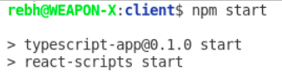

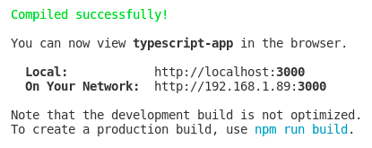

Connect to webserver - http://localhost:3000/
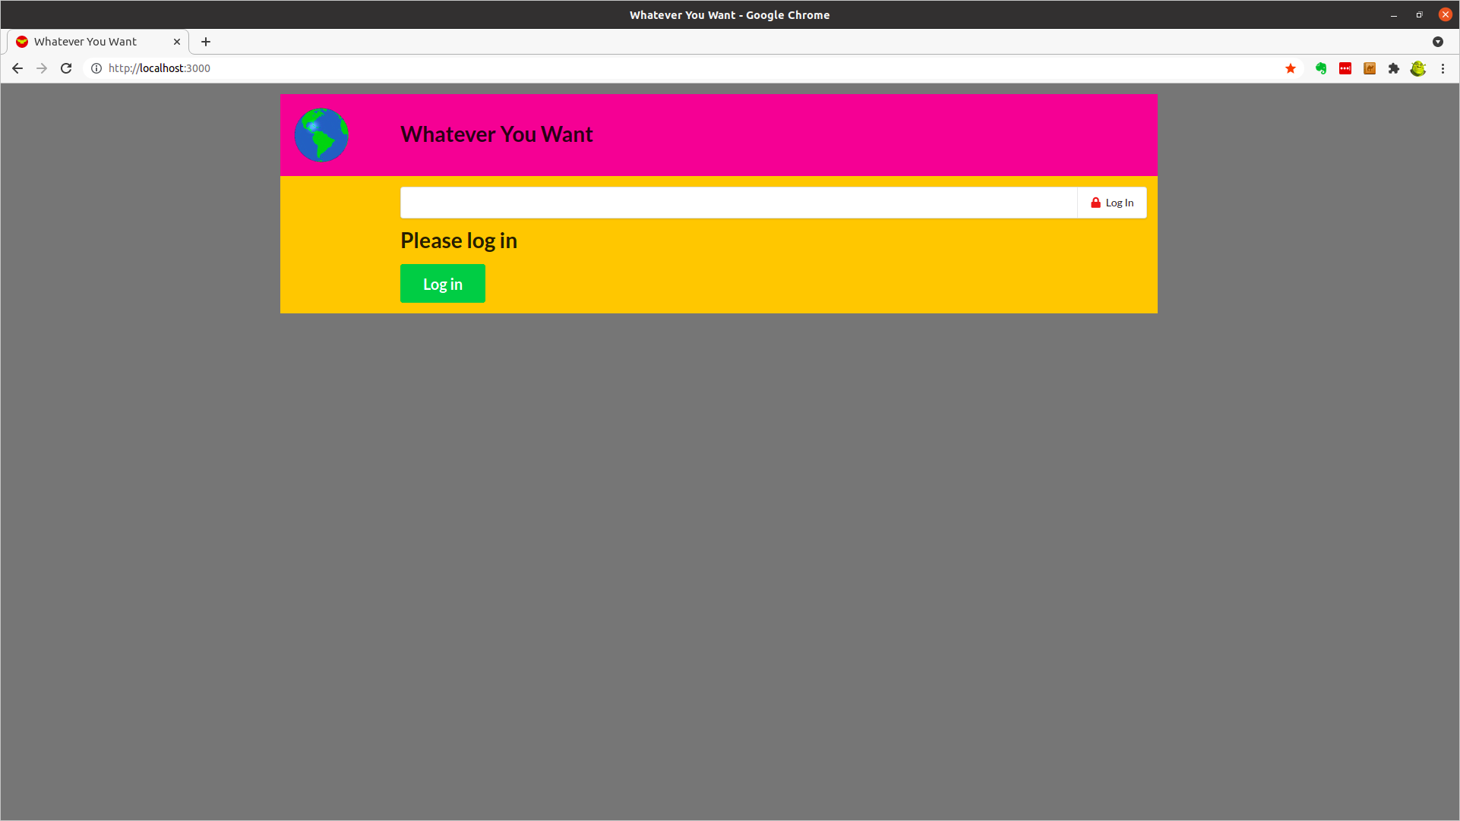

Auth0 Login
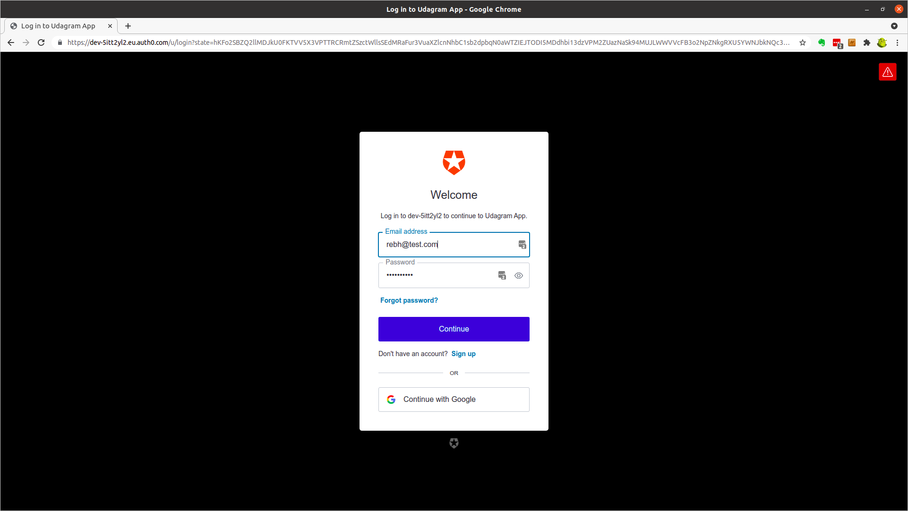

Categories Page
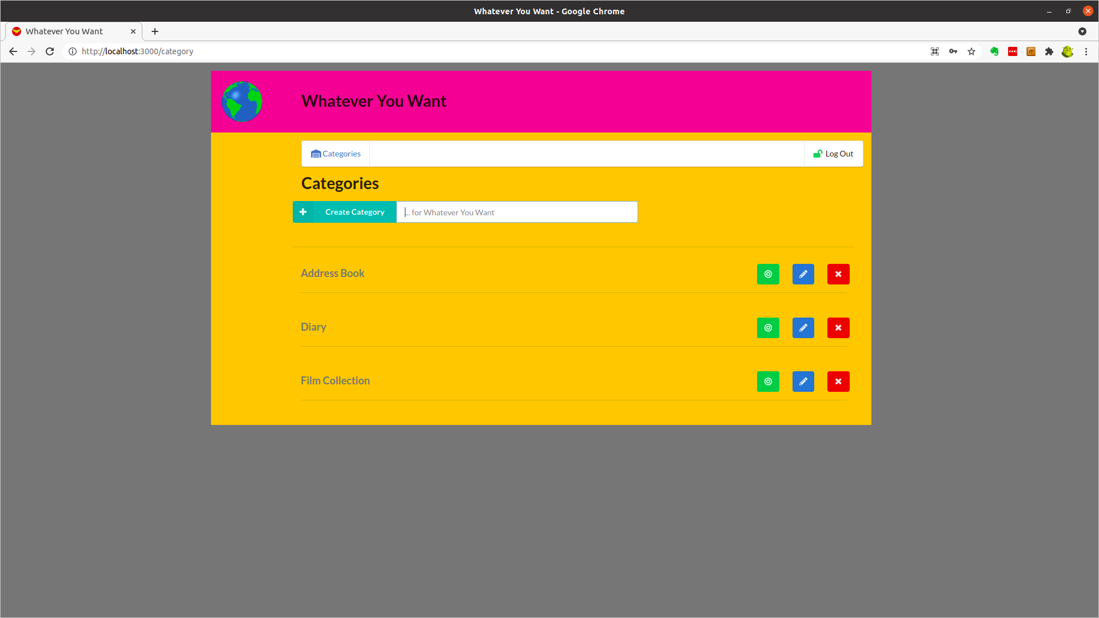

Create New Category – Recipe Cards
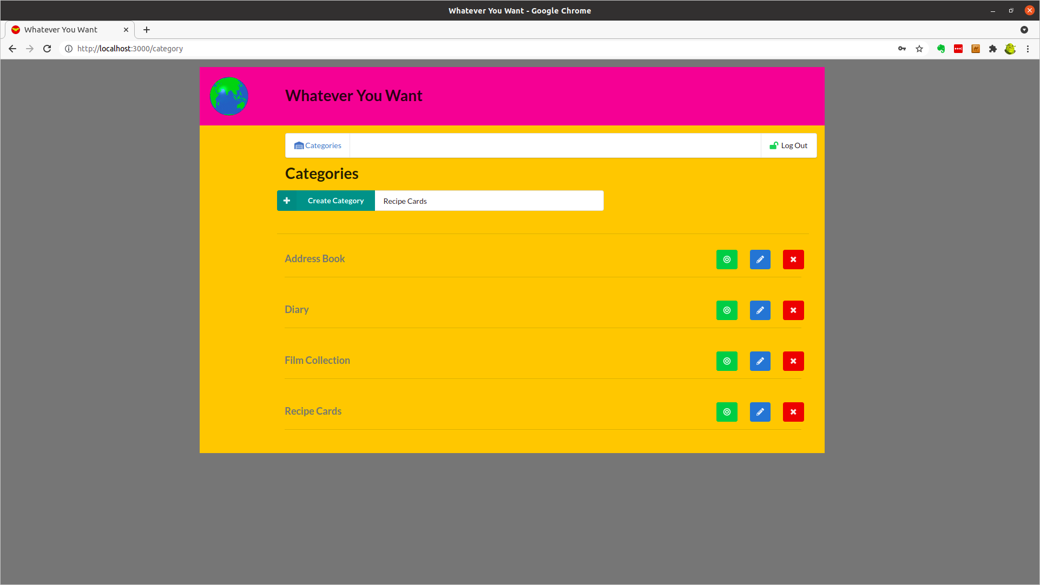

Edit New Category – Recipe Cards
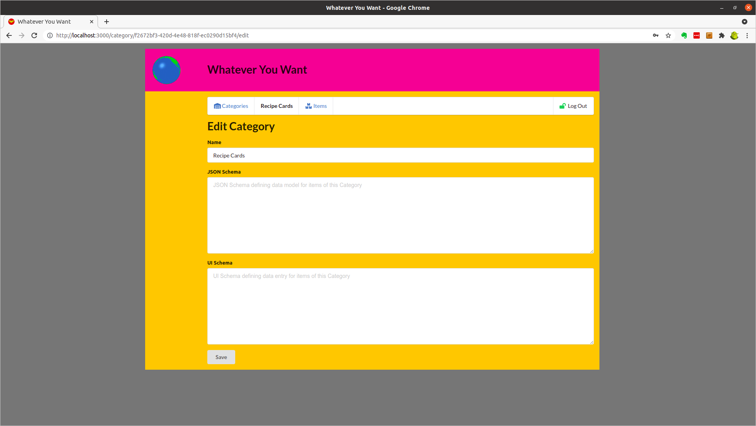

Populate New Category – Recipe Cards
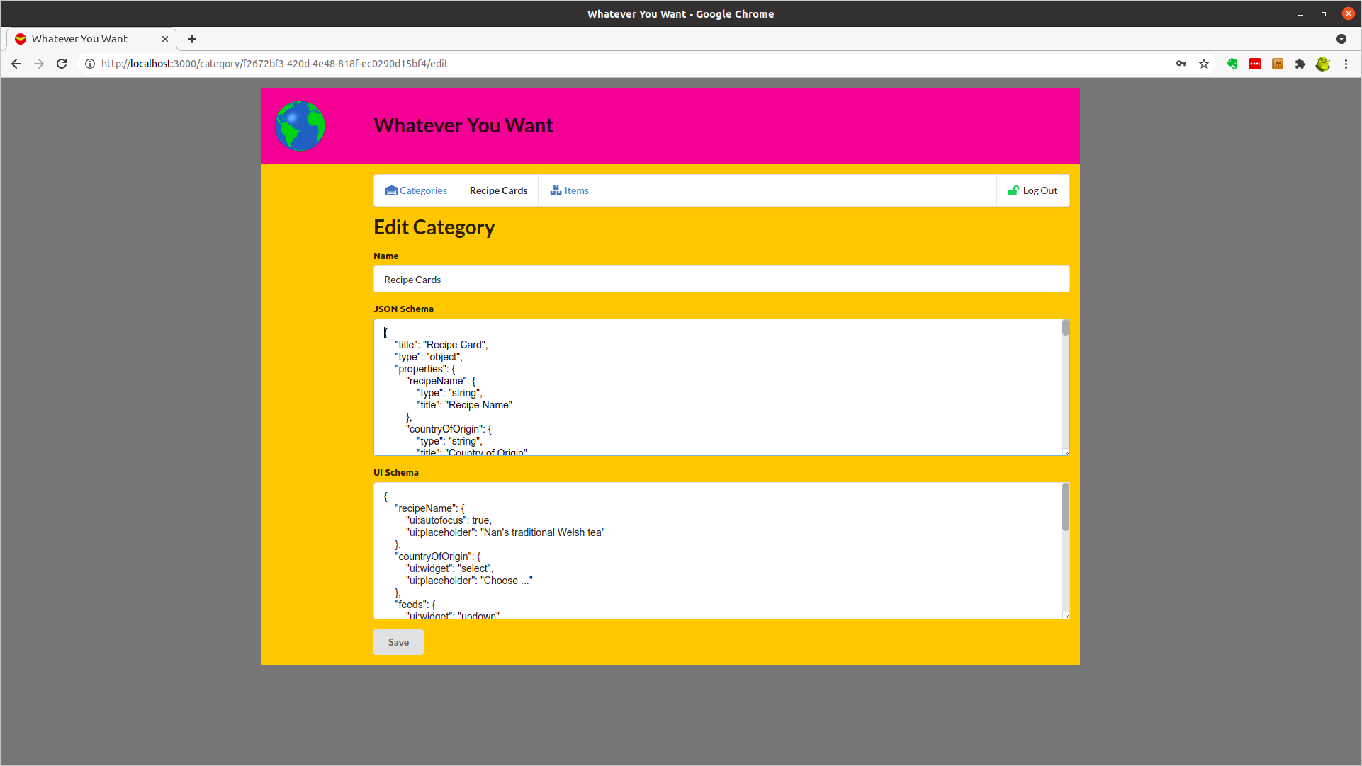

Save New Category – Recipe Cards
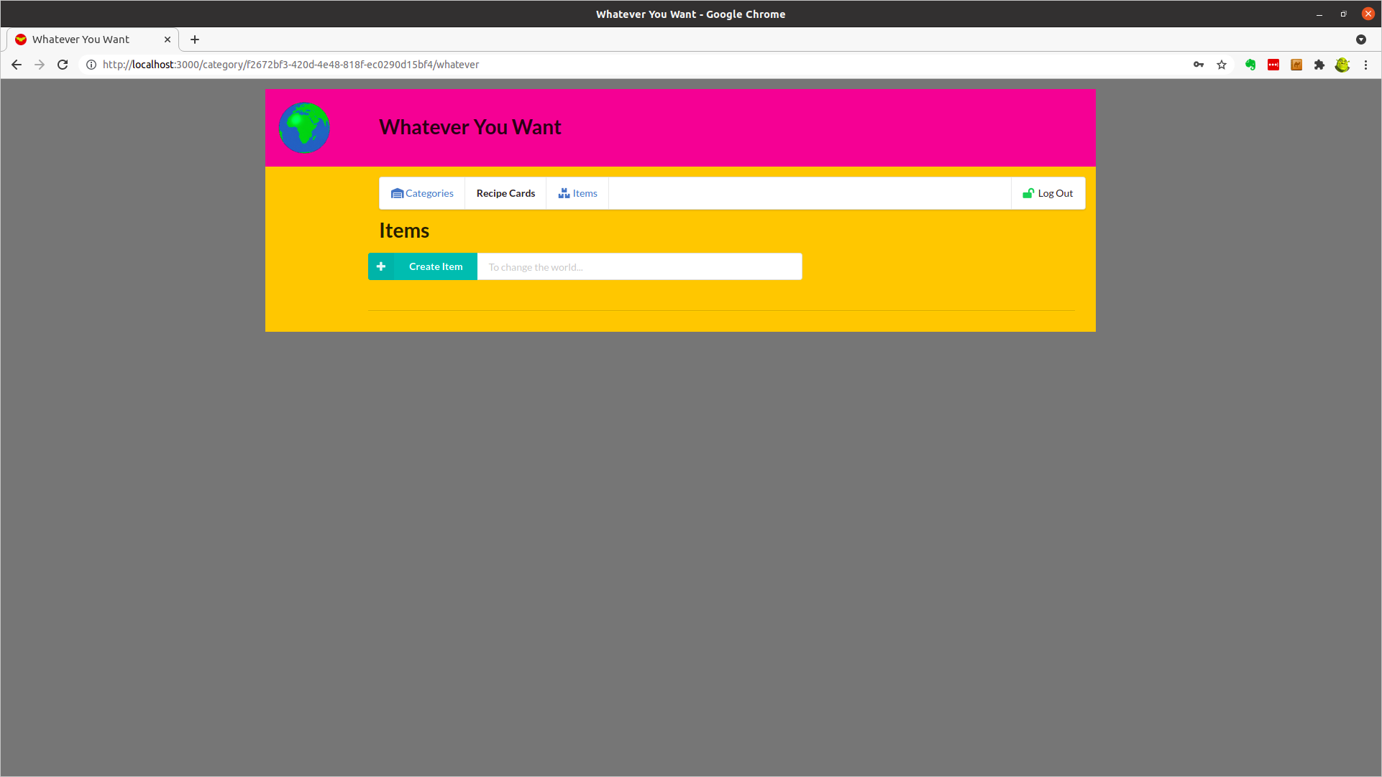

Create New Item – Recipe Cards - Shortbread
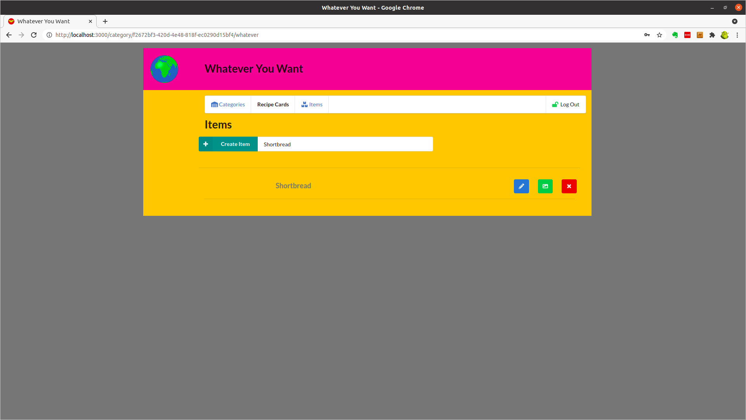

Add Image to New Item – Recipe Cards - Shortbread
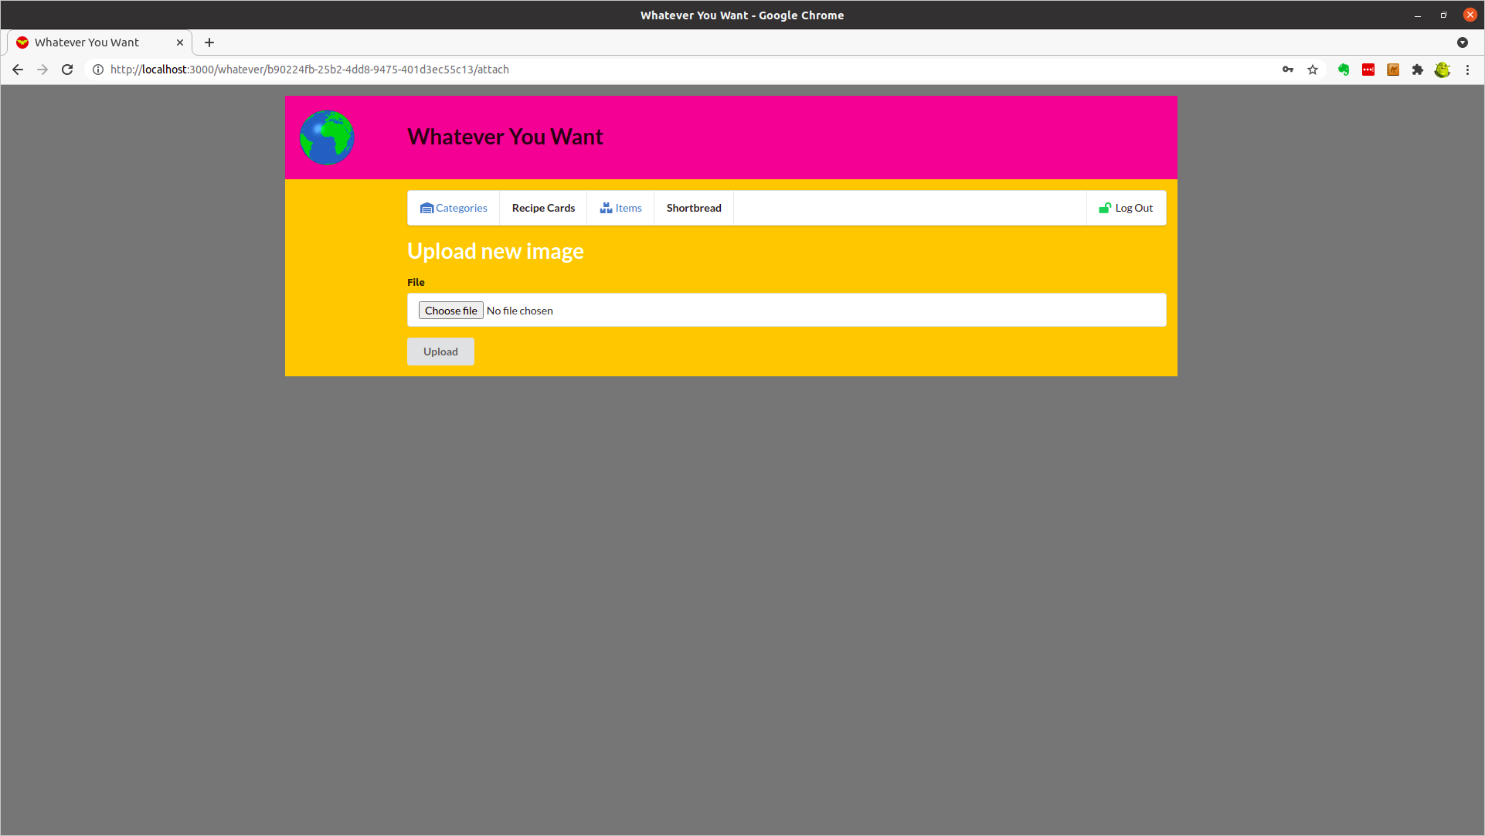

Choose and Upload Image forn New Item – Recipe Cards - Shortbread
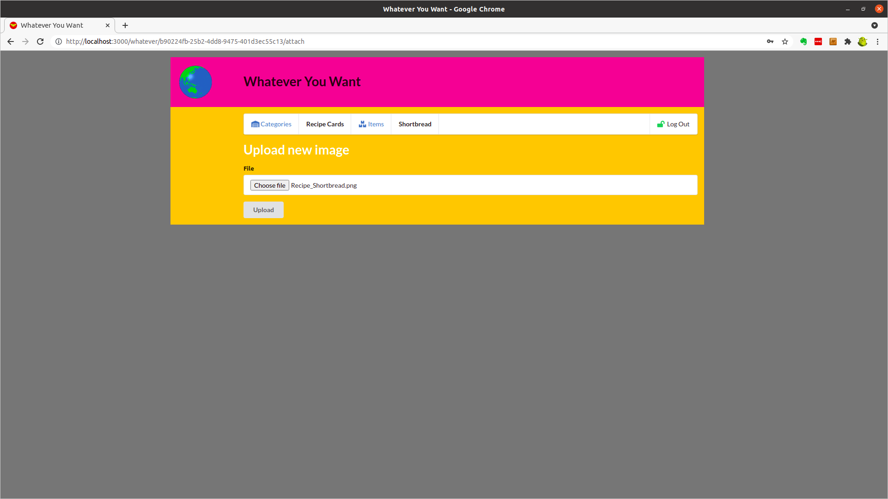

Create New Item – Recipe Cards - Shortbread
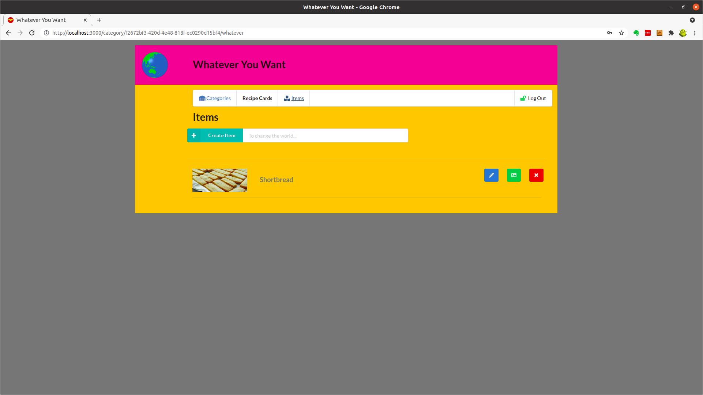

Edit New Whatever Item – Recipe Cards - Shortbread
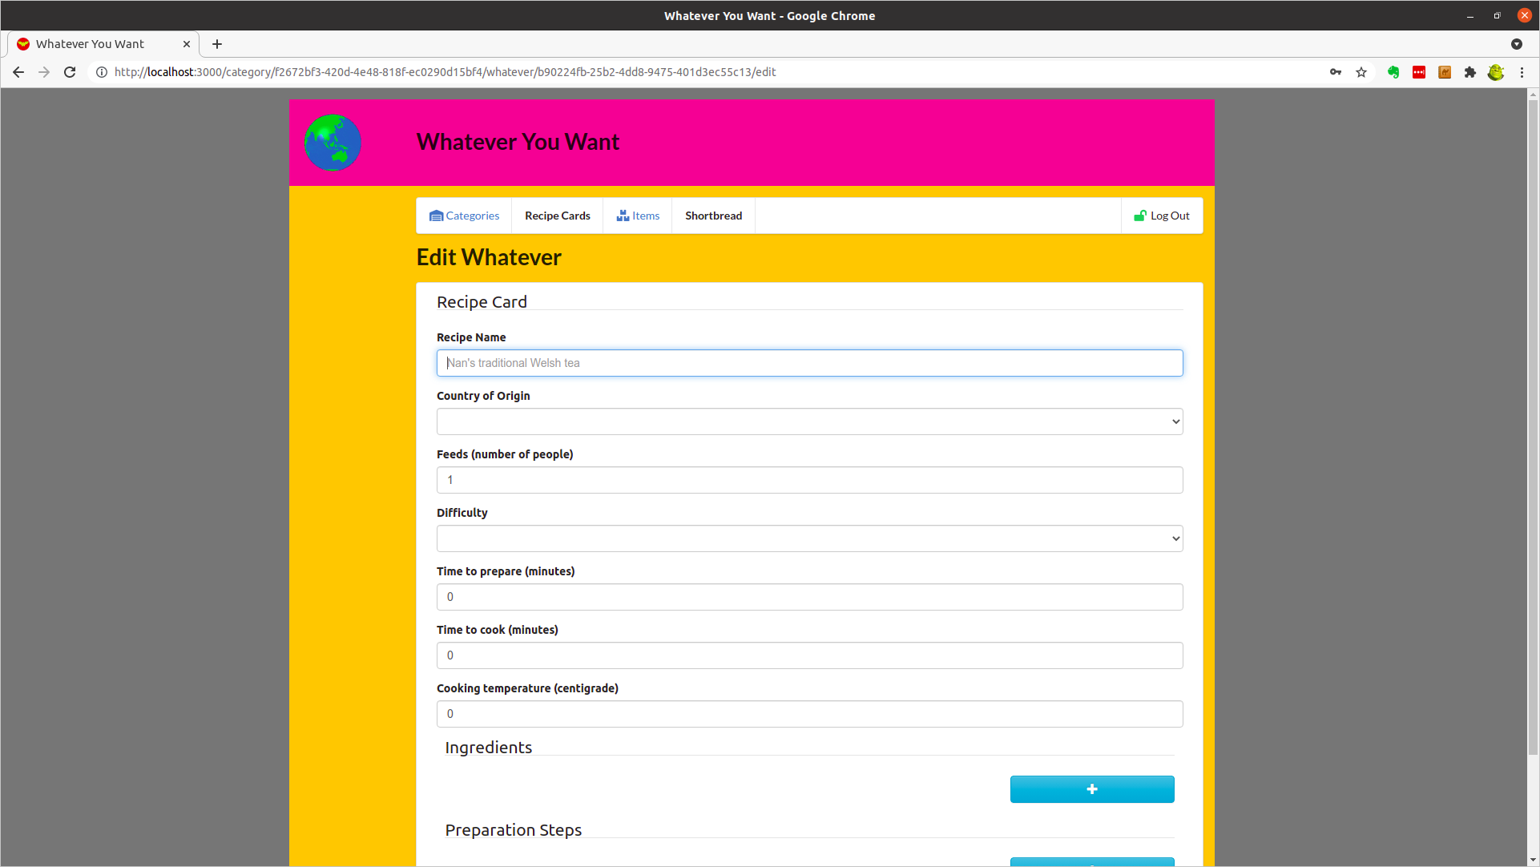

Populate New Whatever Item – Recipe Cards – Shortbread (1)
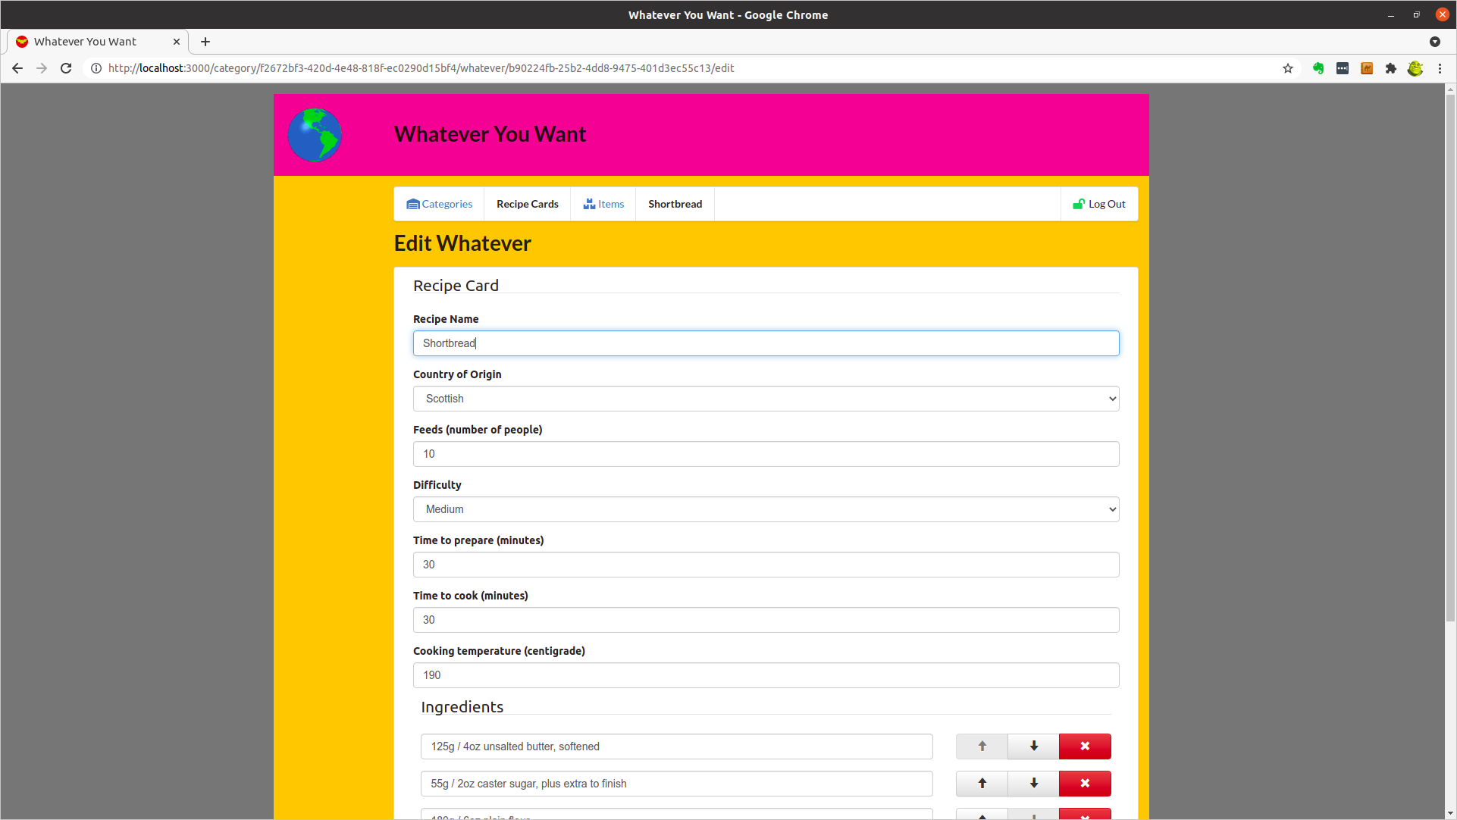

Populate New Whatever Item – Recipe Cards – Shortbread (2)
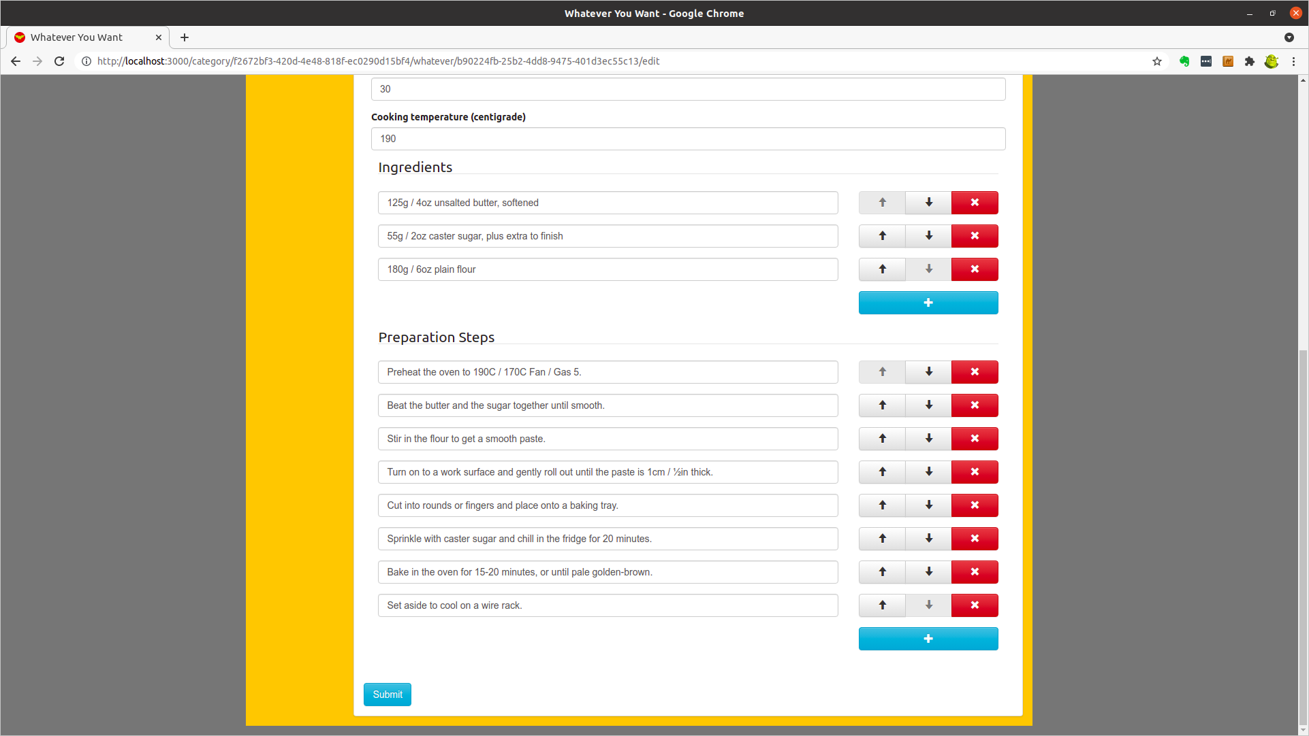

Submit New Whatever Item – Recipe Cards – Shortbread
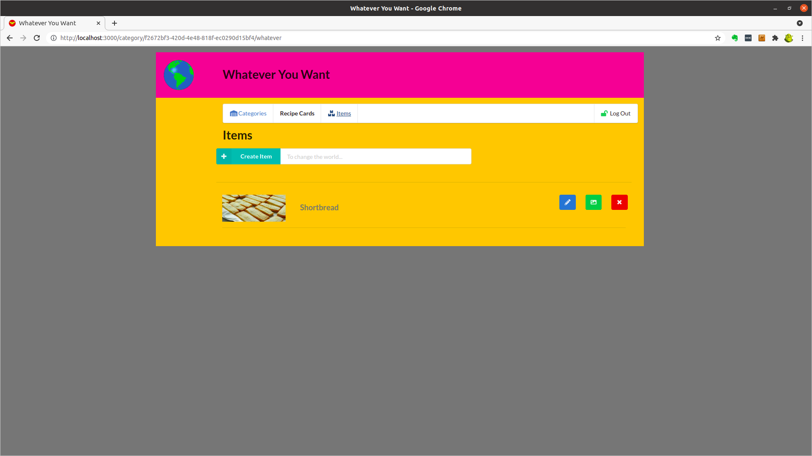

Return to Categories and Select Existing Category – Address Book
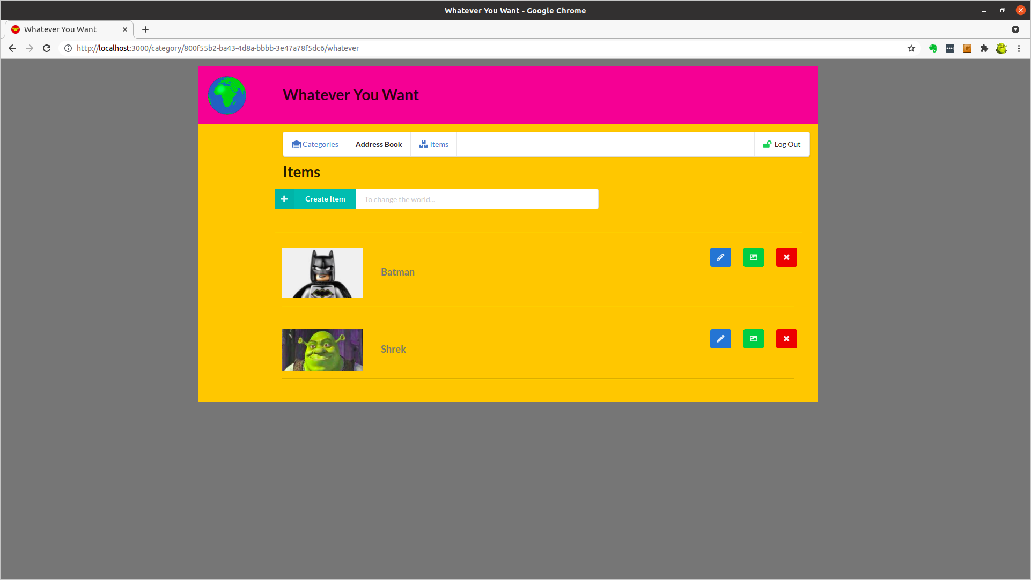

Select Existing Item - Address Book – Batman
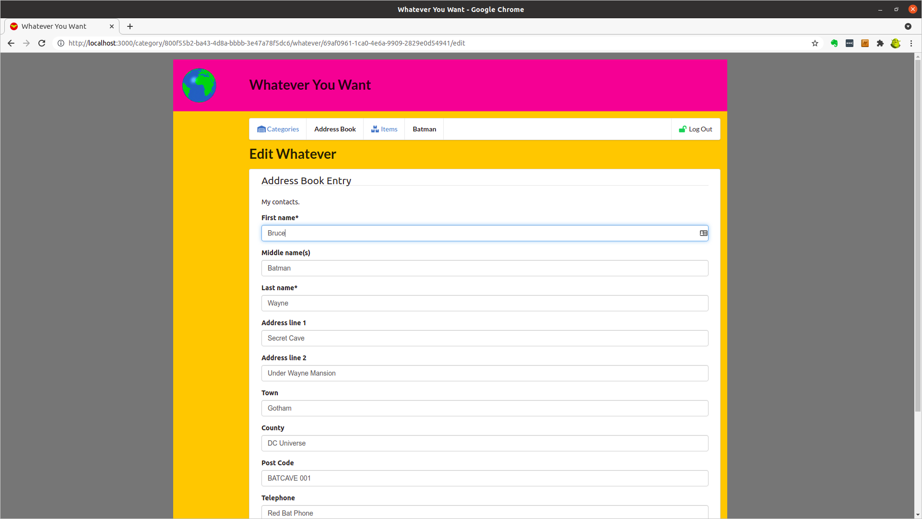

Scroll to the bottom of Existing Item - Address Book – Batman
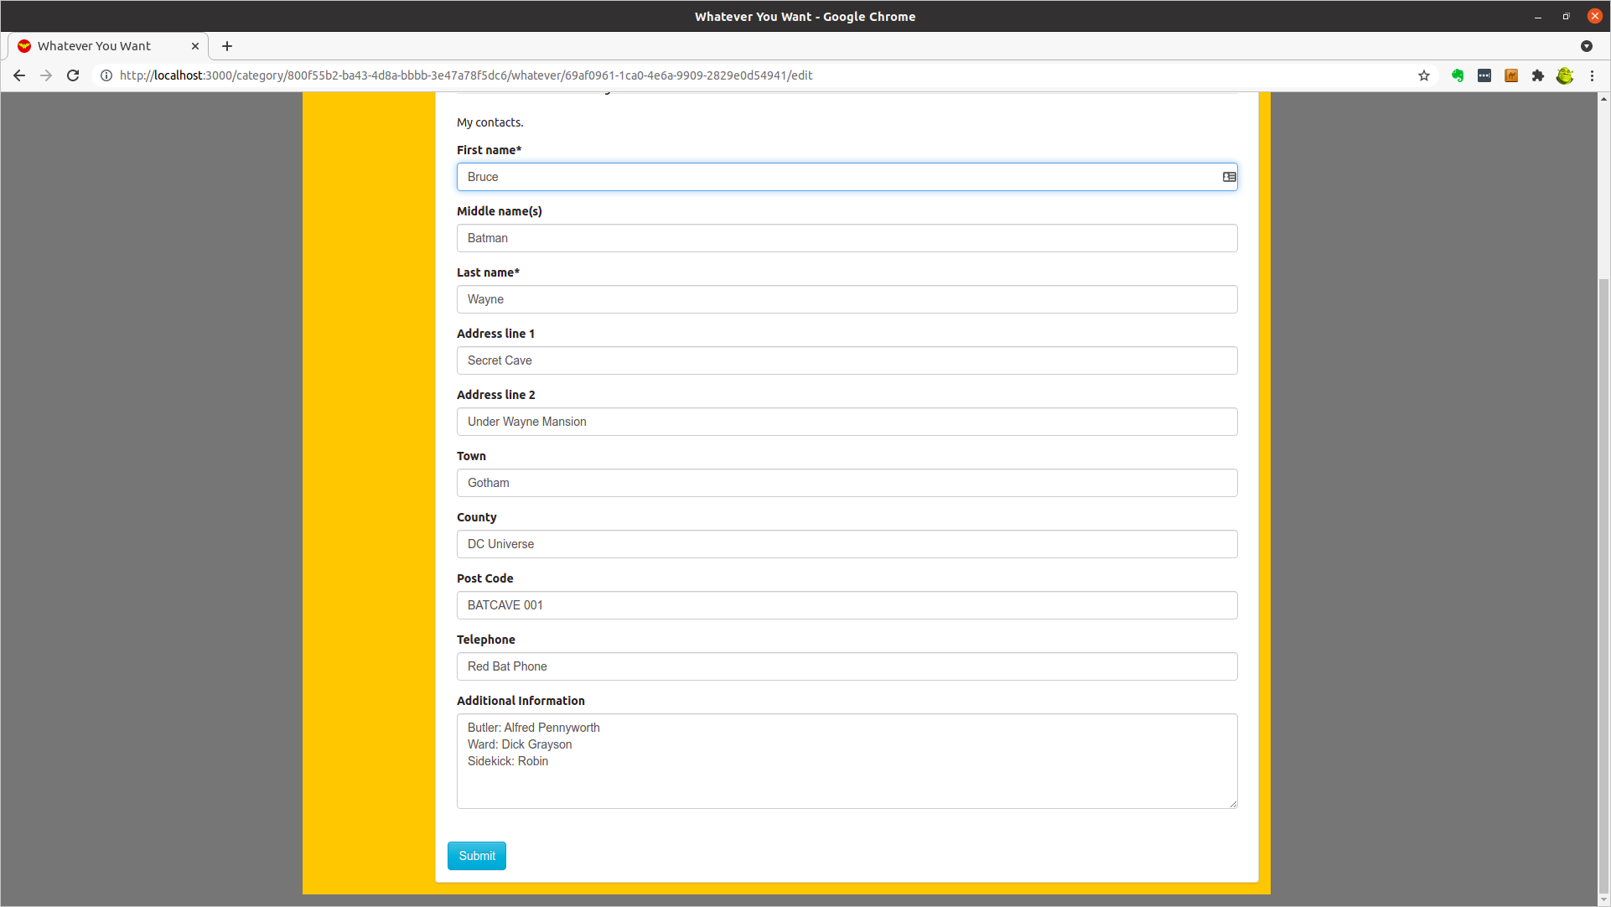

Return to Categories and Select Existing Category – Diary
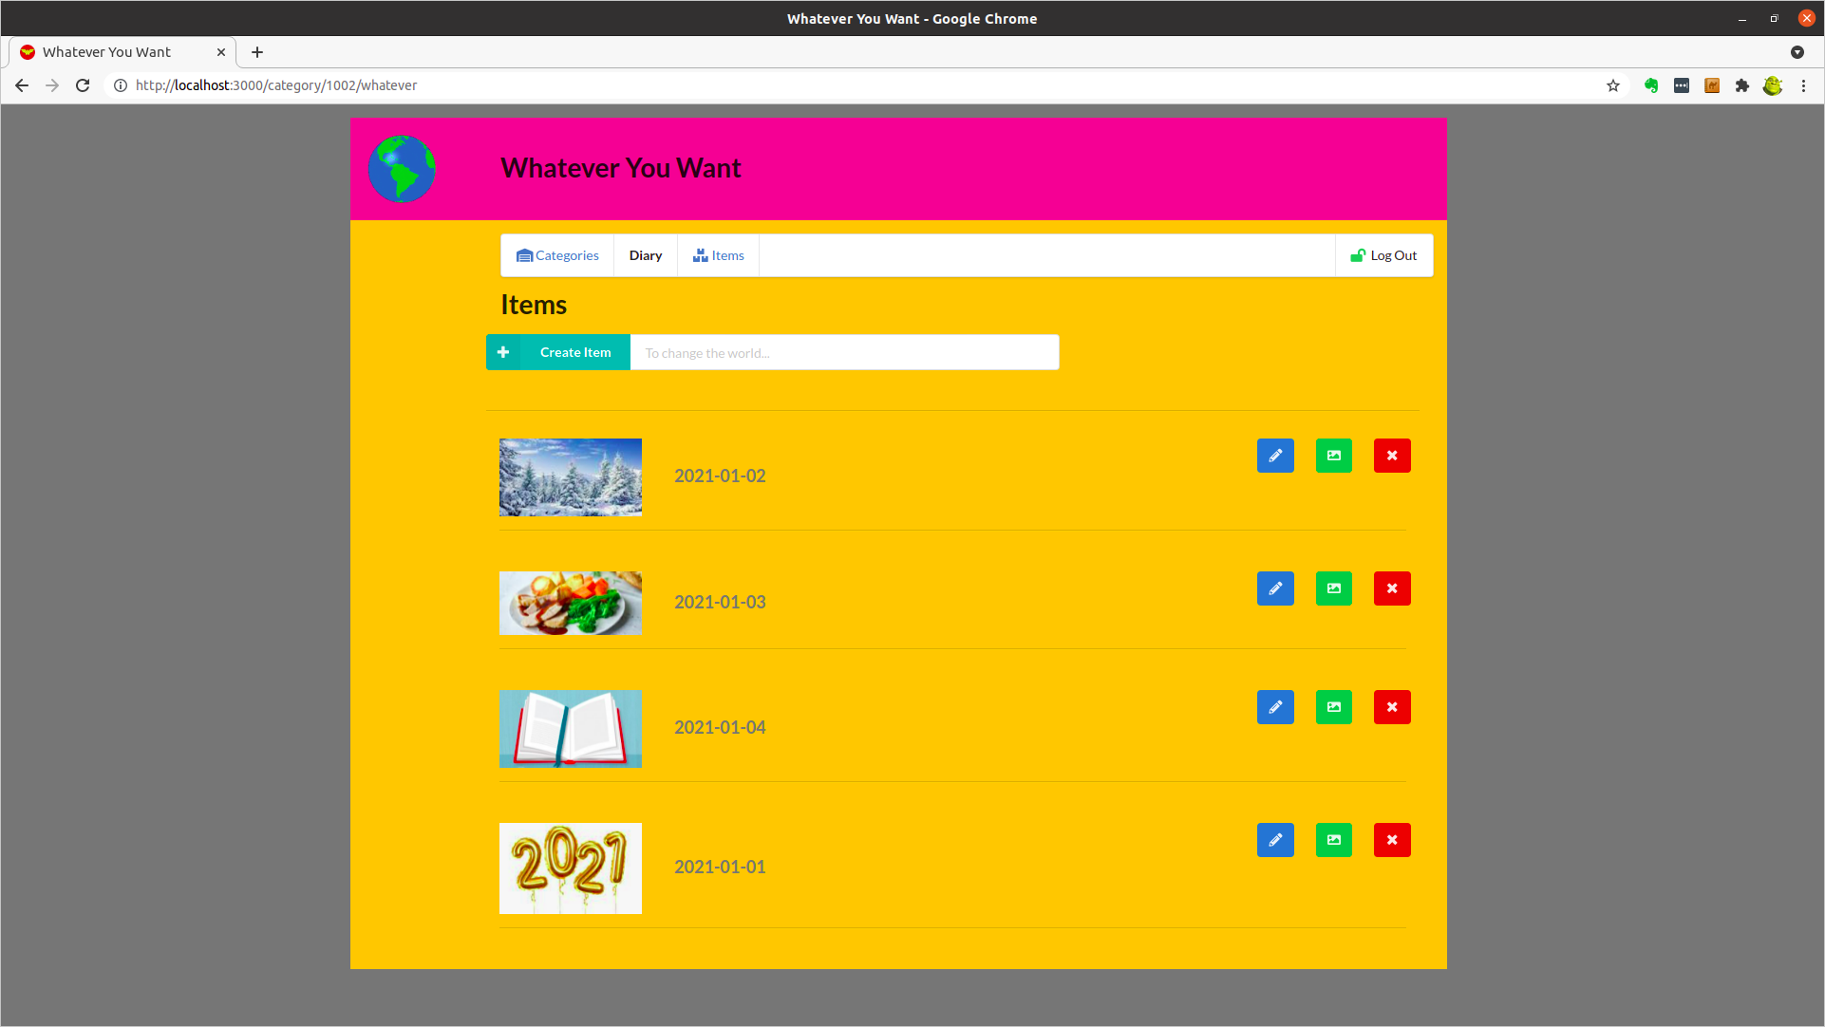

Select Existing Item – Diary - 2021-01-04
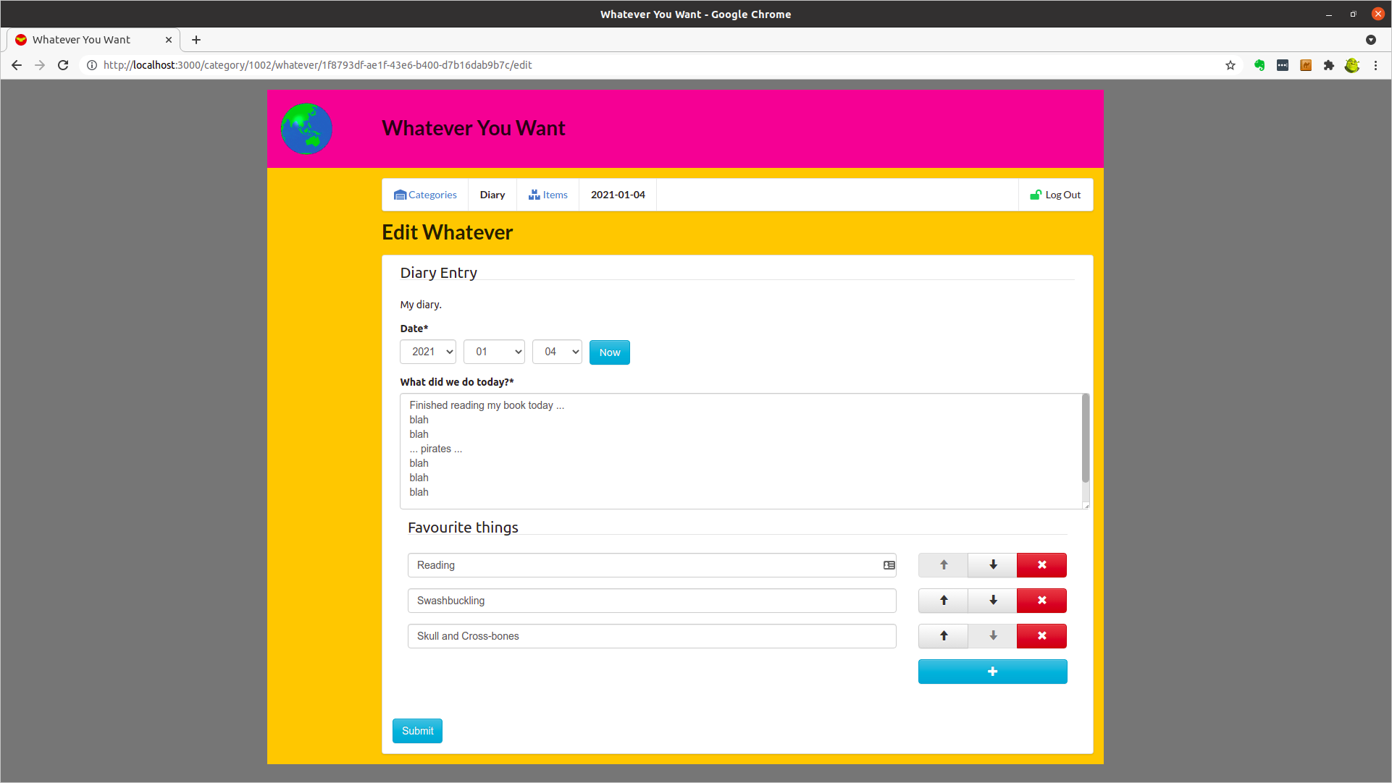

Return to Categories and Select Existing Category – Film Collection
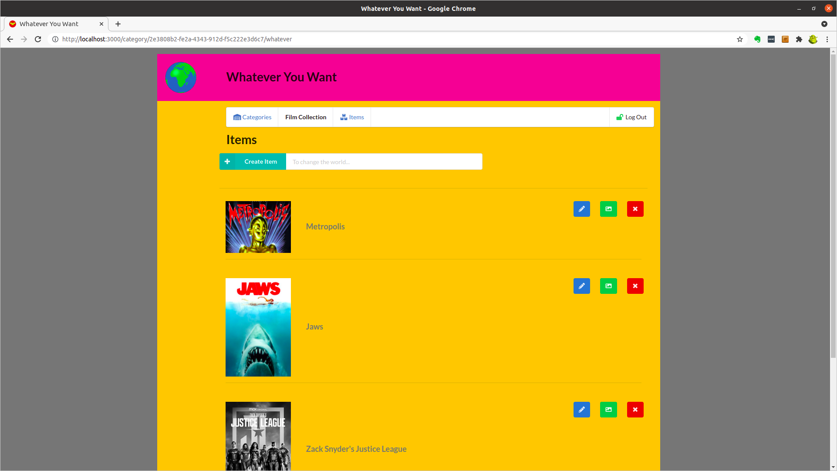

Scroll to the Bottom of the Category – Film Collection
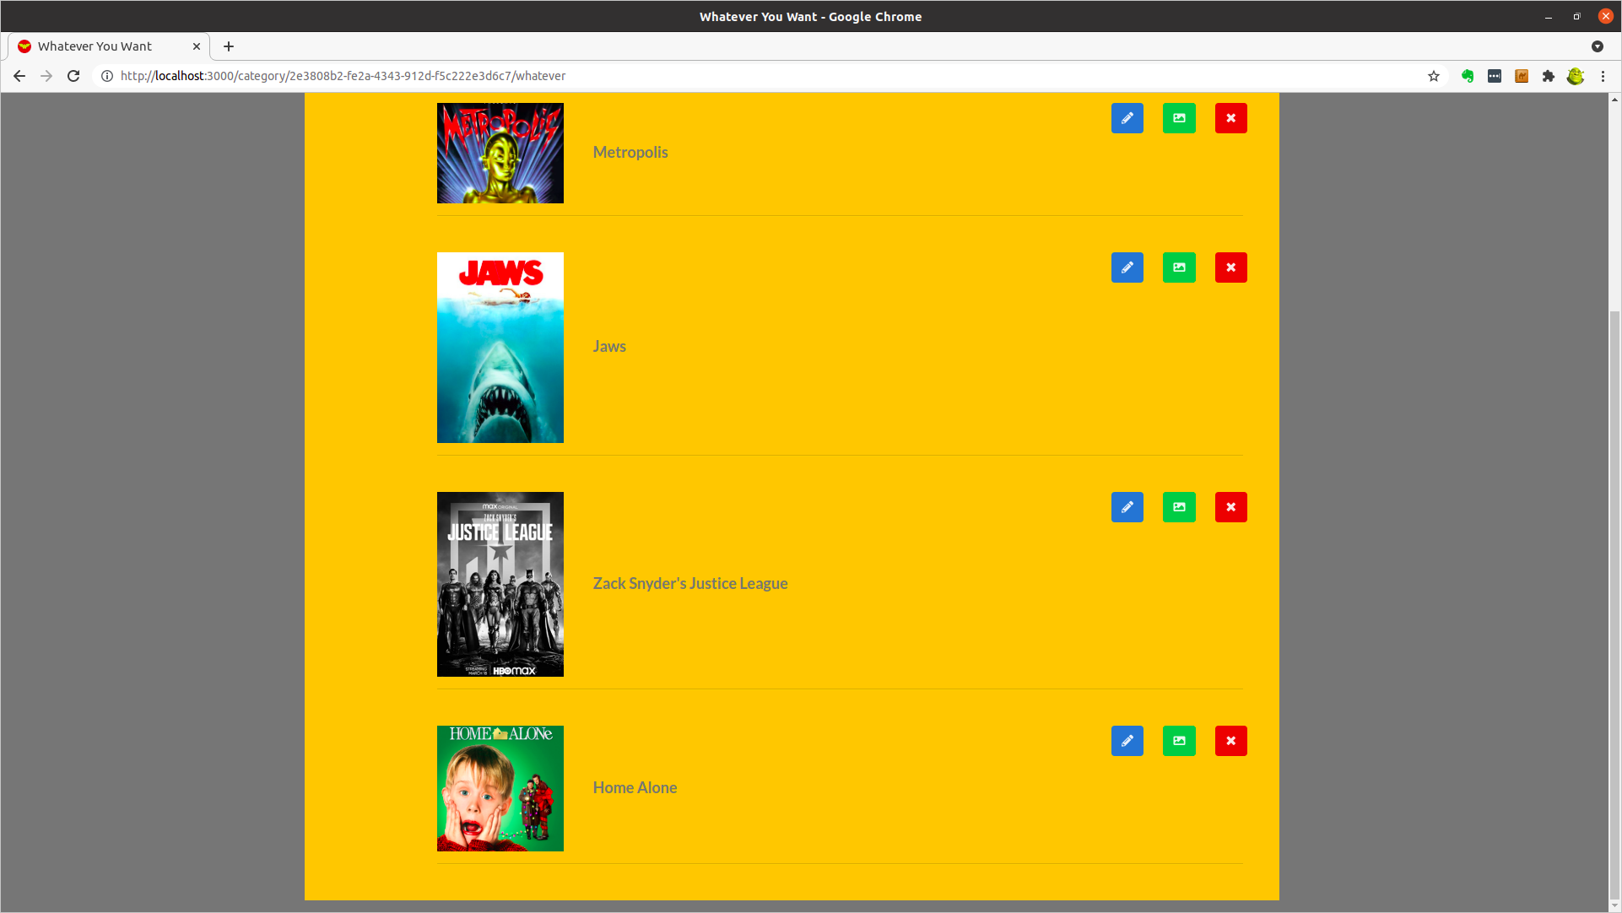

Select Existing Item – FilmCollection - Zack Snyder's Justice League
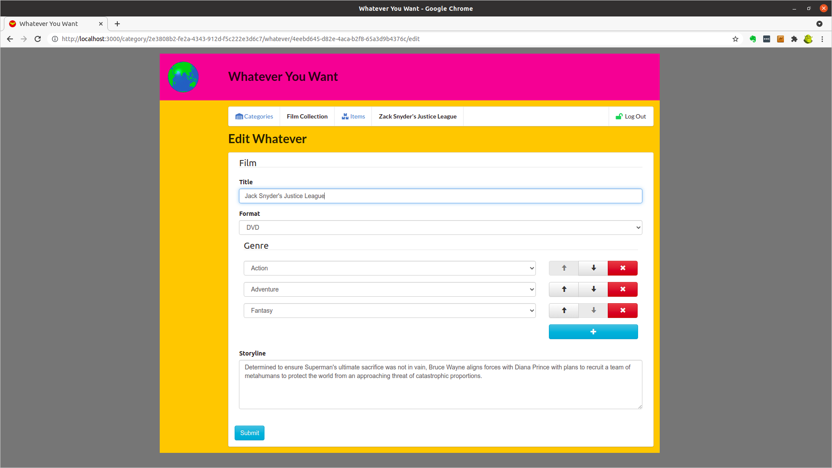

Deployed Services

Serverless.com Dashboard
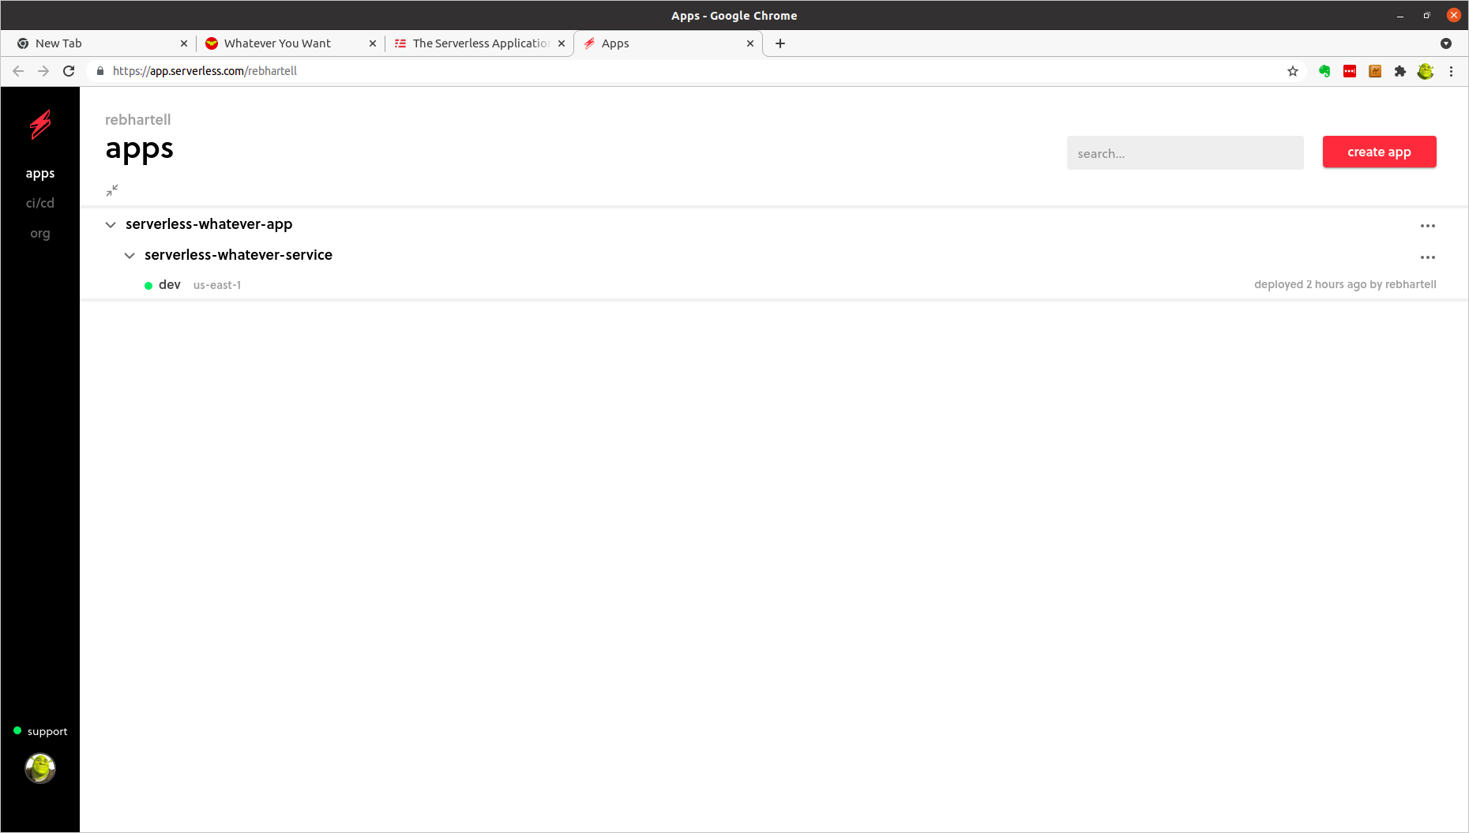

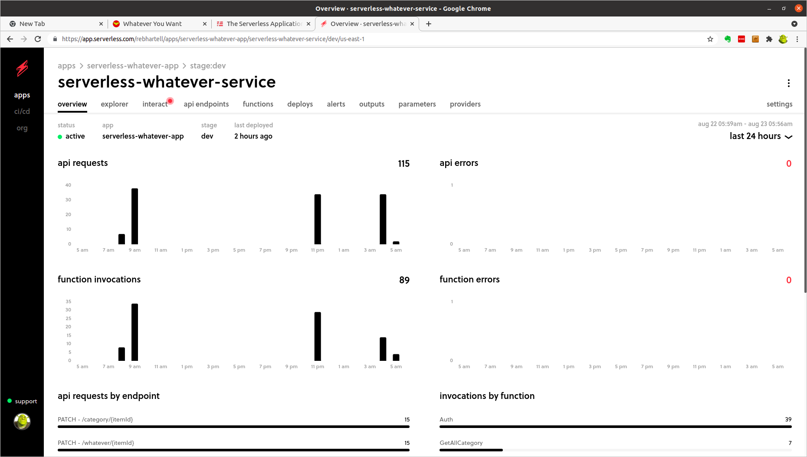

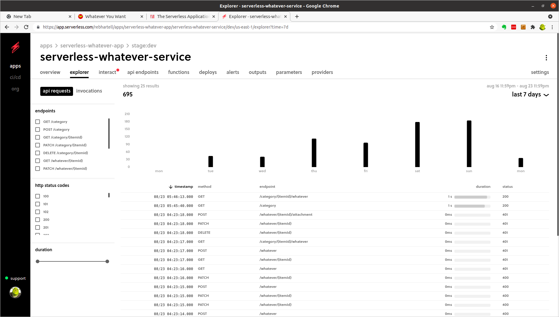

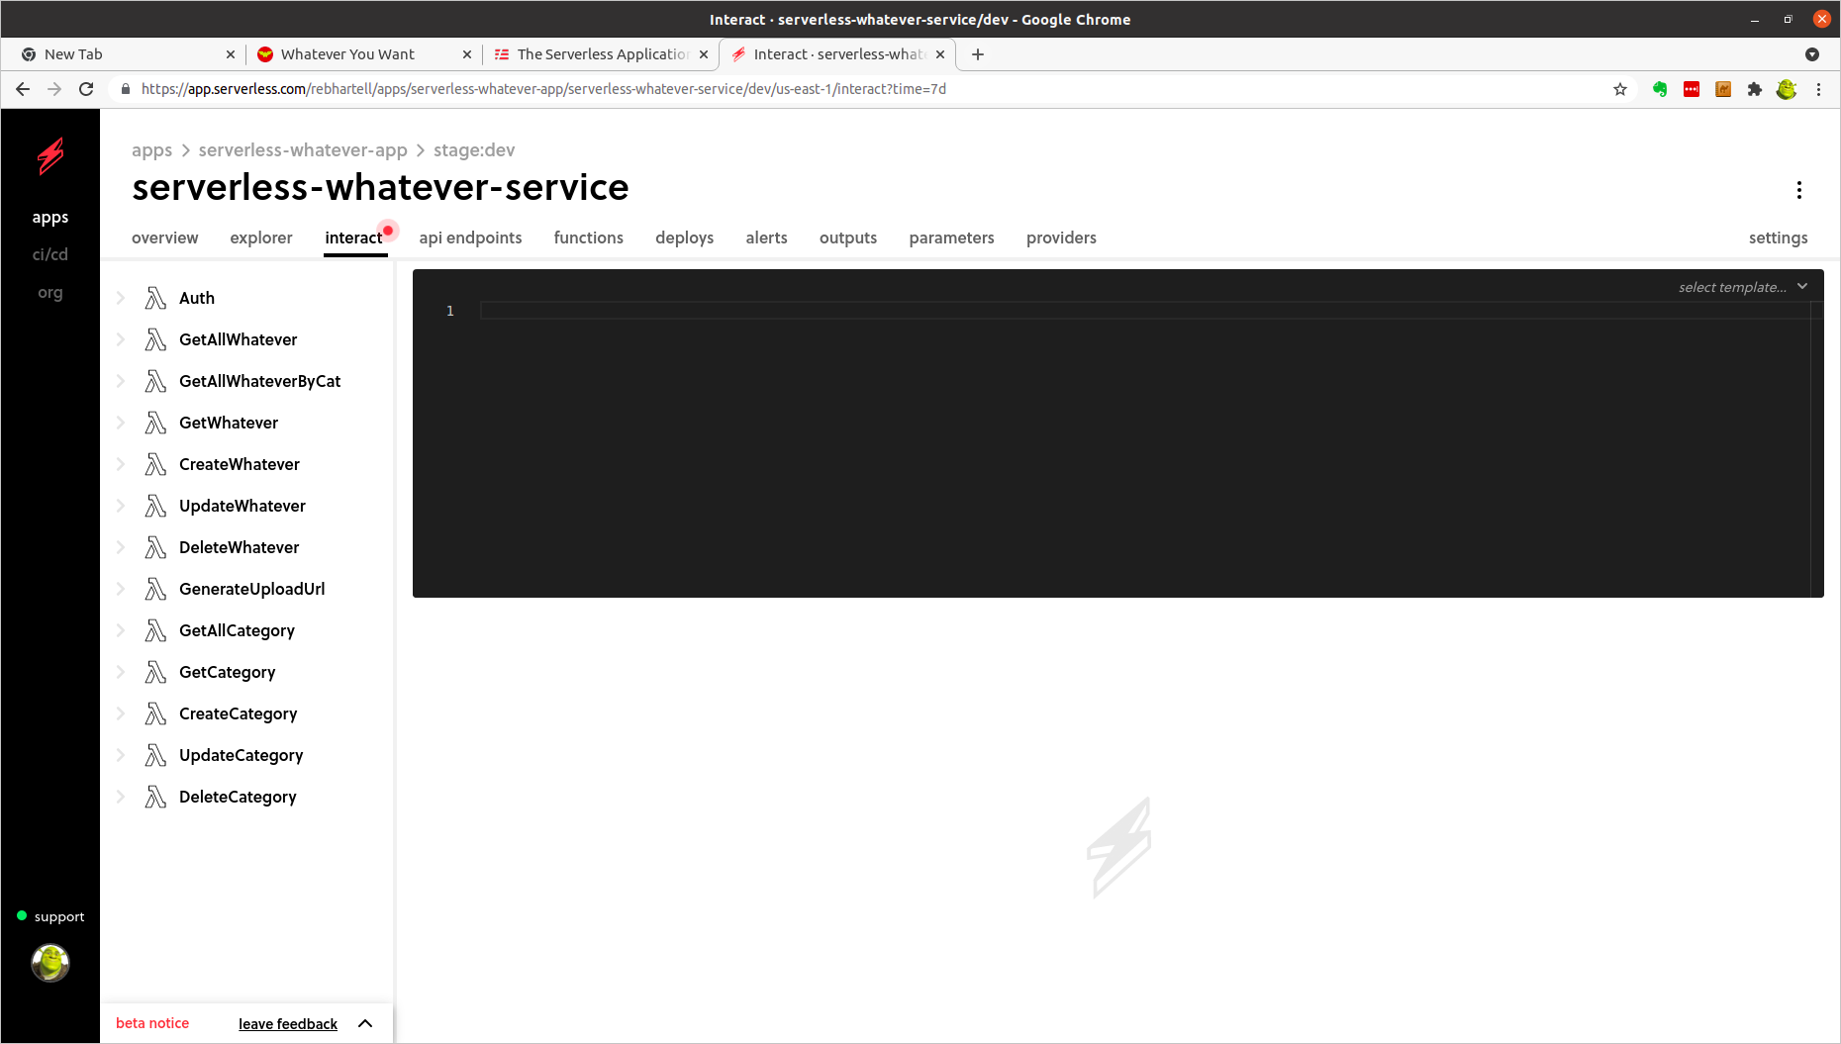

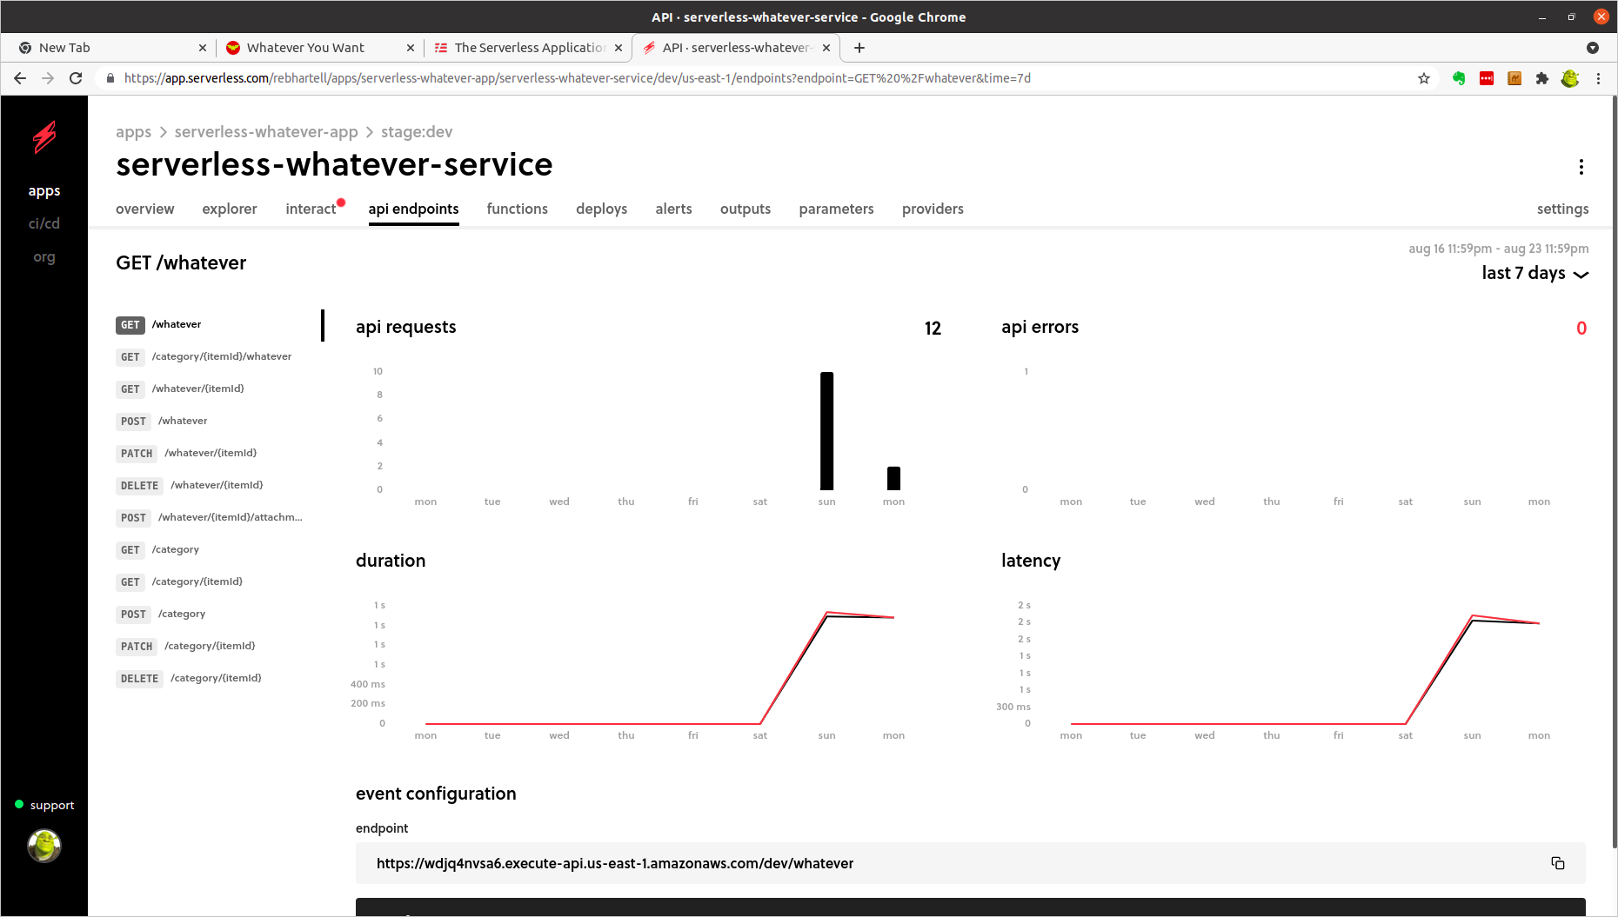

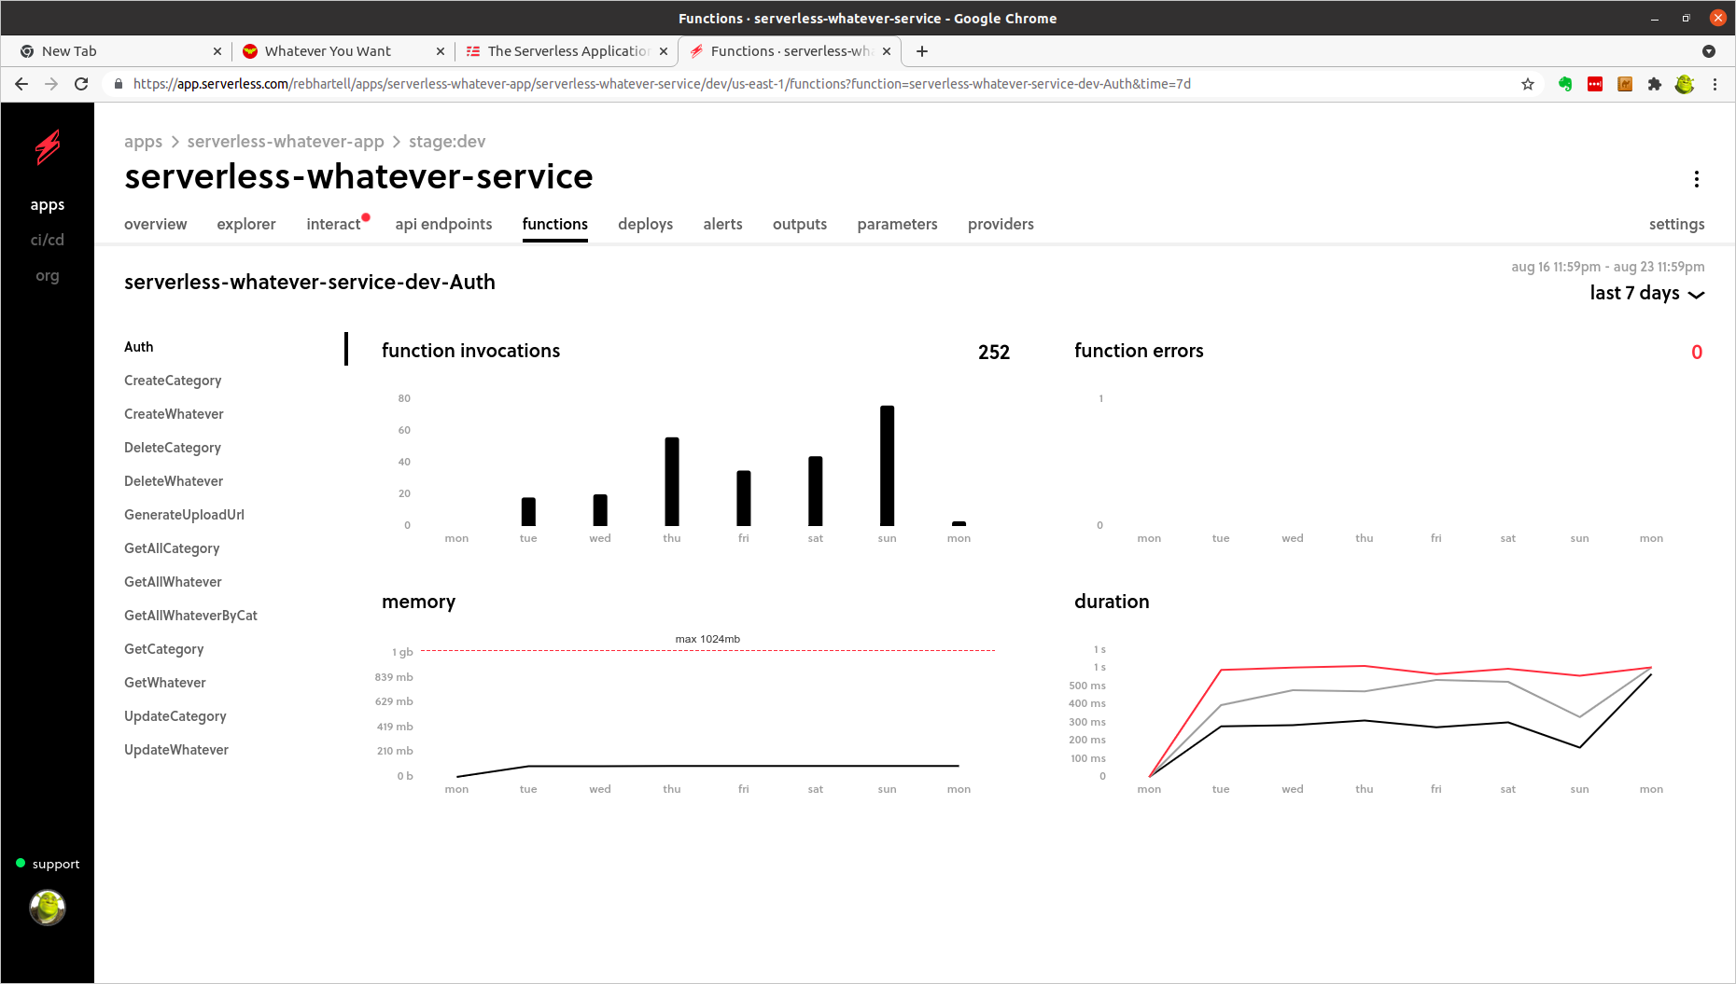

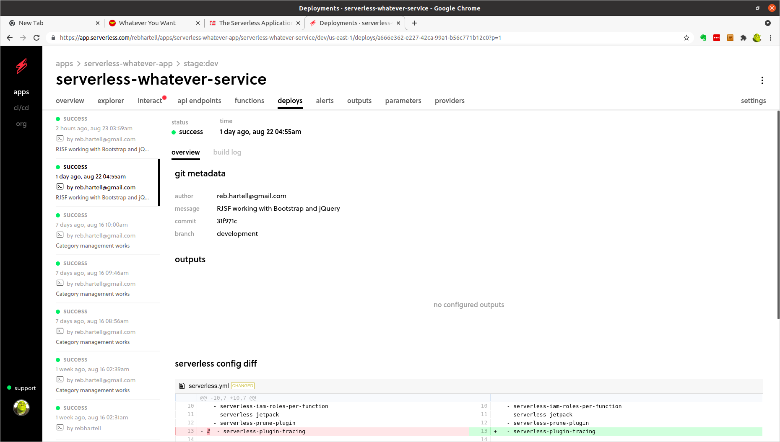

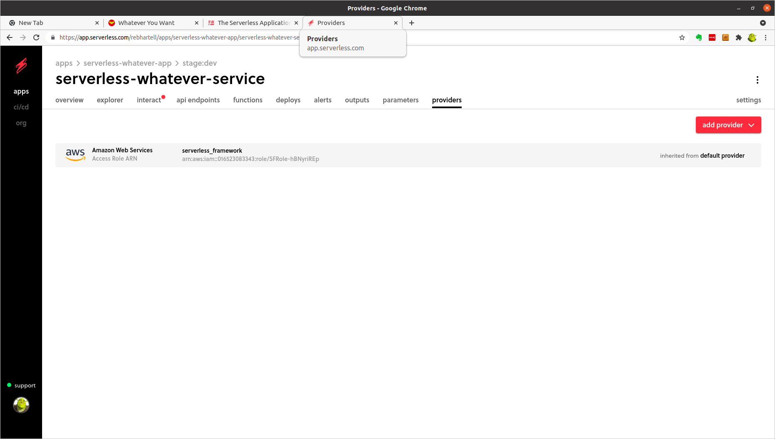

AWS CloudFormation
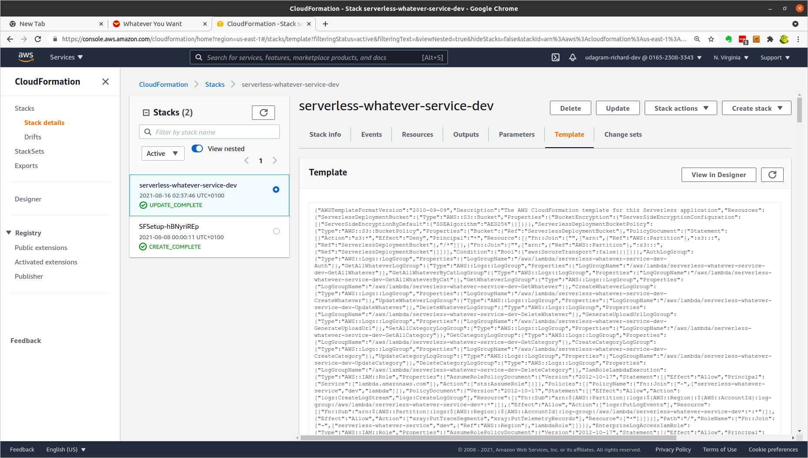

AWS IAM
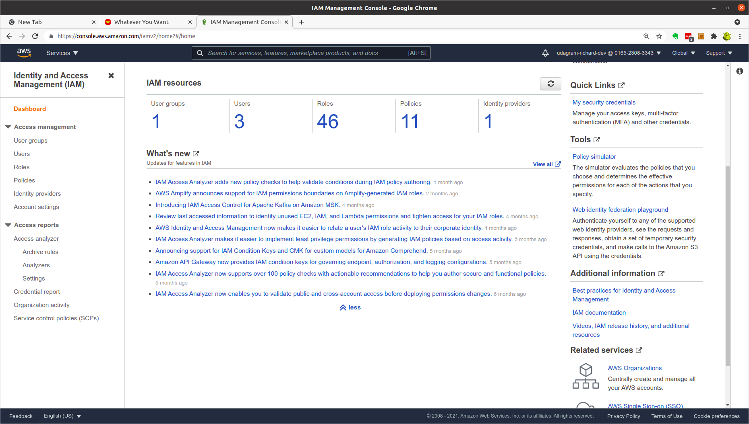

AWS API Gateway
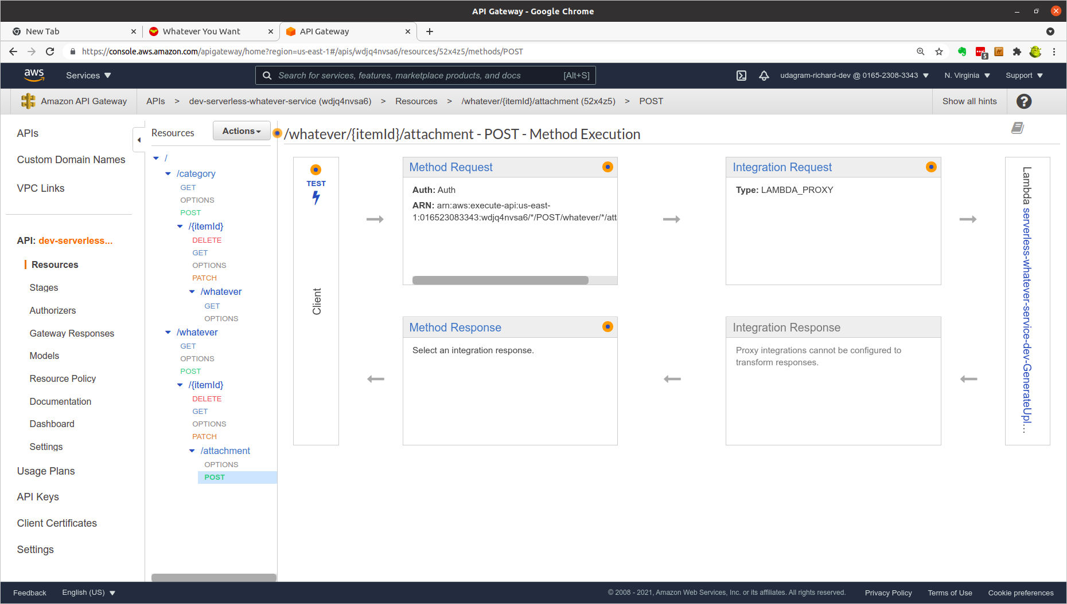

AWS Lambda (1)
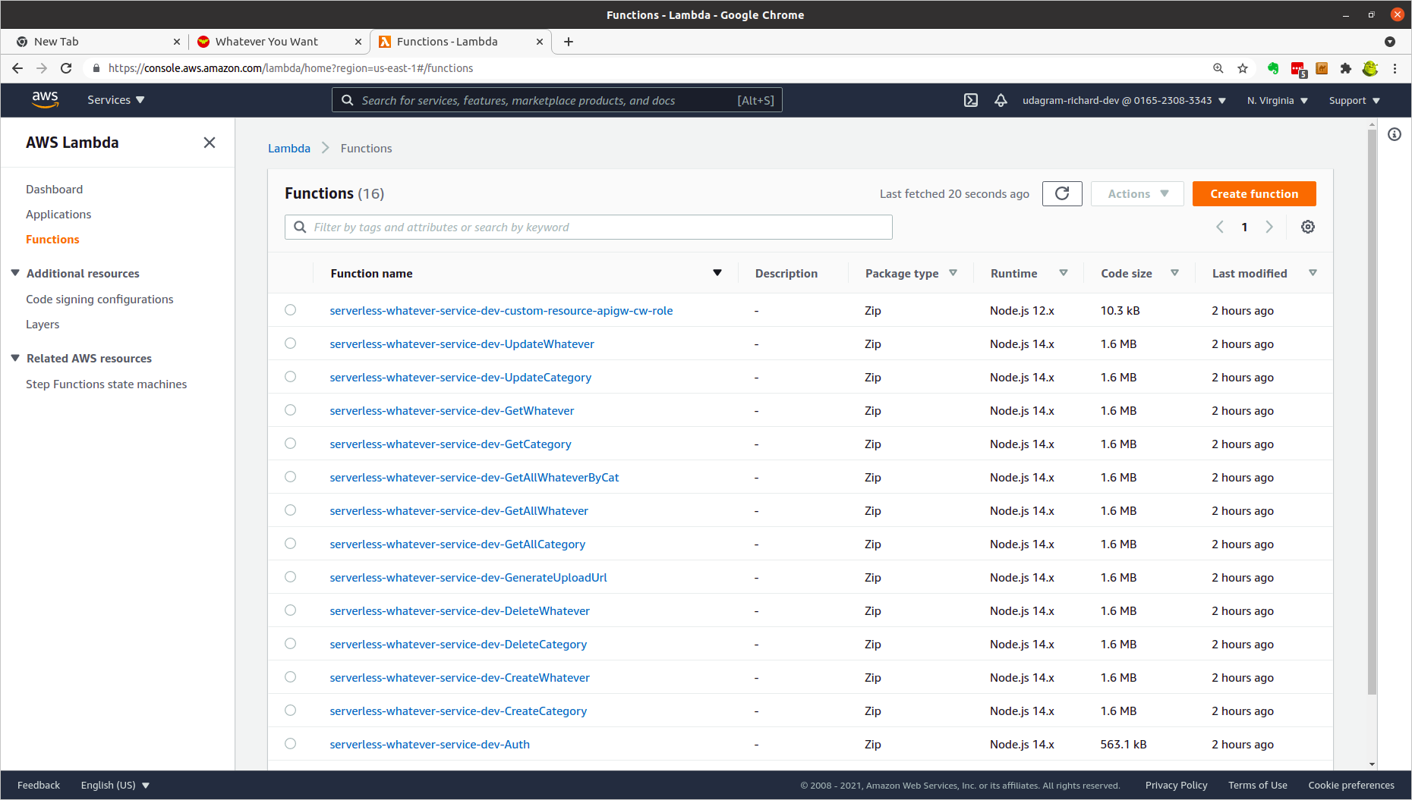

AWS Lambda (2)
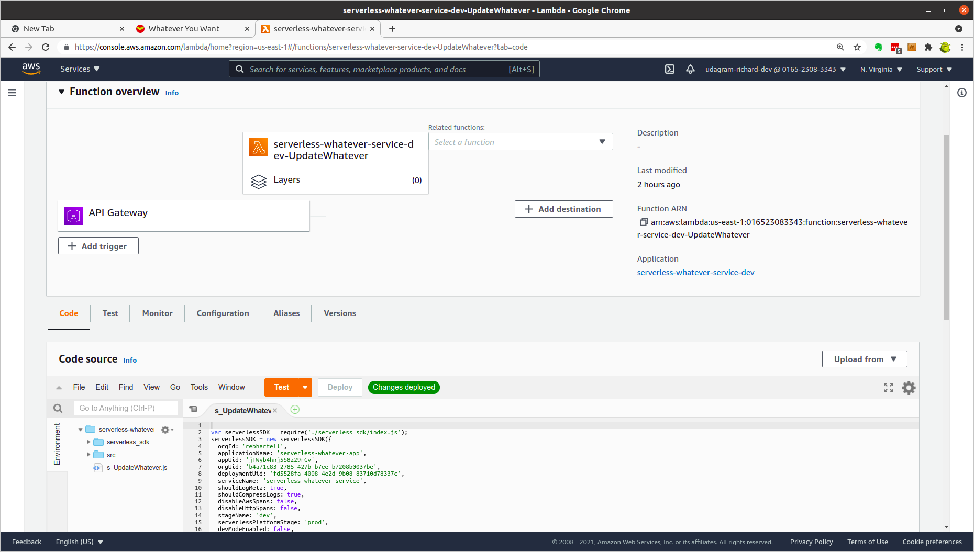

AWS S3 – serverless application
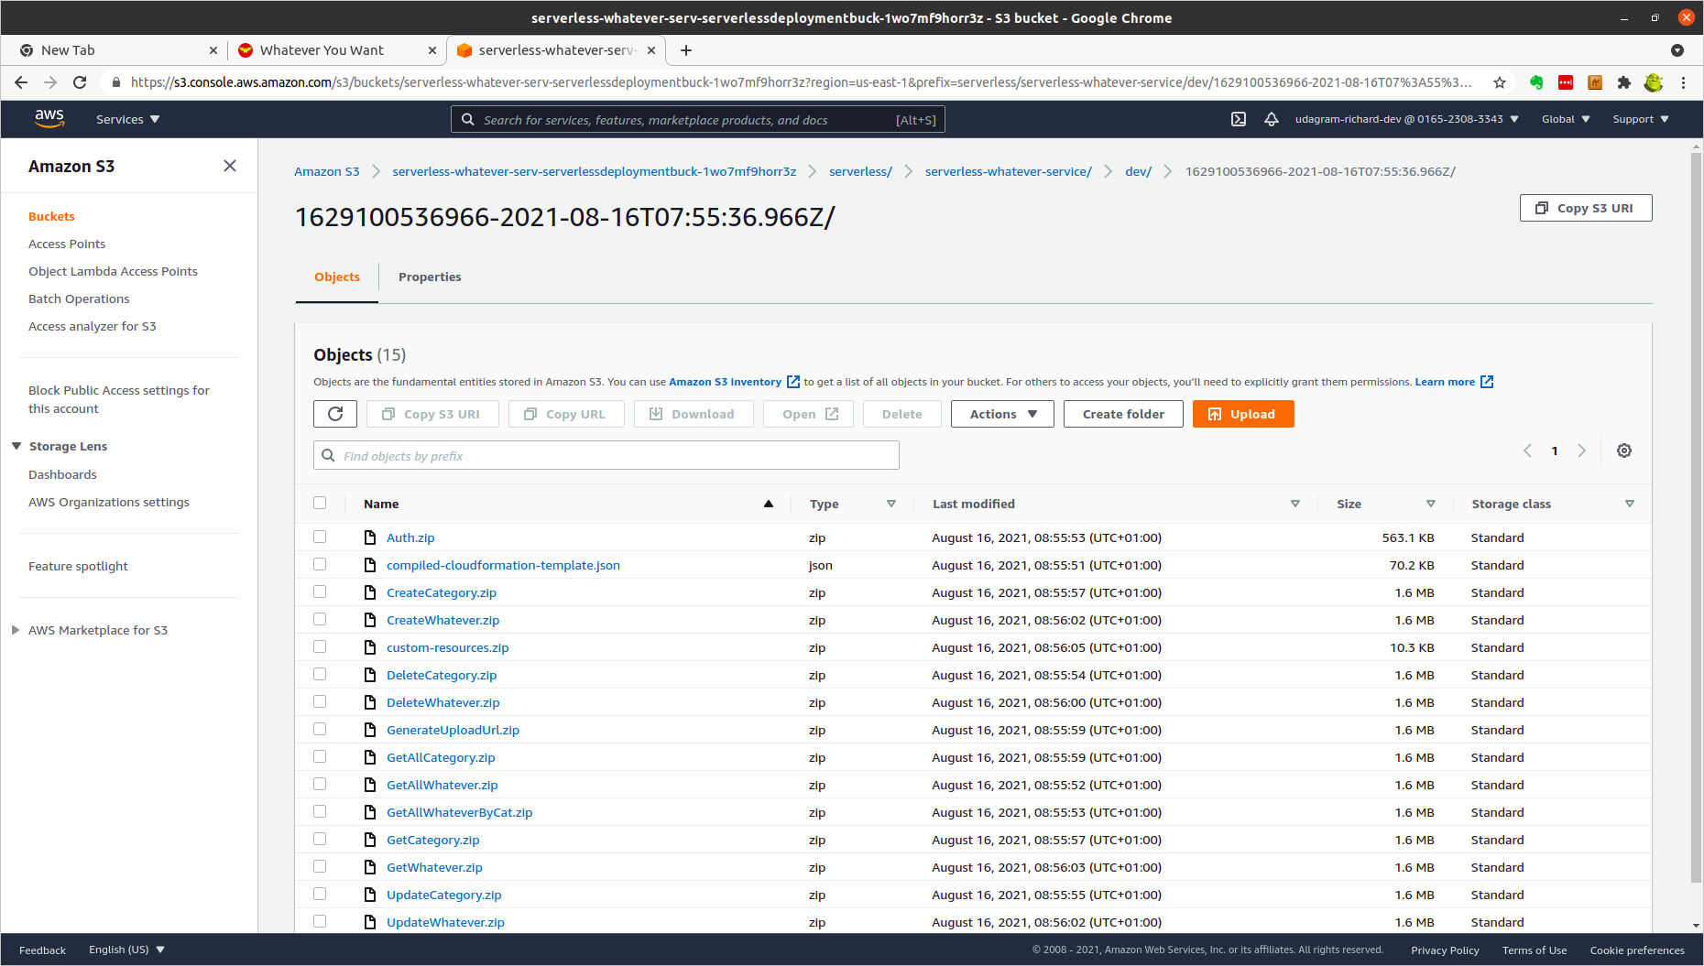

AWS S3 - attachments
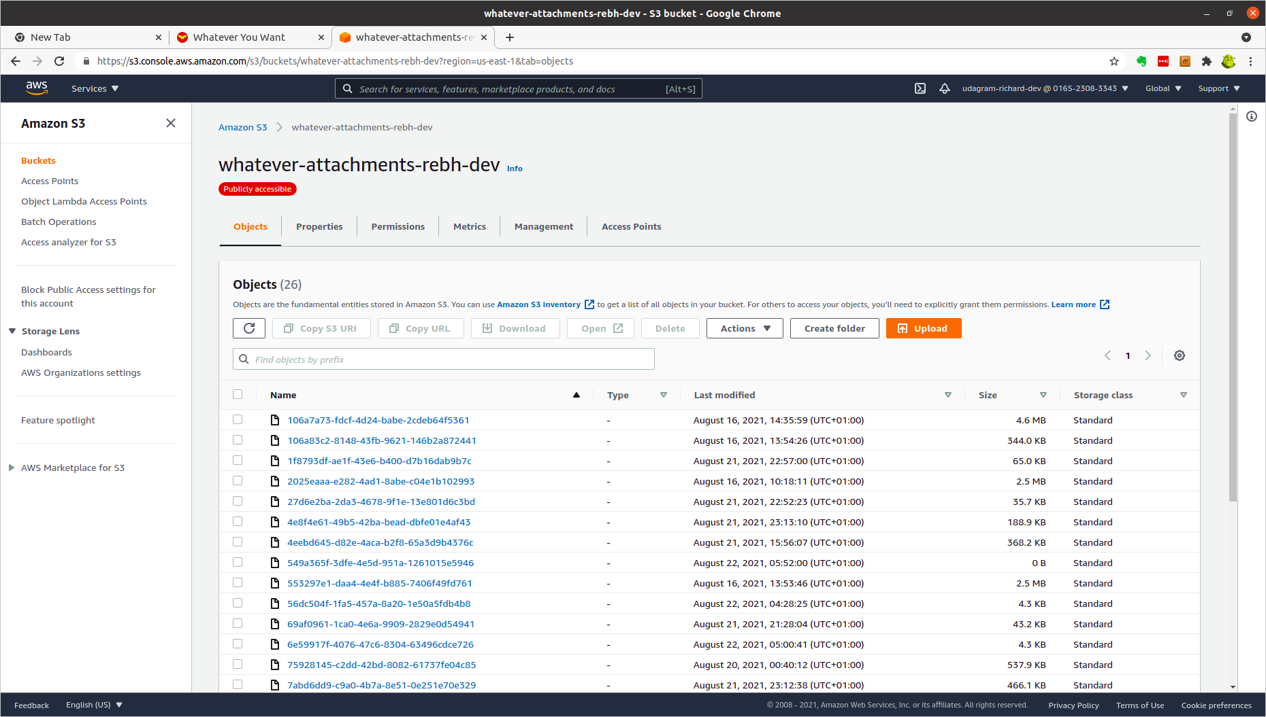

AWS DynamoDB – Category table
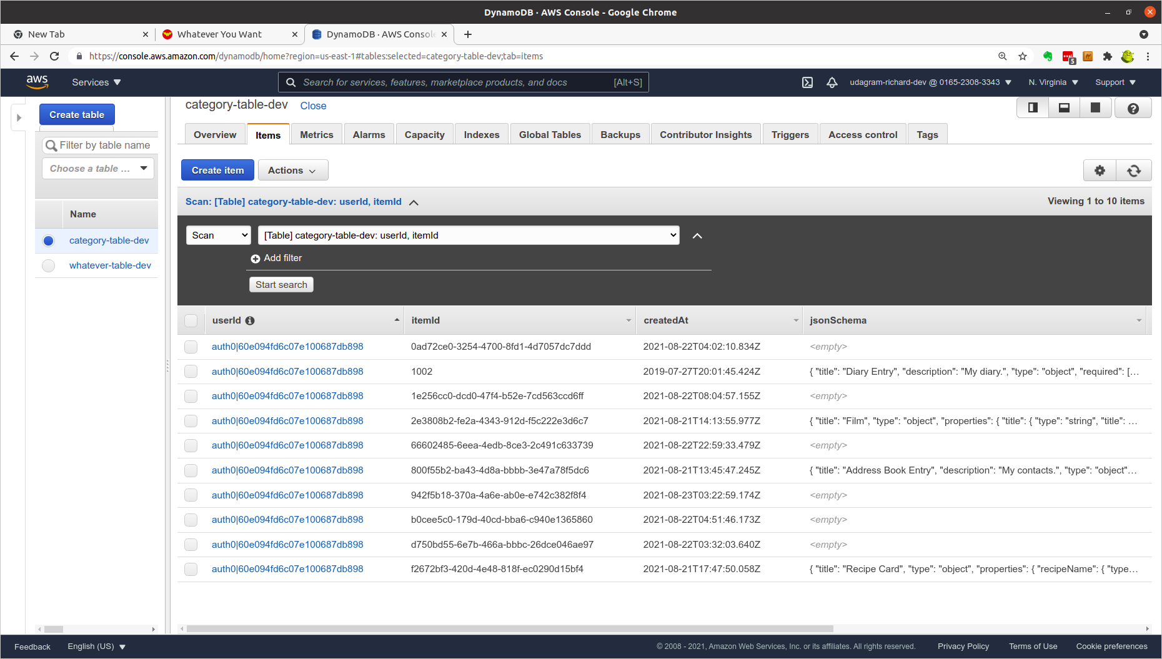

AWS DynamoDB – Whatever table
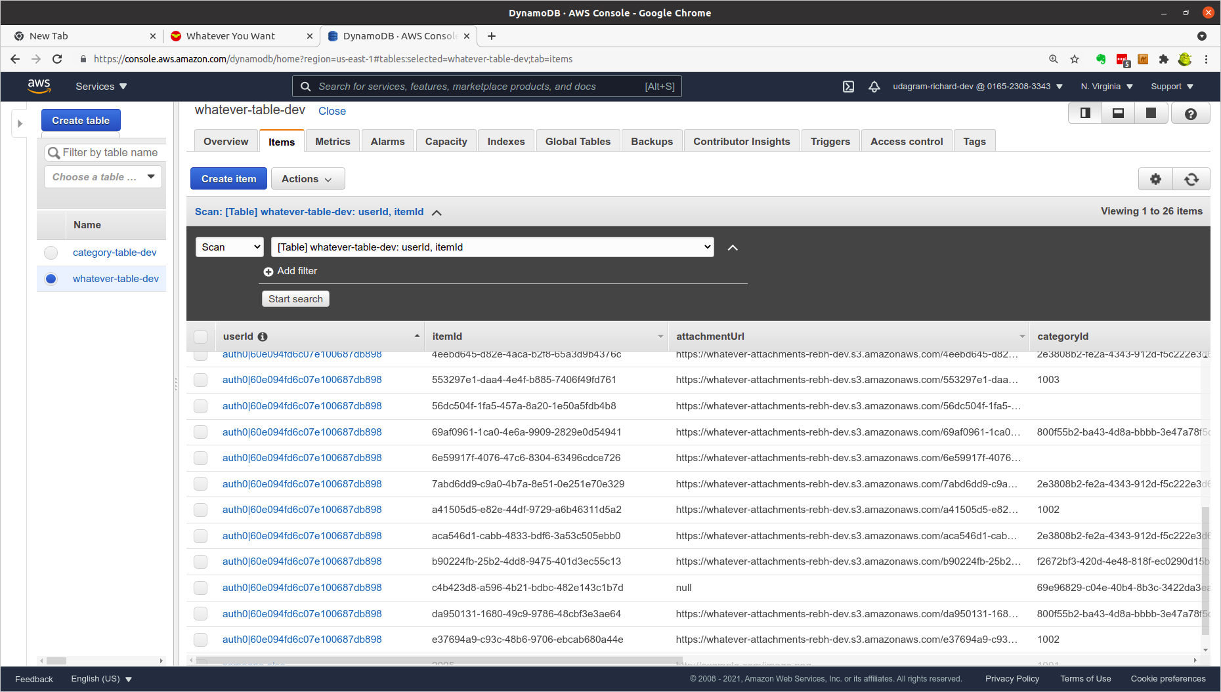

AWS CloudWatch
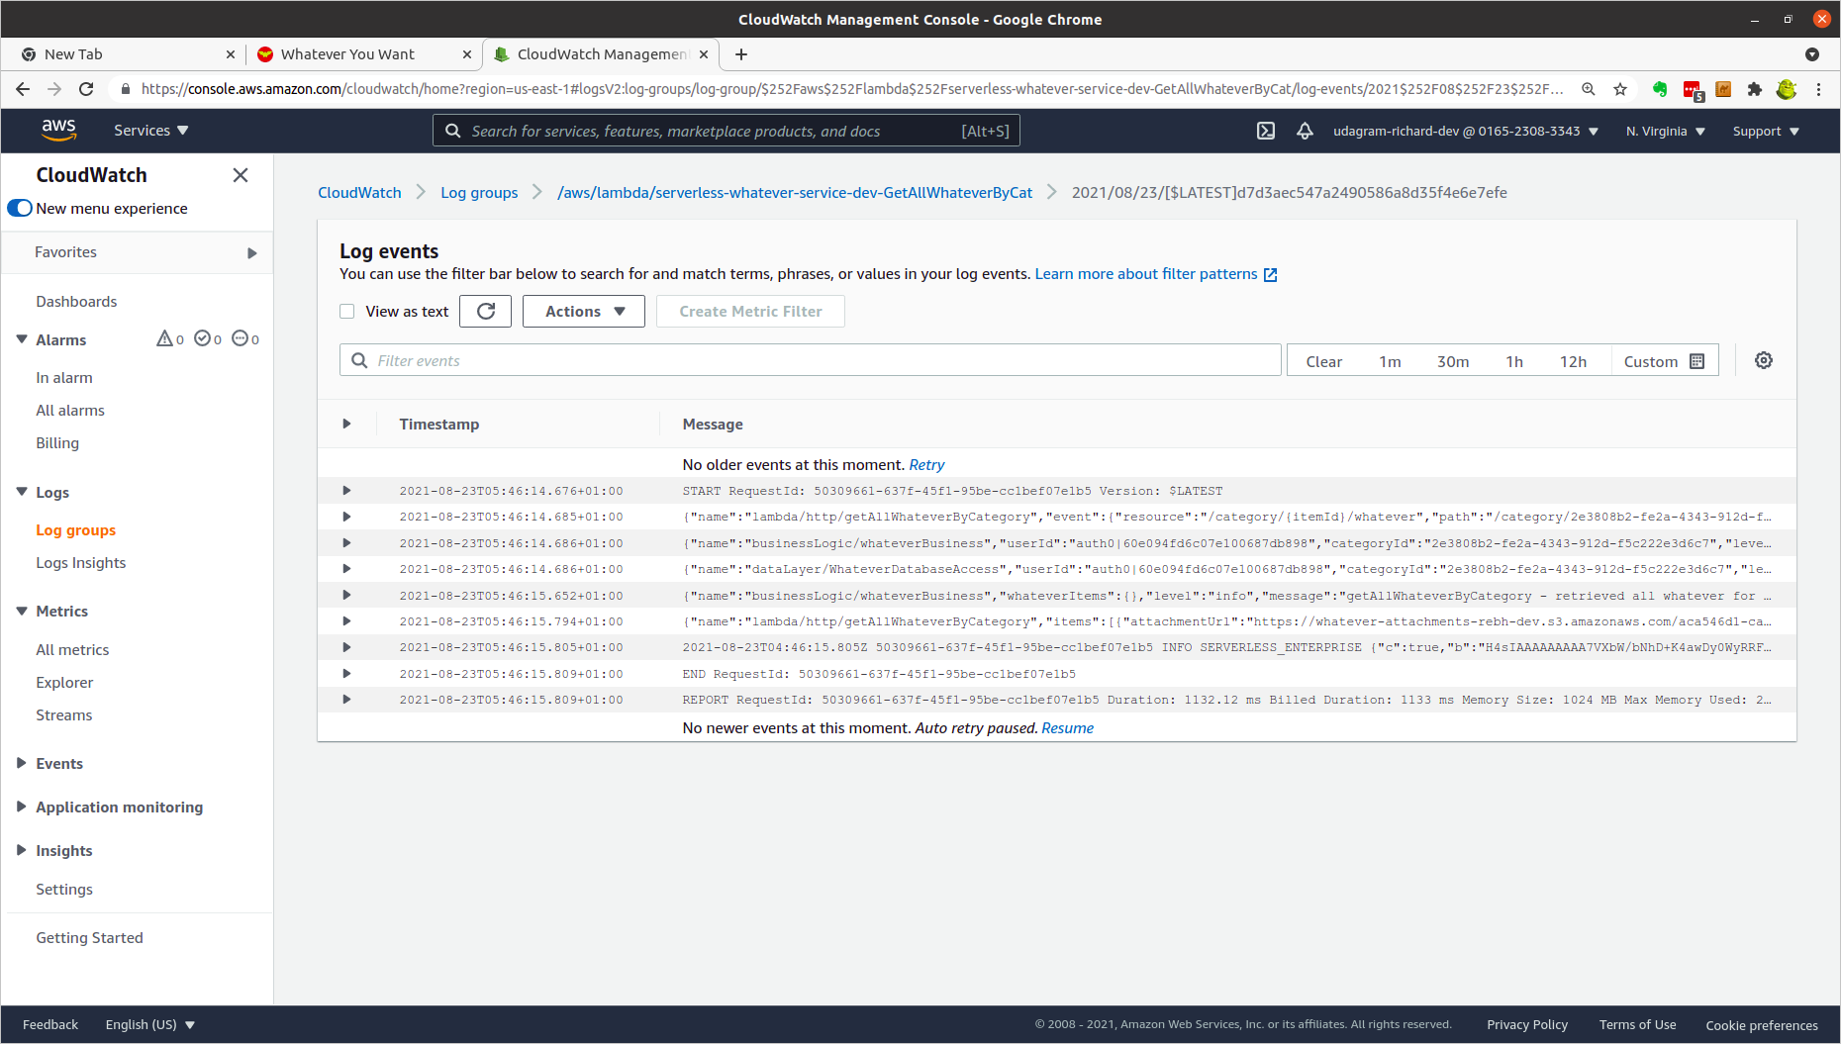

AWS Xray – service map
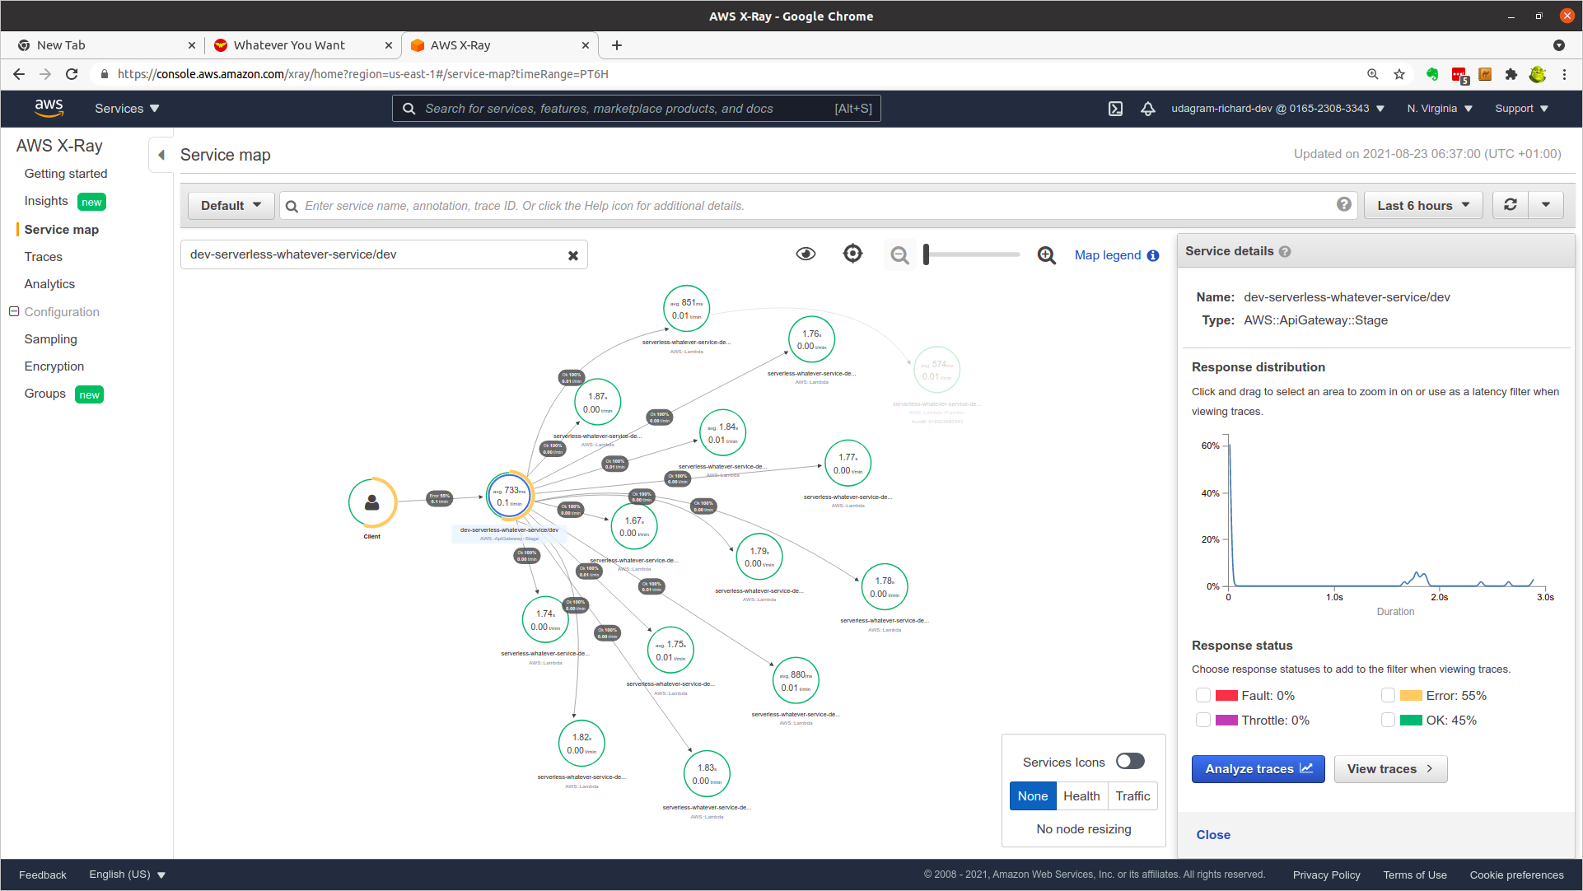

AWS Xray - traces
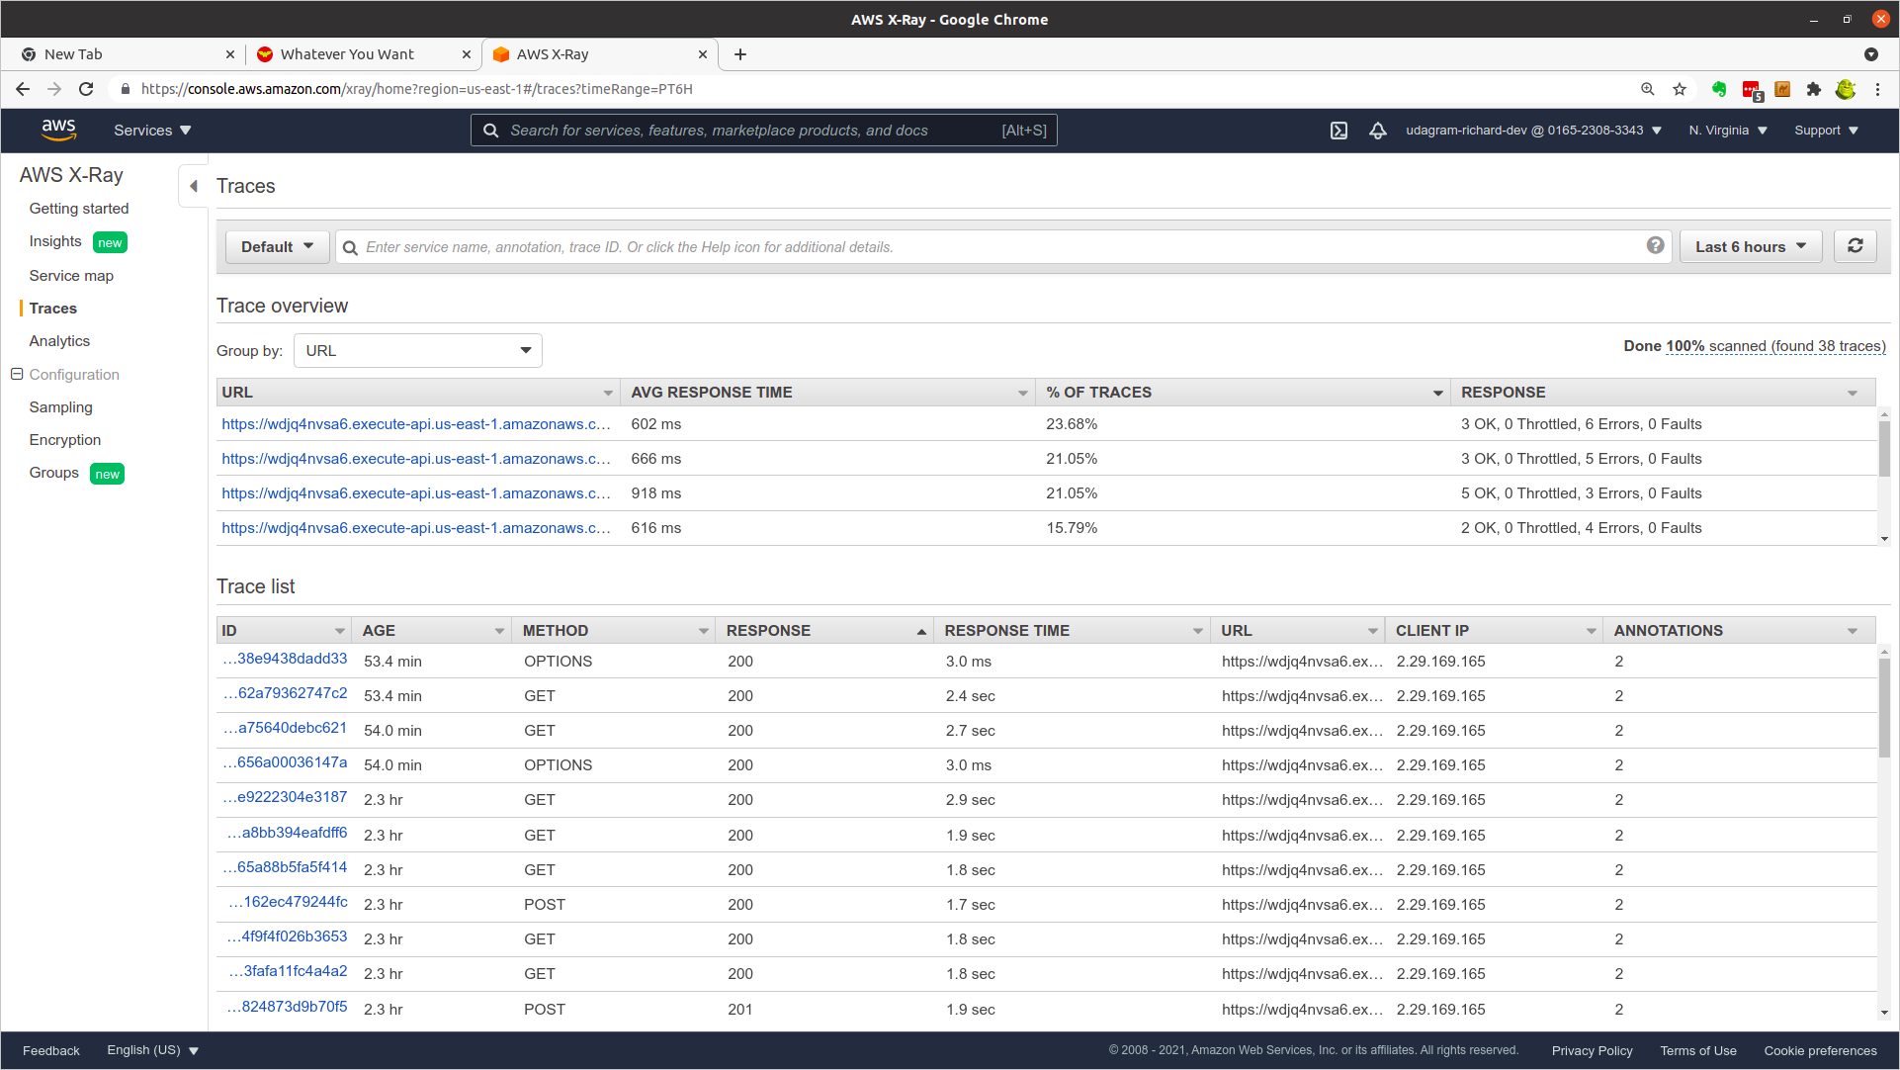

Appendix A – Example JSON Schema, UI Schema, and FormData

Diary
JSON Schema
{
"title": "Diary Entry",
"description": "My diary.",
"type": "object",
"required": [
"date",
"whatDidWeDo"
],
"properties": {
"date": {
"type": "string",
"title": "Date"
},
"whatDidWeDo": {
"type": "string",
"title": "What did we do today?"
},
"favouriteThings": {
"type": "array",
"items": {
"type": "string"
},
"title": "Favourite things"
}
}
}

UI Schema
{
"date": {
"ui:widget": "alt-date",
"ui:options": {
"yearsRange": [2000, 2100],
"hideNowButton": false,
"hideClearButton": true
}
},
"whatDidWeDo": {
"ui:widget": "textarea"
},
"favouriteThings": {
"ui:options": {
"orderable": true
}
}
}

Form Data
{
"date": {
"S": "2021-01-04"
},
"favouriteThings": {
"L": [
{
"S": "Reading"
},
{
"S": "Swashbuckling"
},
{
"S": "Skull and Cross-bones"
}
]
},
"whatDidWeDo": {
"S": "Finished reading my book today ...\nblah\nblah\n... pirates ...\nblah\nblah\nblah\n\n"
}
}

Address Book
JSON Schema
{
"title": "Address Book Entry",
"description": "My contacts.",
"type": "object",
"required": [
"firstName",
"lastName"
],
"properties": {
"firstName": {
"type": "string",
"title": "First name"
},
"middleNames": {
"type": "string",
"title": "Middle name(s)"
},
"lastName": {
"type": "string",
"title": "Last name"
},
"address1": {
"type": "string",
"title": "Address line 1"
},
"address2": {
"type": "string",
"title": "Address line 2"
},
"town": {
"type": "string",
"title": "Town"
},
"county": {
"type": "string",
"title": "County"
},
"postcode": {
"type": "string",
"title": "Post Code"
},
"telephone": {
"type": "string",
"title": "Telephone",
"minLength": 10
},
"additionalInfo": {
"type": "string",
"title": "Additional Information"
}
}
}

UI Schema
{
"firstName": {
"ui:autofocus": true,
"ui:emptyValue": "",
"ui:autocomplete": "family-name"
},
"lastName": {
"ui:emptyValue": "",
"ui:autocomplete": "given-name"
},
"middleNames": {
"ui:emptyValue": ""
},
"address1": {},
"address2": {},
"town": {},
"county": {},
"postcode": {},
"telephone": {
"ui:options": {
"inputType": "tel"
}
},
"additionalInfo": {
"title": "Additional Information",
"ui:widget": "textarea",
"ui:options": {
"rows": 5
}
}
}

Form Data
{
"additionalInfo": {
"S": "Butler: Alfred Pennyworth\nWard: Dick Grayson\nSidekick: Robin"
},
"address1": {
"S": "Secret Cave"
},
"address2": {
"S": "Under Wayne Mansion"
},
"county": {
"S": "DC Universe"
},
"firstName": {
"S": "Bruce"
},
"lastName": {
"S": "Wayne"
},
"middleNames": {
"S": "Batman"
},
"postcode": {
"S": "BATCAVE 001"
},
"telephone": {
"S": "Red Bat Phone"
},
"town": {
"S": "Gotham"
}
}

Film Collection
JSON Schema
{
"title": "Film",
"type": "object",
"properties": {
"title": {
"type": "string",
"title": "Title"
},
"format": {
"type": "string",
"title": "Format",
"enum": [
"",
"cloud",
"DVD",
"VHS",
"Betamax",
"LaserDisk",
"Reel"
],
"default": ""
},
"genre": {
"type": "array",
"title": "Genre",
"items": {
"type": "string",
"enum": [
"",
"Adventure",
"Action",
"Fantasy",
"Comedy",
"Family",
"Horror",
"Drama",
"Animated",
"Crime",
"Mystery",
"Science Fiction"
],
"default": ""
}
},
"storyline": {
"type": "string",
"title": "Storyline"
}
}
}

UI Schema
{
"title": {
"ui:autofocus": true
},
"format": {
"ui:widget": "select",
"ui:placeholder": "Choose ..."
},
"genre": {
"ui:widget": "select",
"ui:placeholder": "Choose ..."
},
"storyline": {
"ui:widget": "textarea",
"ui:options": {
"rows": 5
}
}
}

Form Data
{
"format": {
"S": "DVD"
},
"genre": {
"L": [
{
"S": "Action"
},
{
"S": "Adventure"
},
{
"S": "Fantasy"
}
]
},
"storyline": {
"S": "Determined to ensure Superman's ultimate sacrifice was not in vain, Bruce Wayne aligns forces with Diana Prince with plans to recruit a team of metahumans to protect the world from an approaching threat of catastrophic proportions."
},
"title": {
"S": "Jack Snyder's Justice League"
}
}

Recipe Card
JSON Schema
{
"title": "Recipe Card",
"type": "object",
"properties": {
"recipeName": {
"type": "string",
"title": "Recipe Name"
},
"countryOfOrigin": {
"type": "string",
"title": "Country of Origin",
"enum": [
"",
"English",
"Welsh",
"Scottish",
"Irish",
"French",
"German",
"Spanish",
"Italian",
"Scandinavian",
"American",
"Canadian",
"Mexican"
]
},
"feeds": {
"type": "integer",
"title": "Feeds (number of people)",
"minimum": 1,
"maximum": 5000,
"default": 1
},
"difficulty": {
"type": "string",
"title": "Difficulty",
"enum": [
"Very Easy",
"Easy",
"Medium",
"Complicated",
"Very Complicated"
]
},
"timeToPrepare": {
"type": "integer",
"title": "Time to prepare (minutes)",
"minimum": 0,
"maximum": 5000,
"multipleOf": 5,
"default": 0
},
"timeToCook": {
"type": "integer",
"title": "Time to cook (minutes)",
"minimum": 0,
"maximum": 5000,
"multipleOf": 5,
"default": 0
},
"cookingTemperature": {
"type": "integer",
"title": "Cooking temperature (centigrade)",
"minimum": 0,
"maximum": 1000,
"multipleOf": 5,
"default": 0
},
"ingredients": {
"type": "array",
"title": "Ingredients",
"items": {
"type": "string"
}
},
"preparationSteps ": {
"type": "array",
"title": "Preparation Steps",
"items": {
"type": "string"
}
}
}
}

UI Schema
{
"recipeName": {
"ui:autofocus": true,
"ui:placeholder": "Nan's traditional Welsh tea"
},
"countryOfOrigin": {
"ui:widget": "select",
"ui:placeholder": "Choose ..."
},
"feeds": {
"ui:widget": "updown"
},
"difficulty": {
"ui:widget": "select",
"ui:placeholder": "Choose ..."
},
"timeToPrepare": {
"ui:widget": "updown"
},
"timeToCook": {
"ui:widget": "updown"
},
"cookingTemperature": {
"ui:widget": "updown"
},
"ingredients": {
"items": {
"ui:placeholder": "a measure of an ingredient ..."
}
},
"preparationSteps": {
"items": {
"ui:widget": "textarea",
"ui:placeholder": "step ..."
}
}
}

Form Data
{
"cookingTemperature": {
"N": "190"
},
"countryOfOrigin": {
"S": "Scottish"
},
"difficulty": {
"S": "Medium"
},
"feeds": {
"N": "10"
},
"ingredients": {
"L": [
{
"S": "125g / 4oz unsalted butter, softened"
},
{
"S": "55g / 2oz caster sugar, plus extra to finish"
},
{
"S": "180g / 6oz plain flour"
}
]
},
"preparationSteps ": {
"L": [
{
"S": "Preheat the oven to 190C / 170C Fan / Gas 5."
},
{
"S": "Beat the butter and the sugar together until smooth."
},
{
"S": "Stir in the flour to get a smooth paste. "
},
{
"S": "Turn on to a work surface and gently roll out until the paste is 1cm / ½in thick."
},
{
"S": "Cut into rounds or fingers and place onto a baking tray."
},
{
"S": "Sprinkle with caster sugar and chill in the fridge for 20 minutes."
},
{
"S": "Bake in the oven for 15-20 minutes, or until pale golden-brown."
},
{
"S": "Set aside to cool on a wire rack."
}
]
},
"recipeName": {
"S": "Shortbread"
},
"timeToCook": {
"N": "30"
},
"timeToPrepare": {
"N": "30"
}
}

