Preceptor Guide: Zoll ECG simulator session

Contributor(s): E Krauspe, B Locke, R Sheth, C Long, J Situmeang, A Ryden, S Patel
Last Update: 2026-05-13

Simulation Resources:
- Companion Power Point Slide Deck (resident facing)

- Zoll ECG Simulator (can plug in directly to Zoll R Series monitor/defibrillator)
  - Options: VT, VT-HI, VT-LO, VF, AFIB, AFLTR, NSR, ASYS, SBrady, 1st AVB, 2nd I AVB, 2nd II AVB, 3rd AVB, TdP, Convert.
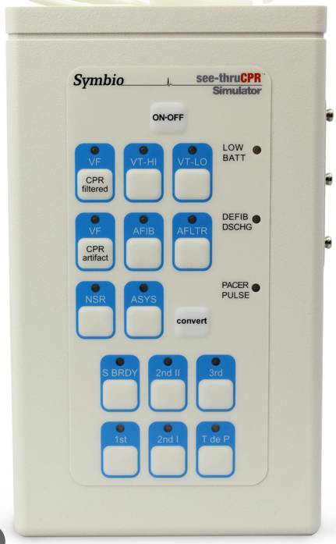
- Zoll R Series Monitor/defibrillator
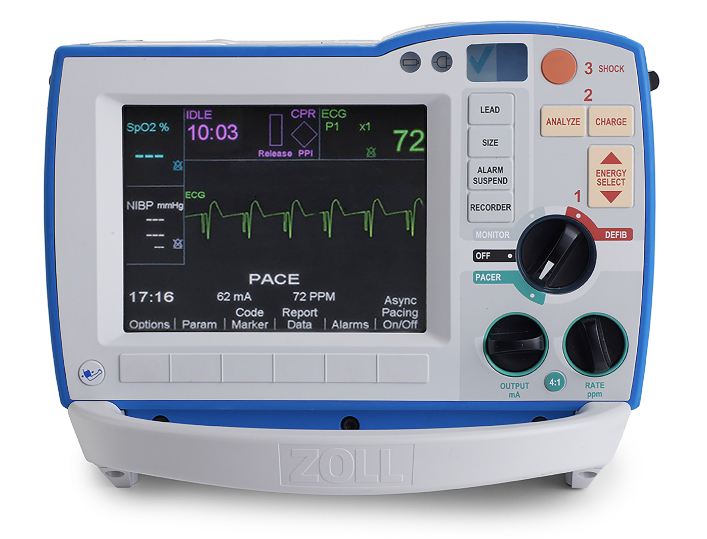

Audience: IM Interns

Duration: 20-30 minutes hands on scenarios
Case List:
Case 1: Metabolic derangements / ESRD - asystole versus fine VF
Case 2: VF/VT arrest with post-ROSC ECG and stabilization
Case 3: Polymorphic VT/TdP after QT-prolonging medications
Case 4: Tachycardia during RRT with adenosine guardrails
Case 5: Complete heart block / unstable bradycardia

Case 1: Metabolic derangements / ESRD - asystole versus fine VF
Scenario:
70M with ESRD found unresponsive on the floor. No pulse. CPR in progress; IV access obtained.
Labs available: pH 6.98, HCO3 12, pCO2 55; K 7.2, iCa 0.98; lactate 9.2, hs-TnI 11k, glucose 98.
Initial rhythm problem: asystole versus fine VF.
Facilitator prompts:
Confirm asystole in more than one lead and check for fine VF before treating as non-shockable.
Ask the nurse recorder: "First rhythm? CPR start time? Next pulse check?"
Assign timekeeper, compressor switch, defib, and meds/pharmacy roles.
Teaching points:
Do not shock true asystole; if uncertain about fine VF, make the less-bad error and involve another rhythm voice.
Calcium, bicarbonate, and insulin-glucose are cause-directed treatments for suspected hyperkalemia. They are not routine arrest medications.
Use the arrest Hs and Ts, ETCO2, and labs to guide cause-directed treatment without delaying CPR/rhythm checks.

Case 2: VF/VT arrest with post-ROSC ECG and stabilization
Scenario:
58F with CAD, remote DES/CABG, HLD, T2DM, and active smoking admitted for UTI with sepsis.
Telemetry alarms code blue on hospital day 2. On assessment, pulses are absent.
Labs available: pH 7.18, HCO3 16, pCO2 48; lactate 6.5, K 4.9, iCa 1.10; glucose 152, hs-TnI 121.
Facilitator prompts:
Prioritize immediate CPR, charging, first shock, and immediate CPR resumption.
Ask the nurse who called the code: "What rhythm triggered the alarm, when did compressions start, and has the first shock happened?"
After ROSC, close the loop on post-ROSC ECG and stabilization tasks.
Post-ROSC checklist:
12-lead ECG as soon as feasible.
Oxygen 100% until reliable SpO2/PaO2; then target SpO2 90-98%.
PaCO2 35-45 if comatose and ventilated; avoid hypotension with minimum MAP >=65.
If unresponsive, use protocolized temperature control for at least 36 hours.
Search for cause: coronary, PE, tamponade, hemorrhage, pneumothorax, toxic/metabolic.
Teaching points:
Time to first shock is critical in VF; antiarrhythmics are adjuncts, not the primary treatment.
Persisting VF/pVT: follow device energy strategy; if unsure, maximum biphasic energy is reasonable. Protect compression fraction and confirm pads/contact. Do not teach routine DSED/vector-change as standard care.
For VF/VT, consider acute MI, electrolyte derangements, hypoxia, and drug toxicity.

Case 3: Polymorphic VT/TdP after QT-prolonging medications
Scenario:
24F receiving antipsychotics and anti-emetics collapses on telemetry and is pulseless.
Monitor shows sustained polymorphic VT consistent with TdP when QT is prolonged.
Facilitator prompts:
Have the resident say the rhythm plan out loud before medication discussion.
Ask nursing/pharmacy: "What QT-prolonging medications has she received, and when was the last dose?"
After stabilization, stop QT-prolonging medications and address bradycardia/QT drivers.
Teaching points:
Sustained polymorphic VT is unstable: shock immediately with unsynchronized high-energy defibrillation because synchronization may fail.
If recurrent TdP with long QT, give magnesium, address bradycardia/QT drivers, and ask for expert help for overdrive pacing or isoproterenol.
Magnesium is for recurrent polymorphic VT with long QT/TdP; it is not routine for polymorphic VT with normal QT.
QT prolongation is more dangerous with slow heart rates.

Case 4: Tachycardia during RRT with adenosine guardrails
Scenario:
36F admitted for alcohol withdrawal. RRT activated on hospital day 3 for HR 180s, dizziness/lightheadedness, and palpable pulses.
Outreach nursing has arrived and has already tried vagal maneuvers.
Facilitator prompts:
Start with the outreach nurse: "Can I get the 30-second story: what changed, what have you tried, and what are you worried about?"
Have the resident state whether this is stable, unstable, or peri-arrest before choosing a medication.
If adenosine is used in the stable setting, reassess for the underlying rhythm it may uncover.
Teaching points:
Adenosine is for stable, regular, monomorphic tachycardia when SVT or regular monomorphic WCT is possible.
Do not give adenosine for unstable, irregular, or polymorphic wide-complex tachycardia.
If the rhythm is narrow and fast, decide whether it is causing instability or reflecting another problem.

Case 5: Complete heart block / unstable bradycardia
Scenario:
82F with bradycardia, confusion, and SBP in the 80s. RRT activated for bradycardia.
ECG shows complete heart block with AV dissociation and HR in the 30s.
Facilitator prompts:
Ask the bedside nurse: "Are pads on? Who can help with sedation? Who is calling cardiology/ICU?"
Organize pacing, sedation, pressors, and expert help before the patient loses pulses.
Teaching points:
Complete heart block is AV dissociation.
Atropine is reasonable in unstable bradycardia, but do not wait on it when high-grade or infranodal block is likely.
Prepare pacing/pressors and transvenous pacing early; transcutaneous pacing will require sedation.
Always have pacing pads in place during rapid responses for unstable bradycardia.

