COVID Vent Basics Work-Book for the Intensi-**ternist**

Brian Locke, MD

Learning objectives:

-What do we do once O2 by NC isn’t enough?

-What do we set our basic settings to? What are our goals with COVID?

-How do we know if our vent strategy is working?

References: onepagericu.com Nick Mark, MD

Scenario: Our 54F with HTN and OA who presented with 4d of URI symptoms followed by SOB, lymphopenia, peripheral GGO on CT scan from yesterday’s case conference is ultimately diagnosed with COVID based on RT-PCR

Unfortunately, her hypoxemia continues to worsen, and she requires 4L by NC to maintain a SaO2 of 88%. Remembering these patient’s tendency to decompensate – you call the ICU who decides to take over as primary.

It’s a dystopian future that may or may not in actuality reflect a current contingency plan. SSTU has been converted to a vent-capable ward. Dr. Milne + you are 1 of 5 IM teams managing these patients with the assistance of 1 PCCM attending/fellow pair. They are a crashing a patient to ECMO. – “get things ready on that patient, we’ll be done in 20 minutes”.

Dr. Milne says “it’s been at least … 5 … years since my last ICU rotation. What do you think we should do?”. Patient now is requiring 6L by NC

What are 4 options to keep this patient oxygenated? What are the advantages and disadvantages of each choice in COVID patients?

**Modes of O2 Delivery:**

|  |  |  |  |  |
| --- | --- | --- | --- | --- |
| **Mode of O2 delivery** | Endotracheal intubation | NIPPV | HFNC | NRB / Awake proning / Wait |
| Advantages | infection control (viral filter + cuff = NOT aerosolizing once tube is in), can control peep / fio2 | can apply PEEP (combats atelectasis) and good O2. | most comfortable, maybe a little peep, can apply lots of O2. | Temporary |
| Disadvantages | tough to liberate (avg in WA = 10 days), 50% will die, patient discomfort. Potentially avoid with less invasive modality? | aerosolizing with our masks (=more hypoxic when that needs to occur, uncontrolled) | also aerosolizing. May delay incubation (=more hypoxic when that needs to occur, uncontrolled).  Lots of O2 use. | Delay the inevitable? |

You decide to get the patient ready to intubate, and this is performed by the PCCM attending without issue. The attending scrambles off to another patient, and an RT comes by. Since this is the university, the RT sets it to “AC-PC” then leaves to another patient.

30 minutes go by. You get an follow-up ABG: 7.35/35/70/25 while the settings are AC-PC with a RR 12, Pressure 18, PEEP 14, FiO2 70%. However, you notice tidal volumes of around 600 mL (the patient is an average-sized female)

**What is AC-PC ventilation? What determine how large a breath is?**

Why is this patient with ***COVID*** on ***pressure control*** ventilation taking large breaths? (what is it about their lungs vs our normal ventilated patients?)

AC = Assist (patient triggers) Control (backup timed rate)

PC = breath continues in until a pressure target is reached. If the lungs are not stiff (=more compliant) = early Covid -> it takes more volume to reach that pressure

VC = breath continues until a volume is met

(Time can be set for either of these modes, usually as a ratio of I;E. This also influences oxygenation.

COVID lungs may be, initially, more like “Normal” than like “ARDS” -> compliance is not as reduced as some other causes (at least initially). Thus, for same pressure, you may get more volume.

What do you want to set the vent settings at to fix this? Why?

|  |  |  |  |  |  |
| --- | --- | --- | --- | --- | --- |
|  | Mode | TV or Pressure | RR | PEEP | FiO2 |
| Value | AC - **VC** | <6ml/kg IBW (60*60 for 5’3” female) = 360cc | MV = 7.2L / 360 => 20 RR | FiO2/5 | Increase to reach spo2 over 88 |
| Why? | we want to control the tidal volumes to keep them below 6 ml/kg (this is one of the few interventions that improves MORTALITY) | Smaller tidal volume = less ventilator induced lung injury | default ~15. Overall minute ventilation = RR * TV = adjust this to adjust pH. | use ARDS net tables | High PEEP = probably better given atelectasis |

You make this adjustment and the patient does well. However, they continue to worsen throughout the next day, and during rounds you find:

Example of what the screen looks like: Top = actual, Bottom = what you’ve set

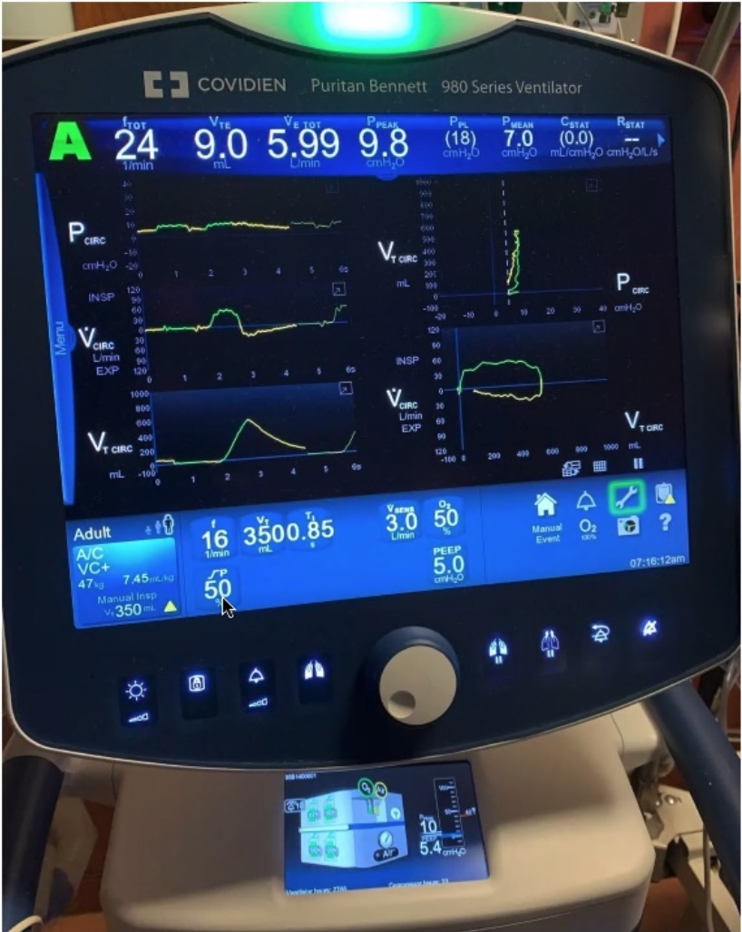

Mode: ACVC.

Patient’s RR: 24 (how is it possible that this is higher than our set rate?) Brainstem/Drive to breath intact, so patient is triggering breaths (the A in AC)). Increasing the vent rate will not increase the actual rate until over 24)

Set ventilator RR: 20

Vt 360

FiO2 80%

PEEP 16

PPeak: 32 (what makes this go up or down?) Resistance in the tubing.

PPlat: 26 (what makes this higher or lower? Whats our goal? The pressure it takes in the alveoli to expand the lung – will increase if lungs are generally stiff or sections of lung are full of something other than air. Must be less than 30 to avoid barotrauma. A close up of text on a white background

SpO2 92%

ABG 7.25 / 60 / 69

What might cause PPeak to go very high very quickly (causes a vent alarm), but PPlat stays the same?

Peak pressure = airway and circuit resistance => kinked/biting tube, mucus, bronchial constriction (try Suction, bronchodilators, observing the length of the tube)

Plataeu = what the alveoli see (=fragile, can be damaged). Lung compliance

Fluid (PNA, blood, inflamm, edema), fibrosis, external (Pneumothorax or effusion)

10-15 is a normal lung. Near 30 = lungs in bad shape.

What are the components to lung protective ventilation?

Tidal volume < 6 ml/kg IBW (avoid volutrauma)

PPlat (= what the alveoli see) < 30 (avoid barotrauma)

How high can you go on PEEP?

Peep will add to PPlat -> as long as PPlat is < 30

What is permissive hypercapnia?

When more ventilation will cause higher pressures (mainly, PPlat) -> tolerate respiratory acidosis instead of increasing lung damage.

What would you do in this situation?

Let ventilation continue as is (permissive hypercapnia) or try to increase the rate past what they are breathing at. For hypoxia – OK for now but if drops, there’s not much room to increase in PEEP or FiO2 – so consider that proning may be necessary soon (or ECMO ultimately)