**University of Utah Internal Medicine Journal Club Template:**

Updated: Brian Locke 2/25/2020

**Non-inferiority randomized controlled trial:**

* Article Title
* Study question and design: What is the null hypothesis
* Why did the trialist perform a non-inferiority trial instead of a superiority trial? What was their non-inferiority margin, and is it justified? If the intervention is found non-inferior to the control, what advantages would result? Does this benefit outweigh the possible inferiority margin?
* Patients included: (where and how were patients enrolled? How did the trialists determine their sample size? What were the inclusion/exclusion criteria? Does this represent the population you’re interested in? Flow diagram and table 1 may be helpful)
* Intervention: (What was the experimental intervention? Aside from the intervention, were patients treated equally - follow-up schedule, permitted additional treatments etc? Does this reflect current practice? Is the intervention realistic in our setting?)
* Outcomes: (Focus on primary outcome. Is this an outcome important to patients, or a surrogate? Is it a composite? Appropriate duration of follow-up? Was there blinding, and of who? Were patients analyzed by the treatment they were assigned to, or the treatment they received? Were the secondary outcomes prespecified or post-hoc?)
* Results: How large was the treatment effect, and what was the precision in the estimate (e.g. confidence interval, P-value)? Was there significant loss to follow-up or crossover between groups? Were the secondary analyses prespecified, or post-hoc? What were the primary adverse events, and how common were they in each group?
* Critique: Are there threats to the internal validity (such as bias or chance) or external validity, aka generalizability? Relevant conflicts of interests?
* Can I apply the results to my patient? How?

Why do we do noninferiority trials? Trial in questions has to have advantages (cost, side effects, convenience) to the std of care. This MUST be true for the trial to be worth running. Additionally, if an active comparator is used, the standard of care should be efficacious in a prior superiority trial (because placebo is non-inferior to placebo)

What is a noninferiority margin? The amount less that the trial investigator is willing to tolerate and still call the treatments equal. This should have some relation to what the minimally important clinical difference is. Importantly, this can’t be 0 (or else, we’d have shown superiority). However, it should be closer to 0 if the outcome is severe (meaning, we’d tolerate very little extra mortality) or if the benefits of the comparator treatment are not that great (meaning, if a drug that doesn’t have many other benefits much inferior, that’s not helpful)

Can’t you just do a regular/superiority trial, w/ p<0.05 for inferiority suggesting they are similar? Standard null hypothesis = no effect, and two tailed confidence interval of 95% is used (meaning, can find the intervention treatment is better, or worse). If the null is not rejected = absence of evidence for a difference – NOT evidence for absence of a difference. Think of a hypothetical trial with N=5 patients. Unlike evidence for a difference, but also no evidence for non-inferiority.

*Null hypothesis = 95% confidence interval for the size of the effect includes the noninferiority margin. (below from *JAMA.*2015;313(23):2371-2372. doi:10.1001/jama.2015.6645)

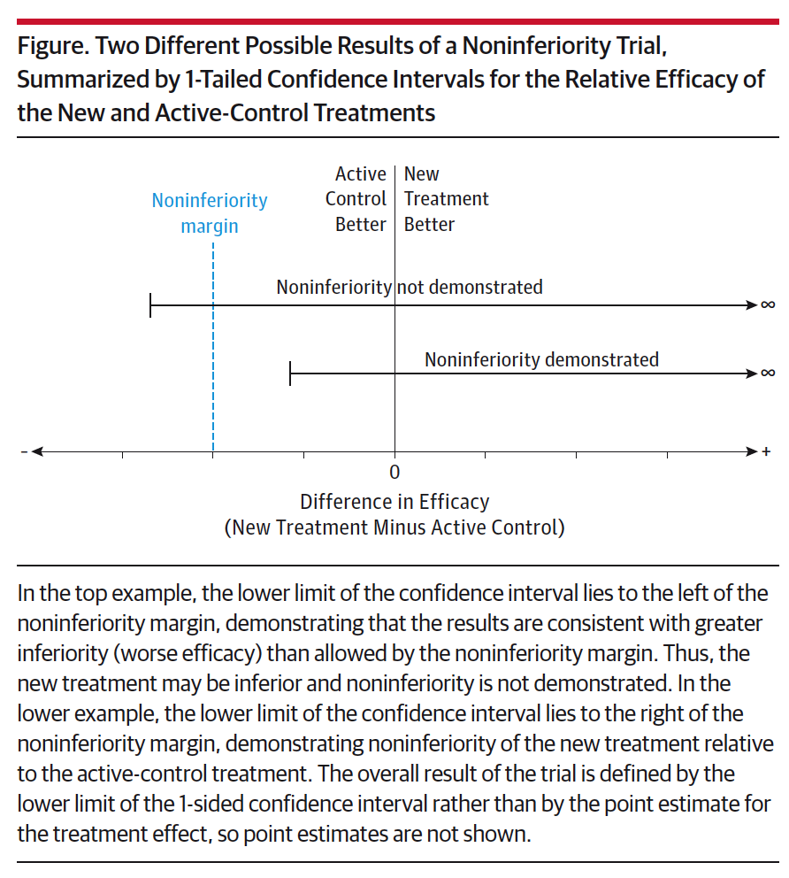

How do the investigators justify their non-inferiority margin? Is it the minimally clinically important difference? Things that influence:

1. Higher event rate = should have smaller margin,

2. Smaller effect size of standard = smaller margin

3. Larger benefits of treatment under consideration (cost, convenience, SE) could justify larger non-inferiority margin.

4. If severe primary end-point such as death, should be a small margin.

What things influence the sample size required to run the study?

1. Noninferiority margin (smaller = larger sample)
2. Power (usually .8) = chance that the study would fail to reject the null if the treatment was non-inferior
3. Event rate and absolute effect size of the interventions in question

Note: an active comparator non-inferiority trial that has a small margin will often require a larger required sample size than a superiority trial… but it may be worth it to run the trial if we don’t believe the treatment actually is superior.

Is it possible to demonstrate superiority in a non-inferiority trial? Kind-of – if the 95% confidence interval for the effect in the experimental arm does not include the non-inferiority margin = non-inferiority, and if it does not include the comparator point estimate = superiority. HOWEVER, usually – these are analyzed with a 1 sided hypothesis test (e.g. only testing inferiority, not superiority) because that’s the primary question – so a second analysis is required, that is, by definition a secondary end-point (not primary)

Does a ‘negative’ non-inferiority trial demonstrate that a treatment is inferior? No – this is the contra statement to the reason why a negative superiority trial does not suggest that treatments are equivalent – absence of evidence is not evidence of absence. The trial just failed to provide evidence they are equivalent.

Non-inferiority trials: do they use intention-to-treat vs per-protocol analyses? Why? Unlike superiority trials where ITT is clearly more “conservative”, this is not the case in ITT (because biasing toward the null is biasing towards non-inferiority = rejecting the null. Thus, results are most meaningful when both ITT and per-protocol analyses are non-inferior