Project 1

<Blackjack>

CSC-17A-48290

Name: Amine Ouaddi

Date Finished: 11/01/2022

**Introduction**

Title: Blackjack

This is the card game blackjack also known as 21.

The objective of the game is to have a number of cards that count to a number higher than the dealer’s while not exceeding 21. The player has 4 options during the game after receiving his first two cards hit, stay, double-down, and split. In the version of Blackjack, I made only hits, and stays available.

I made this game as my project because I intended to do UNO instead, but it turned out to be very difficult, so I chose Blackjack instead.

The benefit of this project is having a simpler version of blackjack that could be played by anyone new to the game as an introduction without risking any money or any knowledge.

**Summary**

Project Size: 512 lines

Variables: approximately 27

This project includes most of the concepts learned in the new chapters such as structures, nested structures, pointers and more. In addition, it can be extended to fit upcoming chapters such as classes.

It took two weeks of work because I was trying to implement concepts, I do not fully understand so the project was a complete mess and at times broke and I decided to redo the entire thing from scratch and went with that as the final product. It was fun learning these new concepts as it expanded my understanding of the C++ language even more.

**Description**

In this program, the function that brings it all together is the game() function. **I will be providing pseudocode of certain part in this function below.**

**I will be providing a flowchart for the function displaycard() below.**

The first function in the program is login(), it is used to login the user into the game by checking his input and comparing it with data in a .dat file. **I will be providing screenshots of the code and output of this function below.**

**Screenshots**

**Code:**

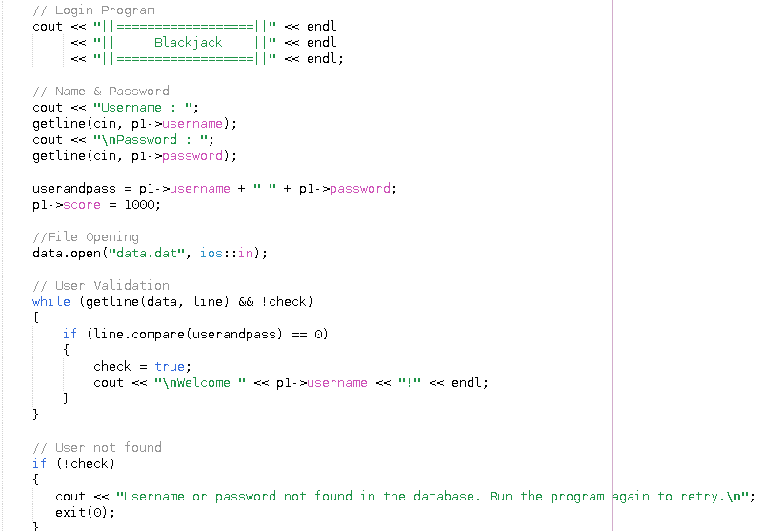

**Output:**

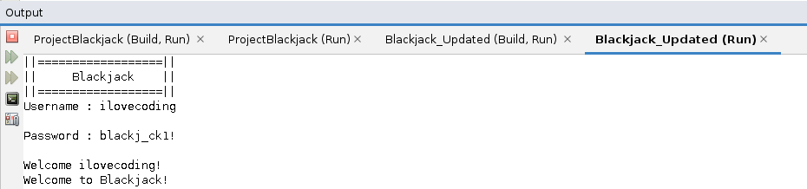

**Flowchart:**

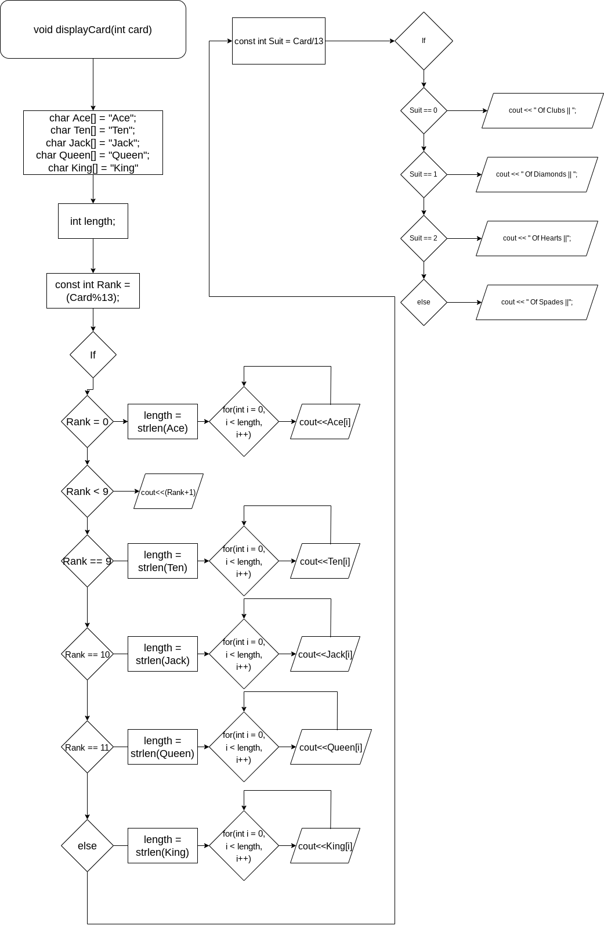

**Pseudocode:**

*While flag is true*

*Call the shuffle function*

*Call the nextCard function 2 times for the PlayerHand struct array*

*Call the nextCard function 2 times for the HouseHand struct array*

*Call the PlayerScoreHand function for the PlayerScore integer*

*Print menu output*

*Wait for user input on bets*

*While the bet is superior to the player’s score*

*Output invalid bet*

*Wait for user input on bets*

*If bet equals 0 or player score equals 0*

*Output not enough money*

*Call scores function*

*Exit program*

**Major Variables:**

|  |  |  |  |
| --- | --- | --- | --- |
| **Type** | **Variable Name** | **Description** | **Location(s)** |
| Boolean | CardsDealt[] | A boolean array for the 52 cards | int main()  void login()  void shuffle()  int nextcard()  void game() |
| Integer | HouseCardCount | An integer to keep count of the house’s cards in play | void login()  int PlayerScoreHand()  int HouseScoreHand()  void DisplayPlayerHand()  void DisplayHouseHand()  void game() |
|  | NewCard | Used to get a new card | void game() |
|  | bets | Gathers input on the user’s bet | void game() |
|  | PlayerScore | Used to save user’s score and update it | void game() |
|  | HouseScore | Similar to PlayerScore but for the AI | void game() |
|  | AceCount | Keeps track of the number of aces | int PlayerScoreHand()  int HouseScoreHand() |
|  | Score | Keeps track of a functions score and returns it | int PlayerScoreHand()  int HouseScoreHand() |
| C-Strings / Char Arrays | Ace, Ten, Jack, Queen, King | Used to output characters in a loop | void DisplayCard() |
| Boolean | flag | Used to loop the game | voidgame() |

**Concepts:**

1. Pointers:

- Player *p1 (found in most functions)

- Int *NextCard (found in int nextcard(bool CardsDealt[], int *)

2. C-Strings & Strings

* String username, string password, string userandpass and more...
* C-Strings in void displayCard(int Card)

1. Structured Data

* Struct Hand
* Struct Player (nested Struct Hand)
* Pointer to Struct Player used in almost every function
* Struct Hand array (Hand PlayerHand[12], Hand HouseHand[12])

1. Binary Files

* Files data.dat, score.txt
* Line.compare used for validation in void login()
* Data.dat recorded with Player user structure
* Pointer to score.txt in void scores()
* Formatting & .seekp used in void scores()
* Multiple formats used at once in void scores() (ios::out || ios::app)

**Program:**  
[Github](https://github.com/reblol/CIS17A/tree/main/Project/Project1)