Angular is a java script framework which allows us to create a reactive single page application.

**Install angular**

npm install -g @angular/cli

**create angular project**

ng new app-name

By default, ngModel is disable, so in order to enable it, it is required to add a module “FormsModule” from @angular/forms in “app.module.ts” file.

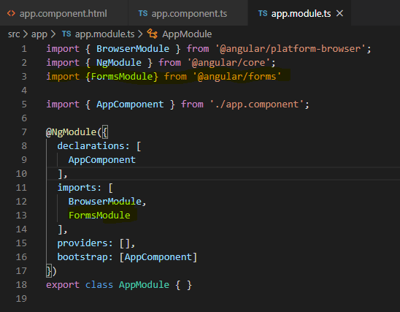

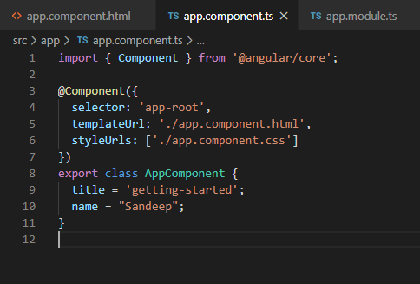

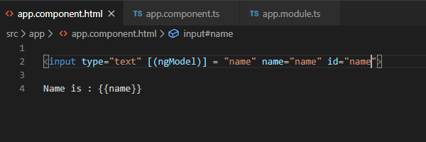

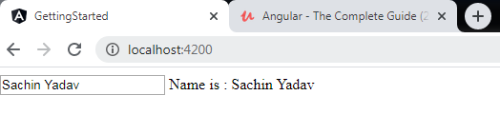

Course structure

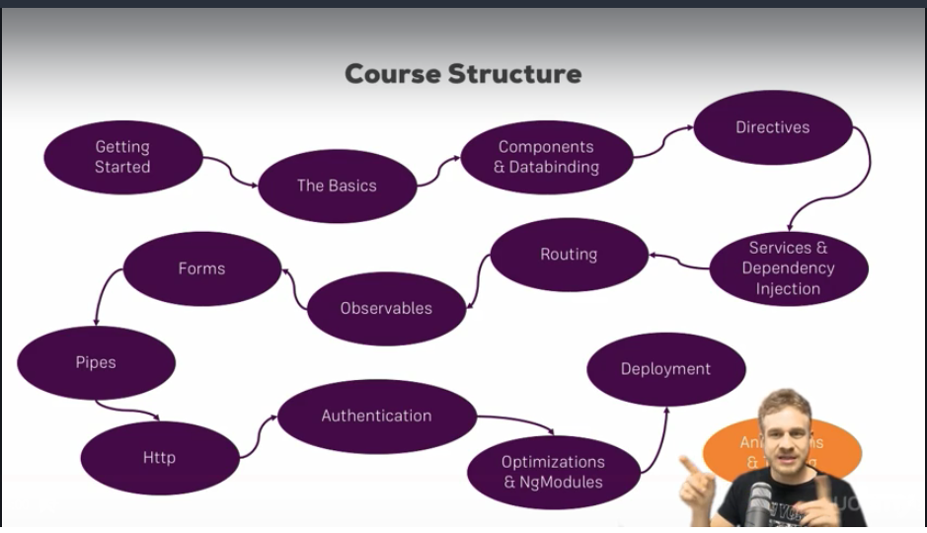

**Typescript**

**Section 2**

Index.html is the default loaded page.

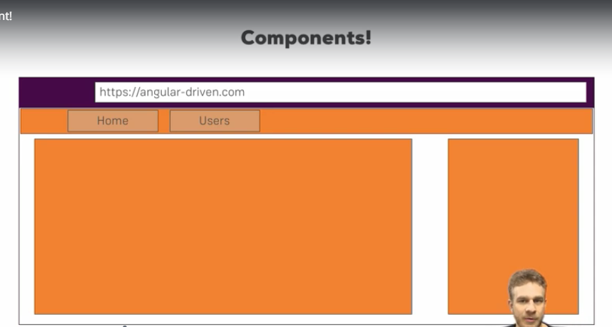

Angular application is a container of components. In the above screenshot, there are three components. Component can have components inside. App component is at the top. “Home” can also be a component.

**How to create a component**

There are two ways to create a component.

1. Create a folder (component name: server) in app folder. Create four files in this component.
2. server.component.ts
3. server.component.html
4. server.component.css
5. server.component.spec.ts

By adding the “@Component” decorator to class, it is declared as component.

Import { Component } from ‘@angular/core’.

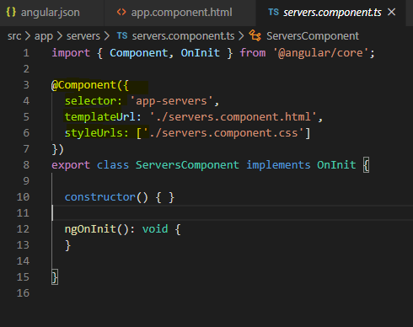

1. Component can be created through angular CLI

ng generate component component-name

ng g c component-name

When component is created, it is added in “app.module.ts” file under declaration section.

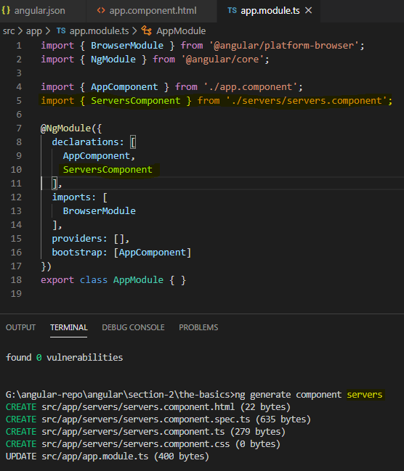

In order to use a component as an attribute, some changes are required in the component’s selector section.

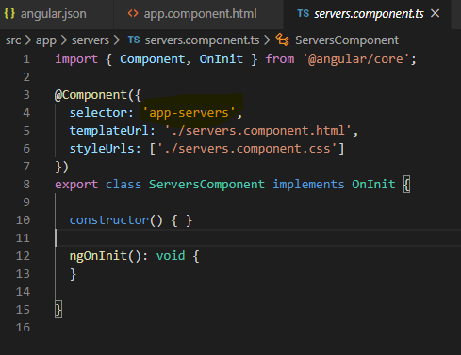

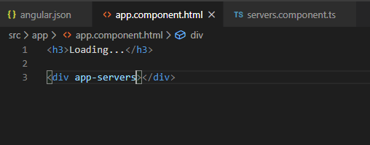

Component can also be used as a class.

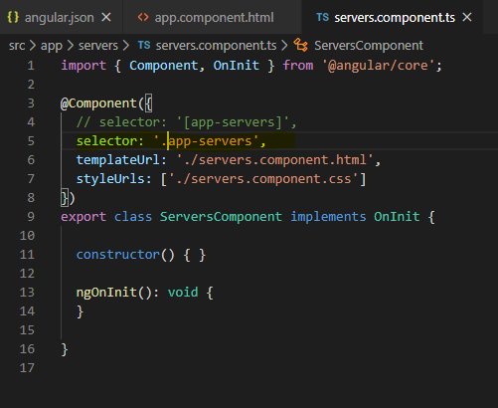

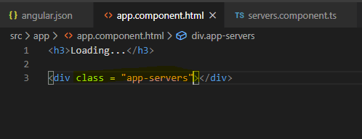

**Databinding**

Data binding is the reflection of variable in a model to the view of an app. Whenever the variable changes the view must update the DOM to reflect the new changes.

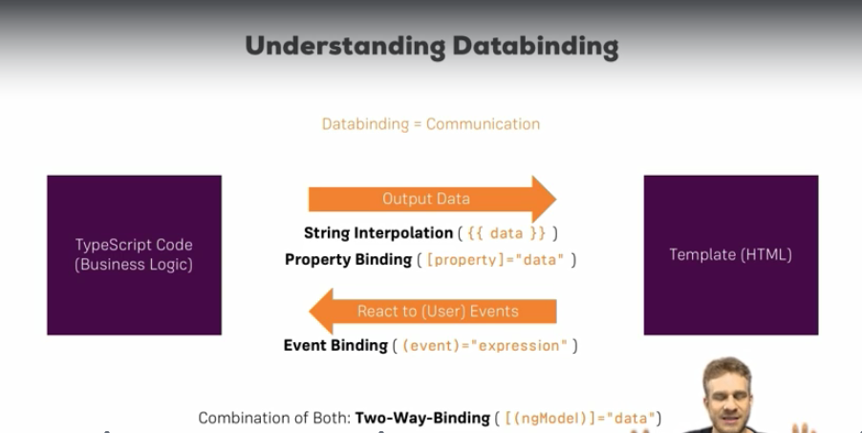

1. String interpolation

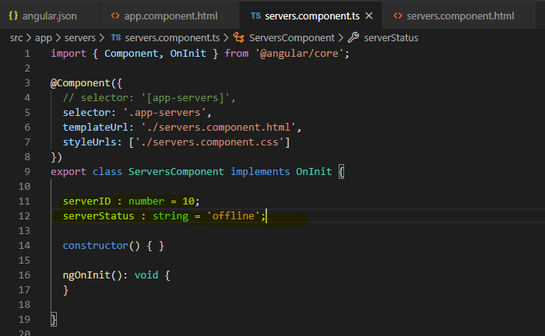

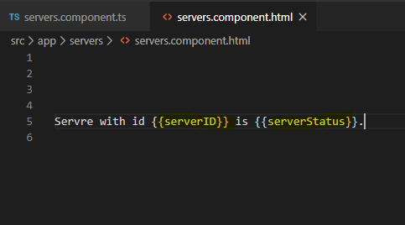

1. Property binding

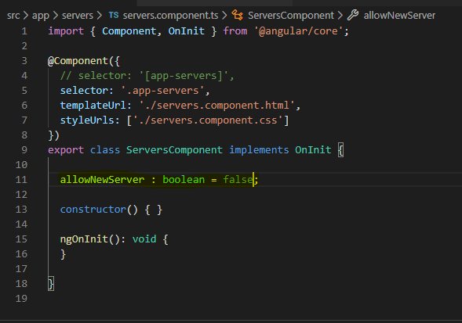

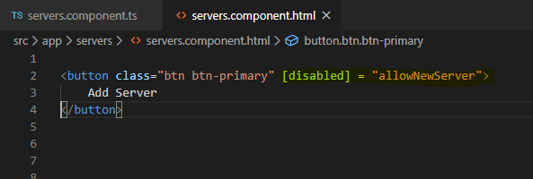

1. Event binding

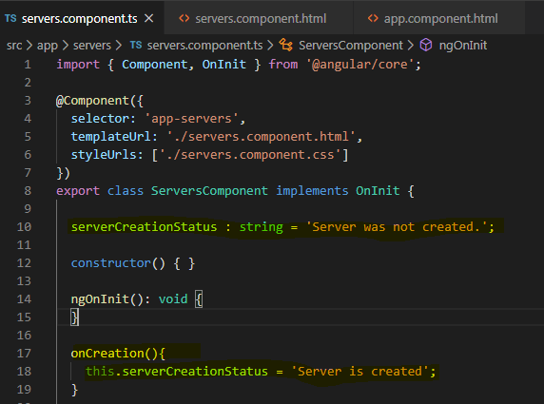

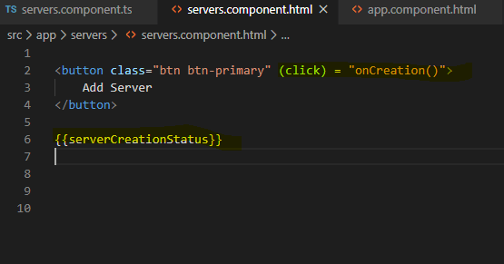

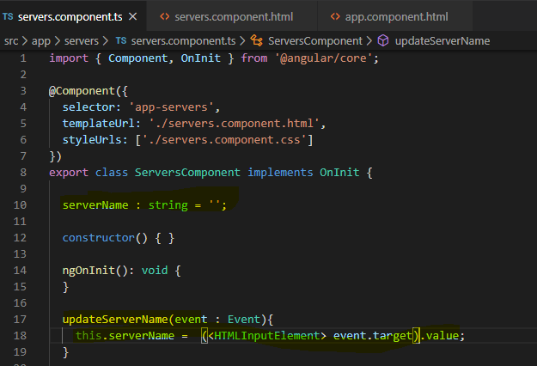

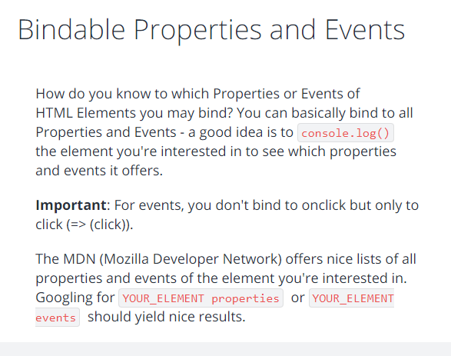

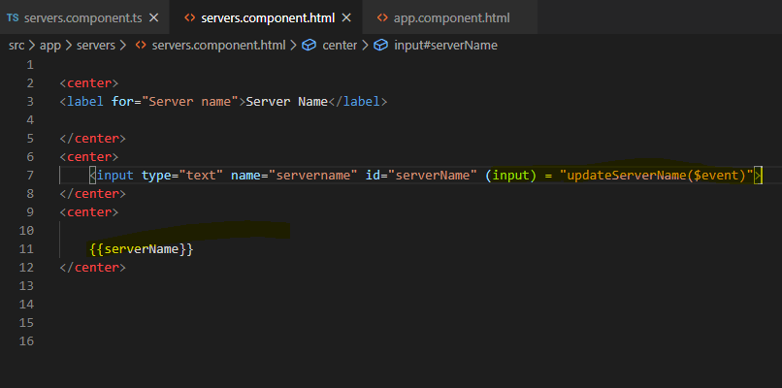

1. Two-way binding

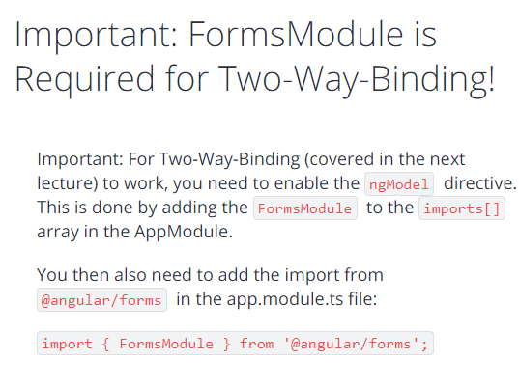

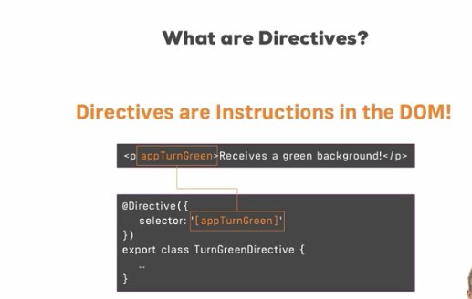

**Built-in directives**

**How to use ngIf**

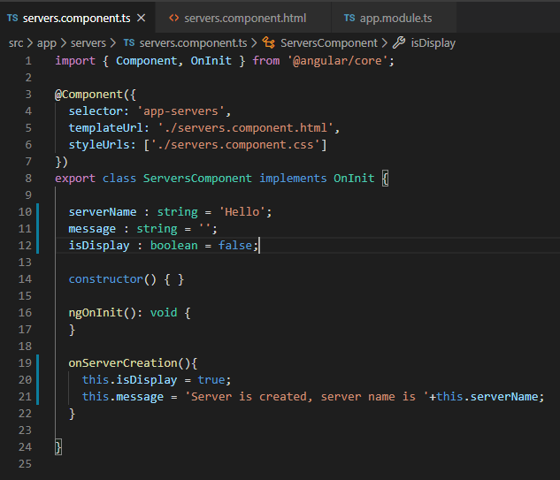

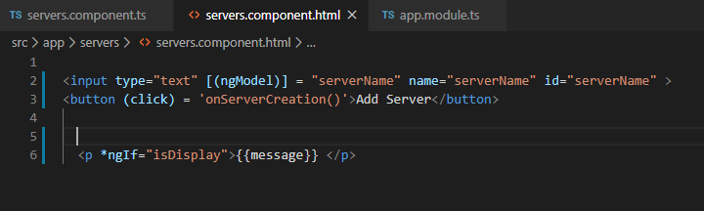

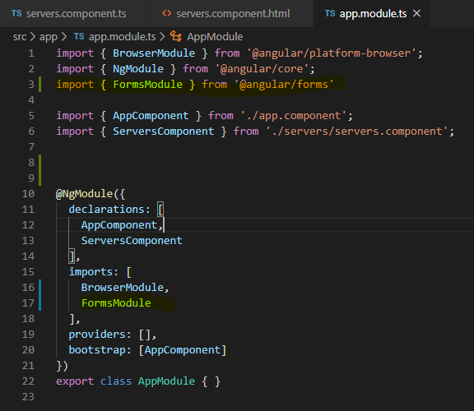

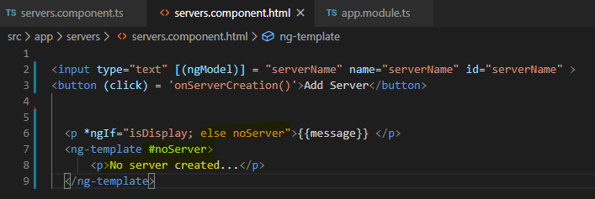

**How to use ngStyle**

ngStyle directives is used as property binding. This is used to apply the css dynamically in the html. Method can be called in this directive.

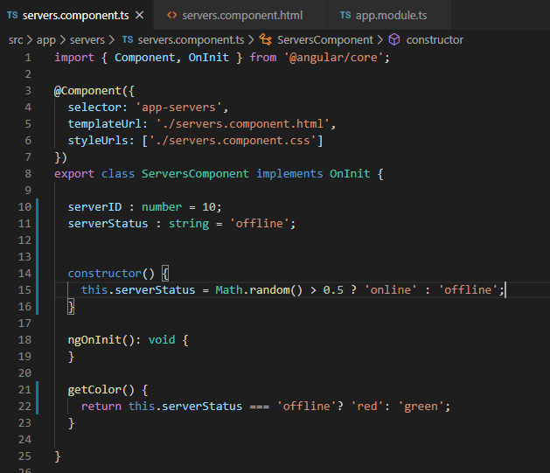

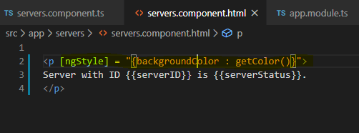

**How to use ngFor**

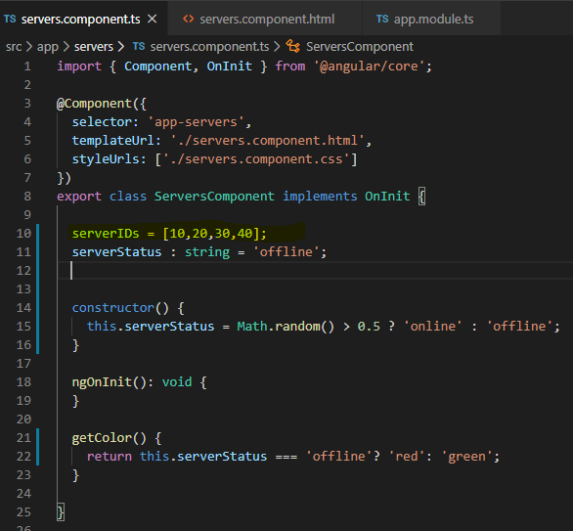

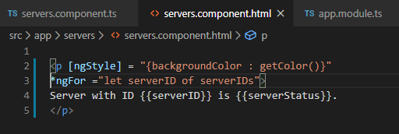

**Section 3**

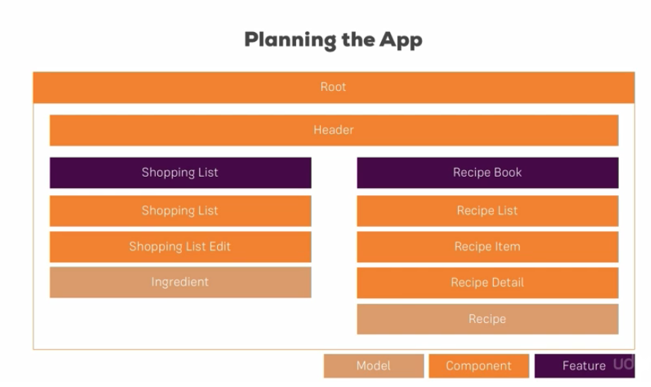

**Section 5**

