**maven错误问题及解决办法**

[INFO] ------------------------------------------------------------------------

[ERROR] Failed to execute goal org.apache.maven.plugins:maven-compiler-plugin:2.3.2:compile (default-compile) on project clothing: Compilation failure

[ERROR] Unable to locate the Javac Compiler in:

[ERROR] C:\Program Files\Java\jre6\..\lib\tools.jar

[ERROR] Please ensure you are using JDK 1.4 or above and

[ERROR] not a JRE (the com.sun.tools.javac.Main class is required).

[ERROR] In most cases you can change the location of your Java

[ERROR] installation by setting the JAVA_HOME environment variable.

[ERROR] -> [Help 1]

[ERROR]

[ERROR] To see the full stack trace of the errors, re-run Maven with the -e switch.

[ERROR] Re-run Maven using the -X switch to enable full debug logging.

[ERROR]

[ERROR] For more information about the errors and possible solutions, please read the following articles:

[ERROR] [Help 1] http://cwiki.apache.org/confluence/display/MAVEN/MojoFailureException

解决办法如下：

打开 ：Window -> Preferences -> Java -> installed JREs ->

选择你正在使用的JRE(应该是一个在jdk。例:C:\Program Files\Java\jdk1.6.0_43 )  
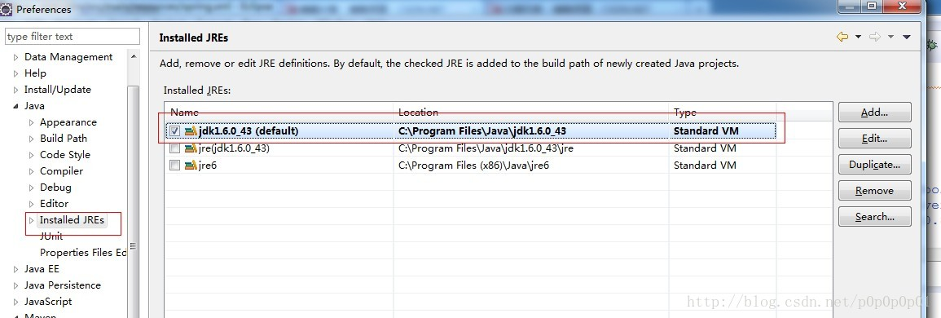点击“Edit”，进入下一个画面：选择添加 C:\Program Files\Java\jdk1.6.0_43\lib\tools.jar ，点击 Finish。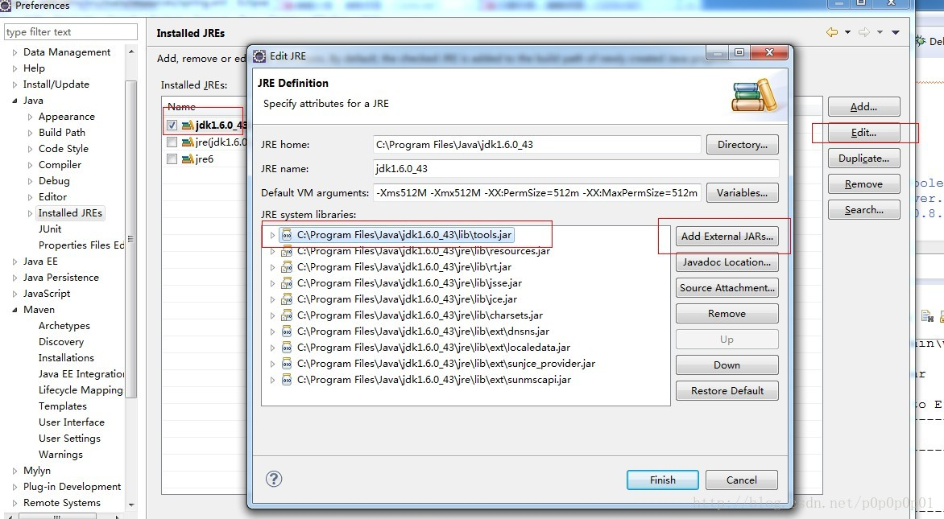接下来，打开 Window -> Preferences -> Java -> installed JREs -> Execution Enviroments ->进入画面：选择JavaSE-1.6和相匹配的 jre 。点击OK。

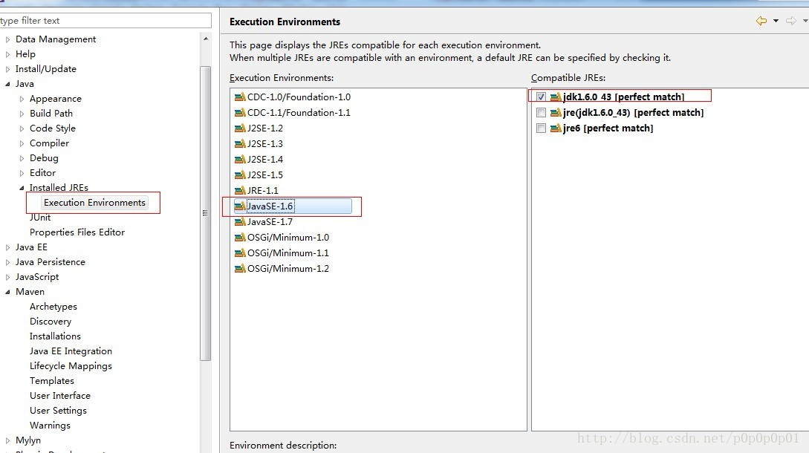

，到此，重新运行 maven install。成功！

exception (java.net.SocketException) caught when processing request: Connection reset by peer: socket write error

解决办法： 不要设置版本号2.1以下的版本

<plugin>

<groupId>org.apache.tomcat.maven</groupId>

<artifactId>tomcat7-maven-plugin</artifactId>

<configuration>

<port>80</port>

<path>/</path>

<url>http://112.74.167.175/manager/text</url>

<username>tomcat</username>

<password>tomcat</password>

</configuration>

</plugin>

org.apache.jasper.JasperException: java.lang.ClassCastException: org.apache.jasper.el.ELContextImpl cannot be cast to org.apache.jasper.el.ELContextImpl

org.apache.jasper.servlet.JspServletWrapper.handleJspException(JspServletWrapper.java:549)

org.apache.jasper.servlet.JspServletWrapper.service(JspServletWrapper.java:470)

org.apache.jasper.servlet.JspServlet.serviceJspFile(JspServlet.java:390)

org.apache.jasper.servlet.JspServlet.service(JspServlet.java:334)

javax.servlet.http.HttpServlet.service(HttpServlet.java:728)

解决办法如下:

修改C:\Tomcat7\conf\context.xml如下：

<?xml version='1.0' encoding='utf-8'?>  
<!--  
  Licensed to the Apache Software Foundation (ASF) under one or more  
  contributor license agreements.  See the NOTICE file distributed with  
  this work for additional information regarding copyright ownership.  
  The ASF licenses this file to You under the Apache License, Version 2.0  
  (the "License"); you may not use this file except in compliance with  
  the License.  You may obtain a copy of the License at  
  
      http://www.apache.org/licenses/LICENSE-2.0  
  
  Unless required by applicable law or agreed to in writing, software  
  distributed under the License is distributed on an "AS IS" BASIS,  
  WITHOUT WARRANTIES OR CONDITIONS OF ANY KIND, either express or implied.  
  See the License for the specific language governing permissions and  
  limitations under the License.  
-->  
<!-- The contents of this file will be loaded for each web application -->  
<Context>  
    **<Loader delegate="true" />**  
  
    <!-- Default set of monitored resources -->  
    <WatchedResource>WEB-INF/web.xml</WatchedResource>  
  
    <!-- Uncomment this to disable session persistence across Tomcat restarts -->  
    <!--  
    <Manager pathname="" />  
    -->  
  
    <!-- Uncomment this to enable Comet connection tacking (provides events  
         on session expiration as well as webapp lifecycle) -->  
    <!--  
    <Valve className="org.apache.catalina.valves.CometConnectionManagerValve" />  
    -->  
  
</Context>

加入了上面的粗体字后，停止Tomcat7服务，在启动Tomcat7服务，还真好使了。

于是记之。

<End>