**Advanced Petrophysics PGE 381L, Fall 2023**

**Unique Number: 20215**

# Homework Assignment No. 6

October 26, 2023

Due on Thursday, November 9, 2023, before 11:00 PM

Name: ____ RENATO ESPIRITO BASSO POLI ____

UT EID: ____ rep2656 _______________________________

**Objectives:**

1. To practice using Coefficient of Variation, Dykstra-Parsons Coefficient of Variation, and

Lorenz Coefficient for heterogeneity quantification

1. To practice calculation of covariance
2. To practice calculation and interpretation of directional variograms
3. To practice interpretation of covariance function and variogram
4. To practice kriging

**Coursework Copyright Policy:** Handouts and data used in this course are copyrighted. The designation "handouts" includes all the materials generated for this class, which include but are not limited to syllabus, quizzes, data, exams, solution sets, laboratory problems, in-class materials, PowerPoint presentations, PDF files, review sheets, additional problem sets, and digital material. Because these materials are copyrighted, students do not have the right to copy them, reproduce them (including digital reproductions), post them on the web, or share them with anyone by either manual or electronic means unless you are expressly granted permission by the instructor.

**Note:** Please scan your homework assignment and upload it as one pdf file on the Canvas website before the deadline. Please name your homework document as follows:

*PGE381L_2023_Fall _HW06_lastname_name.pdf*

Example: PGE381L_2023_Fall_HW06_Heidari_Zoya.pdf

**Question 1:** Download the Excel file “PGE81L_HW_06_Data” including measurements of porosity, permeability, and layer thickness. Please answer the following questions. You can attach an extra page to your solution document and include your plots in that page with appropriate citation in the allotted space after each question.

1. Calculate the coefficient of variation. Show the details of your calculation procedure.
2. Calculate the Dykstra-Parsons coefficient of variation using the two approaches that we practiced in the class. Plot Permeability vs. normal quantiles and calculate the equation of the line that passes through the data. Show the details of your calculation procedure for both approaches.

Hint: do you see outliers? If there are outliers in the data, separate them and then continue with your calculations.

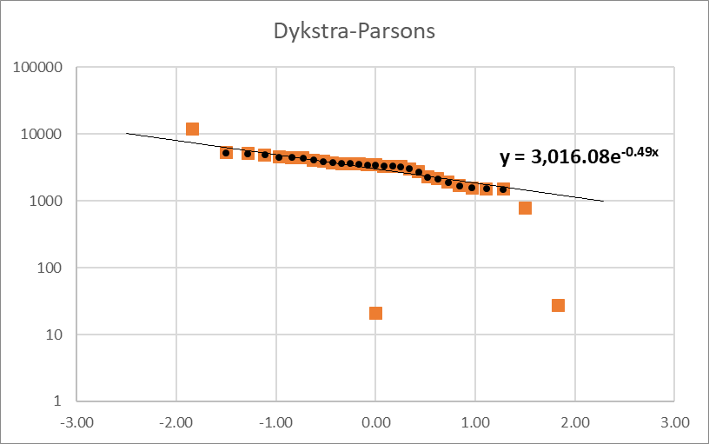 



1. Calculate the Lorenz coefficient. Show the Lorenz plot, the table of your calculations (similar to what we had in the class), and your calculation procedure to estimate the Lorenz coefficient.

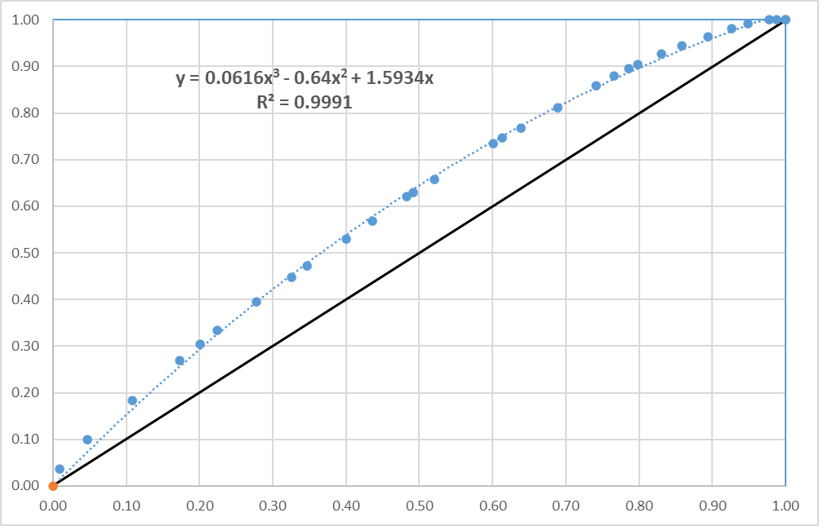



1. What is your opinion about the level of heterogeneity in this formation?

Aside from outliers, the heterogeneity coefficients and plots show a relatively homogeneous formation.

**Question 2:** Table 1 summarizes two-dimensional distribution of irreducible water saturation in a formation. Please answer the following questions. You can attach an extra page to your solution document and include your plots in that page with appropriate citation in the allotted space after each question. (You can use excel or any programming language of your choice for your calculations in this question)

**Table1**

|  |  |  |  |  |  |  |  |  |  |  |
| --- | --- | --- | --- | --- | --- | --- | --- | --- | --- | --- |
|  |  |  |  | Porosity in West-East Direction (%) | | | | |  |  |
| **Location (ft)** | **0** | **10** |  | **20** | **30** | **40** |  | **50** | **60** |
| Porosity in  North-  South  Direction  (%) | **0** | 20 | 15 |  | 19 | 21 | 26 |  | 18 | 19 |
| **10** | 17 | 16 |  | 23 | 21 | 29 |  | 25 | 15 |
| **20** | 22 | 17 |  | 24 | 17 | 26 |  | 32 | 30 |
| **30** | 20 | 15 |  | 27 | 23 | 27 |  | 29 | 20 |
| **40** | 19 | 25 |  | 32 | 28 | 22 |  | 24 | 28 |

1. Calculate the semivariance values on the experimental variogram in the west-east direction at lag distances 10 ft, 20 ft, and 30 ft. Show your calculations, fill out the following table, and plot the variograrm.

|  |  |  |  |
| --- | --- | --- | --- |
| Lag distance (ft) | 10 | 20 | 30 |
|  | 17.6 | 24.6 | 25.28 |



1. Calculate the semivariance values on the experimental variogram in the north-south direction at lag distances 10 ft, 20 ft, and 30 ft. Show your calculations, fill out the following table, and plot the variograrm.

|  |  |  |  |
| --- | --- | --- | --- |
| Lag distance (ft) | 10 | 20 | 30 |
|  | 15.25 | 18.64 | 22.32 |



1. Calculate the semivariance values on the experimental variogram in the northeastsouthwest direction at lag distances 10 2 ft, 20 2 ft, and 30 2 ft. Show your calculations, fill out the following table, and plot the variograrm.

|  |  |  |  |
| --- | --- | --- | --- |
| Lag distance (ft) |  |  |  |
|  | 23.04 | 16.03 | 28.56 |



1. Calculate the semivariance values on the experimental variogram in the northwestsoutheast direction at lag distances 10 2 ft, 20 2 ft, and 30 2 ft. Show your calculations, fill out the following table, and plot the variograrm.

|  |  |  |  |
| --- | --- | --- | --- |
| Lag distance (ft) |  |  |  |
|  | 21.79 | 26.47 | 28.81 |



1. Is the variogram isotropic or anisotropic?

Plotting all variograms in a single grid, we can see less higher correlation lengths and higher variance (sill) in NW-SE and W-E directions. While the data show some degree of anisotropy in porosity, we can see some similarity among the directions analyzed.

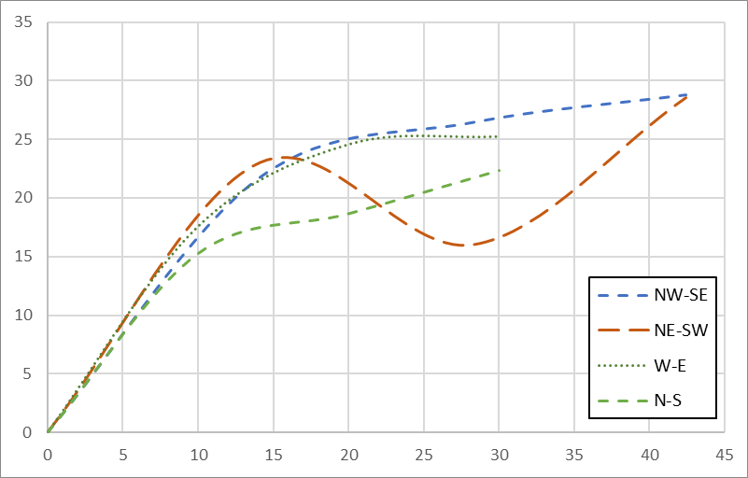

**Question 3:** Consider arrangement of points shown in Figure 1. The volumetric concentration of clay at locations *x1*, *x2*, and *x3* is measured to be 10%, 30%, and 45%. The theoretical autocovariance is given by:



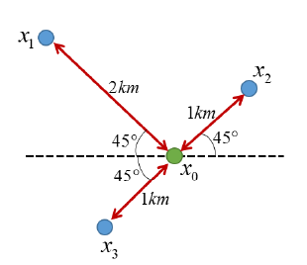

**Figure 1:** Arrangement of data points in Question 3

1. We plan to use ordinary kriging to estimate volumetric concentration of clay at location *x*0. Show your calculations and write the final result in terms of ’s.

km

km

Covariance matrix:

System of equations:

The solution is:

Please write your equation for calculation of ’s **in the following format**. The matrices will be graded.

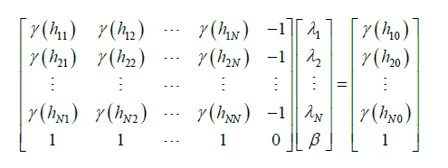

1. Estimate volumetric concentration of clay at location ***x*0**. Show your calculations and write the final result below.

___34.87%___

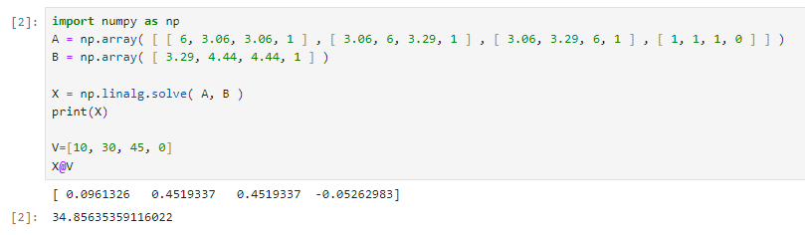

1. Calculate the minimum error variance for estimate of volumetric concentration of clay at location ***x*0**. Show your calculations and write the final result below.

____________

1. Calculate the 99% confidence interval for estimate of volumetric concentration of clay at location ***x*0**. Show your calculations and write the final result below.

________

**Question 5: (Optional) You do not need to submit your solutions for this question.**

Consider the TOC data (TOC_Spatial data) provided to you on Canvas website and investigate the impact of following parameters on kriging results and minimum error variance:

1. Variogram model
2. Variogram parameters such as slope, sill, and nugget effect
3. Number of data points used as input to kriging