**Advanced Petrophysics**

**PGE 381L, Fall 2023**

**Unique Number: 20215**

**Homework Assignment No. 7**

November 9, 2023

Due on Thursday, November 16, 2023, before 11:00 PM

Name: ­­­­­­­­­­_____________________________________________________________________­__

UT EID: ­­­­­­­­­­ ____________________________________________________________________

**Objectives:**

1. To understand concepts of wettability and interfacial/surface tension
2. To practice assessment of wettability

**Coursework Copyright Policy:** Handouts and data used in this course are copyrighted. The designation "handouts" includes all the materials generated for this class, which include but are not limited to syllabus, quizzes, data, exams, solution sets, laboratory problems, in-class materials, PowerPoint presentations, PDF files, review sheets, additional problem sets, and digital material. Because these materials are copyrighted, students do not have the right to copy them, reproduce them (including digital reproductions), post them on the web, or share them with anyone by either manual or electronic means unless you are expressly granted permission by the instructor.

**Note:** Please scan your homework assignment and upload it as one pdf file on the Canvas website before the deadline. Please name your homework document as follows:

*PGE381L_2023_Fall _HW07_lastname_name.pdf*

Example: PGE381L_2023_Fall_HW07_Heidari_Zoya.pdf

**Question 1:** A graduate student in my research team measured the data required for wettability assessment in two rock samples. We labeled them as rock samples A and B. You can find this data in the uploaded Excel file “PGE381L_HW_07_Data”. Please note that she tried to organize her measurements in a way to be able to estimate both Amott and USBM wettability indices. She used brine and decane for her measurements. Use the data provided to you and answer the following questions:

1. Create the plots you need for assessment of USBM wettability index. Estimate USBM wettability index for rock samples A and B.
2. Estimate Amott wettability index for rock samples A and B.
3. Fill out the following two tables and compare the wettability of these two samples.

|  |  |  |
| --- | --- | --- |
| **Amott Index** | **Rock Sample A** | **Rock Sample B** |
| Iw |  |  |
| Io |  |  |
| AI = Iw-Io |  |  |

|  |  |  |
| --- | --- | --- |
| **USBM Index** | **Rock Sample A** | **Rock Sample B** |
| Forced Brine (A2) |  |  |
| Forced Decane (A1) |  |  |
| Wettability Index |  |  |

**Question 2:** The oil/water interfacial tension and contact angle for an oil-water-solid system are 30 dynes/cm and 60˚. How much Super XX water-soluble surfactant would be required to make the system fully water-wet if each part per million (ppm) of Super XX reduces the interfacial tension between water and the solid by 2 dynes/cm, the oil/water interfacial tension by 4 dynes/cm but does not alter the interfacial tension between the oil and the solid?

**Question 3:** We plan to use the setup, illustrated in **Figure 1**, to estimate surface tension of liquid X, *σ*. In this method, we plan to use the force applied to pull up the triangular plate to estimate surface tension. Assume the system is in equilibrium. Answer the following questions:

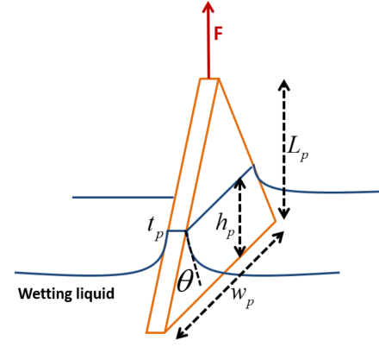

**Figure 1:** Experimental setup for question 1

1. Estimate surface tension as a function of the following parameters:

Force applied to pull up the plate: F

Thickness of the plate: *tp*

Total vertical length of the plate: *Lp*

Total horizontal length of the plate: *wp*

Height of the submerged section of the plate: *hp*

Contact angle between the surface of the plate and the liquid: *θ*

Density of the plate: *ρp*

Density of the liquid: *ρL*

1. Simplify your answer to part (a) assuming that thickness of the plate is negligible compared to its vertical and horizontal lengths.

Optional Question: Figure 2 shows free or spontaneous imbibition of water into two capillary tubes of radii r1 and r2 (where r1<r2) joined through a constriction (pore throat) of radius rA (where rA<r1). At this time, the water-gas menisci in tubes 1 and 2 are still moving to the right. The pressure at the inlet and outlet of each tube is constant and equal to the atmospheric pressure. Derive an equation for the distance (xi) traveled by meniscus i in tube i as a function of time (t) and the other pertinent variables of the problem. Assume xi = 0 at t= 0. Use the following nomenclature:

w = water density

 = water-air interfacial tension

❑ = water-air-solid contact angle

r1 = radius of capillary tube 1

r2 = radius of capillary tube 2

rA = radius of constriction at A

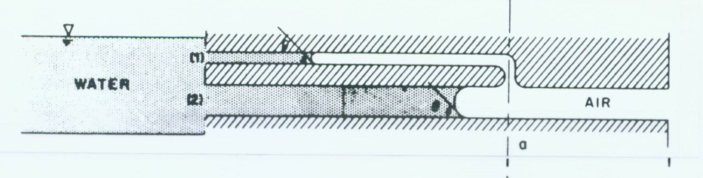

Figure 2