**Advanced Petrophysics**

**PGE 381L, Fall 2023**

**Unique Number: 20215**

**Homework Assignment No. 8**

November 16, 2023

Due on Thursday, December 4, 2023, before 11:00 PM

Name: ­­­­­­­­­­_____________________________________________________________________­__

UT EID: ­­­­­­­­­­ ____________________________________________________________________

**Objectives:**

1. To practice application of Young-Laplace equation to estimate capillary pressure
2. To practice assessment and interpretation of capillary pressure
3. To practice saturation-height analysis
4. To understand trapping mechanisms

**Coursework Copyright Policy:** Handouts and data used in this course are copyrighted. The designation "handouts" includes all the materials generated for this class, which include but are not limited to syllabus, quizzes, data, exams, solution sets, laboratory problems, in-class materials, PowerPoint presentations, PDF files, review sheets, additional problem sets, and digital material. Because these materials are copyrighted, students do not have the right to copy them, reproduce them (including digital reproductions), post them on the web, or share them with anyone by either manual or electronic means unless you are expressly granted permission by the instructor.

**Note:** Please scan your homework assignment and upload it as one pdf file on the Canvas website before the deadline. Please name your homework document as follows:

*PGE381L_2023_Fall _HW08_lastname_name.pdf*

Example: PGE381L_2023_Fall_HW08_Heidari_Zoya.pdf

**Question 1:** This question can be considered as an application of Young-Laplace’s equation in evaluation of oil migration in porous media. Figure 1 shows an oil blob being displaced by water at the pore scale in a reservoir. The blob has encountered a constriction at a pore throat. In order for the oil blob to pass through the constriction and be produced, a sufficiently high pressure gradient must be applied across the blob. If such a pressure gradient cannot be generated by the water injection, then the blob will be trapped as residual oil. The objective of this exercise is for you to calculate the pressure gradients necessary to mobilize the blob for a variety of situations to determine whether or not such gradients can be created under normal oilfield flow conditions. Answer the following questions:

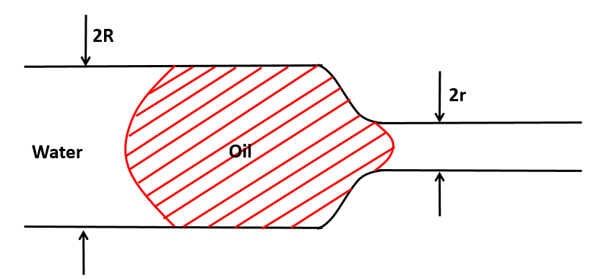 Wetting phase = water

Oil-water interfacial tension =  dynes/cm

Contact angle = ˚

Radius of pore body = R (cm)

Radius of pore throat = r (cm)

**Figure 1**

Length of blob = L (cm)

1. Calculate the pressure gradients required for mobilization of the oil blob for an average sand and a very fine sand. Assume the following:

R = 5r

L = R

θ = 0˚

For average sand: r = 0.005 cm

For very fine sand: r = 0.001 cm

For a normal waterflood:  = 30 dynes/cm

1. Calculate the pressure gradients generated in a normal waterflood in rock types A and B (with an order of magnitude difference in permeability) using the following assumptions:

Darcy velocity = 1 ft/day

Water viscosity = 1 cp

Effective permeability to water in rock type A = 2 darcies

Effective permeability to water in rock type B = 500 md

Are these pressure gradients sufficient to mobilize the oil blob of part (a)?

1. Repeat the calculations of part (b) for an enhanced waterflood in which a surfactant has been added to the injected water so as to reduce the oil-water interfacial tension to 0.01 dyne/cm. Comment on the effectiveness of the enhanced waterflood under normal oilfield flow conditions for rock types A and B.
2. Compare the capillary numbers for the ordinary waterflood and the enhanced waterflood for rock types A and B. The capillary number is given by



where

*Nc* = capillary number

*μw* = water viscosity

*v* = darcy velocity

*σ* = water-oil interfacial tension

We will talk about capillary number later on in the class. In this assignment, I want you to get familiar with this unitless number and the way it is calculated.

**Question 2:** Figure 2 shows an upward migrating oil bubble from a source rock into a reservoir initially fully saturated with water. The migrating bubble has encountered a restriction at a pore throat of radius rH. In order for migration to continue, the leading end of the bubble (A) must squeeze through the pore throat. Assume that ends A and B of the bubble are hemispherical with B having a radius rB.

1. 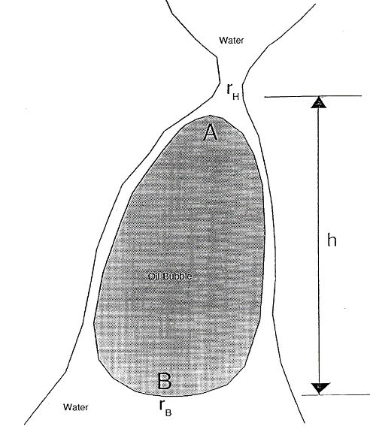Derive the condition necessary for the oil bubble to pass through the restriction and continue with its migration in terms of the following parameters:

Water density = *ρW*

Oil Density = *ρO*

**Figure 2**

Oil/water interfacial tension = *σ*

Gravitational acceleration = *g*

Pore throat radius = *rH*

Bubble base radius = *rB*

Height of bubble = *h*

1. Now assume the following quantitative reservoir properties and calculate the height the bubble must achieve in order to continue migration.

*ρW* = 1.00 g/cm3

*ρO* = 0.8 g/cm3

*σ* = 35.0 dynes/cm

*g*= 981 cm/s2

*rH*= 0.0001 cm

*rB* = 0.01 cm

**Question 3: Figure 3** shows a microchannel placed horizontally on a chip. Assume that the microchannel has a circular shape with radius of *r*. Answer the following questions:

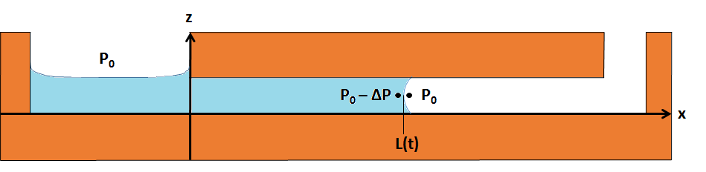

**Figure 3:** Schematic of a capillary-force micro-scale pump

1. Derive an expression for *L*(*t*) as a function of *r*, *t*, fluid viscosity (*µ*), surface tension (*σ*), and contact angle (*θ*).
2. Derive an expression for the speed of fluid advancement in the horizontal microchannel.
3. If you are asked to decide about the pump’s material type, would you use Platinum or Plexiglas? Which one provides a higher pump efficiency?

HINT: Contact angle in the case of Platinum is smaller than the case of Plexiglas.

**Question 4:** The following data are given for the pore doublet model of Figure 7.73 in your textbook:

v1 = 1 ft/Day

L = 500 μm

μ = 1 cp

σ = 30 dynes/cm

θ = 0 degrees

r1 = 50 μm

r2 = 2.5 μm

Assume the capillaries are cylindrical tubes and that capillary tube 1 (with radius r1) is larger than capillary tube 2 (with radius r2). Answer the following questions:

1. Calculate (PA – PB) across capillary tube 1 in dynes/cm2. What percentage of this pressure difference is due to viscous pressure drop and what percentage is due to capillary pressure? Are you surprised by the degree of domination of one force over the other at the pore scale?
2. Calculate the ratio v2/v1. Which capillary tube will be displaced first, the larger tube or the smaller tube in this strongly water-wet medium?

**Optional Bonus Questions:**

**Question 4:** This is the same data set we will use in the class for practice (November 28th lecture). Please work on this example individually to make sure that you learn the concept we covered in the class.

Download the Excel file “PGE81L_HW_08_Data1” including the capillary pressure curves for the two layers of thickness 100 ft in a conventional reservoir. The water-oil density difference is 8.05 lb/ft3. Assume that the water-oil contact is at the bottom of the lower layer. Calculate the water saturation versus depth measured from the top to the bottom of the reservoir. Present the results of your calculations by plotting a graph of Depth versus Water Saturation, with Depth plotted on the vertical axis and Water Saturation plotted on the horizontal axis.

**Question 5:** Table 1 summarizes the results of a centrifuge drainage capillary pressure measurement along with other pertinent data about the experiment. Calculate and plot the drainage capillary pressure curve for the sample. Express your capillary pressure in psi.

Table 1: Centrifuge Data for Question 1

|  |  |  |
| --- | --- | --- |
| *d* | 2.5 | cm |
| *L* | 7.35 | cm |
| *k* | 143 | md |
| ** | 19.0 | % |
| *Vp* | 7.04 | cc |
| *w* | 1.036 | g/cc |
| *o* | 0.822 | g/cc |
| *ow* | 40 | dynes/cm |
| ** | 0 |  |
| *r1* | 8.25 | cm |
| *r2* | 15.6 | cm |
|  |  |  |
| **RPM** | **Vw (cc)** |  |
| 520 | 0.0 |  |
| 800 | 1 |  |
| 860 | 1.5 |  |
| 920 | 2 |  |
| 1000 | 2.5 |  |
| 1100 | 2.9 |  |
| 1200 | 3.2 |  |
| 1400 | 3.6 |  |
| 1620 | 3.9 |  |
| 1800 | 4 |  |
| 2100 | 4.2 |  |

**Question 6:** Download the Excel file “PGE81L_HW_08_Data2” including mercury injection capillary pressure data obtained on a core sample. The core sample has a permeability of 3.86 md and a porosity of 13.2%. Answer the following questions.

1. Plot Sw and Snw versus pore throat radius on the same graph.
2. Calculate the probability density function for the pore volume distribution and plot it on the same graph of Sw and Snw versus pore throat radius. Use the 5-point central difference formula for calculating all derivatives.
3. Calculate the probability density function for the pore radius distribution assuming a bundle of capillary tubes model for the porous medium. Compare this distribution with the pore volume distribution by plotting them on the same graph versus pore throat size. Comment on the pore structure of this sample.
4. Estimate the absolute permeability of the sample from the mercury injection data. How does it compare with the lab measured permeability?

**Question 7:** Solve two questions of your choice from chapter 7 of your text book.