**PGE381L – CHEAT SHEET MIDTERM FALL 2023**

**Units**

|  |  |  |  |
| --- | --- | --- | --- |
|  | SI | Darcy | oilfield |
| Time | s | s | day |
| Length | m | cm | ft |
| Pressure | Pa | atm | psia |
| Flow rate | m³/s | cm³/s | stb/day |
| Viscosity | Pa.s | cp | cp |
| Permeability | m² | Darcy (d) | Millidarcy (md) |
| Compressibility | Pa-1 | atm-1 | psi-1 |
|  |  |  |  |
| Gravity [$L/T^{2}$] | $9.807$ | $980.9$ | - |
| * 1 darcy = 9.869E-9 cm² = 9.869E-13 m²=1.062E-11 ft² | | | |

**Porosity**

Total, Effective *(contribution to flow)*, Interconnected.

Cubic packing: maximum porosity. Best sorting, higher $ϕ$

$ϕ=\frac{Vp}{Vb}=\frac{Vp}{Vp+Vg}=\frac{V_{b}-V_{g}}{V_{b}}$ $V_{g}=\frac{W_{dry}}{ρ_{g}}$ $V_{p}=V_{b}-V_{g}$

$V_{b}=\frac{W_{s}-W_{i}}{ρ_{f}}$ $W_{s}$: weight of saturated , $W_{i}$: weight immersed

Gas expansion - calibration $V_{s}=V_{1}-V_{2}\left(\frac{P_{2}}{P_{1}-P_{2}}\right)$ $V_{s}$: volume of solid

**In situ:**

$ρ_{b}=ϕρ_{fluid}+\left(1-ϕ\right)ρ_{matrix}$ $⟹$ $ϕ=\frac{ρ_{b}-ρ_{m}}{ρ_{f}-ρ_{m}}$ (1) $rhob ↔ ϕ_{D}$

$ρ_{m}=\sum{C_{i}ρ_{i}}$, $C_{i}$: % of the mineral $i$

$ρ_{f}=S_{w}ρ_{w}+\left(1-S_{w}\right)ρ_{o}$ (2)

Density and Neutron log – calibrated to

🡪 wrong lithology

🡪

🡪 direct reading, $Sw=100\%$

Resistivity log – ILD(deep) > ILM > SFLU(shallow) ;;; AT90 > AT30 > AT10

Workflow: $ϕ_{D}$ and $ϕ_{N}$ $→$ $\sqrt{…}$ $→$ $S_{W}$ with Archie $→$ $ρ_{f}$ with (1) $→$ $ρ_{HC}$ with (2)

Low GR: clay free ; resistivities overlap: no invasion

Shaly sands

$C_{sh}=\frac{GR-GR_{clean sand}}{GR_{shale}-GR_{clean sand}}$ Volumetric concentration of shale

$ρ_{B}=ρ_{sh}C_{sh}+ρ_{sand}(1-C_{sh})$

$ρ_{sand}=ρ_{m}\left(1-ϕ_{sand}\right)+ϕ_{sand}ρ_{f}$

$ϕ_{D}^{sh}=\frac{ϕ_{D}-C_{sh}{\left(ϕ_{D}\right)}_{sh} }{1-C_{sh}}$ $ϕ^{sh}$: corrected porosity;

$ϕ_{N}^{sh}=\frac{ϕ_{N}-C_{sh}{\left(ϕ_{N}\right)}_{sh} }{1-C_{sh}}$ ${\left(ϕ\right)}_{sh}$: measurement in shale

**Conductivity $σ=\frac{1}{R}$**

Clay free

Shaly

$$σ_{w}$$

$$σ_{0}$$

$σ_{0}=\frac{σ_{w}}{F}+C$

$C=0$ for clay free rocks

**Impact of stress, compressibility**

$C_{f}=\frac{1}{V_{p}}\frac{∂V_{p}}{∂P}=\frac{1}{ϕ}\frac{∂ϕ}{∂P}$

**Saturation**

Clay free! Log always read $R_{t}$!

**Formation Factor $F=\frac{R_{0}}{R_{w}}=\frac{a}{ϕ^{m}}$** , $R_{0}$: Sw=100% $R_{w}$: resistivity of the water

**Resistivity Index $I_{R}=\frac{R_{t}}{R_{0}}=\frac{1}{S_{w}^{n}}$**

**Archie: $R_{t}=R_{w}\frac{a}{ϕ^{m}S_{w}^{n}}$**

**Picker Plot: $\log{R_{t}}$** vs. $\log{ϕ}$

$r=R\frac{L}{A}$ $r$ is the resistance of the resistor ; $R$ is the resistivity

**Shallow resistivity: $R_{shallow}=R_{mud}\frac{a}{ϕ^{m} S_{xo}^{n}}$**

**Deep resistivity: $R_{deep}=R_{w}\frac{a}{ϕ^{m} S_{w}^{n}}$**

$S_{movable}=S_{xo}-S_{w}$

Electrical double layers around clay crystals

$$R_{wb}$$

$$R_{w}$$

$\frac{1}{R_{t}}=\frac{ϕ_{T}^{m}S_{wt}^{n}}{a R_{w}}\left(1+BQ_{V}\frac{R_{w}}{S_{wt}}\right)$ $S_{wt}$ is the unknown

$\frac{1}{R_{weq}}=\frac{1}{R_{wb}}+\frac{1}{R_{w}}$

Lamination

$R_{V}=C_{sh}R_{sh}+\left(1-C_{sh}\right)R_{sand}$

$\frac{1}{R_{H}}=\frac{C_{sh}}{R_{sh}}+\frac{1-C_{sh}}{R_{san}}$

$$\log{I_{R}}$$

$$\log{S_{w}}$$

Oil wet

Wat wet

**Darcy** *(§107)*

$q=-\frac{kA}{μ}\frac{ΔP}{Δx}$ Linear

$q\ln{\frac{r_{e}}{r_{w}}}=-\frac{k}{μ}2π h\left(P_{e}-P_{w}\right)$ Cylindrical

$v_{d}=\frac{q}{A}=-\frac{\overline{\overline{k}} }{μ} \overline{∇}Φ$ Inclined, anisotropic

**Permeability average**

|  |  |
| --- | --- |
|  | $$k_{avg}=\frac{∑k_{i}h_{i}}{∑h_{i}}$$ |
|  | $$k_{avg}=\frac{∑h_{i}}{∑h_{i}/k_{i} }$$ |

**Carman-Kozeny** *§104*

$k=\frac{ϕr^{2}}{8τ}=\frac{ϕ}{k_{0}τS_{P}^{2}}=\frac{ϕ^{3}}{k_{0}τ S_{s}^{2}{\left(1-ϕ\right)}^{2}}$ $τ={\left(\frac{L_{e}}{L}\right)}^{2}$ Tortuosity

$r$: radius of the capillar

$S_{P}$: wetted surface area of the pores per unit pore volume

$S_{S}$: wetted surface area per unit grain volume

$S$: wetted surface área per unit bulk volume ($S=S_{P} ϕ$)

Granular media: $k=\frac{D^{2}ϕ^{3}}{36 k_{0}τ{\left(1-ϕ\right)}^{2}}$ $⟹$ $D$: diameter of grains

$τ=ϕ F$*(§107)*

Pore circular in cross section 🡪

Cylindrical pores: $k=\frac{ϕr_{H}^{2}}{2τ}$ $⟹$ $r_{H}=\frac{1}{S_{P}}$

Flow through a cilinder(Hagen-Poiseuille): $q=\frac{π R^{2}}{8 μ}\frac{ΔP}{L}$

Flow through fractures (Hagen-Poiseuille): $q=\frac{w^{2}A}{12μ}\frac{ΔP}{L} ⟹k=\frac{w^{2}}{12}$

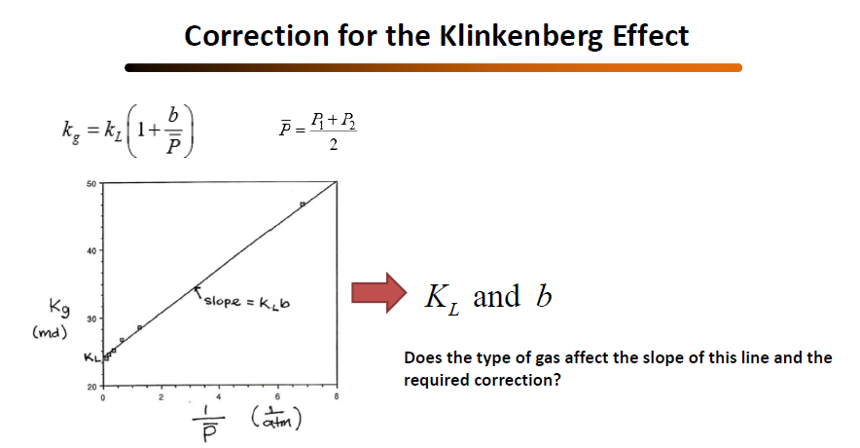Permeability given pore distribution: $k=\frac{ϕ}{32τ}\frac{\int_{0}^{∞}{f\left(δ\right)δ^{4}dδ}}{\int_{0}^{∞}{f\left(δ\right)δ^{2}dδ}}$, $\int_{0}^{∞}{f\left(δ\right)dδ=1}$

**Laboratory assessment (steady state)**

**Darcy and Boile: $q=-\frac{k_{L}A}{μ}\frac{ΔP}{Δx}$** (líq) $q=\frac{k_{G}A}{2μ} \frac{P_{in}^{2}-P_{out}^{2}}{L}$ (gás)

**Klinkenberg: $k_{G}=k_{L}\left(1+\frac{b}{\overline{P}}\right)$** , $\overline{P}=\frac{P_{in}+P_{out}}{2}$

**Workflow:** measure $P_{1},P_{2},q$; Calc $k_{G}$; Extrapolate $k_{L}$

**Anisotropy**

$\overline{\overline{k}}\left(u,v,w\right)=\left[\begin{matrix}k_{u} & 0 & 0 \\ 0 & k_{v} & 0 \\ 0 & 0 & k_{w}\end{matrix}\right]$ Principal axes of anisotropy

$\cos{θ_{12}}=\frac{{\overline{v}}_{1}∙ {\overline{v}}_{2}}{\left|{\overline{v}}_{1}\right|∙ \left|{\overline{v}}_{2}\right|}$

$\frac{1}{k_{s}}=\frac{\cos^{2}{β}}{k_{u}}+\frac{\sin^{2}{β}}{k_{v}}$ Permeability ellipse

Eigen values analysis to find the principal axes: $\det\left(k\left(x,y,z\right)-λI\right)=0$

**Pressure transient analysis (PTA) *🡪 Field units***

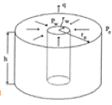**Drawdown:**

$P\left(r,t\right)=P_{i}-\frac{141.2 q μ B}{k h}\left(-\frac{1}{2}E_{i}\left(-\frac{948 ϕ μ c_{t} r^{2} }{kt}\right)\right)$

$P_{wf}\left(t\right)=P(r_{w},t)$

$E_{i}\left(x\right)=0.5722+ln⁡|x|$, $x<0.01$

$P_{wf}\left(t\right)=P_{i}-\frac{162.6 q μ B}{k h}\left(\log{t}+\log{\frac{k}{ϕ μ c_{t} r_{w}^{2}}}-3.23\right)$

Slope: $m=-\frac{162.6 q μ B}{k h}$

$S=1.1513\left(\frac{P_{wf}\left(1hr\right)-P_{i}}{-\left(\frac{162.6 q μ B}{k h}\right) }-\log{\frac{k}{ϕ μ c_{t} r_{w}^{2}}}+3.23\right)$

At $\log{t}=0$, ( $t=1)$, $P_{i}=P_{1}-m\left(\log{\frac{k}{ϕ μ c_{t} r_{w}^{2}}}-3.23\right)$ (initial pressure)

**Buildup**

$t^{*}=\frac{t_{P}+Δt}{t_{P}}$ (Horner time)

$P_{ws}\left(Δt\right)=P_{i}-\frac{162.6 q μ B}{k h}\log{t^{*}}$ (infinite res)

$S=1.1513\left(\frac{P_{wf}\left(t_{P}\right)-P_{ws}(1hr)}{-\left(\frac{162.6 q μ B}{k h}\right) }-\log{\frac{k}{ϕ μ c_{t} r_{w}^{2}}}+3.23\right)$

**Radius of investigation**

$r_{inv}=0.03248 \sqrt{\frac{kt}{ϕ μ c_{t}}}$