Advanced Geomechanics – WP5

3.6.2 Exercise 2: Depletion stress path

For this problem you have to use the geomechanical module of reservoir simulator CMG <https://www.cmgl.ca/>. The software is available to UT Austin students here: <http://pge.utexas.edu/LRC/>

a. Review the files [CMG_Geomechanics_Tutorial.pdf](https://github.com/dnicolasespinoza/GeomechanicsJupyter/) and [CMG_Running_InputFile.pdf](https://github.com/dnicolasespinoza/GeomechanicsJupyter/).

b. Change the vertical stress and well schedule as shown in the figure below (example files: [Injection1.dat](https://github.com/dnicolasespinoza/GeomechanicsJupyter/) and [Production1.dat](https://github.com/dnicolasespinoza/GeomechanicsJupyter/).

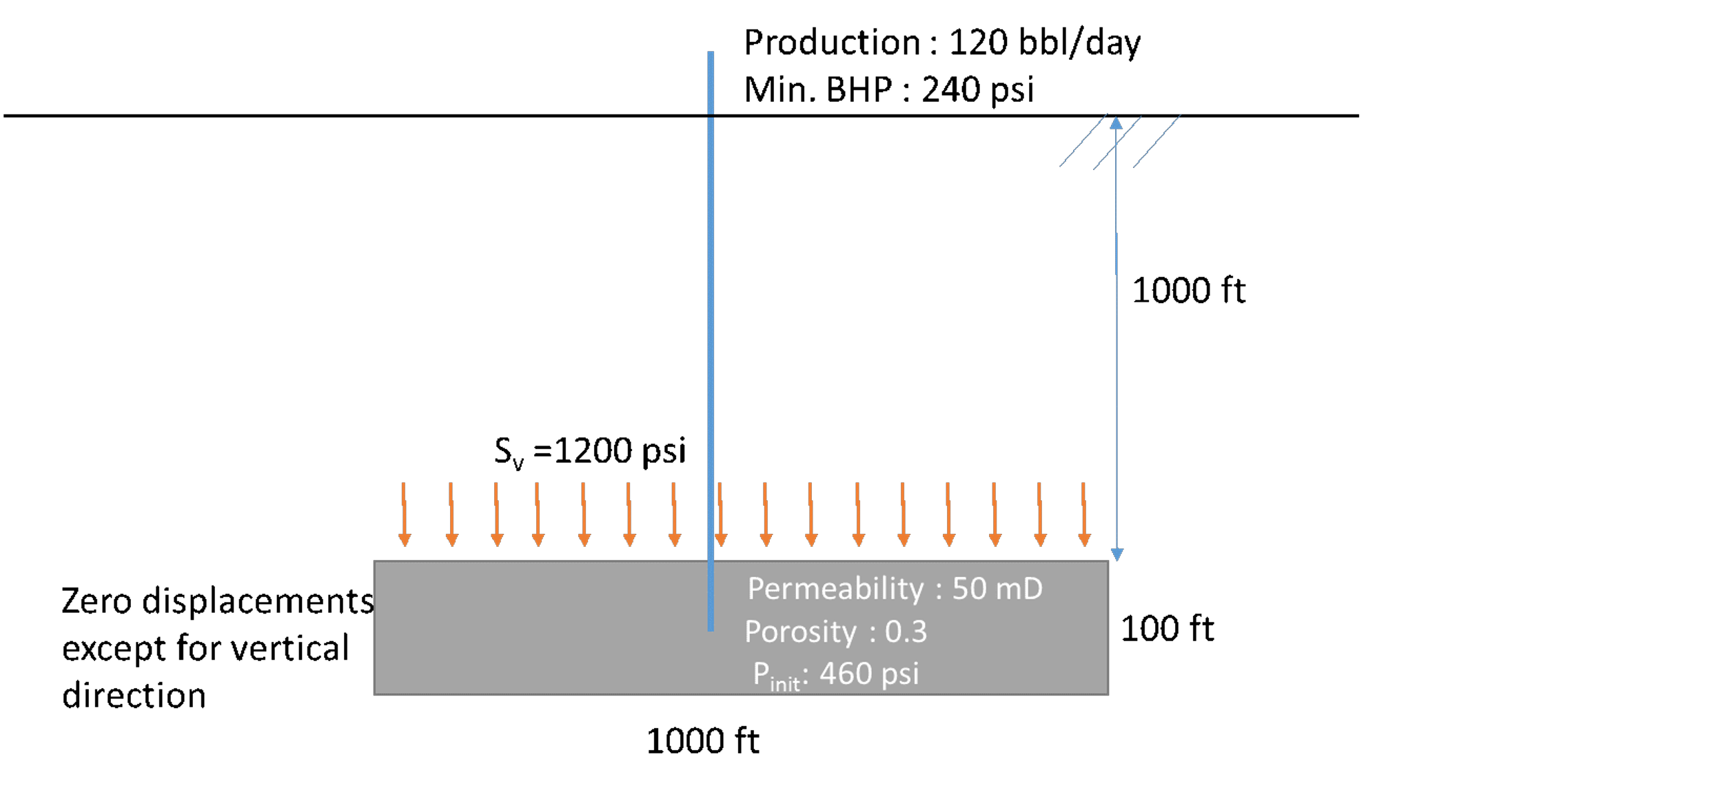

|  |
| --- |
| Figure 3.28: Schematic cross section of reservoir model for depletion. |
|  |

c. What is initial boundary condition in each direction? (i.e. constant stress or zero displacement).

**No displacement at front, back, bottom, left and right. We set constant total stress on top of the reservoir.**

d. Plot 1 - Plot minimum principal total stress (Total stress I), vertical total stress (Total stress K), and pore pressure (Pressure) vs time. (**Note: Please remove initial data (time = 0) when you plot).

e. Plot 2 - Plot minimum principal stress (y-axis) vs pore pressure (x-axis), and verify the slope of the curve is similar with ( is the Biot coefficient and is Poisson’s ratio - **Note: Please remove initial data (time = 0) when you plot pressure and stresses).

**We can see that the slope is similar to .**

f. Run the simulation again using Biot coefficient from the previous laboratory problem, repeat the question “d” using the new simulation result and plot on the same figure.

**Running with (), we get the following plots, and , as expected.**

g. Plot the stress path with Mohr circles for the initial (0.1 days) and final time (100 days).

h. Plot the stress path in the space for the same period of time.

p = (s 1 + 2s 3 )/3;

q = s 1 -s 3

i. What is the absolute minimum pressure to create a hydraulic fracture (i.e. minimum principal total stress) at the end of the simulation when bottom-hole pressure is BHP = 240 psi? Compare with the analytical solution.

The total horizontal minimum stress in the end of the simulation is about , with . The minimum pressure to create a hydraulic fracture would thus be around .

The analytical estimates would be **, which is similar.**