Compositional Equations

The compositional model allows three phases (aqueous, nonaqueous liquid, and nonaqueous vapor) and nc components. Currently, the aqueous component is restricted to the aqueous phase and the nonaqueous components are restricted to the nonaqueous phases. A Peng-Robinson EOS with a volumetric shift parameter is used to calculate fluid densities. Phase equilibrium requires that the component fugacities be equal in the liquid and vapor phases. Phase split calculations for a single phase can be performed using a stability test, borrowing K-values and doing a negative flash, or borrowing K-values and doing a regular flash. Fluid viscosities are calculated using a Lohrenz-Bray-Clark correlation.

Some Definitions
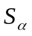 = Saturation of phase α, i.e. pore volume fraction occupied by phase α.

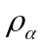 = Molar density of phase α.

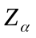 = Z-factor of phase α.

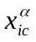 = Mole fraction of component ic in phase α.

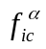 = Fugacity of component ic in phase α.

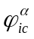 = Fugacity coefficient of component ic in phase α, 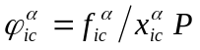.

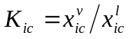is the K-value for component ic.

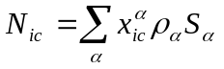is the concentration of component ic per unit pore volume (all phases).

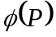 = Porosity.

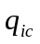 = Molar rate of component ic per unit reservoir volume.

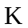 = Diagonal permeability tensor.

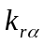 = Relative permeability for phase α.

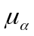 = Viscosity of phase α.

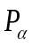 = Pressure in phase α.

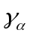 = Density gradient of phase α.

D = Depth

R = Universal gas constant, 10.732460 psia-ft³/ºR-lbM

v = Vapor fraction. Fraction of total nonaqueous moles that are in the vapor phase.

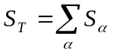is the sum of the saturations which does not sum exactly to one.

Equations for Fluid Flow
Partial differential equations representing component mass balances are:

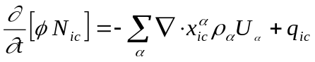

where the velocity of phase α is given by

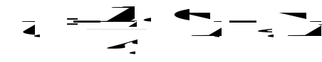.

Phase pressures are defined by

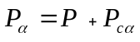

where P_{cα} is the capillary pressure and P is the reference pressure. The reference pressure is used for all flash calculations, all well calculations, and all geomechanical calculations. The keyword REFPRES determines which phase pressure is used as the reference pressure.

Porosity is a function defined by

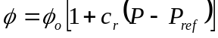

where 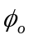 , c_{r}, and P_{ref} are functions of location.

Equations for Molar Volumes and Saturations
The molar volumes (1/ρ_{α}) of the nonaqueous phases (α = 2,3) are given by

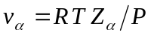

where Z_{α} is the Z-factor for phase α. The molar volume for the aqueous phase has the form

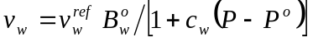

where 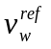 is the water molar volume at the surface, and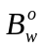 is the formation volume factor at pressure Pº and reservoir temperature. The parameters Pº, c_{w}, and are constants.

The saturations are calculated from the equations

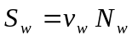

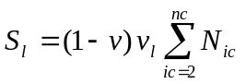

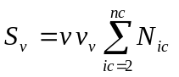

where v is the vapor fraction. The saturations calculated above may not sum to one so the program applies a saturation constraint of the form 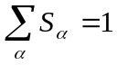.

Equation for Z-Factors
A Peng-Robinson EOS with a volumetric shift parameter is used to calculate Z-factors for each nonaqueous phase. The cubic equation has the form

where 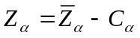. The program chooses the root with the lowest Gibbs free energy whenever multiple roots are encountered in the cubic equation.

The parameters A, B, and C are given by

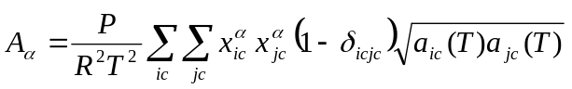

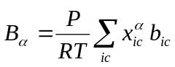

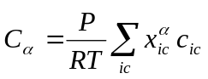

where 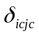is the binary interaction coefficient, b_{ic} is calculated from the input values for critical pressure and critical temperature, and c_{ic} is calculated from input values for volumetric shift, critical pressure, and critical temperature. The equations above assume summation over the nonaqueous components only. The parameter a_{ic} is calculated from the current temperature, critical pressure, critical temperature, and accentric factor. The program generates EOS tables for different values of temperature in order to minimize the calculations involving the generation of the parameters A, B, and C above.

Equation for Vapor Fractions
The Rachford-Rice equation for determining vapor fractions is

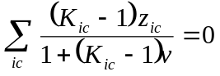

where K_{ic}, and z_{ic} are the K-value and overall nonaqueous mole fraction for component ic, respectively. The fluid is a single-phase liquid when v is zero and is a single-phase vapor when v is one. The negative flash algorithm allows v to be less than zero or greater than one in the equation above. Once v is determined from the Rachford-Rice equation, then the mole fractions in the liquid and vapor phases can be calculated from

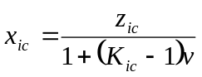 and 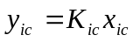

where 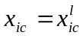, and 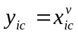. We also have 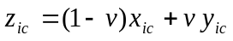.

Equations for Fugacities
Phase equilibrium at constant temperature and pressure requires that the component fugacities be equal in each phase, i.e.

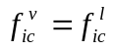

This is a necessary, but not sufficient condition for phase equilibrium. Phase equilibrium at constant temperature and pressure also requires that the Gibbs free energy be a minimum. However, for most reservoir applications it is sufficient to work with equality of fugacities and that is the approach currently taken in the program. Rather than solving the equations above for fugacities, the program solves for ln(K_{ic}) and works with the fugacity coefficients instead of the fugacities 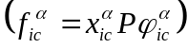 where we replace the equation above by

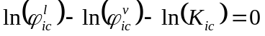

The logarithm of the fugacity coefficient for the Peng-Robinson EOS can be expressed as

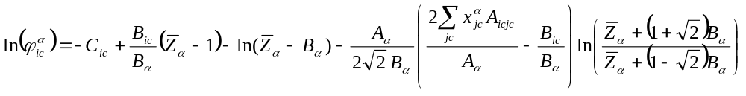

where 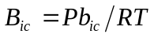, 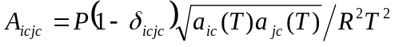, and 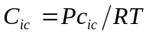. The term C_{ic} is not actually required in the calculations above because it is the same for both phases.

Surface Separation of Phases
All fluids must be flashed through surface separators to convert component rates into volumetric rates. Each surface separator can have multiple stages. Separator flash calculations assume that the liquid phase from stage i feeds into stage i+1 in a separator train. The program assumes ideal gas behavior at surface temperature and surface pressure to determine the volumes of the vapor streams from all stages. The liquid density for the final liquid stream for a separator is based upon the temperature and pressure of the last stage in that separator.

The volumetric rate at the surface is expressed as

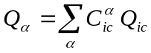

where the coefficients 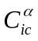 are calculated by flashing the molar rates Q_{ic} sequentially through the stages in a separator. Each phase rate is a homogenous function of first order in the component rates so the coefficients that are used in the above equation are the partial derivatives of the phase rates with respect to the component rates, i.e. 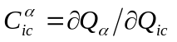. This produces a simple expression for the Jacobian when looking at rate changes in the equation above.

The program minimizes the number of flash calculations for wells by determining the K-values for each stage of a separator at the beginning of a timestep and keeping the K-values constant throughout the timestep. This requires that a full flash be done at the beginning of each timestep, but only the Rachford-Rice and cubic equations need to be solved during subsequent nonlinear iterations.

IMPEC Implementation
The IMPEC calculations in the program assume that all terms on the right hand side of the mass balance equations defined earlier are evaluated at the old timestep except for the fluid pressures. The accumulation term is expanded as

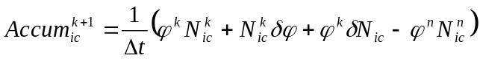

where k is the iteration number for timestep n. Once the term 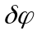 is expanded in terms of the change in pressure, the mass conservation equations can then be rearranged to express the change in N_{ic} in terms of the change in pressures.

The saturation constraint is written as

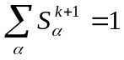

The program assumes that the saturations can be expressed in terms of the P, N_{ic}, v, and ln K_{ic}, and the saturation constraint is expanded as

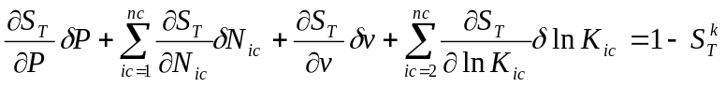

where . The fugacity equations and the Rice-Rachford equation can be expanded in terms of changes in P, N_{ic}, v, and ln K_{ic}, and can then be rearranged to express the changes in v and ln K_{ic} in terms of changes in P, and N_{ic}. The expressions for v and ln K_{ic} can then be substituted into the saturation constraint leaving only changes in P and N_{ic}. The mass conservations can then be substituted into the saturation constraint to eliminate the changes in N_{ic} which then leaves a single equation in terms of the changes in cell pressures. This equation in pressures can be solved using a standard linear solver.

Saturation Derivatives
For the derivatives that follow, we assume that N_{ic}, v, p, and ln(K_{ic}) are independent variables. If one uses the fugacity equations and Rice-Rachford equation to express v and ln(K_{ic}) in terms of N_{ic} and p, then one can use the chain rule to expand the partial derivatives in terms of N_{ic} and p. For the water saturation we have

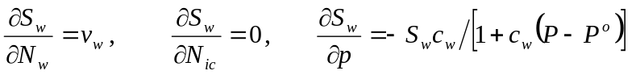

For the liquid saturation we have

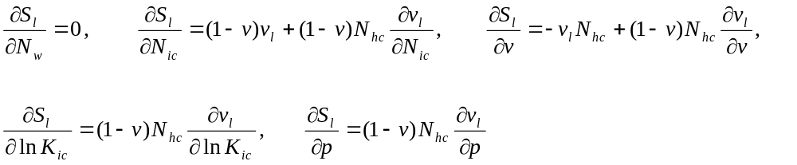

where 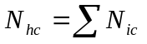

For the vapor saturation we have

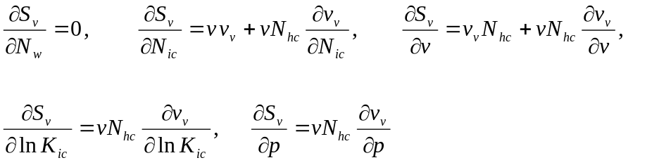

Vapor Fraction Derivatives
The Rachford-Rice equation for determining vapor fractions can be written as

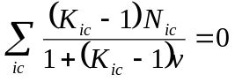

If we assume v is a function of N_{ic} and K_{ic}, then our derivatives for v are

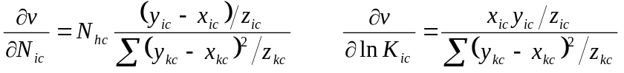

where we have used

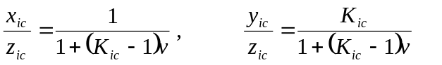

and

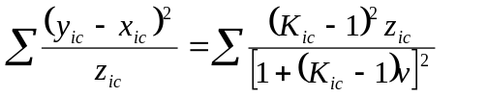

Mole Fraction Derivatives
The liquid mole fraction is

where 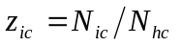.

The N_{ic} derivative of z_{ic} can be written as

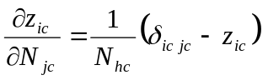

So the derivatives for the liquid mole fractions are

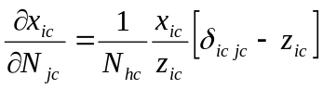

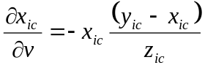

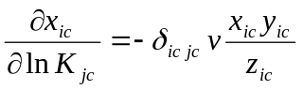

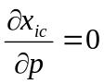

The vapor mole fraction is so we have

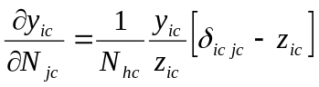

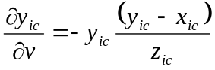

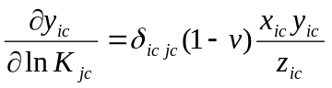

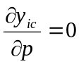

Molar Density Derivatives
The molar density is 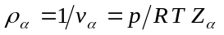so

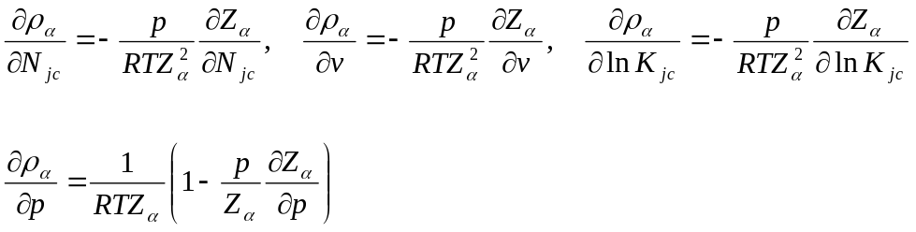

Z-Factor Derivatives
For z-factors we have

