VISCOSITIES COMPOSITIONAL MODEL

For the compositional model, the water viscosity is constant, and hydrocarbon fluid viscosities are calculated using a Lohrenz-Bray-Clark correlation. The procedure for calculating viscosities is:

Low Pressure Estimate for Pure Components

The low pressure pure component viscosity is estimated using a Stiel and Thodos correlation in the form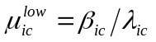, where 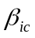 and 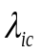 are defined by

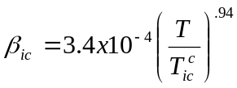 for 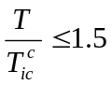

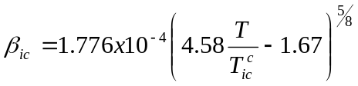 for 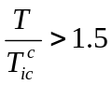
and

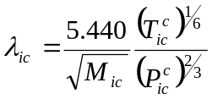

where 5.440 accounts for psia and ºR units for pressure and temperature, respectively.

Low Pressure Viscosity for Phase

The Herning and Zipperer correlation is used to calculate the low pressure phase viscosity using the pure component values as

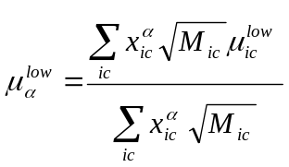

High Pressure Correction

The critical volume for component ic is defined as 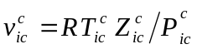 and the average critical volume for a phase is calculated as

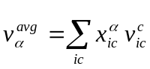

The low pressure phase viscosity is corrected for higher pressures using functional expressions that depend on the reduced molar density defined by 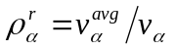 where 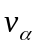is the molar volume for phase α.

The correlation uses the average molecular weight, critical pressure and critical temperature for the phase which are defined by

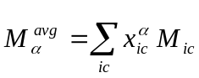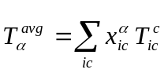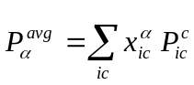

Also a phase value of 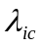 is defined for the phase viscosity correlation and is given by

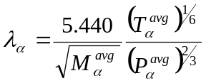

If the reduced molar density is greater than 0.18 then a Jossi et al. correlation is used where

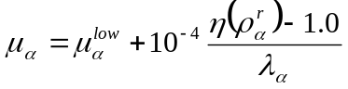
and

If the reduced molar density is less than 0.18 then a Thele linear extrapolation of the Jossi et al. correlation is used where

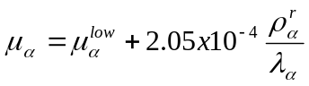
This linear extrapolation forces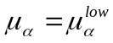 at zero reduced density and equals the Jossi et al. correlation at a reduced density of 0.18.

