Appendix ??
The Implicit Black-Oil Model

I. Black oil model physics

A. Oil component mass balance
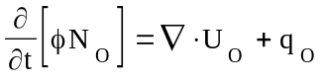

B. Water component mass balance
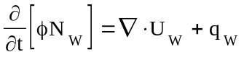

C. Gas component mass balance
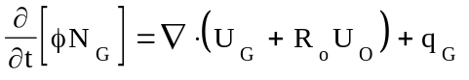

D. Mass velocity of component M in phase m for m equal to g, o, and w
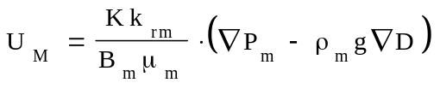

E. Capillary pressure
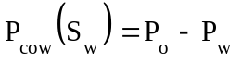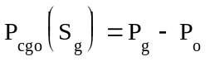

F. Porosity
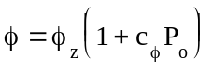 where 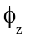 is a function of location and c_{Φ} (~2c_{r}) is constant

G. Three phase relations
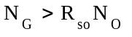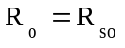
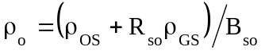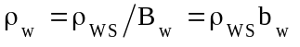
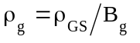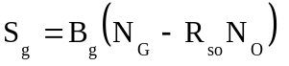
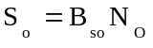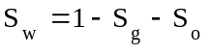
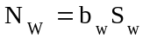

H. Two phase relations (oil and water)
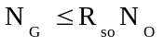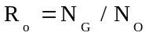
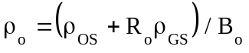
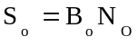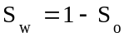
- Two phase oil reservoir volume factor

1. The oil volume factor, B_{o}, can be a complicated function of pressure and composition.
Two such functions are included here but others are possible. An important constraint on these functions is that the compressibility of oil be positive.

2. Simple explicit model (Model 1)
Let 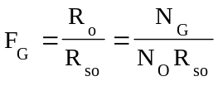 where R_{so} is evaluated at P_{o.} Then
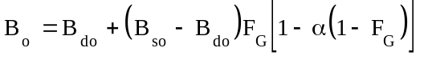
where α is a free parameter that can be used to prevent negative compressibility. Derivatives of B_{o} are:
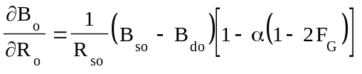
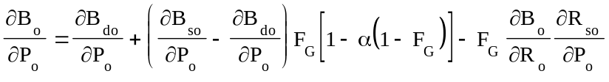

3. Implicit model (Model 2)
Let P_{s} be the oil pressure for which
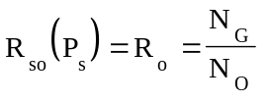
then P_{s} can be obtained by either by Newtonian iteration or by constructing the inverse function 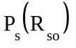. In either case the oil volume factor is given by
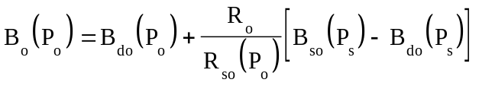
For reasonable functions B_{do} and B_{so}, this function will always yield positive compressibility. The derivatives of B_{o} are:
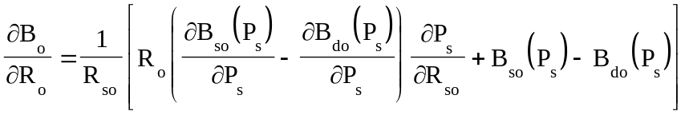
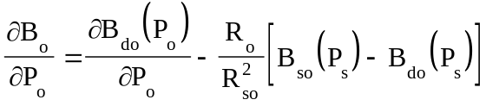
J. Definitions

1. N_{M} = Stock tank volume of component M per unit pore volume (all phases)

2. φ(P_{o}) = Porosity

3. R_{o} = Stock tank volume of gas dissolved in a stock tank volume of oil

4. R_{so}(P_{o}) = Stock tank volume of gas dissolved in a stock tank volume of oil when the oil
is saturated with gas

5. q_{I} = Stock tank rate of injection of component I per unit reservoir volume

6. K = Diagonal permeability tensor

- k_{rm} = Relative permeability to phase m

a. Three phases: k_{rw}(S_{w}), k_{ro}(S_{w},S_{g}), k_{rg}(S_{g})

b. Two phases, oil and water: k_{rw}(S_{w}), k_{ro}(S_{w})

8. B_{m}(P_{m}) = Formation volume factor = Ratio of the volume of phase m (including any
dissolved components) to the stock tank volume of component M.

9. B_{so}(P_{o}) = Formation volume factor of oil saturated with gas = Ratio of the volume of
the gas saturated oil phase to the stock tank volume of the oil component.

10. B_{do}(P_{o}) = Formation volume factor of gas free oil = Ratio of the volume of gas free oil
phase to the stock tank volume of the oil component.

11. b_{w}(P_{w}) = 1/B_{w}

12. μ_{m} = Viscosity of phase m

13. P_{m} = Pressure in phase m

14. ρ_{m} = Density of phase m

15. g = Gravity magnitude

16. D = Depth

17. ρ_{MS} = Stock tank density of component M

18. S_{m} = Saturation of phase m =..Fraction of the pore volume occupied by phase m

19. t = Time

20. = A dimensionless constant that can be used to match volume data for
undersaturated oil or to prevent negative compressibilities.

K. Units

- The internal units of the black-oil model can be made consistent (ie. no conversion factors) with the following associations. A conversion factor is required only in transmissibility terms.

N_{O} stbo/bbl N_{W} stbw/bbl N_{G} mscf/bbl
q_{O} stbo/bbl day q_{W} stbw/bbl day q_{G} mscf/bbl day
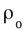 lb/bbl 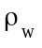 lb/bbl 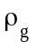 lb/bbl
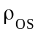 lb/stbo 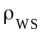 lb/stbw 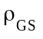 lb/mscf
R_{o} mscf/stbo R_{so} mscf/stbo B_{w} bbl/stbw
B_{o} bbl/stbo B_{so} bbl/stbo B_{do} bbl/stbo
B_{g} bbl/mscf t day P psi
U_{o} stbo ft/day U_{w} stbw ft/day U_{g} mscf ft/day
x,y,z ft Area bbl/ft Vol bbl
K md cp g psi bbl/ft lb

II. Difference equations

A. The primary unknowns are P_{o}, N_{O}, and N_{G}

- Definitions

1. Subscript ijk refers to grid element ijk

2. Superscript n refers to time level n

3. Superscript K refers to the Kth approximation to a quantity evaluated at time level n+1

4. Δt^{n+1} = t^{n+1}-t^{n} = time step size

5. V_{ijk} = Volume of grid element ijk

6. Δx_{i}, Δy_{j}, and Δz_{k} = edge lengths of a rectangular grid element ijk

7. Transmissibility constants
A_{i+1/2,jk} = 2 Δy_{j} Δz_{k} (Δx_{i} / K_{xx,ijk} + Δx_{i+1} / K_{xx,i+1,jk})⁻¹
A_{i,j+1/2,k} = 2 Δx_{i} Δz_{k} (Δy_{j} / K_{yy,ijk} + Δy_{j+1} / K_{yy,i,j+1,k})⁻¹
A_{ij,k+1/2} = 2 Δx_{i} Δy_{j} (Δz_{k} / K_{zz,ijk} + Δz_{k+1} / K_{zz,ij,k+1})⁻¹

8. Upstream weighting
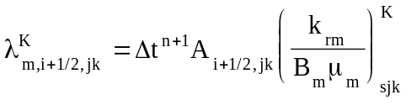
where s = i if 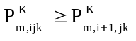 and s = i+1 if 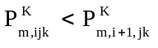.
Similar expressions apply for the y and z directions.

9. Average densities used in gravity terms
ρ_{m,i+1/2,jk} = (ρ_{m,ijk} + ρ_{m,i+1,jk}) / 2
Similar expressions apply for the y and z directions. If phase m does not exist in one of the two elements then the interface density is equal to the density in the element where the phase does exist.

B. Residual formulation

1. Multiply each component balance by Δt^{n} and V_{ijk} and apply backward difference to
time.
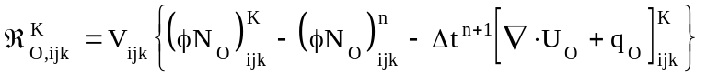
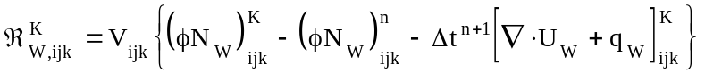
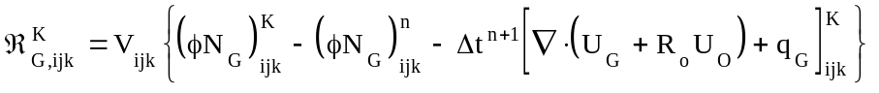

2. Component mass velocities
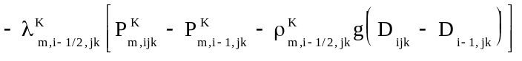
+ similar terms for the y and z directions.
+ similar terms for the y and z directions. Upstream weighting is applied to R_{o}.

C. Jacobian formulation

- Exact computation of the Jacobian is very expensive in terms of computation and memory
requirement. To reduce this cost, we will make some simplifying assumptions. These assumptions will be applied to the Jacobian but not to the residuals and thus will have no effect on the answer but may affect convergence. Indeed, the trick is to reduce computation without slowing or preventing convergence. Assume the following:

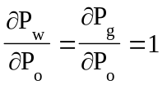

2. Derivative evaluation, three phases
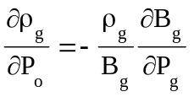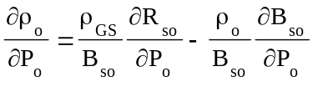
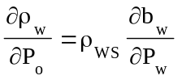 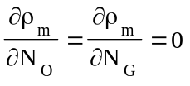 for any m
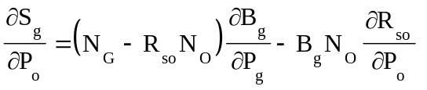
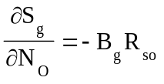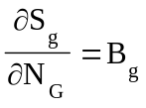
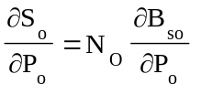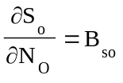
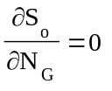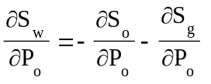
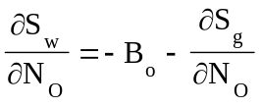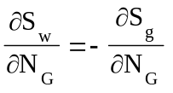
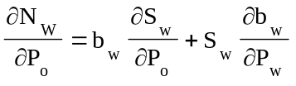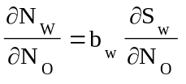
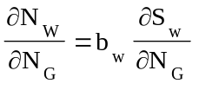 Let 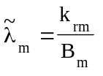
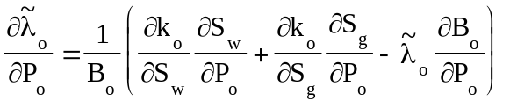
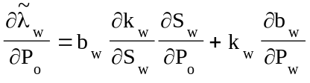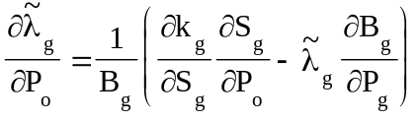
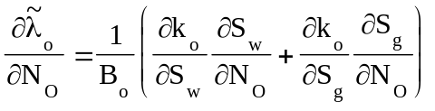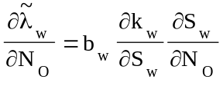
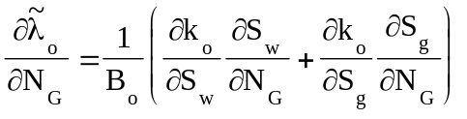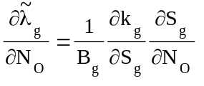
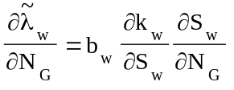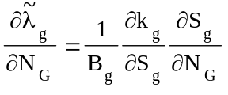
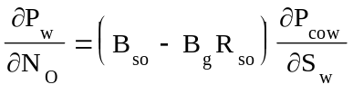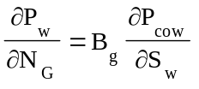
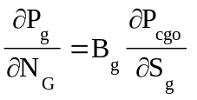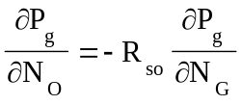

- Derivative evaluation, two phases (oil and water)
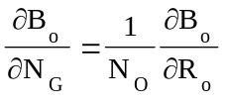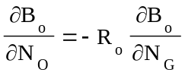
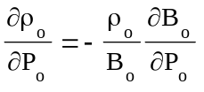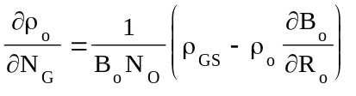
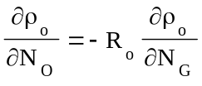
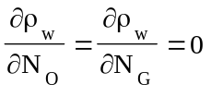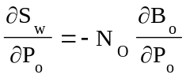
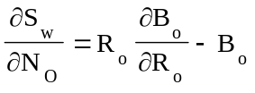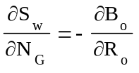
Let
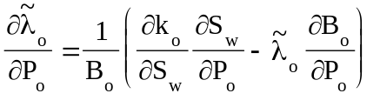
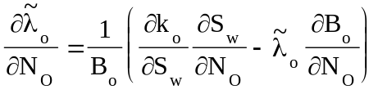
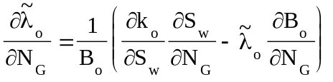
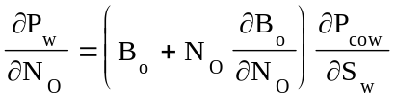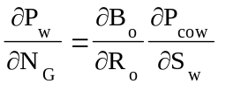

3. Accumulation
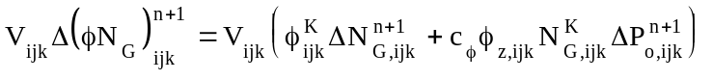
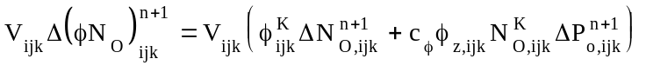
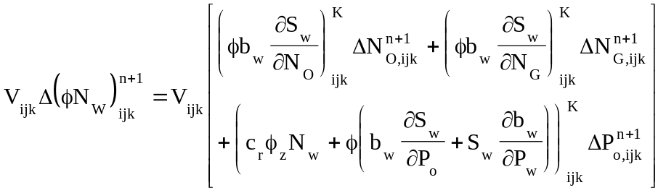

4. Transport
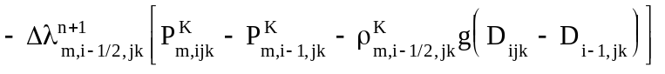
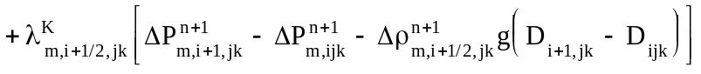
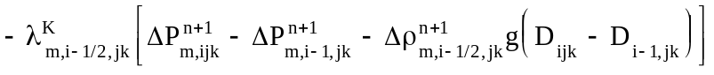
+ similar terms for the y and z directions.
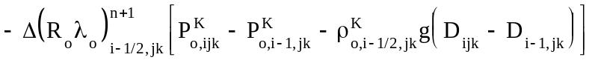
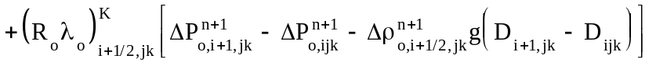
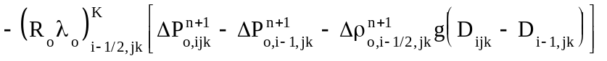
+ similar terms for the y and z directions.

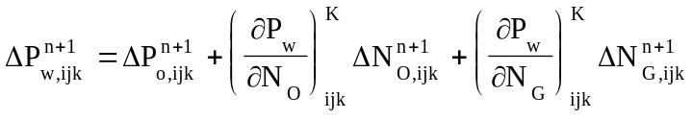
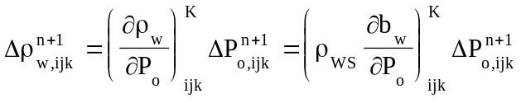
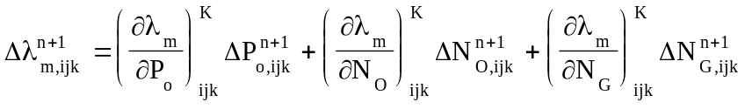

For three phases:
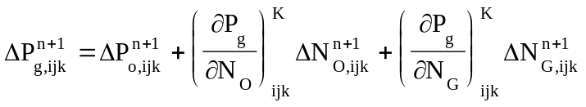
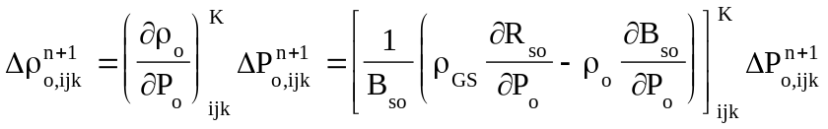
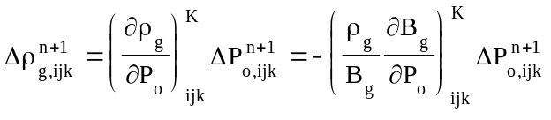
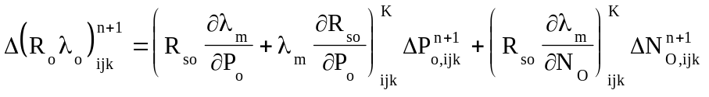
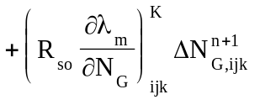

For two phases (oil and water):
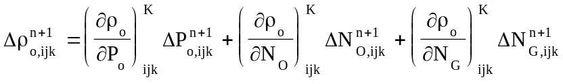
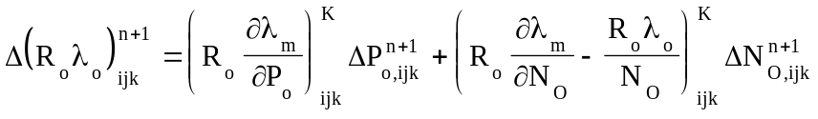
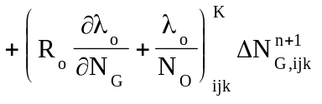

- Initial data input

- Most of the input data for the black-oil model and other physical models is input by the
framework and is documented in Appendix H. Only data specific to the black-oil model is documented here.

- Because of possible keyword conflicts when cases with multiple physical models are run, most
of the key words read by the black-oil model may be either a simple word or that word
preceded by B_.

- ROCKCMP (or B_ROCKCMP) = Pore volume compressibility which is approximately twice
the rock compressibility (default is 5E-7 /psi)

- OILVIS (or B_OILVIS) = Oil viscosity (default 2 cp)

E. WATERVIS (or B_WATERVIS) = Water viscosity (default .5 cp)

F. GASVIS (or B_GASVIS) = Gas viscosity (default .012 cp)

G. DINIT (or B_DINIT) = Depth at which initial conditions are specified (default 0 ft)

H. PWINIT (or B_PWINIT) =Initial water pressure at depth DINIT (default 100psi)

I. SWINIT (or B_SWINIT) = Initial water saturation at depth DINIT (default .4)

J. SGINIT (or B_SGINIT) = Initial gas saturation at depth DINIT (default 0)

K. KRINIT (or B_KRINIT) = Rock type at depth DINIT (default 1)

- FRSOINIT (or B_FRSOINIT) = Initial fraction of R_{so} at depth DINIT (default .9)
R_{o} = FRSOINIT R_{so}. If SGINIT > 0 then FRSOINIT is ignored.

- DFRSOINIT (or B_DFRSOIMIT) = Derivative of initial fraction of R_{so} with respect to depth
(default 0 /ft)

- CVTOL (or B_CVTOL) = Newtonian convergence tolerance (default 1.E-6). This value is
currently the only black-oil data that may also be read in the transient key word input.

- BSO = Reservoir volume factor (bbl/stbo) of gas saturated oil vs pressure (psi). Table input
with no default.

P. BOD = Reservoir volume factor (bbl/stbo) of dead oil vs pressure (psi). Table input with no
default.

Q. BOMODEL = Model number for subsaturated oil volume factor (default 1)

R. BOCONST = Free parameter for BOMODEL = 1 (default 0)

- RBW = Reciprocal of the reservoir volume factor (stbw/bbl) of water vs pressure (psi). Table
input with no default.

T. BG = Reservoir volume factor (bbl/mscf) of gas vs pressure (psi). Table input with no default

U. RSO = Disolved gas factor (mscf/stbo) vs pressure (psi). Table input with no default

V. PSAT = Inverse of the RSO table. Required only if BOMODEL = 2. No default

