Appendix ???
Three-Phase Relative Permeabilities
John Wheeler 12/4/99

Introduction.

Three-phase relative permeability data is rarely available, thus, approximations must be used.

Industry practice is to assume the relative permeabilities of water and gas are the same as two phase relative permeabilities. Only oil relative permeability is treated as a function of both water and gas saturations. Capillary pressures are also assumed to be the same as the two phase functions.

Formulas included here are taken from the review paper “Comparison of the Three-Phase Oil Relative Permeability Models” by Mojdeh Delshad and Gary A. Pope (1989).

IPARS is open ended with respect to three-phase oil relative permeability models; other models can be easily added. The three models currently in IPARS are documented here.

General Definitions.

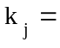Relative permeability of phase j.

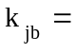Relative permeability of phase j in the two phase jb system.

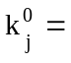Endpoint relative permeability of phase j (ie. other phase(s) are irreducible).

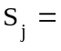Saturation of phase j.

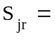Residual saturation of phase j.

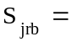Residual saturation of phase j in the two phase jb system.

Stone’s Model I.

The model is normalized by the method of Aziz and Settari.

Estimate residual oil saturation during three-phase flow by Fayer’s approximation.

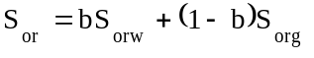

where 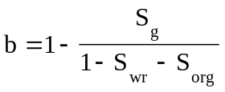

Let 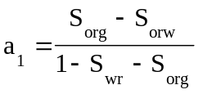

Then 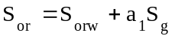

The model is 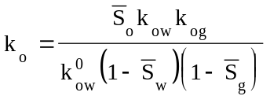 where

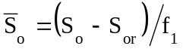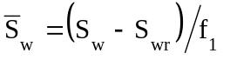

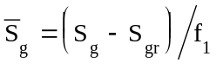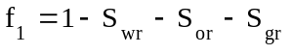

Define some constants and factors to simplify calculations.

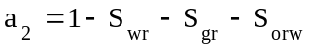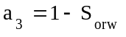

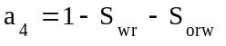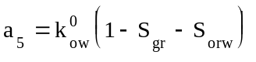

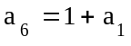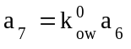

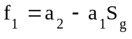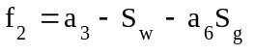

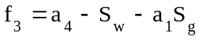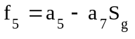

Then 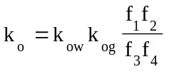

Derivatives.

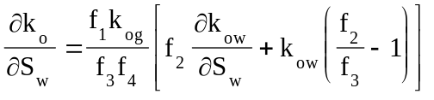

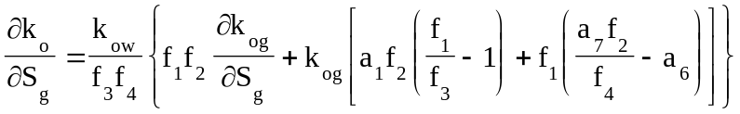

Stone’s Model II.

The model is normalized by the method of Nolen.

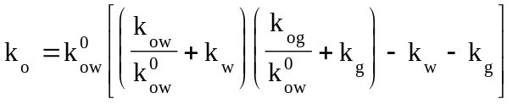

Let

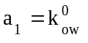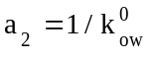

Then 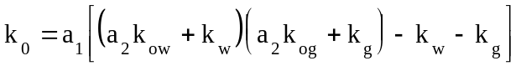

Derivatives

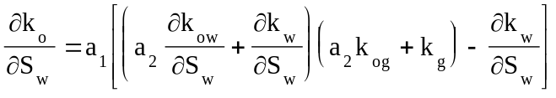

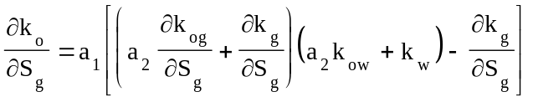

Corey’s Model

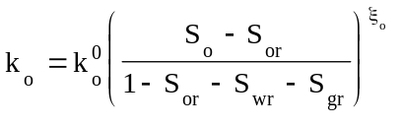

The exponent 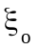will be defined below in terms of the corresponding exponents for the two-phase systems. These exponents are determined by fitting the following to the two-phase oil relative permeability.

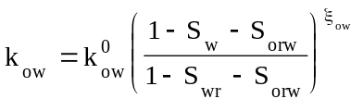

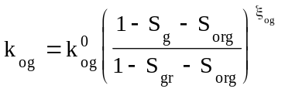

Here we will use Fayer’s approximation for three quantities

Let

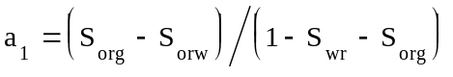

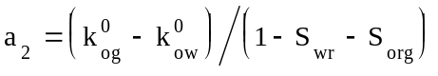

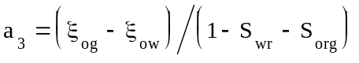

Then

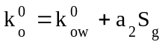

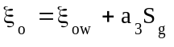

Define more constants and some factors

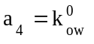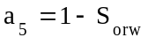

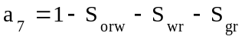

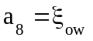

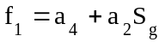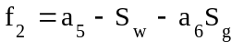

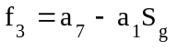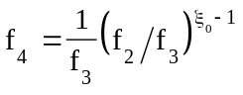

Then

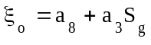

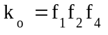

Derivatives

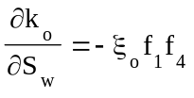

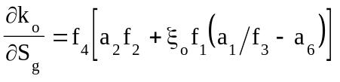

Note that the derivative 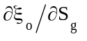 has been neglected.

IPARS input

The three-phase relative permeability for each rock type is identified in the input by the keyword MODREL(i) where i is the rock type.

Of the three models above, only Corey’s model contains parameters (other than two-phase relative permeability data) the user can specify.

RELCON1(i) = 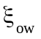

RELCON2(i) = 