Appendix A

Three-Phase Relative Permeabilities

Three-phase relative permeability data is rarely available thus approximations must be used. Industry practice is to assume the relative permeabilities of water and gas are the same as two-phase relative permeabilities. Only oil relative permeability is treated as a function of both water and gas saturations. Capillary pressures are also assumed to be the same as the two phase functions.

IPARS is open ended with respect to three-phase oil relative permeability models; other models can be easily added. The five models currently in IPARS are documented here. Formulas for the first three models were taken from the review paper “Comparison of the Three-Phase Oil Relative Permeability Models” by Mojdeh Delshad and Gary A. Pope (1989).

Some Definitions

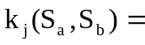 Relative permeability of phase j as a function of saturations.

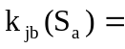 Relative permeability of phase j in the two-phase j-b system.

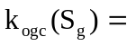 Relative permeability of oil in the three-phase system with water at the connate (irreducible) saturation 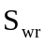.

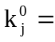 Endpoint relative permeability of phase j (ie. other phase(s) are irreducible).

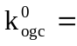 Endpoint relative permeability of the oil phase in the three phase system with oil and water at irreducible saturations and 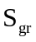.

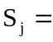 Saturation of phase j.

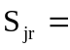 Residual saturation of phase j.

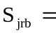 Residual saturation of phase j in the two-phase j-b system.

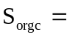 Residual saturation of the oil phase in the three-phase system with water at the connate (irreducible) saturation .

Stone's Model I.

The model is normalized by the method of Aziz and Settari. Note that the nominal two-phase gas-oil measurements are made in the presence of conate water. Estimate residual oil saturation during three-phase flow by Fayer’s approximation.

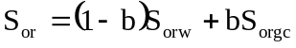

where 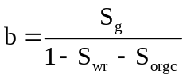
The model is then 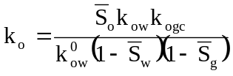 where

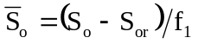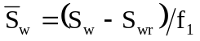

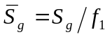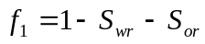

Stone's Model II.

This model is normalized by the method of Nolen.

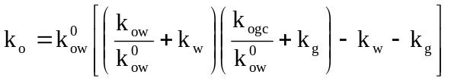

Corey's Model

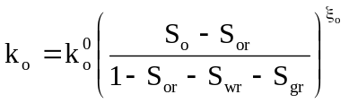

Here the nominal two-phase gas-oil measurements are made in the presence of connate water. The exponent 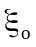is defined in terms of the corresponding exponents for the two-phase systems. These exponents are determined by fitting the following to the two-phase oil relative permeability.

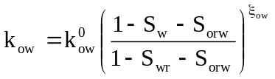

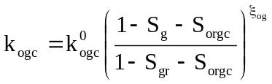

Here we use Fayer’s approximation for three quantities. Let

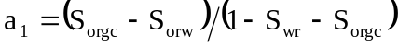

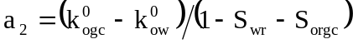

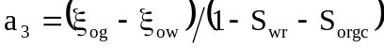

Then

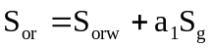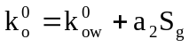

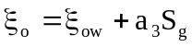

Wheeler's Model I.

This model utilizes gas-oil data taken in the absence of connate water. Oil relative permeability in the three-phase system is given by

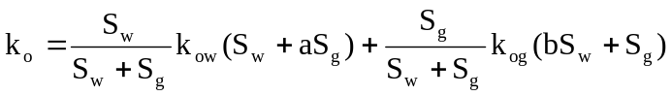

where the arguments of the 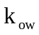 and 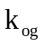 functions are given explicitly in the parentheses. The parameters a and b can be used to fit three-phase data if it is available. In the absence of three-phase data, set a and b equal to either .9 or .95 which produces isopermeability curves slightly concave toward the oil vertex.

Wheeler's Model II.

This model utilizes gas-oil data taken in the presence of connate water. Oil relative permeability in the three-phase system is given by

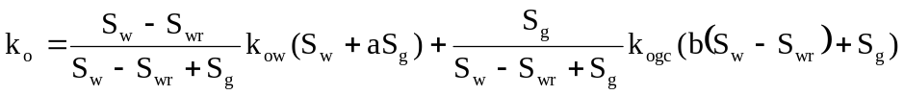

where the arguments of the and functions are given explicitly in the parentheses. The parameters a and b can be used to fit three-phase data if it is available. In the absence of three-phase data, set a and b equal to either .9 or .95 which produces isopermeability curves slightly concave toward the oil vertex.

