Appendix B

Well Theory

Well calculations are a crucial element of all oil reservoir simulations and most aquifer simulations. Wells are the only means the operator has of producing an oil field and otherwise influencing its behavior. Wells are also important in most aquifer simulations but may be overshadowed by surface phenomena such as lakes, streams, and rainfall. Often, these phenomena are represented in a simulation by arrays of wells.

Well/reservoir interaction relates bottom-hole conditions in the wellbore to the conditions in grid elements that the wellbore penetrates. Well management relates bottom-hole conditions to surface facility conditions. This appendix deals only with well/reservoir interaction.

Some Definitions

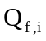 = The reservoir-volume rate of flow of a phase f from the wellbore to grid element i. Production rates are therefore negative.

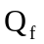 = The total reservoir-volume rate of flow of a phase f from the wellbore to the reservoir.

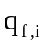 = The mass rate of flow of a phase f from the wellbore to grid element i.

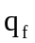 = The total mass rate of flow of a phase f from the wellbore to the reservoir.

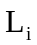 = Length of the open wellbore penetrating element i.

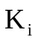 = Permeability of element i normal to the wellbore.

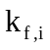 = Relative permeability of phase f in element i. For injection wells, the minimum value is set to .1 to insure that flow occurs.

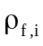 = Density of phase f in element i.

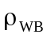 = Average fluid density in the wellbore.

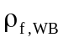 = Average density of phase f in the wellbore.

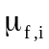 = Viscosity of phase f in element i.

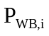 = Wellbore pressure at the center of the open interval in element i.

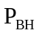 = Bottom hole pressure.

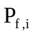 = Pressure of phase f at the center of grid element i.

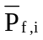 = Formation pressure of phase f in element i at the depth of the center of the open interval in element i.

= gravitational constant.

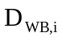 = Depth at the center of the wellbore open interval in element i.

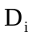 = Depth at the center of element i.

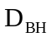 = Depth at the bottom of the open interval.

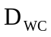 = Depth at the center of the open interval.

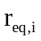 = Equivalent radius of the grid element i center

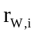 = Wellbore radius in element i.

= Skin factorin element i.

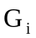 = dimensionless geometric factor.

Calculations

The basic equation coupling a well element to a grid element is given by

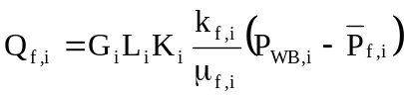.

The mass rate of flow of phase f from the well to grid element i is then

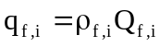.

Note that the reservoir phase density is used here because the volume rate is measured at reservoir conditions. The geometric factor in IPARS defaults to

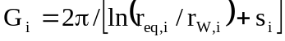

where = .208 * length of a block edge in a plane normal to the wellbore. The constant .208 results from a Peaceman type correlation of effective wellbore radii and strictly applies only to isotropic permeabilities, square grid elements, and single-phase flow from a well at the center of an interior grid element. IPARS allows the user to input a different geometric factor but does not currently offer a selection of factors for other geometries.

The two pressures in the equation for are adjusted for fluid head by

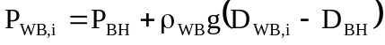 and

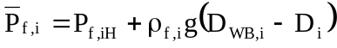.

This introduces the average fluid density, , in the wellbore which is defined implicitly by

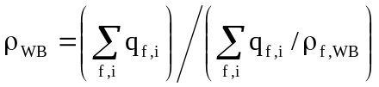

where 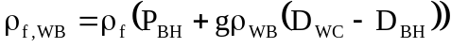.

Total well rates are given by the obvious expressions

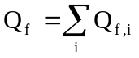 and 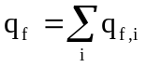

The formal definition of the well-reservoir equations is complete. Although it is less than obvious, these equations together with difference expressions for flow within the reservoir can be solved simultaneously by Newtonian iteration. For production wells, there is one degree of freedom which the user can specify. For injection wells, the number of degrees of freedom is equal to the number of phases injected. In IPARS, the user can specify bottom-hole pressure, total rate, or phase rates.

