Appendix C

Black-Oil Model Theory

The classical black-oil model has long been the mainstay of reservoir simulation; no simulator is complete without a capability for black-oil calculations. The black-oil model in IPARS can represent three phases (oil, water, and gas) and three components (also oil, water, and gas). The gas component is assumed to be distributed in equilibrium between the oil and gas phases. There is no gas component in the water phase, and the oil and water components exist only in their respective phases.

Some Definitions
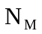 = Stock tank volume of component M per unit pore volume (all phases). Here and below upper case subscripts are used to indicate a component and lower case subscripts are used to indicate a phase.

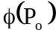 = Porosity.

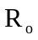 = Stock tank volume of gas dissolved in a stock tank volume of oil.

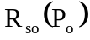 = Stock tank volume of gas dissolved in a stock tank volume of oil when the oil is saturated with gas.

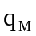 = Stock tank rate of injection of component M per unit reservoir volume.

 = Diagonal permeability tensor.

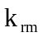 = Relative permeability to phase m. For three phases: 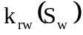, 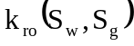, and 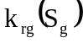. For two phases: and 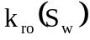.

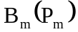 = Formation volume factor defined to be the ratio of the volume of phase m (including any dissolved components) to the stock tank volume of component M.

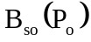 = Formation volume factor of oil saturated with gas, i.e. ratio of the volume of the gas saturated oil phase to the stock tank volume of the oil component.

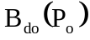 = Formation volume factor of gas free oil, i.e. ratio of the volume of gas free oil phase to the stock tank volume of the oil component.

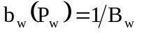

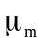 = Viscosity of phase m.

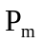 = Pressure in phase m.

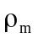 = Density of phase m.

= Gravity magnitude.

 = Depth.

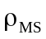 = Stock tank density of component M.

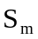 = Saturation of phase m, i.e. pore volume fraction occupied by phase m.

= Time.

= A dimensionless constant that can be used to match volume data for subsaturated oil or to prevent negative compressibilities. Used in only one of the models for subsaturated oil volume factor.

Basic Equations
Partial differential equations representing the oil, water, and gas component mass balance are:

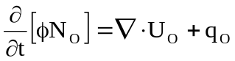

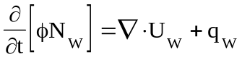

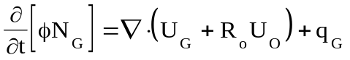

where the mass velocity of component M in phase m is

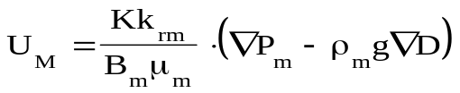.

The two capillary pressure functions are

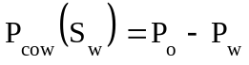 and 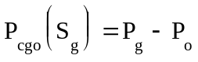.

Porosity is a function defined by

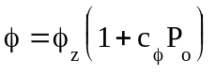 where 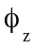 is a function of location and 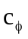 (~2c_{r}) is constant.

The following relationships hold when three phases are present:

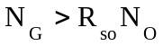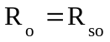

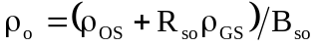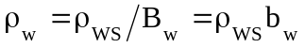

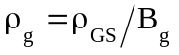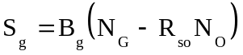

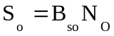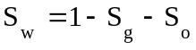

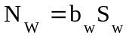

When only two phases (oil and water) are present then these relationships hold:

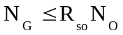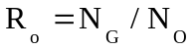

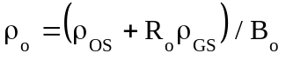

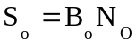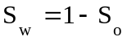

Oil Reservoir Volume Factor For Two Phases

The oil volume factor, B_{o}, can be a complicated function of pressure and composition. Often, however, there is little or no data available except at dead oil (no dissolved gas) and gas saturated conditions. An interpolation function is then necessary for determining volume at intermediate conditions. Two such functions are included here but others are possible. An important constraint on these functions is that the compressibility of oil be positive.

The first model is the simple explicit model (Model 1). Let fraction of gas saturation in the oil phase be
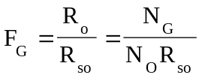 where 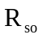 is evaluated at 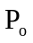. Then

where is a free parameter that can be used to fit data or prevent negative compressibility. Typical values for range from .0 to .3.

Model 2 is implicit; it requires determination of the saturation pressure 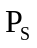 corresponding to the dissolved gas-oil ratio at reservoir conditions.

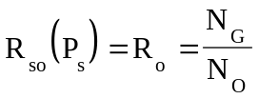

where can be obtained by either by Newtonian iteration or by constructing the inverse function 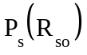; IPARS uses the inverse function. In either case the oil volume factor is given by

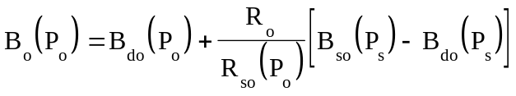

For reasonable functions 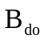 and this function will always yield positive compressibility.

Black-Oil Physical Units

The physical units used in black-oil models are somewhat unusual compared to other engineering units and thus will be documented here.

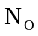 stbo/bbl 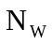 stbw/bbl 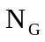 mscf/bbl
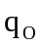 stbo/bbl day 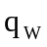 stbw/bbl day 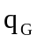 mscf/bbl day
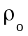 lb/bbl 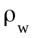 lb/bbl 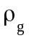 lb/bbl
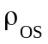 lb/stbo 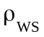 lb/stbw 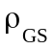 lb/mscf
mscf/stbo mscf/stbo 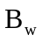 bbl/stbw
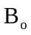 bbl/stbo 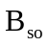 bbl/stbo bbl/stbo
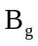 bbl/mscf days psi
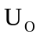 stbo ft/day  stbw ft/day  mscf ft/day
x,y,z ft Area bbl/ft Vol bbl
md cp psi bbl/ft lb

Difference Equations

A number of definitions are in order before presentation of the difference equations:

The primary unknowns are , , and .

Subscript ijk refers to grid element ijk.

Superscript n refers to time level n

Superscript K refers to the Kth approximation to a quantity evaluated at time level n+1

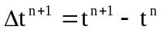 = time step size.

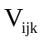= Volume of grid element ijk.

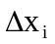, 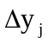, and 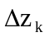 = edge lengths of a rectangular grid element ijk.

Transmissibility constants are defined by

Upstream weighting is applied to the mobilities

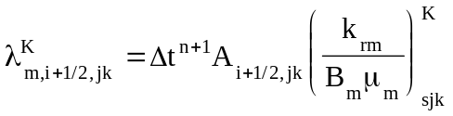

where s = i if 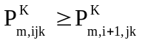 and s = i+1 if 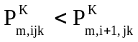. Similar expressions apply for the y and z directions.

Average densities used in the gravity terms,i.e.

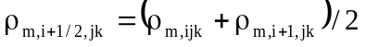

Similar expressions apply for the y and z directions. If phase m does not exist in one of the two elements then the interface density is equal to the density in the element where the phase does exist.

With the above definitions out of way, we can then write difference equations for the three partial differential equations in residual form. Each equation has bee multiplied by 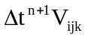 so that each residual represents a mass error in element ijk for time step n+1.

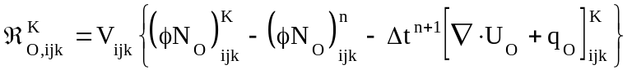

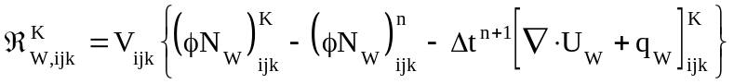

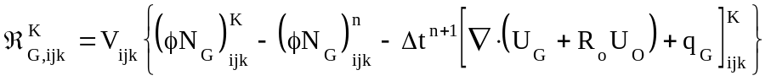

Here the component mass velocities are defined by

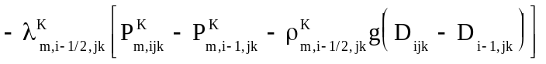
+ similar terms for the y and z directions.

+ similar terms for the y and z directions. Upstream weighting is applied to .

Newtonian iteration is used to drive the residuals to zero. This requires that partial derivatives of the three residuals with respect to the three primary variables be formed into a Jacobian matrix each iteration of each time step. Since exact computation of the Jacobian is expensive in terms of computation time, some simplifying assumptions are made in the calculation. These assumptions are applied to the Jacobian but not to the residuals and thus will have no effect on the answer but may affect convergence. Indeed, the trick is to reduce computation without slowing or preventing convergence. More details on the solution of the black-oil difference equations can be found in the IPARS programmer's manual.

