Appendix D

Oil-Water Model Theory

The oil-water model was originally coded to serve as a template for other physical models to be incorporated into IPARS; it has well served this purpose. The model can represent two phases (oil and water). There is no mass transfer between the phases. As a practical model, the oil-water can be applied only where there is no possibility of free gas and any dissolved gas is uniformly distributed. Over most of its life the model has been referred to as the hydrology model; with this document, the name is being changed more appropriately to the oil-water model.

Some Definitions
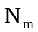 = Mass of phase m per unit pore volume, a function of time and location.

= Porosity, a function of location.

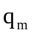 = Mass rate of injection of phase m per unit reservoir volume.

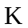 = Diagonal permeability tensor, a function of location.

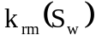 = Relative permeability to phase m.

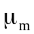 = Viscosity of phase m, a constant.

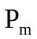 = Pressure in phase m, a function of time and location.

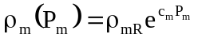 = Density of phase m.

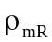 = Reference density of phase m at zero pressure, a constant.

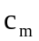= Compressibility of phase m, a constant

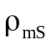 = Stock tank density of phase m.

= Gravity magnitude.

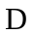 = Depth, a function of location.

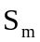 = Pore volume saturation of phase m, a function of time and location.

= Time.

Basic Equations

Partial differential equations representing the oil and water mass balances are represented by

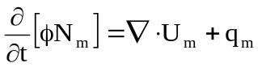

where the mass velocity of phase m is

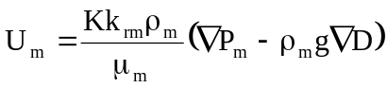
Capillary pressure is defined by

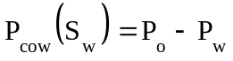

Mass concentration is related to saturation by

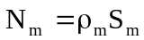

and the saturations must sum to one, i.e.

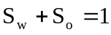

Difference Equations

A number of definitions are in order before presentation of the difference equations:

The primary unknowns are 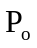 and 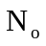.

Subscript ijk refers to grid element ijk.

Superscript n refers to time level n

Superscript K refers to the Kth approximation to a quantity evaluated at time level n+1

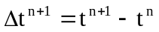 = time step size.

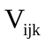= Volume of grid element ijk.

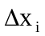, 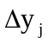, and 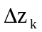 = edge lengths of a rectangular grid element ijk.

Transmissibility constants are defined by

Upstream weighting is applied to the mobilities; for example

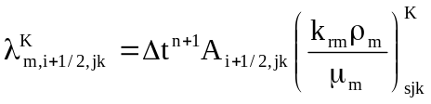

where s = i if 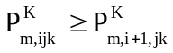 and s = i+1 if 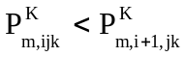. Similar expressions apply for the y and z directions.

Average densities are used in the gravity terms, i.e.

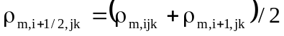

Similar expressions apply for the y and z directions. If phase m does not exist in one of the two elements then the interface density is equal to the density in the element where the phase does exist.

With the above definitions out of way, we can then write difference equations for the two partial differential equations in residual form. Each equation has been multiplied by 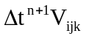 so that each residual represents a mass error in element ijk for time step n+1.

Here the component mass velocities are defined by

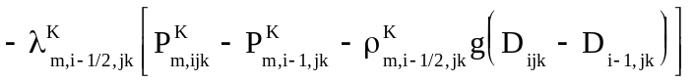
+ similar terms for the y and z directions.

Newtonian iteration is used to drive the residuals to zero. This requires that partial derivatives of the two residuals with respect to the two primary variables be formed into a Jacobian matrix each iteration of each time step. Since exact computation of the Jacobian is expensive in terms of computation time, some simplifying assumptions are made in the calculation. These assumptions are applied to the Jacobian but not to the residuals and thus will have no effect on the answer but may affect convergence. Indeed, the trick is to reduce computation without slowing or preventing convergence. More details on the solution of the oil-water difference equations can be found in the IPARS programmer's manual.

