Appendix E

Single-Phase Model Theory

The single-phase model is the simplest physical model in IPARS. It can provide pressure, flow fields , and well rates for aquifers not in contact with the atmosphere and in conjunction with the IPARS multimodel capability can represent aquifers below an oil reservoir. This second possibility can save a great deal of computer time if the aquifer is extensive and the compositional model is used in the reservoir region.

Some Definitions
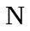 = Fluid mass per unit pore volume, a function of time and location.

= Porosity, a function of location.

= Mass rate of injection per unit reservoir volume.

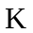 = Diagonal permeability tensor, a function of location.

= Fluid viscosity, a constant.

= Fluid pressure, a function of time and location.

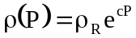 = Fluid density.

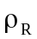 = Fluid reference density at zero pressure, a constant.

= Fluid compressibility, a constant

= Gravity magnitude.

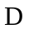 = Depth, a function of location.

= Time.

Basic Equations

The partial differential equation representing a fluid mass balances is represented by

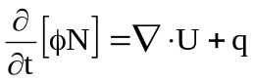

where the fluid mass velocity is

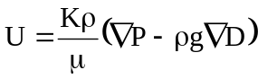

Difference Equations

A number of definitions are in order before presentation of the difference equations:

The primary unknown is .

Subscript ijk refers to grid element ijk.

Superscript n refers to time level n

Superscript K refers to the Kth approximation to a quantity evaluated at time level n+1

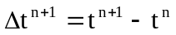 = time step size.

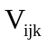= Volume of grid element ijk.

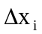, 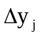, and 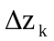 = edge lengths of a rectangular grid element ijk.

Transmissibility constants are defined by

Upstream weighting is applied to mobility; for example

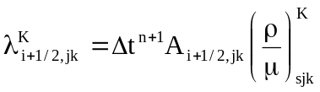

where s = i if 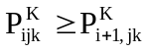 and s = i+1 if 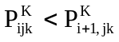. Similar expressions apply for the y and z directions.

Average density is used in the gravity terms, i.e.

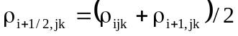

Similar expressions apply for the y and z directions.

With the above definitions out of way, we can then write difference equations for the partial differential equation in residual form. The equation has been multiplied by 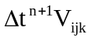 so that the residual represents a mass error in element ijk for time step n+1.

Here the fluid mass velocities is defined by

+ similar terms for the y and z directions.

Newtonian iteration is used to drive the residual to zero. This requires that the partial derivative of the residual with respect to the primary variable be formed each iteration of each time step. Since exact computation of the derivative is expensive in terms of computation time, some simplifying assumptions are made in the calculation. These assumptions are applied to the derivative but not to the residual and thus will have no effect on the answer but may affect convergence. Indeed, the trick is to reduce computation without slowing or preventing convergence. More details on the solution of the single-phase difference equations can be found in the IPARS programmer's manual.

