Class 04
Rebecca Taheri
Janurary 15th, 2026
x <- 1:50
plot(x, sin(x))
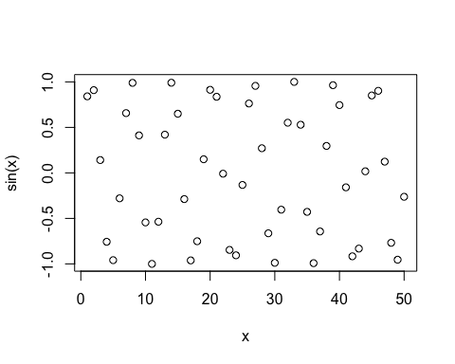
plot(x, sin(x), typ="l", col= "purple", lwd=2)
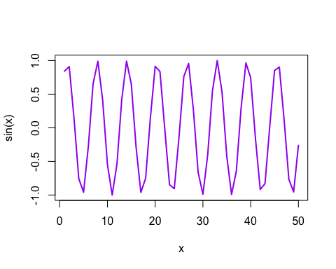
log(10, base = 10)
## [1] 1

