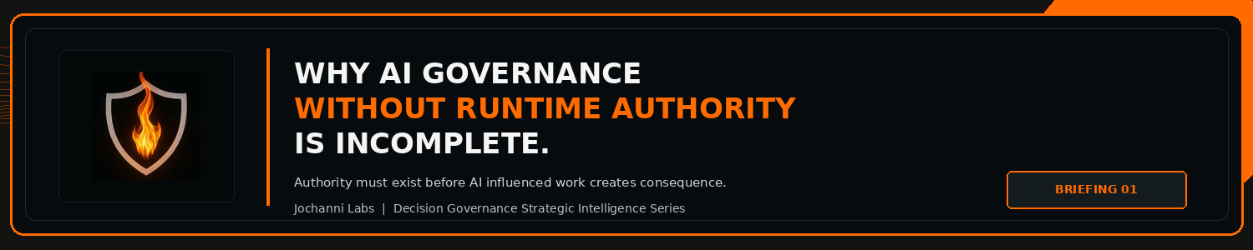
ESTIMATED READ TIME  4 minutes | APPROXIMATE WORD COUNT  790 words | PURPOSE  Strategic intelligence briefing
Core position:
The authority problem is the gap between knowing AI was used and proving the AI shaped
decision path was permitted to move forward.
Essay
Enterprises can document AI activity endlessly and still have no proof that AI influenced actions were authorized before they created consequence.
Much of the current AI governance conversation still carries this weakness. The market has become fluent in inventories, use case reviews, model classifications, policy libraries, risk ratings, committee structures, and compliance preparation. Those artifacts are useful because enterprises need to know where AI is present, who owns it, which risks have been reviewed, and which standards apply. NIST's AI Risk Management Framework reflects this broader discipline through govern, map, measure, and manage functions for AI risk management. The limitation is not the framework. The limitation is what happens when the framework becomes internal process, and the enterprise still cannot prove authority at the moment AI influenced work begins moving toward action.1
The authority problem is the gap between knowing AI was used and proving the AI shaped decision path was permitted to move forward.

Decision Intelligence already treats decisions as structured work. A decision carries context, alternatives, uncertainty, judgment, consequence, execution, feedback, and accountability. Enterprise control functions understand the same reality in operational terms. Approval rights, delegated authority, escalation paths, supervisory review, exception handling, segregation of duties, and audit evidence exist because consequential work cannot depend on informal confidence. AI raises the control pressure because it can now shape the recommendation, analysis, classification, routing, or exception path before the final decision is made.
A human may still click approve, a manager may sign off, and a committee may review the result. None of that automatically proves the decision path was properly governed. The enterprise still has to know whether AI participation changed the risk profile, whether the reviewer had the correct authority, whether the AI influence was visible to that reviewer, whether escalation was required, whether an override was valid, and whether the record proves the action was authorized before the workflow moved forward.

Public AI governance language already points toward accountability, traceability, and oversight. The OECD AI Principles state that AI actors should be accountable based on their roles and context, and that traceability should include datasets, processes, and decisions made during the AI system lifecycle. The EU AI Act also treats human oversight as a risk reduction mechanism for high risk AI systems. These are important signals because they show the public governance conversation moving beyond abstract ethics and toward operational proof. The gap is still how enterprises convert those principles into enforceable authority inside live work.2,3
This is where the current market remains underbuilt. Many tools help an enterprise identify AI systems, classify use cases, summarize obligations, monitor behavior, or prepare evidence. Those functions are useful, but they do not, by themselves, answer the more serious operating question: what is AI influenced work allowed to do before consequence is created?
The answer cannot be left inside a policy document. The answer has to be enforced inside the workflow.
A claims decision influenced by AI does not only need documentation that AI was used. It needs a clear authority path for who may rely on that output, under what condition, at what consequence level, with what escalation obligation, and with what evidence record. The same logic applies to underwriting, hiring, legal review, transaction monitoring, customer remediation, healthcare operations, financial controls, and any workflow where AI materially shapes a consequential outcome.
The enterprise issue is not simply visibility. Visibility tells leadership that AI exists in the process. Authority determines whether the AI influenced process is permitted to move forward.
The distinction is material because 'human in the loop' has become too comfortable as a control phrase. A human in the loop can still be the wrong human, operating with incomplete context, approving under the wrong threshold, bypassing escalation, or relying on AI output without a record that would stand up under internal review, customer challenge, regulator inquiry, or board scrutiny. The control value is not the human's presence. The control value is the authorized decision path.
Decision Governance is the discipline that should emerge around this gap. It is not a replacement for model governance, risk management, or compliance. It is the operating layer that connects AI participation to decision authority before action is taken. Model governance can tell the enterprise whether the system is known, assessed, monitored, and managed. Decision Governance asks whether the decision path shaped by that system was authorized before the enterprise acted.
Those are related questions, not the same question.
As AI moves deeper into enterprise workflows, the strongest institutions will not be the ones with the most governance documents. They will be the ones that can prove how AI participation changed the decision path, who had authority over the consequence, which control condition applied, and why the action was allowed to proceed.
The next control frontier is not visibility. It is enforceable authority over AI influenced decisions before they create consequence.
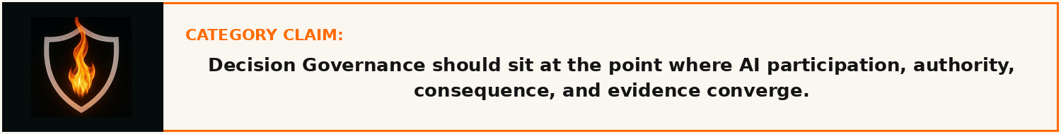
Source Notes
1. NIST AI Risk Management Framework. The AI RMF Core is composed of four high level functions: Govern, Map, Measure, and Manage. Source: https://airc.nist.gov/airmf-resources/airmf/5-sec-core/
2. OECD AI Principles. Accountability includes traceability in relation to datasets, processes, and decisions made during the AI system lifecycle. Source: https://www.oecd.org/en/topics/sub-issues/ai-principles.html
3. EU AI Act, Article 14. Human oversight for high risk AI systems aims to prevent or minimise risks to health, safety, or fundamental rights. Source: https://eur-lex.europa.eu/legal-content/EN/TXT/PDF/?uri=OJ:L_202401689

Prepared for: Kevin Moore, Founder, Jochanni Labs
Publication series: Decision Governance Strategic Intelligence Series

