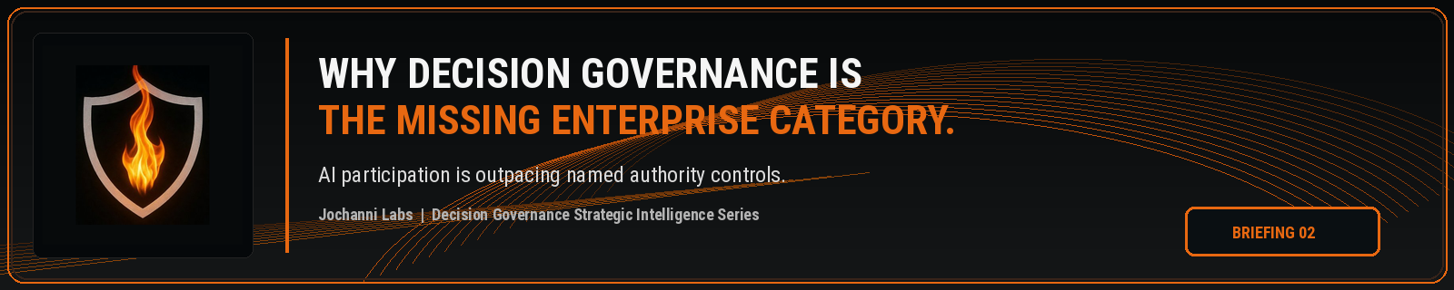
ESTIMATED READ TIME  4 minutes | APPROXIMATE WORD COUNT  820 words | PURPOSE  Strategic intelligence briefing
Core position:
Decision Governance is the missing enterprise category because AI is no longer only a system to be managed. It is becoming a participant in consequential decision paths that require authority, traceability, escalation, and evidence before action moves forward.
Essay
Enterprise AI is moving into decisions faster than the market has named the control category that belongs around it. Organizations can govern models, document use cases, review risk, and prepare compliance evidence while still lacking a clear operating discipline for what happens when AI begins shaping the decision path itself. The missing category is not another label for AI governance. It is Decision Governance, the enterprise discipline required when AI participation changes judgment, authority, consequence, and evidence before action moves forward.
Current AI governance language has value, but it does not fully carry this burden. NIST's AI Risk Management Framework organizes AI risk management through govern, map, measure, and manage functions, giving organizations a serious structure for identifying, assessing, and managing AI risks. The limitation appears when this discipline is treated as the whole operating answer. A governed AI system can still produce output that influences a decision path the enterprise has not properly authorized.¹
Decision Intelligence strengthens this argument because it treats decisions as objects that can be designed, modeled, improved, and measured. Gartner describes decision intelligence platforms as software used to create decision centered solutions that support, augment, and automate decision making by humans or machines. This recognition moves enterprise thinking beyond reports and toward decision flow. Decision Governance extends the control question further by asking whether AI shaped decision flow was permitted to proceed under the organization's authority structure.²
The category gap sits between these disciplines. AI governance asks whether the AI system is known, assessed, monitored, and managed. Decision Intelligence asks how decisions are modeled, executed, and improved. Decision Governance asks who had authority over the AI influenced decision path before the enterprise acted, what condition allowed the path to continue, what escalation should have occurred, and what evidence proves the decision was permitted.
This gap becomes visible when AI moves from information support into operational influence. A fraud operations team may use AI to prioritize an escalation. If that priority changes which customer is investigated, which transaction is delayed, or which case receives supervisory review, the issue is no longer only model performance. The issue is authority over the decision path created by AI participation.
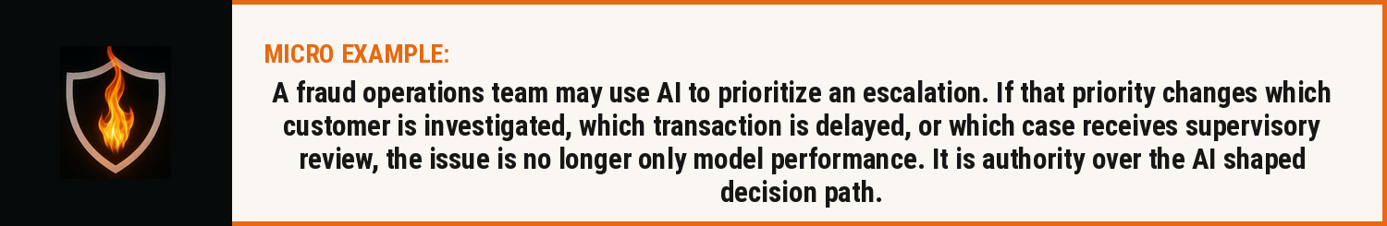
The same pattern appears in underwriting, claims, legal review, customer remediation, workforce decisions, compliance operations, financial controls, and regulated workflow management. A person may remain in the process. The final action may still be manually approved. The control problem remains unresolved if the enterprise cannot prove how AI influenced the decision path, who had authority over the consequence, which rule applied, and why the action was allowed to proceed.
Public governance frameworks are already pointing toward this concern, even if they do not yet name the category in the way enterprises will need to operationalize it. The OECD AI Principles emphasize accountability based on role and context, along with traceability across datasets, processes, and decisions made during the AI system lifecycle. The EU AI Act also treats human oversight as a risk reduction mechanism for high risk AI systems. These public signals confirm that the market is moving toward accountability, traceability, and oversight, but the enterprise category still has to become more precise.³
Decision Governance should sit at the point where AI participation, decision authority, consequence, and evidence converge. It should not replace model governance, enterprise risk management, compliance, internal audit, or Decision Intelligence. It should connect them at the execution boundary where AI shaped work becomes enterprise action. Without that category, organizations will keep stretching existing disciplines until they lose precision.
Categories shape budgets, ownership, requirements, controls, and board level accountability. A problem without a category gets scattered across risk, technology, legal, compliance, product, data, and operations. Each function sees part of the issue. No one owns the decision authority layer across the full path from AI participation to enterprise consequence.
The firms that understand this early will not frame the problem as another dashboard, checklist, or policy library. They will recognize that AI participation requires a decision control discipline capable of proving who had authority, what changed, which threshold applied, what escalation path existed, and why the action was authorized before consequence was created.
The missing enterprise category is Decision Governance. It names the control discipline enterprises will need as AI moves from generating output to shaping decisions.

Source Notes
1. NIST AI Risk Management Framework. The AI RMF Core is composed of four high level functions: Govern, Map, Measure, and Manage. Source: https://airc.nist.gov/airmf-resources/airmf/5-sec-core/
2. Gartner Peer Insights, Decision Intelligence Platforms market definition. Gartner defines decision intelligence platforms as software to create decision centered solutions that support, augment, and automate decision making of humans or machines. Source: https://www.gartner.com/reviews/market/decision-intelligence-platforms
3. OECD AI Principles. Accountability includes traceability in relation to datasets, processes, and decisions made during the AI system lifecycle. Source: https://www.oecd.org/en/topics/sub-issues/ai-principles.html
4. EU AI Act, Article 14. Human oversight for high risk AI systems aims to prevent or minimise risks to health, safety, or fundamental rights. Source: https://artificialintelligenceact.eu/article/14/
Prepared for: Kevin Moore, Founder, Jochanni Labs
Publication series: Decision Governance Strategic Intelligence Series

