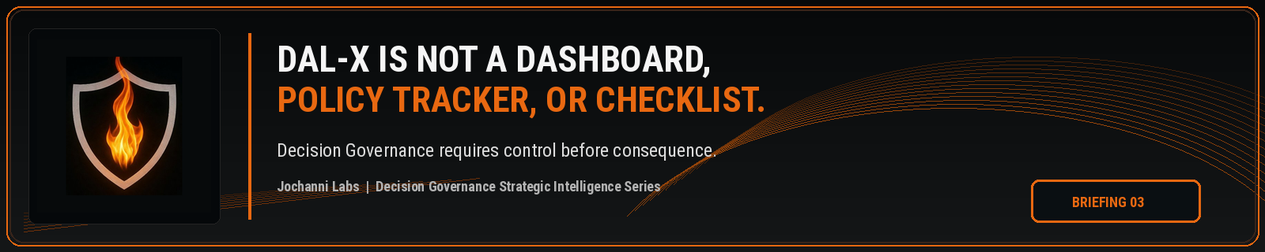
ESTIMATED READ TIME  4 minutes | APPROXIMATE WORD COUNT  890 words | PURPOSE  Strategic intelligence briefing
Core position:
DAL-X is not a visibility surface, policy repository, or readiness checklist. It is the control layer required when AI influenced work needs authority, routing, evidence, and execution restraint before consequence is created.
Essay
A dashboard can show enterprise leaders what happened. Policy trackers record what the organization intended. Compliance checklists confirm which obligations have been reviewed. None of those mechanisms, standing alone, controls whether AI influenced work was permitted to move forward before consequence was created.
The distinction is material because AI governance is being pulled toward surfaces that look organized but remain too far away from the decision moment. The enterprise can collect use cases, classify systems, assign owners, store policies, and prepare evidence while the actual AI shaped decision path still moves through business operations without a live authority check. The result is governance visibility without execution control.
NIST's AI Risk Management Framework gives organizations an important structure for governing, mapping, measuring, and managing AI risk. ISO/IEC 42001 also frames AI management systems around policies, objectives, and processes for responsible AI use. These are serious governance disciplines. The issue is not their relevance. The issue is whether the enterprise treats governance structure as enough when AI begins influencing decisions that require authority before action.¹
DAL-X belongs in that gap. It is not designed to replace AI risk management, model governance, internal audit, legal review, or compliance operations. It is designed to sit where those disciplines become operationally incomplete: the point where AI generated or AI influenced work is close enough to action that the enterprise must decide whether it can proceed, pause, escalate, require review, create an exception, restrict an override, or preserve a decision record.
Dashboards do not answer that control question. They can display open items, risk levels, usage trends, and workflow activity. Those views may be useful for oversight, but a dashboard is still a representation of activity. They do not, by themselves, evaluate authority conditions or prevent an unauthorized decision path from moving forward.
Policy trackers stop too early. Policy language can define expectations, but it does not guarantee that the right authority holder saw the AI influence, applied the correct condition, and approved the action before the workflow continued. The enterprise can have strong policy language and still lack an enforceable decision path.
A compliance checklist is even more limited when the issue is runtime consequence. Checklists help confirm whether required topics have been considered, documents have been prepared, controls have been discussed, and reviews have occurred. They do not prove that AI shaped work was governed at the moment it became eligible for action.
A credit exception illustrates the difference. A bank can document that an AI system was reviewed, store the policy governing its use, and show a dashboard of exception volume. If AI influenced the exception recommendation and the workflow allowed approval without the correct authority threshold, the control failure is not solved by the dashboard, policy, or checklist. The failure sits in the decision path.
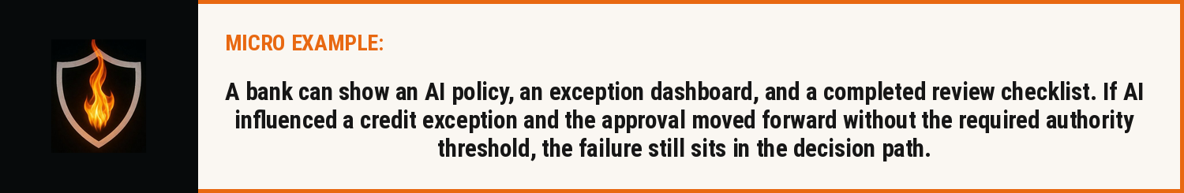
Public regulation is already forcing more attention toward traceability and oversight. The EU AI Act requires high risk AI systems to support automatic event recording over their lifetime and treats human oversight as a risk reduction mechanism. Those requirements point toward operational proof, but an event log or oversight reference still has to be connected to authority if the enterprise wants to prove that the decision was permitted before action moved forward.³
The category conversation needs to be sharper. AI governance can establish the program. Model governance can manage the system. Compliance can interpret obligations. Internal audit can test the control environment. Decision Intelligence can improve how decisions are modeled and executed. Decision Governance has to address whether AI participation changed the authority requirements attached to the decision path.
DAL-X is positioned against that authority problem, not against the existence of dashboards, policies, or checklists. Those artifacts may remain necessary. They become insufficient when the enterprise needs to prove control at the execution boundary. The question is no longer only whether the organization has governed AI as a system. The question is whether the organization governed the decision path shaped by AI before it created consequence.
This is the reason DAL-X cannot be reduced to a screen, a tracker, or a compliance worksheet. Its value depends on whether it can enforce the path between AI participation, authority condition, decision state, escalation, override, and evidence. Without that path, the enterprise may have governance material around AI, but it does not have enforceable authority over AI influenced decisions.
The next control standard will not be satisfied by more visibility alone. It will require proof that AI influenced work was reviewed, routed, authorized, restricted, or stopped before the enterprise acted. DAL-X exists for that control layer.

Source Notes
1. NIST AI Risk Management Framework. The AI RMF Core is composed of four high level functions: Govern, Map, Measure, and Manage. Source: https://airc.nist.gov/airmf-resources/airmf/5-sec-core/

2. ISO/IEC 42001:2023. ISO states that the standard specifies requirements and guidance for establishing, implementing, maintaining, and continually improving an AI management system within an organization. Source: https://www.iso.org/standard/42001

3. EU AI Act, Article 12. High risk AI systems technically allow for the automatic recording of events over the lifetime of the system. Source: https://eur-lex.europa.eu/eli/reg/2024/1689/oj

4. EU AI Act, Article 14. Human oversight for high-risk AI systems aims to prevent or minimise risks to health, safety, or fundamental rights. Source: https://eur-lex.europa.eu/eli/reg/2024/1689/oj

Prepared for: Kevin Moore, Founder, Jochanni Labs
Publication series: Decision Governance Strategic Intelligence Series

