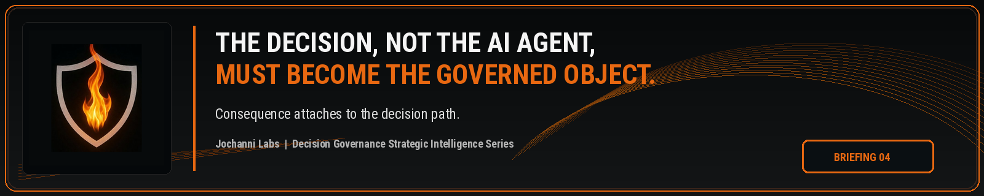
ESTIMATED READ TIME  4 minutes | APPROXIMATE WORD COUNT  875 words | PURPOSE  Strategic intelligence briefing
Core position:
The AI agent is only a participant in the control problem. The decision is the governed object because the decision carries consequence, authority, evidence, and institutional accountability.
Essay
Enterprise AI programs are starting with the object they can see most easily: the agent. They register the agent, identify the model, classify the use case, assign an owner, document the workflow, and track whether the system is operating inside an approved environment. The work belongs in the control environment, yet it stops short of the harder question. Once AI participates in work that can affect an outcome, the enterprise has to govern the decision path, not only the machine that contributed to it.
The AI agent can be known while the decision path remains controlled only in appearance. An inventory may show which agent exists. A risk rating may describe the system. A dashboard may report usage. None of those records, by themselves, prove whether the AI shaped decision was authorized, whether the authority holder saw the relevant influence, whether escalation was required, or whether the action was allowed to proceed under the institution's control model.
The governed object must be the decision because consequence attaches to the decision. Customers are approved or denied. Claims are paid, challenged, or escalated. Transactions are released, blocked, or investigated. Candidates are advanced or rejected. Legal positions are accepted or revised. Credit exceptions are granted or refused. The agent may influence the path, but the institution owns the decision and the consequence created by that decision.
NIST's AI Risk Management Framework recognizes AI risk management through govern, map, measure, and manage functions, and its map function points to the difficulty of visibility and control across parts of the AI lifecycle. The framework also recognizes that documentation should assist relevant AI actors when making decisions and taking subsequent actions. The enterprise gap begins when documentation about the system does not become authority over the decision path shaped by the system.¹
Agent centered governance creates a false sense of completion. The organization can know the agent exists, approve the use case, define intended use, test the model, and still miss the most important control question in live work. What did AI participation change about the decision that followed? If the answer changes risk, authority, review, escalation, override, or evidence, the decision has become the object that requires governance.
A fraud review agent may flag a transaction, but if its recommendation changes investigation priority, customer treatment, account restriction, or escalation timing, the governed object is not the agent record. The governed object is the decision path that converted AI participation into institutional action.

This shift is necessary because agents will not remain isolated tools. They will be placed inside workflows, connected to orchestration layers, given access to internal systems, and used to accelerate professional judgment. Some agents will recommend, draft, classify, or route. Others will trigger downstream work. The control issue will not be solved by asking only whether the agent is approved. The stronger control question is whether each AI influenced decision path was permitted before consequence was created.
Public governance language already points toward this direction, even if the market has not named the category cleanly. The OECD AI Principles link accountability to roles, context, and traceability across datasets, processes, and decisions made during the AI system lifecycle. The EU AI Act requires record keeping for high risk AI systems and treats human oversight as a risk reduction mechanism. Those signals push enterprise AI governance toward evidence, oversight, and lifecycle accountability. Decision Governance goes further by making the decision path the control object before enterprise action moves forward.²
The distinction is material for regulated enterprises. A bank does not only need to know which AI agent helped evaluate a lending exception. It needs to know whether the lending decision crossed a consequence threshold, whether the approval authority changed, whether the reviewer had the right mandate, whether the override path was valid, and whether the evidence record can prove why the decision was permitted. Agent governance cannot carry that burden by itself.
The same logic applies across insurance, healthcare operations, legal review, capital markets, human resources, public sector programs, and enterprise operations. The decision is where business consequence, legal exposure, customer impact, operational accountability, and institutional authority converge. The AI agent remains relevant, but it is not sufficient as the anchor object because the agent does not contain the full decision context.
Decision Governance should force a cleaner operating model. The enterprise should still maintain agent registries, model inventories, policy records, use case reviews, and monitoring dashboards. Those artifacts create visibility around the AI system. The decision object creates control over the institutional outcome. It connects who or what influenced the decision, which authority condition applied, which escalation route was required, which override was allowed, and which evidence record proves the decision was authorized before action.
This is why the decision, not the AI agent, must become the governed object. Agent governance tells the enterprise what participated. Decision Governance tells the enterprise whether the resulting decision path had authority. As AI moves deeper into real workflows, institutions will need both, but the control center has to move closer to the consequence.
The next enterprise control standard will not be satisfied by asking whether the agent was approved. It will require proof that the AI influenced decision path was authorized before the enterprise acted.

Source Notes
1. NIST AI Risk Management Framework. The AI RMF Core is composed of four high level functions: Govern, Map, Measure, and Manage, and the Map function frames context for AI system risks and decisions. Source: https://airc.nist.gov/airmf-resources/airmf/5-sec-core/

2. OECD AI Principles. Accountability includes traceability in relation to datasets, processes, and decisions made during the AI system lifecycle. Source: https://www.oecd.org/en/topics/sub-issues/ai-principles.html

3. EU AI Act, Article 12. High risk AI systems shall technically allow for automatic recording of events over the lifetime of the system. Source: https://eur-lex.europa.eu/eli/reg/2024/1689/oj

4. EU AI Act, Article 14. Human oversight for high risk AI systems aims to prevent or minimise risks to health, safety, or fundamental rights. Source: https://eur-lex.europa.eu/eli/reg/2024/1689/oj

Prepared for: Kevin Moore, Founder, Jochanni Labs
Publication series: Decision Governance Strategic Intelligence Series

