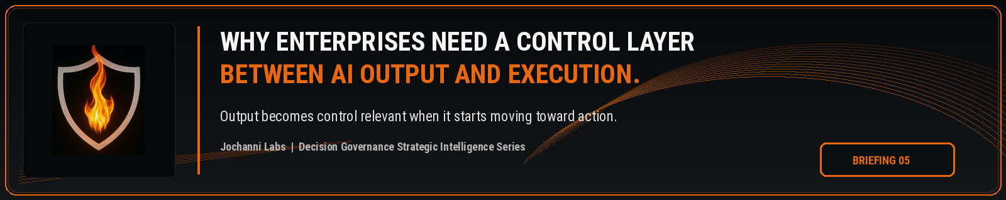
ESTIMATED READ TIME  4 minutes | APPROXIMATE WORD COUNT  880 words | PURPOSE  Strategic intelligence briefing
Core position:
The enterprise control gap sits between AI output and business execution. Output is not consequence until the organization allows it to move into action.
Essay
Enterprises are moving AI generated output into real work faster than their control models can absorb. A summary becomes a recommendation. A recommendation becomes a routing decision. A risk classification changes review priority. A draft influences a legal, financial, operational, customer, or employee outcome. The dangerous assumption is that output remains harmless until a system executes an action on its own. The stronger enterprise view is that AI output becomes control relevant the moment it begins shaping the path toward execution.
Most AI governance programs still sit too far upstream or too far downstream. Upstream controls focus on model approval, intended use, policy, and risk classification. Downstream controls focus on monitoring, logging, review, and remediation after activity has already occurred. Both sides are needed. The missing layer is the control point between generated output and business action, where the enterprise can decide whether the AI influenced work may proceed, must pause, requires review, triggers escalation, narrows approval rights, or needs an evidence record before consequence is created.
The control point is not a dashboard and not a policy library. It is an execution boundary. The enterprise needs to know whether the output is eligible to influence the next step before a workflow, agent, employee, or operating process converts it into institutional action. Without that boundary, AI can become a silent participant in decisions while the organization continues to behave as if normal process controls are enough.
NIST's AI Risk Management Framework defines the AI RMF Core through govern, map, measure, and manage functions, which support structured AI risk management across organizations. The public framework gives enterprises a disciplined way to organize AI risk activity. The unresolved operating problem appears when those functions are translated into internal governance, yet the enterprise still lacks an explicit control layer at the moment AI output becomes eligible to affect execution.¹
AI output does not need to be autonomous to create execution risk. The change often comes through human judgment operating on AI content: an analyst adopts a summary, a supervisor relies on an exception rationale, a reviewer accepts a classification, a manager advances a workflow, a compliance officer reprioritizes a queue. In each case, the system may not execute the final step, but the output has already changed the decision path. The control layer has to operate before that path becomes action.
A customer remediation team may use AI to classify complaints by severity. If the classification changes which customers receive escalation, which cases receive faster handling, or which issues are treated as low risk, the enterprise cannot rely only on the fact that a human later reviewed the queue. The control question is whether the AI generated classification was allowed to influence remediation priority under the firm's authority model.
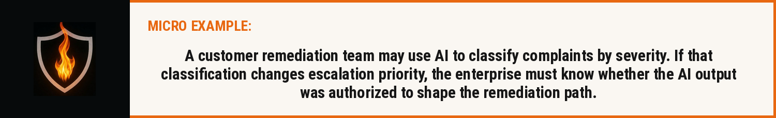
The same exposure appears in agentic workflows with more force. An agent can draft a response, assemble evidence, recommend the next action, route a case, update a ticket, prepare a transaction, or trigger another system. Once agents begin operating inside workflows, the control problem is no longer limited to model quality. The organization needs an enforceable boundary before generated work becomes executable work. Otherwise speed becomes a substitute for judgment, and automation begins to outrun authority.
Public governance language already points in this direction. OECD accountability guidance includes traceability across datasets, processes, and decisions made during the AI system lifecycle. The EU AI Act requires record keeping for high risk AI systems and treats human oversight as a risk reduction mechanism. Those public signals support a broader control conclusion: enterprises need more than awareness that AI participated. They need proof that AI shaped work was governed before it crossed into action.²
The layer between output and execution should answer operational questions that policy alone cannot answer in real time. What type of work did AI produce? Which decision could it affect? What consequence level is attached to that decision? Which authority holder owns the next step? Which trigger condition applies? Is review mandatory? Can the action continue automatically? Does an override require a reason code? What evidence must be preserved before the workflow moves forward?
Those questions belong inside the operating path, not in a quarterly governance review. A quarterly review may find patterns after the fact. A control layer acts at the point where the institution still has the ability to stop, redirect, escalate, or authorize the action. The closer the control sits to execution, the more useful it becomes for preventing unauthorized consequence rather than merely explaining it later.
The category problem is becoming clearer because existing labels do not fully name this layer. Model governance manages the system. AI governance organizes risk, policy, oversight, and accountability. Observability shows behavior. Compliance readiness prepares evidence. Workflow automation moves work through a process. None of those labels fully describe the authority checkpoint between AI generated output and enterprise execution.
Decision Governance names the missing control discipline because the enterprise outcome is created through a decision path. A model output may start the path, an agent may accelerate it, and a human may complete it. The governed question is whether the path had authority before the organization acted. A control layer between output and execution gives the enterprise a place to enforce that question before consequence becomes real.
This is why enterprises need a control layer between AI output and execution. AI adoption will continue to accelerate, and the volume of generated work will only increase. The institutions that protect themselves will not be the ones that merely document output after it moves. They will be the ones that can prove what AI output was allowed to influence before execution occurred.
The next enterprise control standard is not output visibility. It is governed passage from AI generated work into authorized action.


Source Notes
1. NIST AI Risk Management Framework. The AI RMF Core is composed of four high level functions: Govern, Map, Measure, and Manage. Source: https://airc.nist.gov/airmf-resources/airmf/5-sec-core/
2. OECD AI Principles. Accountability includes traceability in relation to datasets, processes, and decisions made during the AI system lifecycle. Source: https://www.oecd.org/en/topics/sub-issues/ai-principles.html
3. EU AI Act, Article 12. High risk AI systems shall technically allow for automatic recording of events over the lifetime of the system. Source: https://eur-lex.europa.eu/eli/reg/2024/1689/oj
4. EU AI Act, Article 14. Human oversight for high risk AI systems aims to prevent or minimise risks to health, safety, or fundamental rights. Source: https://eur-lex.europa.eu/eli/reg/2024/1689/oj
Prepared for: Kevin Moore, Founder, Jochanni Labs
Publication series: Decision Governance Strategic Intelligence Series

