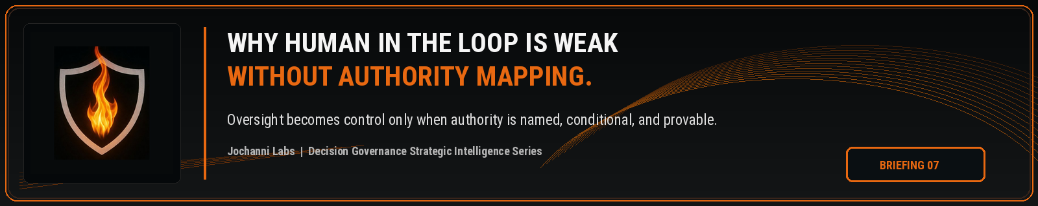
ESTIMATED READ TIME  4 minutes | APPROXIMATE WORD COUNT  845 words | PURPOSE  Strategic intelligence briefing
Core position:
Human oversight becomes enforceable control only when authority is mapped to the decision, the condition, and the consequence before action moves forward.
Essay
Human in the loop has become one of the most comfortable phrases in enterprise AI governance. It sounds responsible because it suggests judgment, restraint, and human accountability. The weakness is that the phrase often stops at participation. It does not prove authority.
A person can sit inside a workflow and still lack decision rights over the outcome. A reviewer can see an AI output without knowing how it shaped the decision path. A manager can approve a recommendation without holding the correct authority for the consequence level. A committee can review a system while the actual workflow still moves AI influenced work forward through informal operating habits.
Human oversight is directionally correct, but weak without authority mapping. The EU AI Act recognizes human oversight for high risk AI systems and states that oversight should aim to prevent or minimize risks to health, safety, or fundamental rights during use. The public requirement points toward a real control need, while the enterprise still has to answer the operating question: which human, with which authority, under which condition, over which decision, before which action?¹
Authority mapping is the missing structure behind the phrase human in the loop. It defines who has authority over a decision, what the authority covers, when it applies, when it changes, when escalation is required, when override is valid, and when the decision must stop because the proper authority is missing. Without that map, human involvement can become procedural comfort instead of enforceable control.
The authority problem becomes sharper when AI participates before the final action. A model may draft the analysis. An agent may recommend the next step. An assistant may summarize a customer file. A workflow tool may rank exceptions. A professional may use the output as the basis for approval. The final human action can look legitimate while the decision path has already been shaped by AI in a way the authority model never recognized.
A claims reviewer may approve an AI prioritized file, but if the claim moved into a high consequence exception category, the reviewer’s presence is not enough. The enterprise needs to know whether that reviewer had authority for that category, whether the AI influence was visible, whether escalation should have occurred, and whether the record proves the proper authority path was followed before disposition.
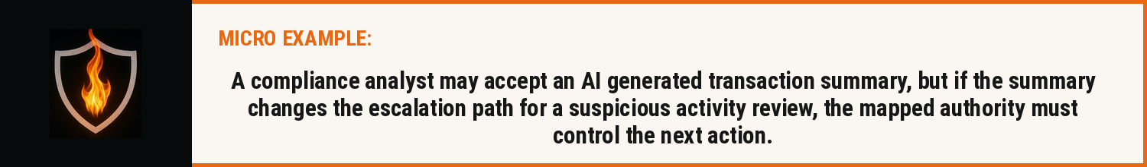
This is why authority mapping must be treated as a core AI governance requirement, not as an administrative role directory. A directory says who works in the organization. An authority map says who can permit a consequential decision to proceed under defined conditions. It connects role, decision type, consequence level, escalation route, override right, evidence requirement, and accountability record.
NIST’s AI Risk Management Framework gives enterprises a useful risk management structure through Govern, Map, Measure, and Manage functions. The structure supports oversight and organizational discipline, while enterprise AI control still needs a sharper operating layer around decision authority. The organization must be able to move from broad governance intent into a specific answer about who has decision authority when AI changes the workflow.²
The OECD AI Principles also emphasize accountability based on roles and context, with traceability across datasets, processes, and decisions during the AI system lifecycle. The language reinforces the central issue. Accountability cannot remain abstract when AI enters consequential work. It has to be tied to a named authority path that can be reviewed, challenged, and evidenced.³
The phrase human in the loop also fails because it assumes the loop is stable. In real enterprise work, authority shifts with context. A low risk approval may sit with an analyst. A high consequence exception may require a senior reviewer. A regulated decision may require second level review. A customer impact decision may require business owner approval. An override may require a different authority holder from the person who performed the initial review.
AI intensifies those shifts because AI can change the posture of the work before anyone notices. A recommendation that looks routine may become high consequence because the AI output affects eligibility, pricing, customer treatment, legal exposure, financial control, or regulatory response. If the authority map is not connected to those conditions, the enterprise can have a human present while the wrong authority path is being used.
Real control requires the enterprise to know when authority is sufficient, when it is missing, when it must narrow, when it must escalate, and when it must be preserved as evidence. This is not an argument against human oversight. It is an argument against treating human presence as a substitute for governed authority.
Decision Governance requires a stronger standard. Human review should be connected to the decision object, the AI influence, the consequence level, the mapped authority holder, the escalation path, the override rule, and the evidence record. Without those connections, the enterprise may have review activity, but it does not have a reliable authority structure over AI influenced decisions.
The next control frontier is not putting a human somewhere in the workflow. It is proving that the correct human authority governed the AI influenced decision before it created consequence.

Source Notes
1. EU AI Act, Article 14. Human oversight for high risk AI systems aims to prevent or minimize risks to health, safety, or fundamental rights during use. Source: https://eur-lex.europa.eu/eli/reg/2024/1689/oj/eng
2. NIST AI Risk Management Framework. The AI RMF Core is composed of four high level functions: Govern, Map, Measure, and Manage. Source: https://airc.nist.gov/airmf-resources/airmf/5-sec-core/
3. OECD AI Principles. Accountability includes traceability in relation to datasets, processes, and decisions made during the AI system lifecycle. Source: https://www.oecd.org/en/topics/sub-issues/ai-principles.html
Prepared for: Kevin Moore, Founder, Jochanni Labs
Publication series: Decision Governance Strategic Intelligence Series

