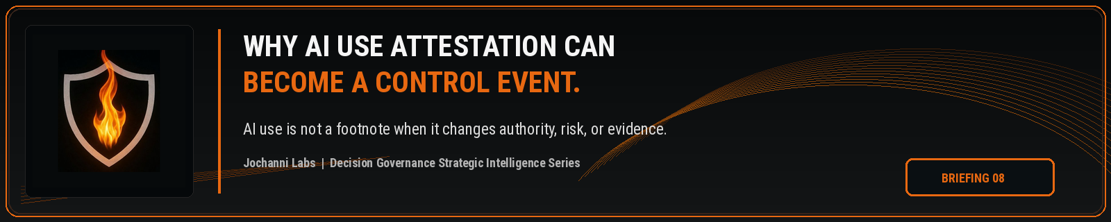
ESTIMATED READ TIME  4 minutes | APPROXIMATE WORD COUNT  835 words | PURPOSE  Strategic intelligence briefing
Core position:
AI use attestation becomes a control event when the admission of AI participation changes risk, authority, escalation, review, or evidence before action moves forward.
Essay
AI use attestation should not be treated as a harmless disclosure field. In consequential enterprise work, the moment someone confirms that AI shaped an analysis, recommendation, classification, summary, draft, or exception path, the organization has new information about the decision. If that information changes the control posture of the work, the attestation should become a control event.
Example: AI Use Attestation
I attest that AI was used to assist with the preparation of this business output
The current enterprise habit is usually lighter. Teams ask whether AI was used, capture the answer in a form, store it in a record, and move on. The approach may create documentation, but it does not automatically change authority, escalation, review, or evidence. The attestation becomes passive unless the enterprise has logic that interprets what the admission should cause.
This is where AI governance often underestimates its own data. An attestation is not only a statement about tool usage. It can be a signal that the decision path has changed. If AI materially influenced the work, the enterprise may need a different reviewer, a higher approval threshold, a second line check, a more complete evidence record, or a stop condition before the action proceeds.
NIST’s AI Risk Management Framework gives enterprises a useful structure for governing, mapping, measuring, and managing AI risk. The structure supports disciplined AI risk practice, while enterprise control still needs an operating mechanism for translating AI use signals into decision level consequences. A recorded attestation should not sit outside the control model when it reveals that AI participation shaped consequential work.¹
The authority problem becomes clear when a business user marks that AI was used in a workflow. The answer cannot remain a yes or no field if the work involves customer eligibility, pricing, underwriting, legal interpretation, claims disposition, hiring, surveillance, compliance review, financial control, or regulatory response. In those contexts, AI use may alter the decision state even when a human remains the final actor.
A legal analyst may attest that AI helped draft a contract risk summary. The admission may be acceptable for low consequence internal review. It may not be acceptable if the summary is being used to support a binding legal position, a customer remediation decision, or an executive approval package. The same attestation carries different control weight depending on the decision and consequence level.

The EU AI Act reinforces the relevance of traceability and logging in high risk AI contexts. Article 12 requires high risk AI systems to technically allow automatic recording of events over the lifetime of the system, while Article 26 places log retention obligations on deployers of high risk AI systems to the extent those logs are under their control. The point for enterprise operating design is direct: AI participation needs records that can support scrutiny after the fact and control before the fact.²
AI use attestation can sit at the boundary between those two needs. It can help establish the record, but it can also become the trigger that changes what happens next. If the organization treats the attestation only as documentation, it loses the chance to control the decision before consequence is created.
The OECD AI Principles also connect accountability to traceability across datasets, processes, and decisions during the AI system lifecycle. The public language is important because it recognizes that accountability is not limited to the model. It includes the process and the decisions shaped by AI. AI use attestation belongs inside that traceability chain when the attested use affects a consequential decision path.³
A serious control model should ask more than whether AI was used. It should ask what type of AI use occurred, what work product was affected, which decision was influenced, what consequence level applies, who has authority, whether escalation is required, whether the human reviewer saw the AI influence, and what evidence must be preserved. Those questions convert attestation from a compliance checkbox into a control signal.
This is also why attestation logic cannot be universal. AI use in a brainstorming memo does not carry the same control weight as AI use in a credit decision, legal recommendation, customer denial, clinical workflow, security alert, transaction review, or regulatory filing. The same phrase, AI was used, can mean very different things depending on the decision environment.
Decision Governance should treat attestation as conditional. Low consequence AI use may only require disclosure and recordkeeping. Medium consequence AI use may require review. High consequence AI use may require named authority, escalation, secondary approval, or prohibition if the AI influence violates the enterprise control standard. The control response should match the decision context, not the generic presence of AI.
This is where real AI governance moves beyond policy. A policy can tell employees when to disclose AI use. A governed decision system should determine what the disclosure changes. The disclosure should be capable of raising risk, changing authority, routing review, creating evidence, or stopping movement when the authority path is incomplete.
AI use attestation becomes powerful when it is connected to decision state. It becomes weak when it is collected as a static field. Enterprises do not need more ceremonial disclosure. They need disclosure that can activate control when AI participation changes the decision path.
The next control frontier is not asking people whether AI was used. It is determining when the answer should change what the enterprise is allowed to do next.

Source Notes
1. NIST AI Risk Management Framework. The AI RMF Core is composed of four high level functions: Govern, Map, Measure, and Manage. Source: https://airc.nist.gov/airmf-resources/airmf/5-sec-core/
2. EU AI Act, Articles 12 and 26. Article 12 addresses automatic recording of events for high risk AI systems, and Article 26 addresses deployer obligations including keeping logs generated by high risk AI systems where under the deployer control. Source: https://eur-lex.europa.eu/eli/reg/2024/1689/oj/eng
3. OECD AI Principles. Accountability includes traceability in relation to datasets, processes, and decisions made during the AI system lifecycle. Source: https://www.oecd.org/en/topics/sub-issues/ai-principles.html
Prepared for: Kevin Moore, Founder, Jochanni Labs
Publication series: Decision Governance Strategic Intelligence Series

