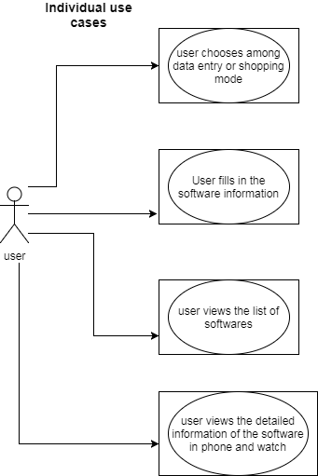

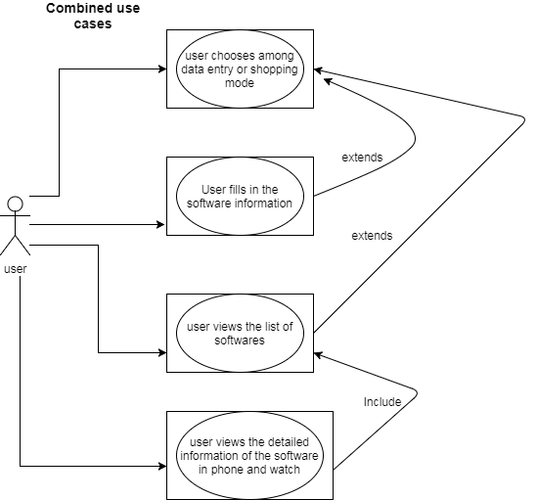

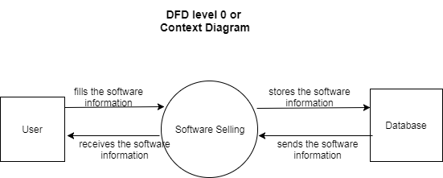

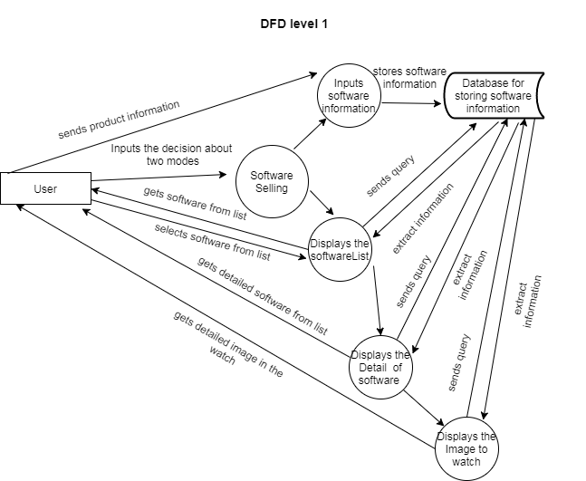

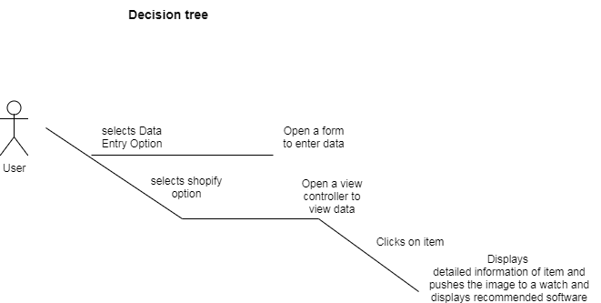

**Use Case Scenario**

View software list with detailed description with image on apple watch

Primary actors: Users

Precondition: Watch should be connected with phone

Database should be connected and instantiated

Normal Use Case Scenario

1. Users open the app
2. Two buttons, one for entering the software information and one for viewing the software list are displayed
3. If user clicks the enter information button, user is navigated to a form where user can enter the information of software to be stored
4. If the user clicks the shopify button, user is navigated to a list of software
5. User selects the software which interests the user
6. Next window consisting of detailed information of software is opened and the image of the selected software is available on watch for viewing

Exception Use Case Scenario

1. User opens the app
2. Two buttons, one for entering the software information and one for viewing the software list are displayed
3. The user inputs multiple empty values or random software in the form or
4. The user now goes to the shopify option where user will see empty rows

**Noun extraction for extracting entity classes**

This application will have a feature for adding software. Then the user can view the list of software with details. The image of the software is transferred to the watch if user clicks on a particular software.

Application: This noun is outside of the scope

Feature: abstract noun in our case

Software: This is our entity class holding long lasting information about software

User: Out of scope for our project

Details: Attributes of our software entity

Image: Attributes of our software entity

Watch: Doesn’t hold long lasting information so cannot be identified as entity class

