Monitoring the Effects of La Nina on Forest Health with Vegetation Indices

Rebekah Wehner
Department of Geography and Geoinformation Science, George Mason University
GGS-416 Satellite Image Analysis
Dr. Edward Oughton
November 29, 2022

Abstract

Using multispectral analysis of the satellite imagery from Sentinel-2 MSI sensors, this study examines the forest health in the Kakamega Forest in western Kenya. Indicators of forest degradation are quantified by calculating Normalized Difference Vegetation Index, Normalized Difference Moisture Index, Red Edge Normalized Difference Vegetation Index, and Green Chlorophyll Index. A four-year time-lapse series was compiled measuring the average rate of change encompassing the La Nina ENSO event of 2020-2022. Given the higher-than-average temperatures and reduced precipitation produced by the event, the study examines vigor and hardiness of the forest and finds stress indicators in year four. The potential impact of this on carbon stock and flux suggests that this should be further studied to determine resiliency or possible forest loss.

Introduction

Forest loss is a global concern with far-reaching impacts on greenhouse emissions and climate change. Deforestation and forest degradation are the two sides of forest loss. Deforestation pertains to the clearing of forests, often due to land use changes such as converting forests into commercial agriculture. This leads to permanent forest loss. While commercial agriculture is the leading cause for deforestation, other reasons are sustenance agriculture, urban expansion, surface mining, and industrial projects (Hosonuma et al., 2012). Forest degradation pertains to changes that negatively affect the forest’s ability to function as an ecosystem. Some drivers of forest degradation are climate change-induced higher temperatures, changes in weather patterns, pests, disease, firewood collection, charcoal production, fires, cattle grazing, and illegal logging (Jayathilake et al., 2021). Illegal logging has bulldozed roads haphazardly, damaged vegetation and undergrowth, marred forest floors, and created bare clearings. Evidence of forest degradation is seen through biomass loss, forest fragmentation, and changes to carbon stock and flux. Implications of forest degradation are an increased risk of forest fires, biodiversity loss, decreasing precipitation in the local area, soil degradation, and lessening of the forest’s role in climate mitigation (Prăvălie, 2018).

Carbon dioxide is one of the greenhouse gases responsible for the greenhouse effect. The greenhouse effect refers to the layer of gases in Earth’s atmosphere that absorbs heat and reflects it back to Earth, and it is responsible for keeping Earth at a temperature that supports life. While there have been variations to Earth’s temperature during various ages, the Intergovernmental Panel on Climate Change has found that Earth has been warming at a faster rate due to human activities since the industrial age and that the changes to Earth’s climate are “widespread, rapid, and intensifying” (IPCC, 2022). Carbon dioxide is emitted into the air via natural processes as well as by human activities. The anthropogenic carbon emissions are due largely to energy production such as burning of fossil fuels. Carbon can be sequestered, or stored, in rocks, the ocean, or living organisms. Forests play a vital role in Earth’s carbon cycle. The amount of carbon that is on Earth does not change but where it is located is in constant flux. Photosynthesis of vegetation uses sunlight and carbon dioxide in the air transforming it into oxygen and glucose. Beyond photosynthesis pulling carbon from the air, carbon is stored in the wood and is an important carbon sink in the terrestrial biosphere. Carbon sinks are thus named because they absorb more carbon than they release, and they are the opposite of a carbon source. Large carbon sinks are the ocean, soil, and forests.

Materials
While the exact percentage in not known, between a quarter and a third of the Earth’s carbon sink is accredited to tropical forests; however, this amount will vary with a possibility that that the tropical forests can change from a carbon sink to a carbon source (Mitchard, 2018). As a spatial distribution on a national level, Brazil and Indonesia hold 35% of carbon sequestered in tropical forests as well as the emit the most carbon due to deforestation and forest degradation (Baccini et al., 2012). As more carbon is released than can be absorbed, the extra carbon remains in the atmosphere contributing to global warming. Forest degradation greatly affects biodiversity, particularly in tropical forests, although the extent varies by region and surrounding area, taxonomic group, and the type and length of the degradation. (Gibson et al., 2011). Forest health is supported by the variety of life forms and ecosystems services, such as photosynthesis, nutrient cycling, the creation of soils, the water cycle—rely on biodiversity to function well (Cardinale et al., 2018). Industrial and urban development have changed nearby forest structures and biodiversity leading to increased pests and forest fire risks that threaten the resilience of the forest to recover (Watson et al., 2018).

Deforestation and degradation can create a positive feedback loop on climate change. As climate changes and temperatures increase, hydro-meteorological extremes also increase. The Amazon rainforest had 100-year drought events in 2005, 2010, and 2016 as well as mega-floods in 2009, 2012, and 2014, and these events led to an increase in tree mortality and altered the carbon stock (Marengo et al., 2018). This affects the ecosystem of the forest. If vegetation is stressed, dies, or is removed, then the output of photosynthesis of the forest is negatively impacted reducing the forest’s ability to absorb carbon in the atmosphere. Deforestation leads to warmer mean temperatures and a reduction in rainfall in the local environment leading to a change in the spatial and temporal distribution of rainfall, and there is a critical deforestation threshold where this occurs (Lawrence et al., 2015). Changes to the regional climate due to an increase of carbon dioxide risk a reduction in atmospheric moisture by evapotranspiration (Marengo et al., 2018). A study found that after the 2005 drought in the Amazon, the area of rainforest with a water deficit of 100mm temporarily became a carbon source as its carbon emissions were greater than carbon removal (Yang et al., 2018). Study sites across the Amazon during 2010 and 2018 have correlated the Amazon’s carbon emission with the intensification of dry seasons and greater carbon emissions (Gatti et al., 2021). Droughts increase the risk of fire which in turn damages the forest further leaving the forest more prone to fire. Forest fire is both a driver of forest degradation as well as a potential output and risk of a forest being degraded.

As data mounts to the dangers of climate change, it is important to track Earth’s carbon. Understanding where carbon is being stored and released is vital to making decisions that could slow the rate of global warming. Using satellite data from 2001-2019, it was estimated that Earth’s forests were a carbon sink of −7.6 ± 49 GtCO2e yr−1 after calculating the emissions and removals of carbon over the period of study (Harris et al., 2021). The United Nations Framework Convention on Climate Change (UNFCCC) recognizes the important role that forests play in combating climate change and implemented REDD+. REDD+ encourages sustainable forest management, forest protection, and reduction in carbon emissions by monitoring forests with results-based financing. The goal is to bring together support to help countries make action plans, address reasons for deforestation and forest degradation, track and report carbon emissions, and have transparency with actions maintaining environmental integrity while making allowances for developing countries individual circumstances (UNFCCC, 2022). Case studies have shown that deforestation and forest degradation drivers are regional specific often due to the economic needs and opportunities of the area, national polices, as well as the stage of development of the country (Geist et al., 2002). While there is not one sweeping, simple cause, there are regional patterns. This means that there can be no universal policy to combat deforestation and forest degradation. Plans and actions to combat deforestation and forest degradation must be specific to the area.

Deforestation and the permanent removal of forests is a clear and definable measurement to structure the conversation of carbon budget—balancing emissions for given amount of global warming. Carbon density maps have been created tracking land use change and biomass density and the sum of carbon changes to quantify the carbon flux with a bookkeeping model giving insights to deforestation’s role in carbon emissions (Baccini et al., 2012). There are more variabilities to understanding how a forest is impacted by degradation and defining measurements of forest health. A study of indigenous occupied and protected forests in the Amazon showed that a carbon emission by degradation were nearly twice as large than previously thought (Walker et al., 2020). Understanding the role that degradation plays into accurate estimates of carbon stock and flux is important to make accurate plans to balance emissions with anthropogenic climate change, and this is an area that could use more study to better comprehend the many nuisances involved and their impacts on the carbon budget.

Method
Kakamega Forest is Kenya’s only rainforest. It is found is in the western part of the country, near the border with Uganda. The Kenya Wildlife Service, a division of the Kenyan government charged with conserving and protecting wildlife states that the Kakamega Forest National Reserve is home to “over 380 species of trees, 330 species of birds, 27 species of snakes, 7 primates, over 400 species of butterflies and several mammals” (KWS, 2022). A leftover of the lowland Congolean rainforest, Kakemega Forest is now less than 238 km2. A study of the historical forests of Africa from 1900 to 2000 has found that 21.7% of tropical forests have been deforested, and about 93% of the forests found in East Africa have been deforested (Aleman et al., 2018). Due to its isolation from the larger Guineo-Congolian rainforest, it has one of the largest primate populations as well as birds unique just to the Kakamega Forest—not found anywhere else in Africa or the world. Because of its uniqueness, it is on the UNESCO’s tentative list as a World Heritage Site (WHC, 2022). Western Kenya has two rainy seasons a year centered on April/May and September. The recent La Nina multi-year event is ongoing and started September 2020 and is projected to continue through 2022 (NWS, 2022). La Nina causes dry weather and warmer temperatures in East Africa. The drier than normal conditions have put Kenya, Somalia, and Ethiopia in a drought.

This study aims to monitor the health of the Kakamega Forest during the recent La Nina event during the years 2020-2022. The Sentinel-2 MSI sensor has thirteen bands to image the Earth, each focusing on certain sections of wavelengths of the electromagnetic spectrum. The three bands encompassing visible light and the near infrared light have a 10-meter resolution, while six of the bands have a 20-meter resolution and three of the bands have a 60-meter resolution. The satellites Sentinel-2b and Sentinel-2a have orbits that are in tandem with each other allowing the same location on Earth to be re-imaged every five days. This study uses seven of the bands to create four different Vegetation Indices of the area to gain insight into the health of the forest. The study area is roughly 50 kilometers², or about 19 miles² , inside the protected forest. Satellite images are cropped to this study area. The Sentinel-2 images were acquired through the EU’s Copernicus Open Access Hub. The images were preprocessed by the Payload Data Ground Segment (PDGS), orthorectified, and corrected for bottom of atmosphere reflectance provided by supplier.

A time series was developed targeting the end of the typical April-May rainy season. The four images were selected in preference to the cloud cover percentage and chosen as close as possible to a recurring yearly anniversary. A large drawback with using optical sensors in remote sensing is the likelihood of cloud interference. This is made more challenging when imaging areas of high precipitation, such as a rainforest. The original intention of this study was to produce a second time series targeting the end of the second rainy season in September-October, but there were not enough usable images during the study period to produce a complete series. For the best results with Vegetation Indices, all clouds in the images should be masked out as they can skew the results. The images chosen for the study are May 17, 2019, with 1% cloud cover, June 25, 2020, with 7% cloud cover, June 5, 2021, with 2% cloud cover, and May 16, 2022, with less than 1% cloud cover. A fifth image of June 15, 2022, with 3% cloud cover was used to verify the results of the data from May 16, 2022.
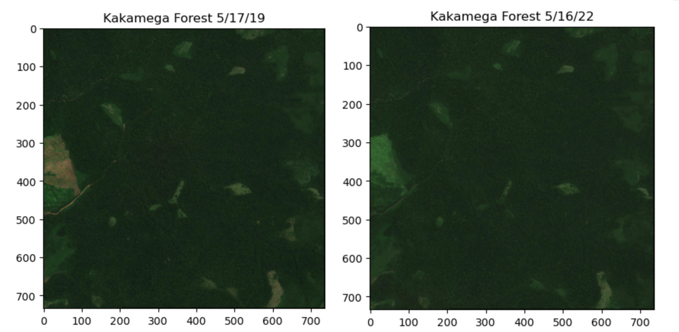
Figure 1, Kakamega Forest study area in Kenya on 5/17/19, first in time series, and 5/16/22, last in time series.

The Vegetation Indices were chosen to target vegetation attributes that may affect forest health to determine whether the Kakamega Forest is at risk of degradation. Indices are mathematical combinations of spectral bands that enhance contrast of a particular property. Normalized Difference Vegetation Index, or NDVI, is widely used to measure the health and density vegetation. Normalized Difference Moisture Index, or NDMI, is used to measure the water content in vegetation. Red Edge Normalized Vegetation Index, or RENDVI, is also used to measure health of vegetation, but as it uses just the narrow “red edge” wavelength, it is more sensitive to variations, which can be helpful in determining stress. Green Chlorophyll Index, or GCI, is used to estimate the chlorophyll content of vegetation. Each index listed above is calculated for every date in the time series, and every index of the first and last date of the time series is used to calculate the difference from beginning of La Nina and the end. Histograms will be created to show the distribution of the reflectance values of the Vegetation Indices. The change detection of the differences will show the spatial distribution of the change.
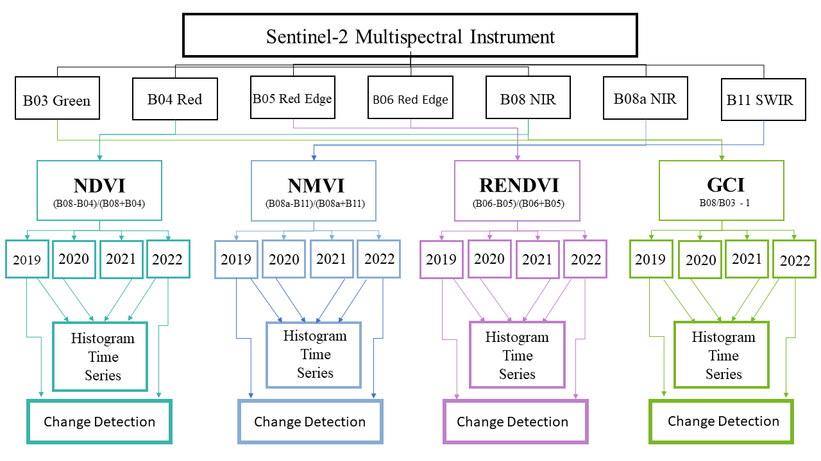
Figure 2, Diagram of method in study using Sentinel-2 satellite images to create Vegetation Indices

NDVI
NDVI capitalizes on the fact that much of the visible red light is absorbed by a healthy leaf due to the chlorophyll found in the leaf’s pigment while large amounts of near infrared light are reflected off the leaf due to the spongy parenchyma cells that irregularly arranged creating pockets of air in the cells, which scatters the near infrared light. The satellite’s bands record the amount of reflected light in specific wavelengths. NDVI utilizes the reflectance values of the red band, with a central wavelength of 665 nm, and the NIR band, with a central wavelength of 842 nm, using the formula of (NIR-red/NIR+red). NDVI enhances contrast between the two bands thus showing the presence of vegetation, or lack thereof. The formula yields values from -1 to 1. The closer the number is to 1, healthier and denser the vegetation is. Dense green vegetation will have NDVI values of 0.60 and above.
NDMI
NDMI is a spectral band combination used to monitor the water content of vegetation. The SWIR band is less affected by atmospheric noise and is sensitive to moisture inside the leaf. It is used to create drought maps with wildfire monitoring and is useful in agriculture to indicate water stress in crops. It combines the near infrared band with the short-wave infrared band with the formula (NIR-SWIR/NIR+SWIR).
RENDVI
RENDVI uses the narrow bands along the “red edge” and can be referred to as Narrowband Greenness. The red edge describes the sharp increase along the wavelengths of 680-725nm that is the characteristic pattern to the reflectance of vegetation. Using two narrow bands in this region will pick up subtleties. RENDVI can more finely distinguish small changes in canopy structure as well as detect stress at earlier stages. A limitation to NDVI with dense canopies is with saturation and the scattering of light bouncing around the foliage. RENDVI will also be affected by saturation but to a lesser degree (Xie et al., 2018). RENDVI can better discern smaller variations that may otherwise get obscured due to saturation.
GCI
GCI is useful in estimating the amount of chlorophyll in vegetation due to the reflectance of NIR and the green band, with the central wavelength of 560nm. The chlorophyll in the leaf’s pigment reflects green light in the visible spectrum giving the vegetation the characteristic green appearance. There is a linear relationship between the greenness of the leaf and the amount of chlorophyl present in the leaf, and GCI is a better indicator than NDVI for greenness (Viña et al., 2011). The formula for GCI is NIR/green – 1.

Results

Dense and healthy vegetation is likely to have values greater than 0.60. All vegetation will have slightly different optimal NDVI values and will vary depending on the phenological stage. It is important to compare images with the same phenology. This is accomplished by choosing the same time of the growing season. As there is not a baseline of optimal NDVI known for the specific type of trees, the goal is to compare change. There is a slight decrease in NDVI from year one to year two. This reverses in year three. Year four shows a significant loss in NDVI falling lower than the typical average of dense canopies. The NDVI average rate of change from 5/17/19 to 5/16/22 decreased by 40.85%.
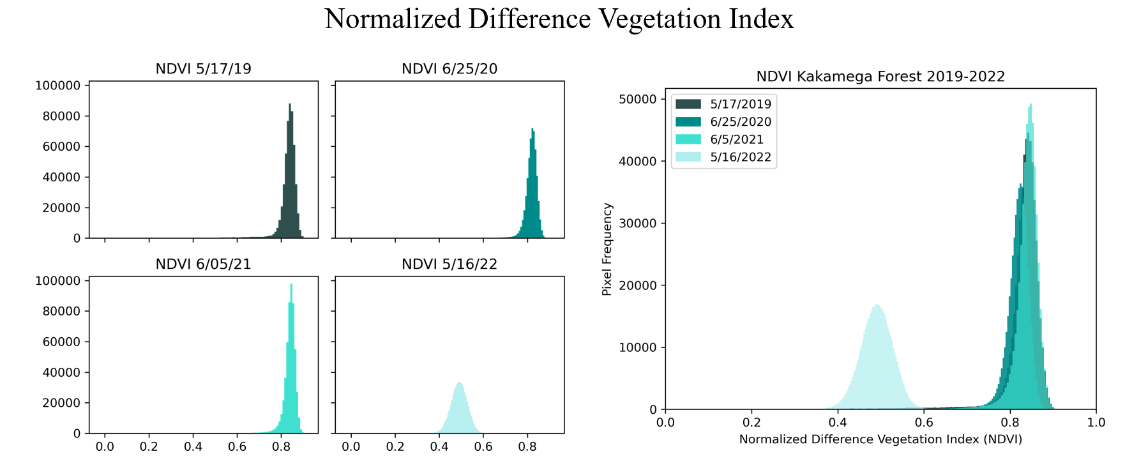
Figure 3, distribution of reflectance values of NDVI over the study period
NDMI is sensitive to the water content in vegetation. Typical green vegetation values can range form -0.1 to 0.4. The denser the foliage is the higher the NDMI value is due to volume of vegetation being measured. The study shows a decreasing trend in year one through three. This reverses in year four. The NDMI average rate of change from 5/17/19 to 5/16/22 decreased by 27.53%.
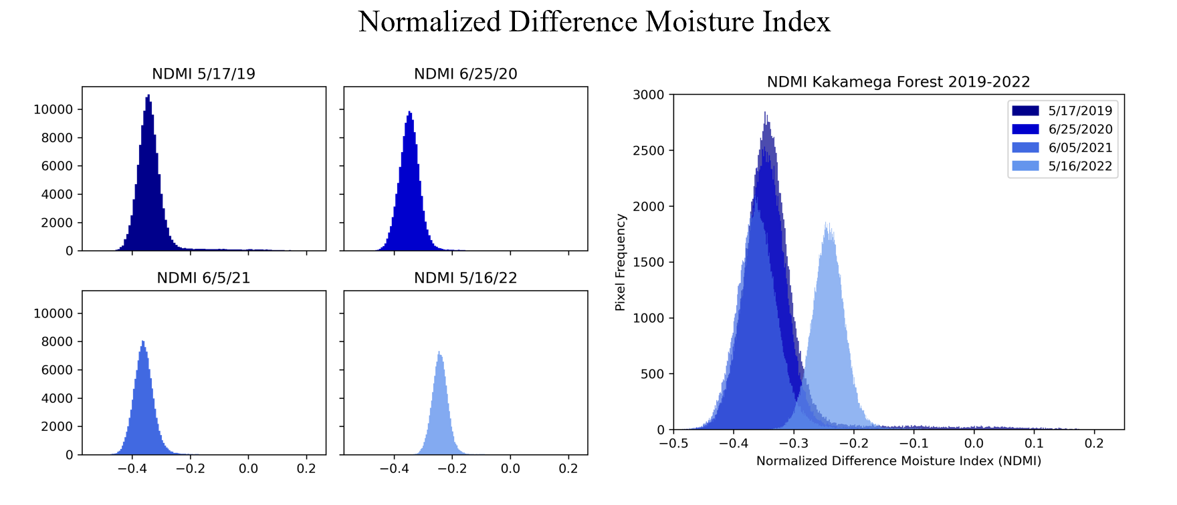
Figure 4, distribution of reflectance values of NDMI over the study period

RENDVI suffers less from saturation than NDVI, and the RENDVI can either confirm the NDVI values or lead to additional insights. The RENDVI average rate of change from 5/17/19 to 5/16/22 decreased by 41.19%. The RENDVI shows a greater loss of 0.34%.
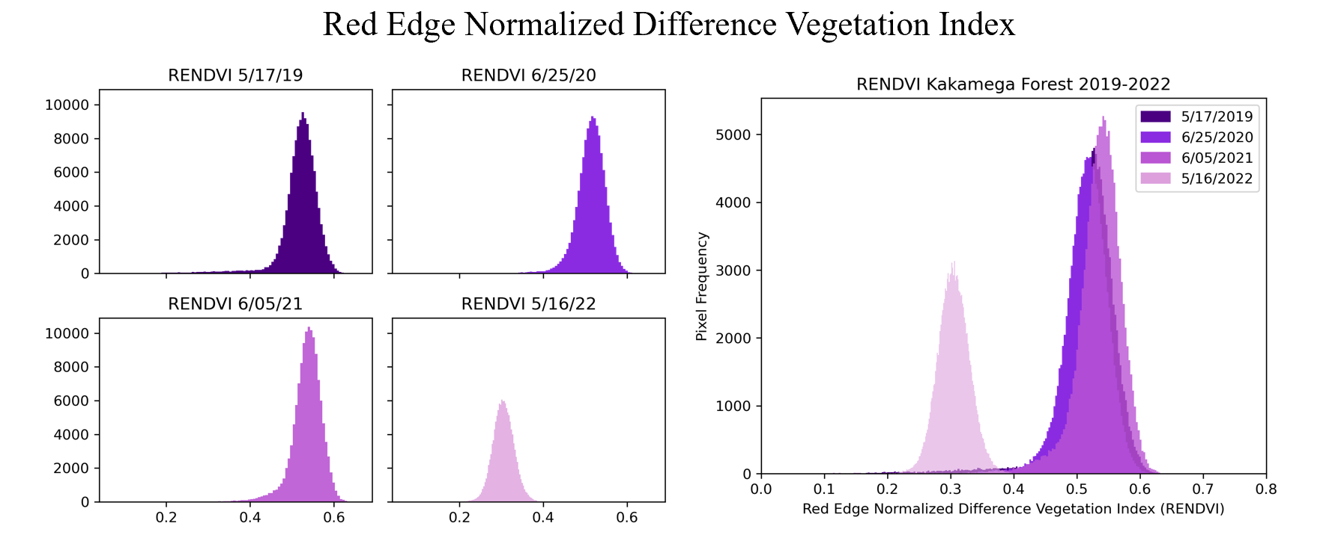
Figure 5, distribution of reflectance values of RENDVI over the study period
GCI measures the amount of green light reflected as a way of estimating chlorophyll content of the leaves as there is an established linear relationship. There was a small decrease from year one to year two. Year three shows a small gain, however not completely back to the original values of year one. There is a large decrease in year 4. The GCI average rate change from 5/17/19 to 5/16/22 decreased by 71.35%.
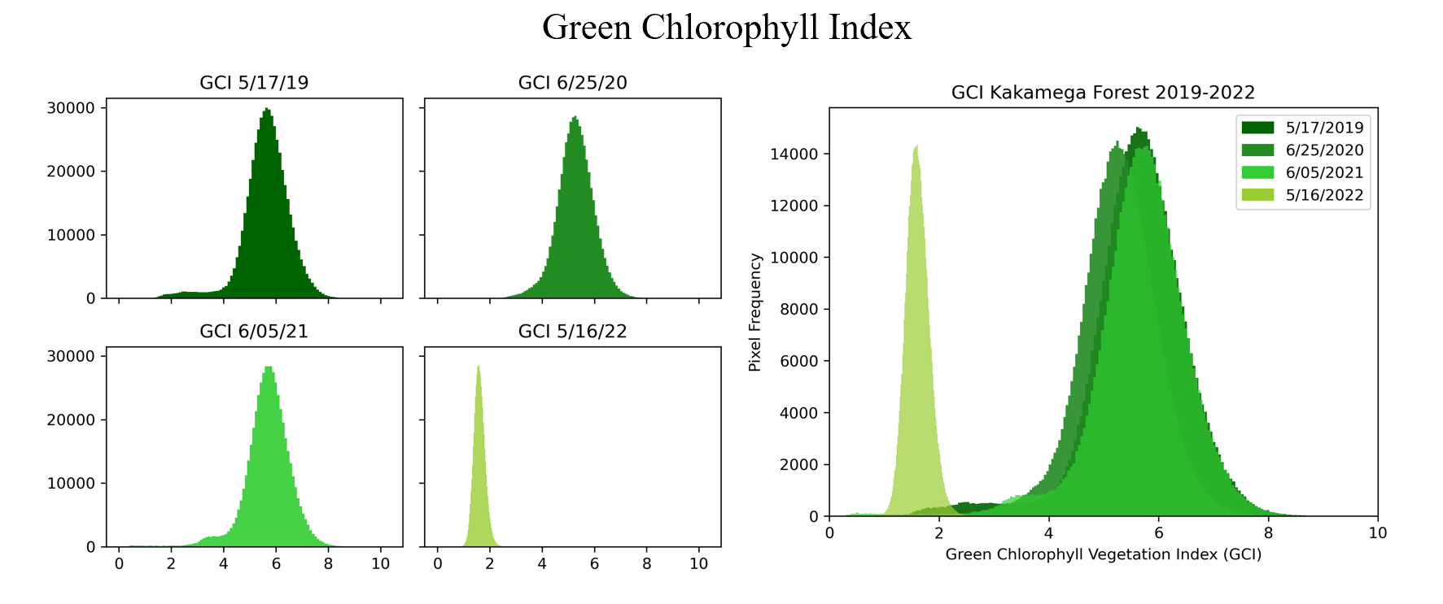
Figure 6, distribution of reflectance values of GCI over the study period

There was a large shift in every Vegetation Index for year four. Spectral indices are prone to atmospheric interference. To confirm that there was no outside variable that caused this jump, an image in June 2022 was evaluated. This image confirmed the data from May 2022 with just minor variations.
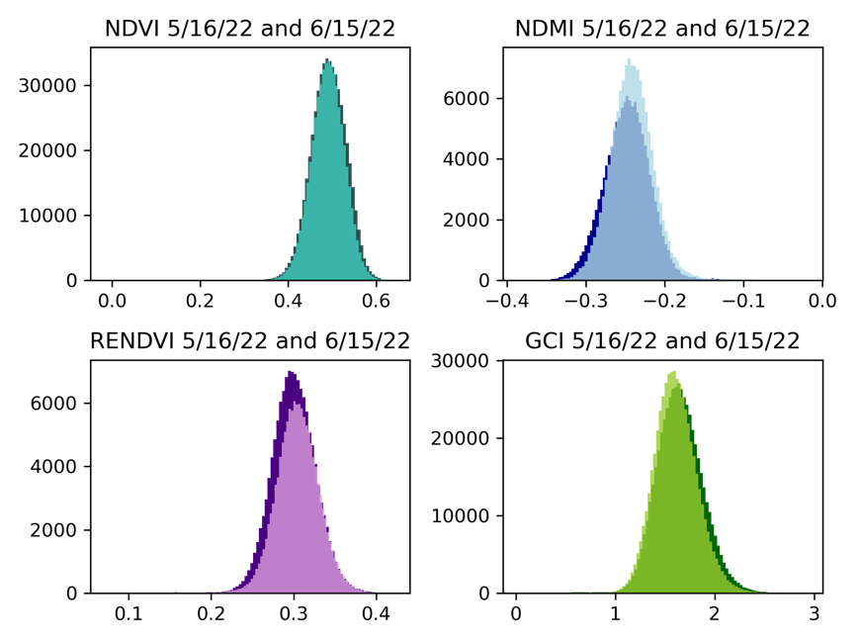
Figure 7, comparison of the distribution of values of the Vegetation Indices of 5/16/22 and 6/15/22

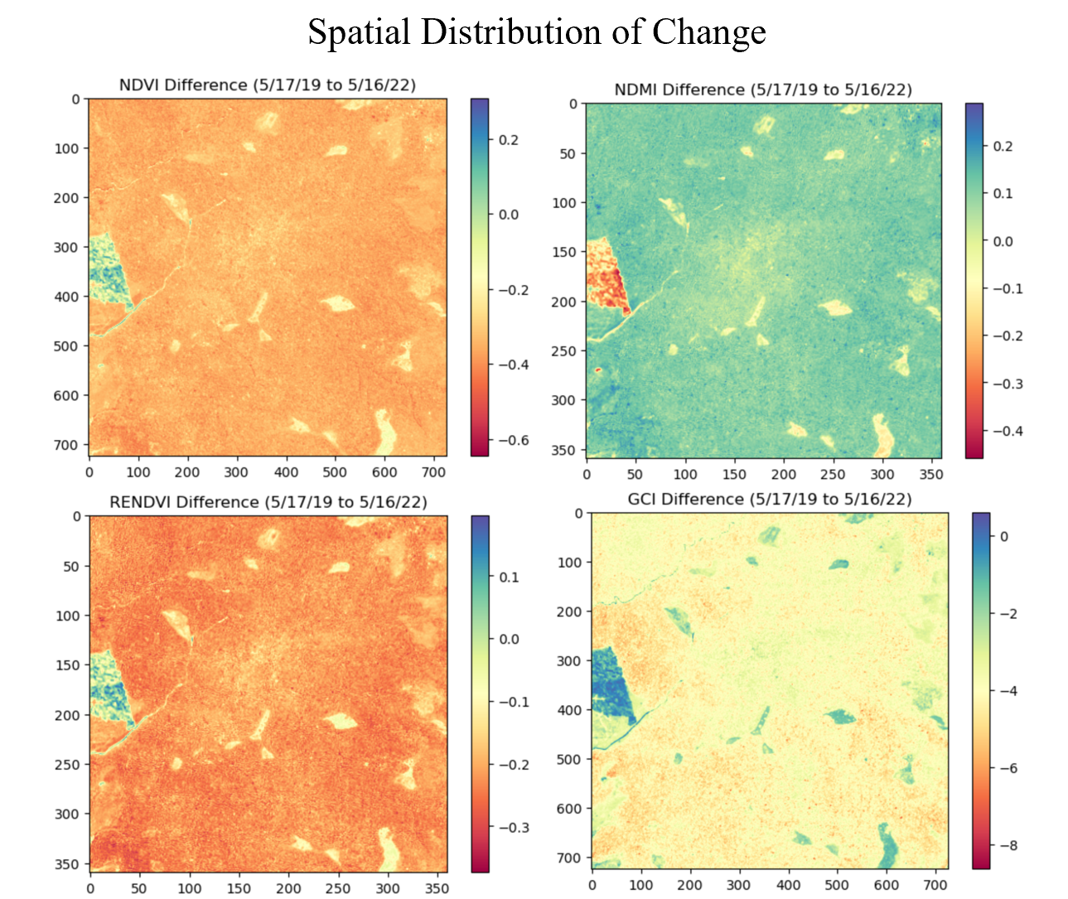
Figure 8, spatial distribution of change of NDVI, NDMI, RENDVI, and GCI over study period
Discussion

The four Vegetation Indices investigated in the study period show a consistent pattern of decline in year four. In year three both the NDVI, RENDVI, and GCI showed gains. This may be due in part to regreening deforested areas. This regreening is observed in the 2022 true color image of the study area. NDVI is often used to measure the health and vigor of vegetation. The steep decrease in year four is concerning, and these results were echoed with the RENDVI. The NDMI showed a decrease during the study period indicating that the vegetation showed water stress. The greatest decline was in the GCI indicating a loss of chlorophyll in the Kakamega Forest. This potential loss of chlorophyll could impact the forest’s ability to act as a carbon sink. Any decrease in carbon balance could have ramifications to the local pattern and amount of rainfall, negatively affecting the biodiversity of this distinctive rainforest, and compounding climate change. Deforestation and forest degradation need to be closely monitored to effectively balance carbon emissions to slow the rate of climate change.

This study cannot measure biomass or tree mortality, important indicators of forest degradation, nor can it measure carbon loss or gain. It can point to a potential loss, but it cannot quantify loss. This study cannot measure resiliency, or the ability for the forest to recover from stress. The study area has two natural rainy seasons, and this study only looked at a time series after one of the rainy seasons due to unusable images due to cloud interference. Spectral indices are sensitive to clouds limiting the data needed to monitor rainforests in this way. There are natural patterns and variations to weather and this study period is too short to understand if these results are abnormal in the larger weather pattern. More study will need to done to understand when and if the Kakamega Forest recovers from this stress, and what the carbon impact of this stress is.

Conclusion

The regional complexity of carbon stock and flux issues resists general solutions. Carbon tracking must be concise and repeatable to quantify the local conditions and metrics. Multispectral analysis allows targeted measurements to be taken at scale, providing a broader, clearer picture of forest loss and the potential impact to carbon emissions. This is increasingly important due the intensifying effects of climate change and the positive feedback loop of climate change on deforestation and forest degradation. Given enough data, trend analysis could provide novel solution opportunities and inform policy decisions. The results seen in this study of the Kakamega Forest reinforce the need to leverage this technology with all haste.

Bibliography

Aleman, J. C., Jarzyna, M. A., & Staver, A. C. (2018). Forest extent and deforestation in tropical Africa since 1900. Nature Ecology & Evolution, 2(1), Article 1. https://doi.org/10.1038/s41559-017-0406-1
Baccini, A., Goetz, S. J., Walker, W. S., Laporte, N. T., Sun, M., Sulla-Menashe, D., Hackler, J., Beck, P. S. A., Dubayah, R., Friedl, M. A., Samanta, S., & Houghton, R. A. (2012). Estimated carbon dioxide emissions from tropical deforestation improved by carbon-density maps. Nature Climate Change, 2(3), Article 3. https://doi.org/10.1038/nclimate1354
Boulton, C. A., Lenton, T. M., & Boers, N. (2022). Pronounced loss of Amazon rainforest resilience since the early 2000s. Nature Climate Change, 12(3), Article 3. https://doi.org/10.1038/s41558-022-01287-8
Cardinale, B. J., Duffy, J. E., Gonzalez, A., Hooper, D. U., Perrings, C., Venail, P., Narwani, A., Mace, G. M., Tilman, D., Wardle, D. A., Kinzig, A. P., Daily, G. C., Loreau, M., Grace, J. B., Larigauderie, A., Srivastava, D. S., & Naeem, S. (2012). Biodiversity loss and its impact on humanity. Nature, 486(7401), Article 7401. https://doi.org/10.1038/nature11148
Gatti, L. V., Basso, L. S., Miller, J. B., Gloor, M., Gatti Domingues, L., Cassol, H. L. G., Tejada, G., Aragão, L. E. O. C., Nobre, C., Peters, W., Marani, L., Arai, E., Sanches, A. H., Corrêa, S. M., Anderson, L., Von Randow, C., Correia, C. S. C., Crispim, S. P., & Neves, R. A. L. (2021). Amazonia as a carbon source linked to deforestation and climate change. Nature, 595(7867), Article 7867. https://doi.org/10.1038/s41586-021-03629-6
Geist, H. J., Lambin, E. F. (2002). Proximate Causes and Underlying Driving Forces of Tropical Deforestation: Tropical forests are disappearing as the result of many pressures, both local and regional, acting in various combinations in different geographical locations. BioScience, 52(2), 143–150. https://doi.org/10.1641/0006-3568(2002)052[0143:PCAUDF]2.0.CO;2
Gibson, L., Lee, T. M., Koh, L. P., Brook, B. W., Gardner, T. A., Barlow, J., Peres, C. A., Bradshaw, C. J. A., Laurance, W. F., Lovejoy, T. E., & Sodhi, N. S. (2011). Primary forests are irreplaceable for sustaining tropical biodiversity. Nature, 478(7369), Article 7369. https://doi.org/10.1038/nature10425
Harris, N. L., Gibbs, D. A., Baccini, A., Birdsey, R. A., de Bruin, S., Farina, M., Fatoyinbo, L., Hansen, M. C., Herold, M., Houghton, R. A., Potapov, P. V., Suarez, D. R., Roman-Cuesta, R. M., Saatchi, S. S., Slay, C. M., Turubanova, S. A., & Tyukavina, A. (2021). Global maps of twenty-first century forest carbon fluxes. Nature Climate Change, 11(3), Article 3. https://doi.org/10.1038/s41558-020-00976-6
Hong, C., Burney, J. A., Pongratz, J., Nabel, J. E. M. S., Mueller, N. D., Jackson, R. B., & Davis, S. J. (2021). Global and regional drivers of land-use emissions in 1961–2017. Nature, 589(7843), Article 7843. https://doi.org/10.1038/s41586-020-03138-y
Hosonuma, N., Herold, M., Sy, V. D., Fries, R. S. D., Brockhaus, M., Verchot, L., Angelsen, A., & Romijn, E. (2012). An assessment of deforestation and forest degradation drivers in developing countries. Environmental Research Letters, 7(4), 044009. https://doi.org/10.1088/1748-9326/7/4/044009
IPCC. (2022). Summary for Policymakers [H.-O. Pörtner, D.C. Roberts, E.S. Poloczanska, K. Mintenbeck, M. Tignor, A. Alegría, M. Craig, S. Langsdorf, S. Löschke, V. Möller, A. Okem (eds.)]. In: Climate Change 2022: Impacts, Adaptation, and Vulnerability. Contribution of Working Group II to the Sixth Assessment Report of the Intergovernmental Panel on Climate Change [H.-O. Pörtner, D.C. Roberts, M. Tignor, E.S. Poloczanska, K. Mintenbeck, A. Alegría, M. Craig, S. Langsdorf, S. Löschke, V. Möller, A. Okem, B. Rama (eds.)]. Cambridge University Press, Cambridge, UK and New York, NY, USA, pp. 3-33, doi:10.1017/9781009325844.001.
Jayathilake, H. M., Prescott, G. W., Carrasco, L. R., Rao, M., & Symes, W. S. (2021). Drivers of deforestation and degradation for 28 tropical conservation landscapes. Ambio, 50(1), 215–228. https://doi.org/10.1007/s13280-020-01325-9
Kenya Wildlife Service. (2022). Kakamega Forest National Reserve. Kenya Wildlife Service. Retrieved November 29, 2022, from http://www.kws.go.ke/content/kakamega-forest-national-reserve
Lawrence, D., Vandecar, K. (2015). Effects of tropical deforestation on climate and agriculture. Nature Climate Change, 5(1), Article 1. https://doi.org/10.1038/nclimate2430
Marengo, J. A., Souza, C. M., Thonicke, K., Burton, C., Halladay, K., Betts, R. A., Alves, L. M., & Soares, W. R. (2018). Changes in Climate and Land Use Over the Amazon Region: Current and Future Variability and Trends. Frontiers in Earth Science, 6. https://www.frontiersin.org/articles/10.3389/feart.2018.00228
Mitchard, E. T. A. (2018). The tropical forest carbon cycle and climate change. Nature, 559(7715), Article 7715. https://doi.org/10.1038/s41586-018-0300-2
Modified Copernicus Sentinel data (2022)/Sentinel Hub
Prăvălie, R. (2018). Major perturbations in the Earth’s forest ecosystems. Possible implications for global warming. Earth-Science Reviews, 185, 544–571. https://doi.org/10.1016/j.earscirev.2018.06.010
National Weather Service. (2022). El Nino & La Nina Information. NOAA’s National Weather Service. Retrieved November 17, 2022, from https://www.weather.gov/ict/enso
Viña, A., Gitelson, A. A., Nguy-Robertson, A. L., & Peng, Y. (2011). Comparison of different vegetation indices for the remote assessment of green leaf area index of crops. Remote Sensing of Environment, 115(12), 3468–3478. https://doi.org/10.1016/j.rse.2011.08.010
Walker, W. S., Gorelik, S. R., Baccini, A., Aragon-Osejo, J. L., Josse, C., Meyer, C., Macedo, M. N., Augusto, C., Rios, S., Katan, T., de Souza, A. A., Cuellar, S., Llanos, A., Zager, I., Mirabal, G. D., Solvik, K. K., Farina, M. K., Moutinho, P., & Schwartzman, S. (2020). The role of forest conversion, degradation, and disturbance in the carbon dynamics of Amazon indigenous territories and protected areas. Proceedings of the National Academy of Sciences, 117(6), 3015–3025. https://doi.org/10.1073/pnas.1913321117
Watson, J. E. M., Evans, T., Venter, O., Williams, B., Tulloch, A., Stewart, C., Thompson, I., Ray, J. C., Murray, K., Salazar, A., McAlpine, C., Potapov, P., Walston, J., Robinson, J. G., Painter, M., Wilkie, D., Filardi, C., Laurance, W. F., Houghton, R. A., … Lindenmayer, D. (2018). The exceptional value of intact forest ecosystems. Nature Ecology & Evolution, 2(4), Article 4. https://doi.org/10.1038/s41559-018-0490-x
World Heritage Center. (2022). The Kakemega Forest. UNESCO World Heritage Centre. Retrieved November 29, 2022, from https://whc.unesco.org/en/tentativelists/5508/
Xie, Q., Dash, J., Huang, W., Peng, D., Qin, Q., Mortimer, H., Casa, R., Pignatti, S., Laneve, G., Pascucci, S., Dong, Y., & Ye, H. (2018). Vegetation Indices Combining the Red and Red-Edge Spectral Information for Leaf Area Index Retrieval. IEEE Journal of Selected Topics in Applied Earth Observations and Remote Sensing, 11(5), 1482–1493. https://doi.org/10.1109/JSTARS.2018.2813281
Yang, Y., Saatchi, S. S., Xu, L., Yu, Y., Choi, S., Phillips, N., Kennedy, R., Keller, M., Knyazikhin, Y., & Myneni, R. B. (2018). Post-drought decline of the Amazon carbon sink. Nature Communications, 9(1), Article 1. https://doi.org/10.1038/s41467-018-05668-6

