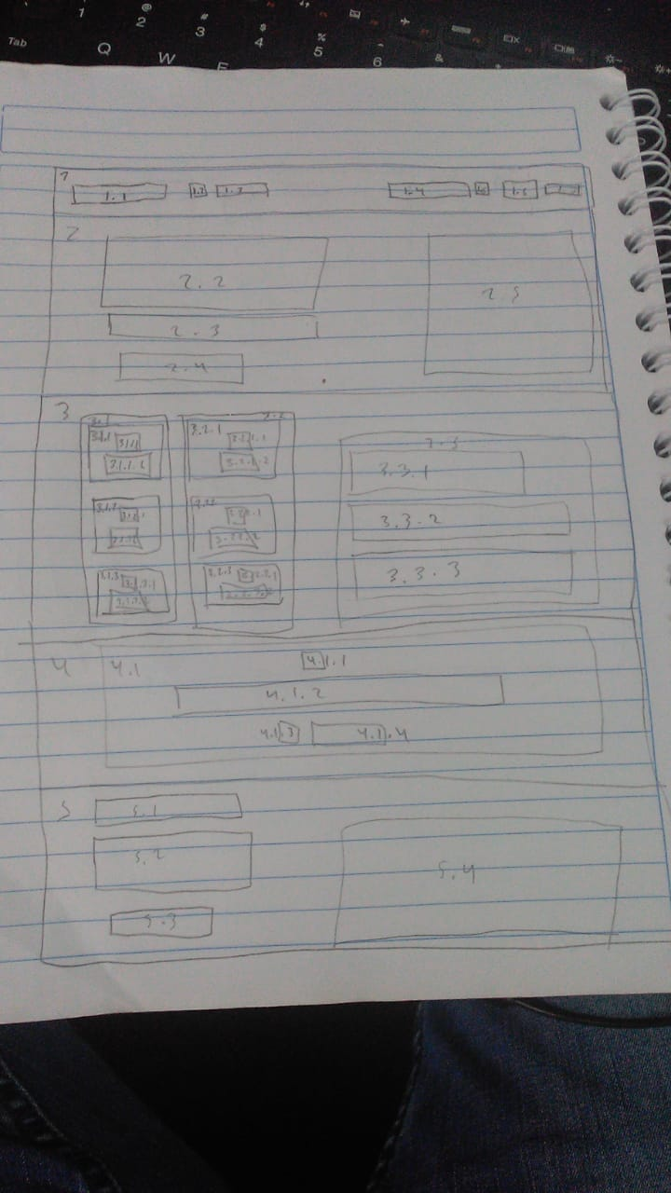

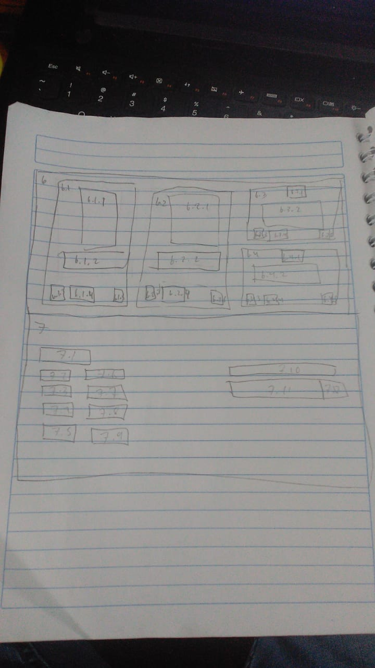

|  |  |  |
| --- | --- | --- |
| Número | Tag | Clase |
| 1 | Div | barra |
| 1.1 | Img | logo |
| 1.2 | Img | ltcl |
| 1.3 | a | learntop |
| 1.4 | Input | search |
| 1.5 | Img | Search-icon |
| 1.6 | Button | probut |
| 1.7 | a | signin |
| 2 | div | start |
| 2.1 | p | h2 |
| 2.2 | Div | h3 |
| 2.3 | Button | button |
| 2.4 | Img | imgstart |
| 3 | div | whatis |
| 3.1 | div | logos1 |
| 3.1.1 | div | reactdiv |
| 3.1.1.1 | img | logolang |
| 3.1.2 | div | rnativediv |
| 3.1.2.1 | img | logolang |
| 3.1.3 | div | reduxdiv |
| 3.1.3.1 | img | logolang |
| 3.2 | div | logos2 |
| 3.2.1 | div | jsdiv |
| 3.2.1.1 | img | logolang |
| 3.2.2 | div | nodediv |
| 3.2.2.1 | img | logolang |
| 3.2.3 | div | vuediv |
| 3.2.3.1 | img | logolang |
| 3.3 | div | whattext |
| 3.3.1 | p | titwhat |
| 3.3.2 | p | par |
| 3.3.3 | p | par |
| 4 | div | tweet |
| 4.1 | div | twt |
| 4.1.1 | img | quote |
| 4.1.2 | div | tw |
| 4.1.3 | img | shaunphoto |
| 4.1.4 | p | shaun |
| 5 | Div | today |
| 5.1 | p | titwhat tod |
| 5.2 | p | par a |
| 5.3 | Button | Button free |
| 5.4 | Img | coins |
| 6 | div | featured |
| 6.1 | div | f1 |
| 6.1.1 | img | imgf |
| 6.1.2 | p | pf |
| 6.1.3 | img | phf |
| 6.1.4 | p | nf |
| 6.1.5 | img | lock |
| 6.2 | div | f2 |
| 6.2.1 | img | imgf |
| 6.2.2 | p | pf |
| 6.2.3 | img | phf |
| 6.2.4 | p | nf |
| 6.2.5 | img | lock |
| 6.3 | div | f3 |
| 6.3.1 | img | Imgf 2 |
| 6.3.2 | p | Pf 2 |
| 6.3.3 | img | phf |
| 6.3.4 | p | nf |
| 6.3.5 | img | lock |
| 6.4 | div | f4 |
| 6.4.1 | img | Imgf 2 |
| 6.4.2 | p | Pf 2 |
| 6.4.3 | img | Phf |
| 6.4.4 | p | nf |
| 6.4.5 | img | lock |
| 7 | div | footer |
| 7.1 | img | logo |
| 7.2 | p | foottext |
| 7.3 | p | foottext |
| 7.4 | p | foottext |
| 7.5 | p | foottext |
| 7.6 | p | foottext |
| 7.7 | p | foottext |
| 7.8 | p | foottext |
| 7.9 | p | foottext |
| 7.10 | p | foottext |
| 7.11 | Input | search |
| 7.12 | img | Search-icon |