what can i do to launch the project?

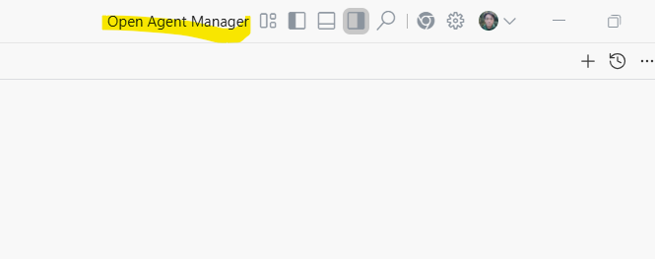
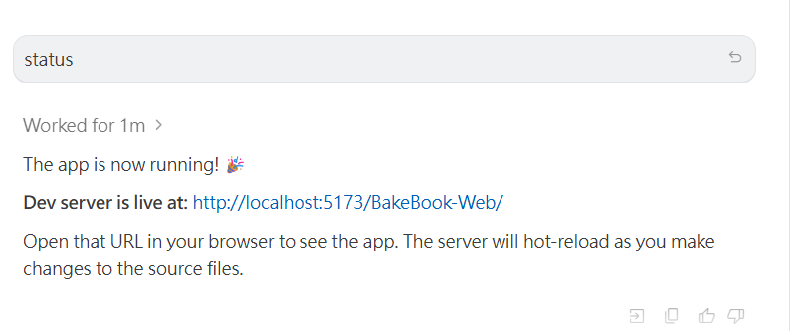

help me to review each of functions and fix the problem for me.

help me to fix all the bugs without my green light

