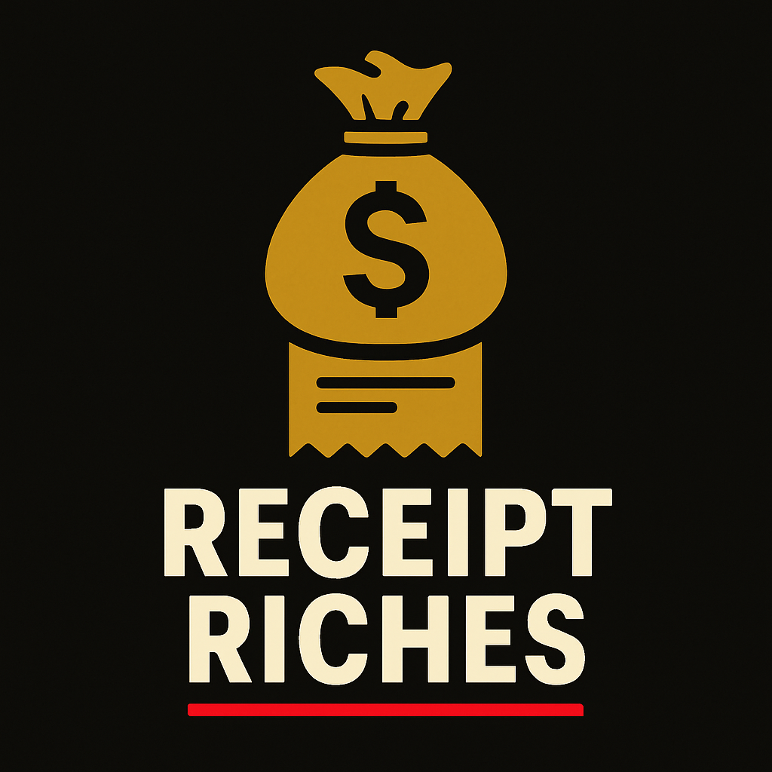

# Cover Letter for Receipt Riches

Dear [Investor/Partner/Supporter],  
  
I hope this message finds you well. My name is [Your Name], and I am the founder of Receipt Riches — a mobile app and digital platform created to teach everyday people how to save real money through the power of extreme couponing.  
  
Inspired by my own journey of making every dollar count, I envisioned a tool that not only helps people save but also transforms how they shop, plan, and think about their financial habits. At a time when prices are rising and budgets are tightening, Receipt Riches is here to put power back in the hands of the consumer.  
  
Our app features real-time deal matchups, tutorial videos for beginners and pros alike, and a growing community of smart savers. With planned partnerships, educational outreach, and a strong monetization strategy, Receipt Riches is more than an app — it’s a movement to help people shop smarter and live richer.  
  
I’m excited to share this vision with you and invite you to be part of its growth. I’ve attached our official business plan, outlining our goals, features, market strategy, and mission. I believe Receipt Riches has the potential to make a real difference in communities across the country — and I’d love the opportunity to talk further about it.  
  
Thank you for your time, your interest, and your belief in innovation that helps real people.  
  
Sincerely,  
[Your Name]  
Founder & Visionary, Receipt Riches  
[Your Contact Info]