Learning Categories Using Semantic Priming

in a Bayesian Framework

Ray Luo

Electrical Engineering and Computer Sciences
University of California
Berkeley, California 94720
rluo@cory.eecs.berkeley.edu

Abstract
A probabilistic algorithm for unsupervised learning of categories using internal comparisons is presented. The Bayesian merging algorithm uses parent category prototypes to facilitate basic category comparisons. Our model takes on the new task of learning internal representation with no explicit feedback. We assume that humans make implicit comparisons between novel categories and merge categories they consider similar, in a probabilistic sense. We find that the algorithm out performs simple data incorporation, and that the algorithm supplemented by feature comparisons did even better. The consideration of context brought about by feature comparison allows the model to generalize over noisy examples. However, a more compact representation is desired.

Introduction
Humans can learn nouns easily given a few examples and almost no explicit feedback. A simple explicit memory model can account for neither the rapidity nor the accuracy of learning. Thus we must rely on a model of implicit memory that accounts for the effects of past experience. One approach is to represent nouns as basic categories with uncertain feature values. As more data are incorporated, the categories look more and more like what the noun represents in the real world. Since categories are built up from experience, we expect physical interaction to improve category acquisition. We suggest that implicit category comparisons (via semantic priming) model this physical interaction.
Much of the modeling ideas presented are inspired by Schooler et. al. (2001). As in Schooler et. al., we apply rational analysis (Anderson, 1990) to the modeling of results from psychological experiments. The REM model of Schooler et. al. was an attempt to account for episodic retrieval via a model that assumes that priming acts to “alter the word’s lexical-semantic memory representation” (2001). Justification for direct alteration of the representation are given in Schooler et. al. Our priming effects will be based on comparison tasks. Most objections to Bayesian models point to the lack of plausibility for the human mind to perform probabilistic computations during experimental tasks. Our model will make simplifying assumptions on the REM model by using simpler Bayesian methods that we assume are at least can be computed neurally. Moreover, we will apply Bayesian reasoning to learning a best current model. We will simplify the algorithm by making some assumptions on human perceptual capabilities and mental representations.
We focused on animal categories so as to simplify direct comparison with psychological experiments. Ideas suggested here are relevant for text categorization as well. In particular, any domain that can be decomposed into hierarchical categories can be modeled. Our algorithm uses a simple representation of features and categories to facilitate comparison. In a real-world application, Bayesian network representations should be constructed for both basic and parent categories. We’ll suggest how this can be done later, although the implementation is only at an experimental phase.

Assumptions
First, we assume that no perceptual errors are made during learning and testing. That is, there is no probability distribution associated with input animal features for each example. The lack of errors in perception does not, however, imply that the input data is noiseless. We assume that the distributions of attributes of an animal are independent and jointly Gaussian. Data are generated using normal distributions with pre-determined means and variances that reflect the attribute domain for each animal. Noisy examples with random features are also fed into the model periodically. The assumption suggests that the only probabilistic aspect of category-learning is captured by our model. Thus, our model (and not the perceptual system) is responsible for handling noisy data.
Second, only two levels of categories are relevant to our task. Our basic categories consist of animal types. In particular, data for ant, snail, frog, cat, wolf, cow, and whale were given as input. Note, however, that the model forms abstract models of the data, so no actual label is given to any category. The idea is that a category is described by average feature values and a measure of the spread of feature values. It is the model’s task to minimize the complexity of sets of categories while maximizing the probability of correctly identifying the category of any example given the feature values. This can be done using inference on a belief network. Our superordinate parent categories consist of graded conceptual categories involving the animal types. For example, the large animal category should include whale and cow as salient examples, with wolf, and possibly cat having graded membership. Graded membership is not represented explicitly, however. The model will keep track of one best prototype, which can be updated with a given probability during comparison tasks. We construct conceptual categories using the different features associated with animals. In particular, large animal, small animal, cute animal, hideous animal, ferocious animal, and tame animal were used. Ideally, we should model other objects as well and allow our conceptual categories to be simply large, small, cute, hideous, etc. This makes the model more general, less domain-dependent, but harder to assess. Thus we stick to animals at present.
Third, inferences and comparisons done on particular members of basic categories are necessary for learning and structuring both basic and superordinate parent categories. Here we focus on feature value comparisons. We can ask, for example, “which animal is larger, cat or frog?” Luo (2000) reviews these tasks. In modeling early development, we can associate the semantic priming that results from querying the subject with changes in the underlying categories. Our claim is that these changes result from comparison of basic category feature values with prototype feature values. In the example above, size feature values for cat and frog are compared with the prototype large animal feature value. Changes are made to the abstract categorical representations of cat and frog size values and spreads. Prototype values are updated as needed. One natural question that arises is: if feature value estimates are already kept by our basic category representation, couldn’t we just compare the estimates and return the appropriate category (in this case, cat for the larger animal)? There are three problems with this approach. First, the approach predicts that all comparisons should take the same amount of time on average. This has been shown to be false (Banks et. al., 1976). For example, it is much faster to decide between whale and ant than cat and frog. Second, the approach predicts that no errors could occur. For example, frogs would always be judged smaller than cats. This does not hold experimentally (Luo, 2000). We need, instead, a model that is generally true, but can give wrong answers in some contexts. Third, there are uncertainties associated with feature estimates (This is why we need a measure of spread). For example, some cats (tigers) are very large while other cats (kitty) are very small. As more examples of cats are shown to the system, the model becomes better and better at estimating the relative size of cats, but it is never absolutely sure that cats are smaller than wolves. Our approach is to compare cat and wolf sizes with the prototypical size. We can model differences in judgment reaction times by relative distances between category and prototype size feature values. You can think of our approach as a variance reduction technique. We are leveraging our knowledge about prototypical cases, which also have associated uncertainty values.
Fourth, there exist abstract category representations in the mind independent of, but influenced by, linguistic labels. Our model keeps abstract categories with no particular linguistic interpretation. The reason for this is that synonyms abound in the real world. While there is evidence that no “exact” synonyms exist in the technical sense, our model of the mind relies on generalization over similar word senses. Hence, frog and toad may refer to relatively similar animals that have similar values with respect to our set of features. A child may not be able to distinguish (at least at first) between these similar animal types. Thus we need a structure that represents the features of a frog-toad without labeling it. We can then compare these abstract categories amongst themselves and perform inferences purely on the basis of feature structures. Words with different senses (cat, for example) are described by different categories while different words denoting animals with similar features (frog and toad, for example) are described by the same category. We hope to show in the future that the linguistic label associated with an abstract category is a probability distribution over words or phrases acquired from experience. Instead of saying, for example, that the word cat has two senses (kitty and tiger), we say that abstract category A has a probability of 0.95 of being labeled “cat” and abstract category B has a probability of 0.5 of being labeled “cat.” With experience, the abstract categories become finer because the variances of the feature values become smaller. In the limit of infinite experience, the two word senses of “cat” will be described by separate abstract categories with labeling probability 1.0, because a separate abstract category will describe “tiger” with probability 1.0. We hope that someone will prove the following claim (it shouldn’t be hard): Given a pre-defined, finite, sufficiently “nice” set of training examples, the category partitions formed by the algorithm will converge in probability to a set of non-overlapping category distributions (in the sense of zero variance feature values) as the number of sweeps goes to infinity. This statement would then imply that each category would eventually be labeled by its own word. In this paper, we assume that most likely labels are found magically by some other mechanism. We don’t really have to worry about possible ambiguity here because our comparison simulations are done with abstract categories and our prototypes generalize over the entire domain independently of particular word labels. Note, however, that a prototype is a single instance from our basic categories. When humans are confronted with a question regarding size, however, they don’t automatically think of, say, a whale. Our assumption here is that they performs subconscious comparisons with a vague superordinate prototype whose variance is averaged over a few salient examples.
Lastly, we assume that our direct representation of human semantic processing can be efficiently implemented neurally. One approach is to translate our mean-variance representation into a simple Bayesian network. We’ll describe this after giving the model and the algorithm.

Model
The basic claim of the model is that the meaning of a noun in some restricted domain is its abstract representation in relation to all other nouns in the domain. (This, of course, is nothing new; see, for example, (Anderson, 1990).) Moreover, this relationship is captured by comparisons with sets of superordinate prototypes that capture general characteristics of objects referred to by basic terms.
The model acquires basic category representations by merging abstract models of category partitions and by performing inferences and comparisons using these abstract partitions. Implicit reinforcements for correct and incorrect responses are assumed to be provided internally. (This models controlled experimental paradigms in which the subject is given a pair of objects whose feature values fall on some subjective scale. Errors are frequently caused by priming and by going too fast.) Moreover, learning probability distributions for category labels is assumed to be incremental, so that we don’t need to tell the subject not to say something, because she won’t say it (as the model predicts).
Thus we have abstract categories that model the internal representations of nouns and learning mechanisms that takes knowledge from the real world, and reconstructs, as best as they can, the entities that the nouns represent, using comparison-based implicit learning (Schooler et. al., 2001). Note that for our domain, this consists only of two hierarchical levels. Extensions beyond animal types can be constructed by treating each superordinate category as also a basic category.

Algorithm
Both model merging and prototype formation depend on order of data presentation. Since any possible merge with lower cost will be performed, there is a chance that the optimal merge will not be performed. Similarly, since early experience is weighted more heavily in prototype formation, we may get unrepresentative prototypes fairly late into the learning process.
We chose to model prototype acquisition as “Markov.” That is, the mean feature value for a prototype is drawn from either the current value or the maximum (or minimum) value over subordinate categories. As the model accumulates experience, it tends to stay with the current value; initially, it tends to choose the optimal value. The idea is that a single basic category instance serves as the prototype, but that the variance associated with the prototype is estimated from the current variance and the difference between the optimal value and the current value. Hence, the model forgets the past in the sense that the current prototype value variance captures all we need to know about past prototype values. The reason for this design decision is the seemingly transient nature of a prototype. When we think of a cat, we are basing our estimates on prior knowledge about distributions of feature values of a cat. When we think of a large animal, however, we first think of the idea of large. Then we may think of some specific animal prototypical of large animals. We don’t know everything about this prototype animal but we do know that it is large. After using this information, the prototype is put away. Our claim is that we don’t know all the feature value distributions of any prototype of any superordinate category. Given this assumption, one sensible model would be to base our prototype on either the last prototype or the best possible prototype. The probability of choosing between the two depends on experience. As more and more examples are observed, we are less likely to switch to the best possible prototype, because the current prototype must already be pretty good.
Now, we will walk through the algorithm in detail. An overview is presented in Fig. 6. First, we create random examples consisting of size, cuteness, and ferocity values for our animal types (ant, snail, frog, cat, wolf, cow, and whale), with noisy examples given random features values. Next, we give the data to the model incrementally. The model first scans through the categories to see if the new example can be put into an existing category. If not, a new category is constructed. After a few data incorporation steps, the merging algorithm is invoked. We compute the cost of every pair of possible merges and choosing the best merge to perform. For our purposes, we perform the first merge with a higher probability (lower cost) than the probability (cost) of the original model. The basic idea is that we are trying to maximize

P(Model | Data) = P(Data | Model) ⋅ P(Model) / P(Data).

P(Data) can be ignored since it is the same for any merge. This equation is translated to:

cost(Model) = α ⋅ size(Model) + (1 - α) ⋅ var(Model),

where size(Model) is the total number of categories (i.e. the size of the partition), and var(Model) is the total variance of all category feature values. The idea is that a set of data, a smaller model is a better, more succinct description of an underlying representation. Therefore, we want to minimize the size of the partition by merging categories together. But merging requires us to recomputed the variance of feature values for the resulting category, which can increase because the two categories to be merged are distinct. We should keep the variability low if we are to make good predictions about which category a novel set of feature values belongs to. Thus we have a trade-off between compactness and representational power. The algorithm will keep finding and merging categories until a merge with a lower cost cannot be found.
Between data incorporation steps, we periodically invoke the query mechanism, which models implicit comparisons that facilitates category-learning. We first update the prototypes probabilistically by parameterizing the experience of a child. We define a past experience factor (pef) between 0 and 1 that is initially small, but becomes larger as the number of sweeps increases. With probability 1 minus pef, we replace our superordinate prototypes (large animal, small animal, cute animal, hideous animal, ferocious animal, tame animal) with the example with the optimal feature value in our category partition. Since pef increases with time, we are less likely to change our prototypes as we obtain more and more experience. Next, we find the best matching categories that correspond to the querying examples. We compare these categories with the prototype categories for each feature. We explicitly change our categories by a small amount that is related to pef. The larger category is moved toward the value of the larger prototype, the smaller category is moved toward the value of the smaller prototype, and similarly for cuteness and ferocity. The idea is that given a pair of examples, we are asked to choose, for example, which animal is larger. We code the target example as being large and the rejected example as being small. This primes our future judgments on both of the examples (Luo, 2000). Specifically, our internal representation of the target and rejected examples are changed by some small factor determined by experience and by the distance between feature values of examples and prototypes. Note that our prototype representation can also be changed if the target example feature value is “more optimal” than the prototype feature value. This can happen because we only update the prototypes probabilistically (so the prototypes may not be the best prototypes).
Next, we discuss the translation of the model to a Bayesian network. As suggested by Koller & Sahami (1997), we can represent categories as discrete nodes that serve as parents of Gaussian feature nodes. Thus we specify the statistics for each feature and query the category node given the feature evidence. The problem to be worked out is to implement an unsupervised learning algorithm that updates the values that the category node can take on as more evidence arrives. Fig. 7 shows an early attempt at integration in which a superordinate parent category is represented just as another evidence node. Here we have assumed independence of each feature value. The superordinate category node “large” is a binary representation of a “decision” based on current feature estimates. Note that prototype values are kept implicitly within the distribution for the superordinate node. It may be better to use decision nodes for the superordinate category nodes, but we’re not sure how inference would work.

Results
Fig. 1 shows the size of the category partition, the categories given as examples, and the categories learned using no model merging and no feature comparison. For simplicity, only the size feature values of the categories are shown. Similar results can be plotted for the cuteness and ferocity dimensions. Note that a lot of categories were formed despite data incorporation, because no pruning is allowed. Fig. 2 shows the categories learned using model merging alone and Fig. 3 shows the categories learned using both model merging and feature comparisons. In general, category partitions learned using feature comparisons tend to generalize a bit more, so that we typically get a smaller number of categories. Note that one obvious problem with the model merging algorithm is that it tends to give inaccurate values for animals whose size is small.
We can change the parameters for both the model merging and the feature comparison algorithms. Fig. 4 and Fig. 5 shows the results for example runs for which the algorithms took into account the size of the model more and made greater changes to feature values during comparison. Note that both learned categories are very good. Note also that with feature comparison, we model the values for the 3rd and 7th categories better than with model merging alone. Over many iterations of the experiment, we find that feature comparison tends to do wonders when pef is set to be small ( 0.1). In that case, feature comparison tends to generalize more than model merging alone.

Discussion
Our Bayesian model merging algorithm applied to category-acquisition is not without its faults. For example, we are assuming that in the presence of small sample sizes, humans still believe that the distribution of feature values in the real world is approximately normal for each distinct animal. More reasonable approached involving the Dirichlet density can be found in Anderson (1990). We are also assuming that each feature comparison task occurs regularly and that all features of a category are compared. In the real world, this is rarely the case. We might be led into comparing, for example, sizes more than cuteness, and cats and dogs more often than polar bears and lady bugs. A proper model for comparison tasks in early language acquisition would involve modeling the world in which the child lives, which is beyond our present scope and capabilities. Note also that we are assuming the independence of each feature given the category, which cannot be a true model of the world. Finally, the model assumes that model merging and feature comparison happens independently. Note, however, that depending on our current comparison task, we might be more or less willing to merge disjoint categories. For example, we may be asked to compare cardinals and blue jays. We don’t have much of an idea of what they are and might consider them to be close to each other in size. Might they also not be in one category?
One other proposal would be to treat the problem as minimization of Boolean complexity given features and examples. The best model is that which minimizes the minimal formula associated with the disjunctive normal form of the evidence written with conjunction among features and disjunction among examples. We haven’t worked this out, however.
The Bayesian network representation needs to be explored thoroughly. We need to work out the way learning of category values will work for a Bayes net. Superordinate category representation is another area for improvement. One idea is to use separate nodes for each category value (ie. animal name). Then all we have to do is prune the network as more evidence arrives. The problem is that each node would be the parent of the feature values. Hence each augmentation of a feature adds O(k) links, where k is the number of values a category can take on. We should also allow feature values to link with each other, thereby removing the feature value independence assumption.
We presented a Bayesian approach to learning category representation. We saw that learning is facilitated by implicit interactions with the real world. Here, we considered feature comparison and priming. The principle, however, is more general. In modeling domain knowledge, we need to consider the various contexts in which a name can occur and the various interpretations the name can take on with respect to superordinate category prototypes.

References
Anderson, J. R. 1991. The adaptive nature of human categorization. Psychological Review, 98(3):409-429.

Banks, W. P.; Fujii, M.; and Kayra-Stuart, F. 1976. Semantic congruity effects in comparative judgments of magnitudes of digits. Journal of Experimental Psychology: Human Perception and Performance, 2:435-447.

Koller, D. and Sahami, M. 1997. Hierarchically classifying documents using very few words. In Proc. ICML-97, 170-178.

Luo, R. 2000. Response interference in categorical judgment tasks. Online http://inst.eecs.berkeley.edu/~rluo/categ_learn_doc/ perc&cog_np&sc-revised-text.doc.

Schooler, L. J.; Shiffrin, R. M.; and Raaijmakers, J. G. W. 2001. A Bayesian model for implicit effects in perceptual identification. Psychological Review, 108(1):257-272.

Appendix
Matlab code for the algorithm can be found at http//inst.eecs.berkeley.edu/~rluo/categ_learn_doc/ categ_learn.zip.
Run the file learn_animal_categories in Matlab to begin experimenting. You should have the BNT toolkit installed http://www.cs.berkeley.edu/~murphyk/Bayes/request.html.

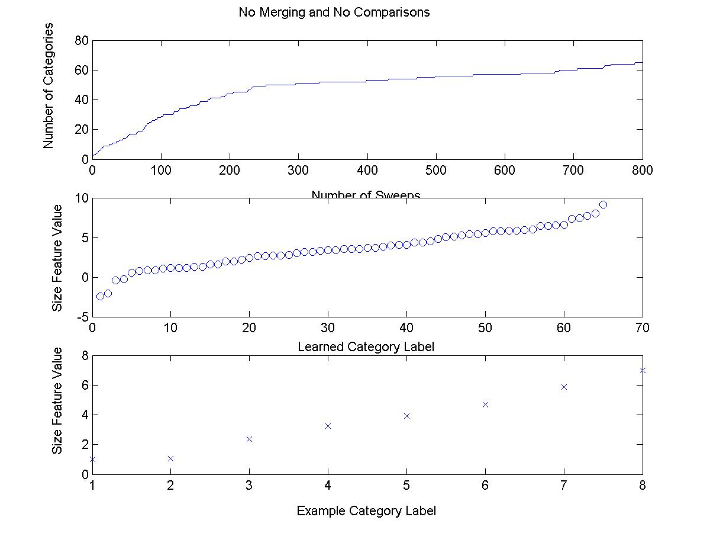

Fig 1. Size features of categories learned with no merges and no compares.

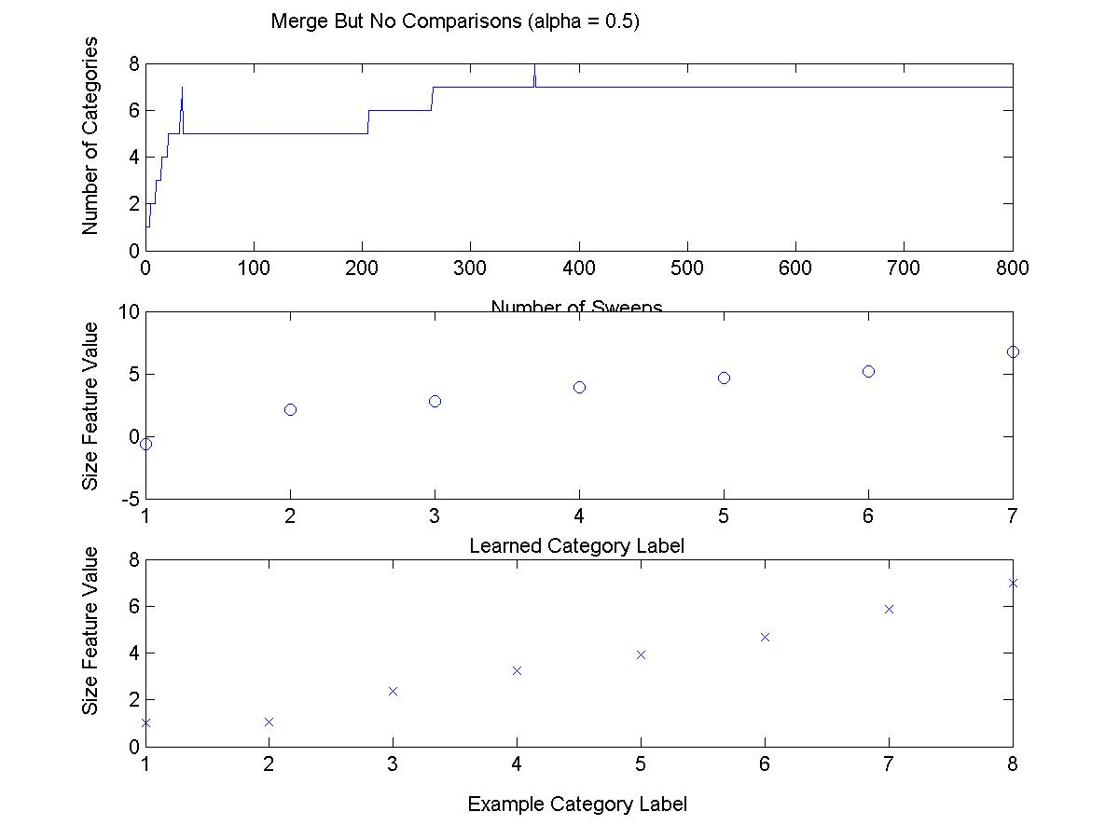

Fig 2. Size features of categories learned with merges but no compares (expt 1).

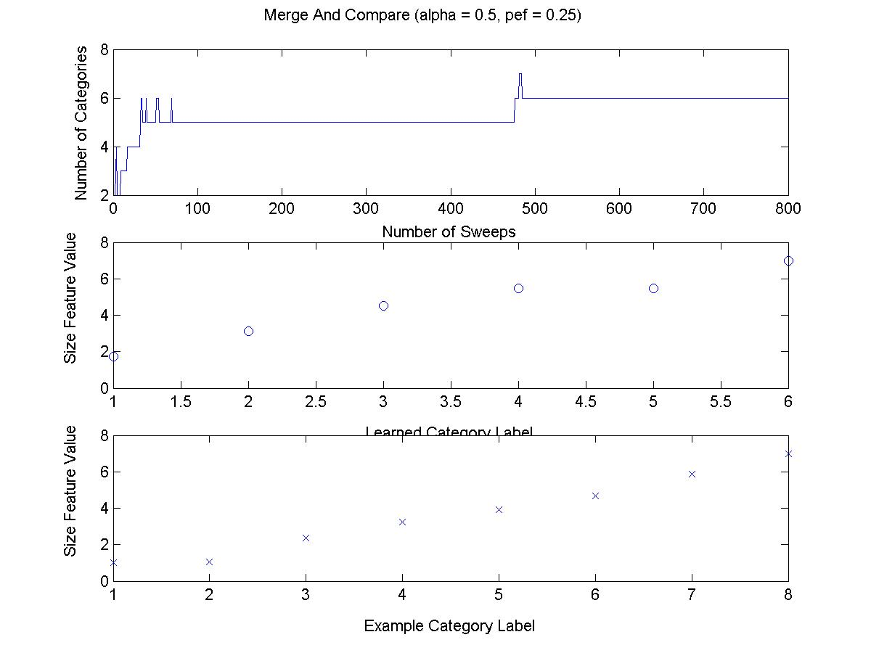

Fig 3. Size features of categories learned with merges and compares (expt 1).
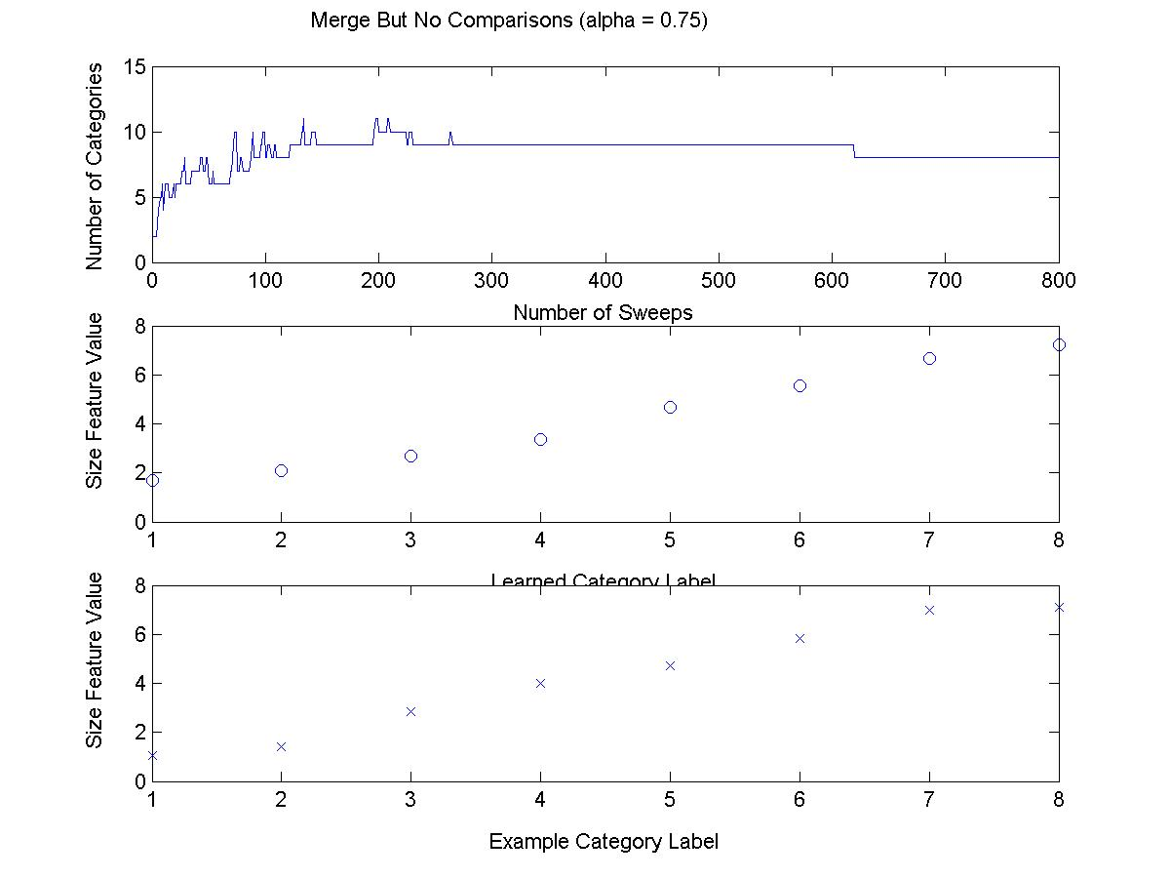

Fig 4. Size features of categories learned with merges but no compares (expt 2).
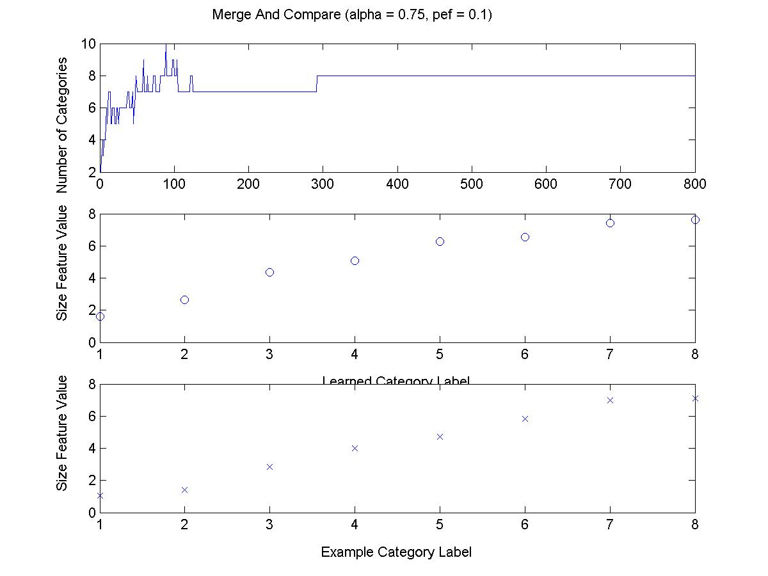

Fig 5. Size features of categories learned with merges and compares (expt 2).

Initialize parameters
updateCategoryModel

put into category if similar, else new category

trainCategoryModel

if no more data, done
else update;
merge and query
once in a while
mergeCategoryModel

keep merging if found

queryCategoryModel

compare example features, update model
Done

Fig 6. High-level algorithm overview.

Cate-gory

Size
Cute-ness
Fero-city
large (bin)

Fig 7. A Bayesian network implementation.

CS 289 Final Project, December 3, 2001

