Response Interference in Categorical Judgment Tasks
Ray Luo
University of California, Berkeley

Abstract
Response delay and facilitation in categorical judgment tasks were studied under the framework of two potentially competing theories. The negative priming model and the semantic coding model were presented as possible explanations of response interference. To test the models, subjects were asked to either choose the larger or choose the smaller of a pair of animals. Reaction time (RT) differences were found when subjects were required to choose an animal in the target trial that was previously ignored in the prime trial. For example, when subjects were asked to perform the same categorical judgment (e.g. choose larger) in both the prime and the target trial, mean (target trial RT minus prime trial RT) was found to be 29.9 msec. When subjects were asked to respond to the smaller of two small animals that was previously ignored, mean RT difference was found to be –152.1. Results indicate that neither negative priming nor semantic coding fully explains the data. A related effect known as semantic congruity, however, was found in the data and provided support for the coding model.

Response Interference in Categorical Judgment Tasks
We make binary categorical decisions almost continuously. Where should I move to? LA or San Francisco? Which day was warmer? Yesterday or today? Who is faster? Dan or Dave? Which is more important? Homework or video game? Natural questions arise in any attempt to understand human decision making processes. The two most debated research questions are: What type of information is represented by an encoding? And how does the processed information affect categorical response? This paper examines both of these traditional questions from a different perspective. Instead of focusing on “What?” and “How?” we will concern ourselves with the question “When?” namely, when do processing and response occur.
To describe categorical judgments more rigorously, two models of binary decision-making are presented and compared under a standard experimental procedure designed to measure reaction time. The first model was first used to explain a phenomenon observed in rapid encoding-response experiments. Tipper (1985) presented his subjects with pictures of two distinct objects, one in each color, and asked them to pay attention to only the object in a specified color. In the prime trial, for example, subjects might be presented with a green trumpet and a red anchor and might be asked to identify the green object. In the target trial, the previously ignored anchor would now appear in green along with some other arbitrary red object. It was found that in the target trial, reaction times (RTs) were significantly slower. Tipper explained this phenomenon by postulating a “negative priming” effect in which previously rejected stimuli suppressed subsequent response involving those stimuli. This model claims that information (such as object identity) is processed by mechanisms that inhibit irrelevant details.
In contrast with negative priming’s explanation of rapid object-incoherent response tasks is a different model that was first used to explain semantic information encoding during categorical judgment tasks. Banks et al. were the first to propose a semantic coding model to explain the results of symbolic comparative experiments (e.g. Banks, 1977). According this hypothesis, three types of mental structures are responsible for comparative judgments: database, processing codes, and processing mechanisms. Banks suggested that when a pair of stimuli is first presented, the processing mechanisms “generate processing codes from the data base and manipulate them until they match the previously stored and coded instructions” (p. 131). For example, suppose that the subject is presented with a table and a car and asked to choose the more expensive object. After this prime trial, the car is coded with E+ for expensiveness and table is coded with I+ for inexpensive, since an object can only be expensive or cheap, and not both. In the target trial, the same table is presented along with a box of crayons. When asked to choose the more expensive object, the response will be table, but the reaction time (RT) will be longer since the subject must convert the I+ encoding to an E+ encoding. Note that this is also what negative priming predicts: table is rejected in the prime trial, thus inhibiting the response in the target trial.
Now suppose instead that the subject is presented with the table and a diamond in the target trial. If she is asked to choose the less expensive object, the semantic coding model predicts a faster RT (since table is already coded as I+). Negative priming, however, suggests that the response ought to be slow because, again, the previously rejected stimulus (table) suppresses subsequent response involving the stimulus. Here, then, is the trial that distinguishes the two models.

Additional Considerations
Although each conjecture stated above gives a different prediction of the observed RT difference between target and prime trials, we cannot conclude that they contradict one another. Negative priming was traditionally used to model rapid, previously inhibited responses in the probe trial while semantic coding was used to explain memory mismatch between response and question posed. Studies have shown (Banks, Fujii & Kayra-Stuart, 1976) that in a set of trials involving the comparison of magnitudes of a pair of digits, subjects were faster when asked to pick the larger of two large digits (e.g. 8 and 9) and slower when asked to pick the smaller of two large digits. Similar effects were observed for smaller digits. It is possible that long term effects of repeatedly coding large digits as large and small digits as small contribute to this phenomenon. To distinguish the delay associated with judgment-instruction mismatch from semantic coding effects due to prime trial stimulation, we will refer to the phenomenon described above as semantic congruity, as Banks et al. have done.
Another complication involves the size differences between a pair of stimuli. Moyer and Landuer (1967) found that RTs associated with digit comparison tasks increased as the numerical difference between the two digits decreased. For example, subjects gave quick responses when asked to choose the larger of 3 and 8, and slow responses when asked to choose the larger of 6 and 7. This phenomenon, which we refer to as the distance effect, needs to be accounted for even under situations when semantic congruity is observed.
Instruction mismatch between prime and target trials can also influence the observed RT. We expect that subjects would need additional processing time to encode a new instruction during target trial (e.g. Which is smaller?) relative to the old instruction given in the prime trial (Which is larger?). Care must be taken to ensure that instruction mismatch is accounted for by appropriate controls.
We also need to control for the RT decrease or increase due to expectancy. When subjects are presented during the target trial with a stimulus that has already appeared in the prime trial, they may respond differently in different situations. They could, for example, find the coincidence bizarre. In this case, RTs would be longer than normal. They could also find that the processing is easier perform (since they already coded for the stimulus in a previous trial). In this case, RTs would be shorter than normal. Expectancy is an important contributor to observed RTs; another form of control is needed to account for it.

Recent Developments
Confrontation between negative priming and semantic coding was never considered in the literature because the former was used to model rapid inhibitory decision-making processes and the latter was used to predict RTs for a single trial due to coding mismatch in previous trials. Semantic mismatch was generally regarded as the result of discrepancies between the representation of the stimulus in the present trial and its representation in short or long term memory. Negative priming, on the other hand, modeled small RT differences in fast responses that rely on the speed of mental reflex. In other words, subjects were forced to analyze even the rejected stimulus in a semantic coding task, but were encouraged to pay no attention to the rejected stimulus in a negative priming task. Recall that in Tipper’s original experiments, subjects were not required to pay attention to the green object in order to recognize the red object.
Recently, the interpretation of negative priming given above has been dispelled by MacDonald, Joordens, and Seergobin (1999). In a series of experiments designed to test negative priming under conditions where attention to distractors was necessary, MacDonald et al. found that negative priming effects were enhanced. Subjects were asked to discriminate (not just recognize) the larger of two animals in both the prime and the probe trial. Distractors in the prime trial became targets in the probe trial. It was found that probe trial RTs were significantly longer than those in traditional negative priming experiments (e.g. Tipper, 1985, using Stroop color words). MacDonald et al. believed that their findings challenged “the basic assumption that the negative priming effect arises because the critical item was ignored or not attended to on the prime trial” (1999). We may ask, however, “Are these RT differences due to negative priming, or some other effect?” To qualify their interpretation, the present study examines a task in which both negative priming and semantic coding make predictions about outcome RTs. The task even allows us to distinguish between the two models because they give different predictions for a specific type of trial.

Method

Subjects
Six students at the Claremont Colleges (Pomona College and Harvey Mudd College, Claremont, California) participated in the experiment. Two of the students generated data for qualitative analysis only and did not sit through the entire experiment. The other subjects each performed the experiment three times, the first run being a practice exercise. All participants were sufficiently fluent in English to understand the stimuli displays. No subject had any difficulty seeing the stimulus array.

Apparatus
A Macintosh computer from the Pomona College psychology lab was used to display the stimuli and record the RTs of the response. The Superlab program was used to perform the experiment.

Procedure
Before the trials, subjects were given a list of all animal names used in the experiment: mouse, dog, horse, elephant, and whale. They were asked to verify the size order of the animals by ranking them in increasing integers of 1 to 5 (1 being the smallest). This was done to ensure familiarity of the subjects with the stimulus array. During each run, general instructions were followed by a total of 66 stimulus displays. Each successive display was shown right after the response to the previous display was received. Instructions for each pair of stimulus (i.e. choose smaller or choose larger) were shown at the center of the top of the screen; two animal names were shown at the left and right sides of the screen. The subjects were asked to press the “z” and “m” buttons to select the leftmost and rightmost animal, respectively.
Four types of trials were presented during each run. Fig. 1 shows a typical pair of prime and probe displays in the first type of trials (reliability trials). Note that negative priming (NP) and semantic coding (SC) give the same prediction in reliability trials. NP predicts a RT delay in the probe trial due to previous inhibition and SC predicts a RT delay in the probe trial due to coding mismatch. The second type of trials (discrimination trials) presented displays similar to the ones shown in Fig. 2. In this case, NP still predicts a RT delay during the probe trial. SC, however, predicts a shorter RT in the probe trial. As Fig. 2 shows, the distractor in the prime trial (horse) is coded S+. When asked in the probe trial for the smaller of whale and horse, the previously S+ encoding of horse ought to facilitate the response. Note, however, that in nature, horse is not generally speaking a small animal. Thus the semantic congruity effect predicts a slower RT just for the probe trial since the subject is asked to choose the smaller of two large animals. This illustrates a peculiarity in the discrimination trials. As Fig. 3 shows, displays involving a match in the instruction-judgment relationship (i.e. semantically congruent trials) were also used. In these pairs of prime and target trials, both semantic coding and semantic congruity predict a faster RT during probe response. From Fig. 3, dog was first coded as S+ in the prime trial. During the probe trial, the previously rejected smaller animal (dog) was asked for. In this case, dog is a small animal, so semantic congruity predicts a fast RT. Semantic congruity was not explicitly considered in the reliability trials. In that case, however, semantically congruent pairs were not systematically distributed. In calculating mean RT differences between prime and probe trials (i.e. mean(probe trial RT − prime trial RT) ), we expect the random placement of semantically congruent and incongruent pairs into probe and prime trials to cancel out the net semantic congruity effect.
The remaining two types of trials were part of a network of controls designed to isolate the difference in prediction given by NP, SC, and semantic congruity. Typical displays of control trials are shown in Fig. 4. Notice that prime and target stimuli are all different; no linkage between prime and target trials are predicted. To account for the expectancy effect, a new type of control known as associated control was introduced (see Fig. 5). In the associated control trials, the previously accepted animal was again asked for in the probe trial. If expectancy is indeed a factor, we expect RT differences between the responses given in prime and probe trials. We then subtract this difference from reliability and discrimination trial RTs to get the net effect of NP or SC.
To control for the distance effect, only animals similar in size were used in the reliability and discrimination trials. For example, elephant may be compared with horse or dog, but not with mouse. Similarly, whale would be compared with horse or elephant, but not with dog. The distance effect was not explicitly accounted for in the control and associated control trials although the placement of long distance vs. short distance pairs was randomized. If the distance effect were important in these trials, they would cancel each other when mean RT differences are calculated, since it is equally likely for a mouse-whale pairing to occur in the prime or the probe trial. Note also that each animal (mouse, dog, horse, elephant, and whale) is sufficiently distinguishable from each other in terms of size. There is also no clustering of animals into a particular size range. This ensures that the distance effect is predictable and easy to account for.
To control for instruction mismatch between prime and target trials, we allowed some control and associated control trials to display prime and probe arrays that differed in instructions (i.e. Which is larger? vs. Which is smaller?). The RT delay associated with these trials should be subtracted from RT differences found in discrimination trials, because all discrimination trial stimuli involved changes in instruction between prime and target displays.
Serial positioning of the stimuli was controlled by random placement of the animal names in the left and right sides of the display. As a consequence, correct keystroke responses for each display was also randomized (i.e. the probability of having the same correct keystroke response for both prime and probe trials is 0.5). Residual encoding was controlled by displaying a normative pair of stimuli before each trial. These normative displays contained animal names that matched none of the three animals names found in each reliability, discrimination, and associated control trials. The idea is that normative displays “normalizes” the playing field before each trial, so that RT differences can reliably be attributed to the prime and target trial responses. For the control trials, a normative display consisted of the animal ignored in the probe trial and another animal that appears in neither the prime nor the probe trials. Since there were only five animal names available, we felt that having an ignored name in the normative display would make virtually no difference in the mean RTs.
Another variable that we attempted to control was the time delay between successive displays. In half of the runs, subjects were given the standard treatment of randomized blocks of six reliability trials, six discrimination trials, six control trials, and four associated control trials. Each trial consisted of three displays (normative, prime, probe) in sequence. The order of appearance of the trials was randomized. Subjects were not given any breaks between successive stimuli pairs. In another half of the runs, each trial was preceded by a 2.5 second blank display followed by an instruction which asked the subject to press both “m” and “z” keys simultaneously to continue. The effect of these two extra displays was to slow down the experiment and eliminate any possible residual encoding left over from the previous trial. By comparing the results found in the fast runs against the slow runs, we can examine the effect of time delay between successive trials.

Results
In this experiment, we are interested in the RT difference (ΔRT) given by probe trial RT minus prime trial RT. It this number is positive, a RT delay in the target trial is observed; if this number is negative, task facilitation in the target trial is observed. Table 1 shows the mean ΔRT described above for each type of trial, averaged from about 20 to 40 samples each. Extreme outliers are excluded. Notice that ΔRT for the discrimination trials is greater than the ΔRT for the reliability trials. This, of course, does not take into account instruction mismatch effects, expectancy, or semantic congruity. Note also that the discrimination trials involving semantically congruent target responses (discrimination trials 3 and 5) display a large facilitation in the probe trial response. ΔRTs for instruction mismatch trials (control trials 2 and 5, associated control trial 1) are also calculated. Uncertainties for the data are given by standard deviation of the mean of the sample. Fig. 6 shows a box plot of the set of data. Note the greater variability of ΔRTs for semantically congruent discrimination probe trials. This is due to the smaller sample size for these trials, which are a subset of the discrimination trials.
To find the actual effects on ΔRT due to each type of stimuli, we first subtract the mean control trial ΔRT from the mean ΔRTs for reliability, discrimination, associated control, and semantically congruent trials (instruction mismatch trials are essentially a subset of the control trials). The reason mean ΔRT for control trials is slightly negative is that subjects felt more comfortable with each successive display during any given trial (the effect is most conspicuous for the slow runs). Next, we subtract the mean associated control ΔRT from the result calculated as above. The mean ΔRT for associated control trials is slightly positive (since we had to subtract control trial mean ΔRT from it to get the net effect) indicating a RT delay due to expectancy. Finally, we subtract the mean instruction mismatch ΔRT from the resulting mean ΔRTs of discrimination and semantically congruent trials found above (we do not subtract from the reliability trials because for these trials, all instructions were congruent for prime and probe displays). Doing all the calculations we just mentioned, we obtain the net ΔRT due to specific types of trial stimuli. These results are given in Table 2 and illustrated graphically in Fig. 7.
In Table 2, the error given for each mean ΔRT is found by propagating from the errors in Table1.
From Fig. 7, we observe that negative priming cannot explain the semantic congruity effect. For example, given two small animals, subjects will choose the smaller of the two quickly despite what occurs in a previous trial. Negative priming does not explain ΔRT for discrimination trials particularly well since the mean ΔRT is nearly zero, indicating neither inhibition nor facilitation. Semantic coding does not explain the discrimination trial ΔRT very well either since the expected facilitation does not occur. In any case, both theories support the findings in the reliability trials since mean RTs are increased in the probe trial as expected. The most statistically significant piece of information in Table 2 is the large target facilitation found in discrimination trials where targets and instructions are semantically congruent (e.g. Fig. 3). This indicates that even in a fast experimental task, previous semantic encoding is extremely important. Every time we see the words elephant or whale, for example, we automatically retrieve out of our memory the concept of large size. It appears that semantic congruity is a part of every judgment the subject makes. The influence of development and previous coding seems strong even for a rapid judgment task.

Fast vs. Slow Runs
Further analysis of the experimental data reveals some surprising results. When we separate the mean ΔRTs for slow and fast runs of the experiment, we find that, contrary to expectations, reliability trial mean ΔRT decreases and discrimination trial mean ΔRT increases. Semantically congruent discrimination trial mean ΔRT stays about the same. Negative priming can now better explain the discrimination data and semantic coding falls apart for the same data. Both results, however, are extremely variable. Many of the effects observed may simply be due to random chance. We therefore concluded that to alter ΔRTs significantly, greater change of speed is necessary for this particular task.

Discussion
According to MacDonald et al. negative priming effects are increased for tasks where attention to distractors is required. In this experiment, we have challenged the assumption that the RT increases observed for these tasks are actually due to negative priming. Negative priming predicts that previously ignored stimuli are inhibited in the probe trial. We found, however, that in tasks such as those given by Fig. 3, response to ignored stimulus is actually significantly enhanced in the probe trial. If negative priming is to explain the wider scope associated with semantic interference tasks, it must append to its simple theoretical framework an account of phenomena such as the semantic congruity effect.
According to Banks et al. semantic coding is responsible for the cross-trial interference found in a categorical judgment task. While this experiment does not contradict the semantic coding hypothesis for successive trials, it does offer some insight into possible improvements of the theory. It is noted that long-term coding effects are more important than immediate encoding of information. In fact, between-trials encoding seems to neither facilitate nor delay probe trial RTs. This experiment supports the claim, however, that information in a categorical judgment task is indeed coded by categorical variables such as L+ and S+.

Implications
Looking again at the data from Table 2, we must conclude that semantic coding or learning takes place slowly. In a rapid decision-making task, information is retrieved from memory, and not necessarily encoded from previous trials. Hence the effect of semantic congruity is significant but the effect of semantic coding is not. We can understand the data by postulating an automatic mechanism for semantic processing. Every time we see the word whale or elephant, L+ encoding is retrieved from memory, and not directly encoded. The next time we see whale or elephant, L+ is retrieved again. This experiment supports the idea that the mind does not keep a handful of information at its fingertips, even in a rapid binary decision task. If it did, we would see large semantic coding effects or perhaps even negative priming. Instead, the mind asks for the encoding again and again, comparing it each time to relevant information and discarding the result as time passes. This new model of code processing is given in Fig. 8.
Under this model of memory processing, we would explain a typical trial as follows. First the subject is told about the category of discrimination, in this case, size. This shifts the memory system into a binary coding mode involving two categories: L+ and S+. A whale and a horse are presented, with instructions asking for the larger animal. As soon as the word whale is read, the binary coding machine (mind) automatically processes whale as L+. Similarly horse is processed as L+. Now the machine must distinguish between the larger of two L+s. This is where the bulk of the processing time is distributed. After generating a response, most of the encoded information is thrown out since a new pair of stimuli now appears. The process continues until the end of the experiment. How, then, does the mind learn (and remember certain codes) ? It learns by focusing attention to the task. It must process and encode a specific piece of information continuously. For example, if it must learn that a “quoma” is “large,” then it must associate quoma with the L+ binary encoding. If the association between quoma and large is weak, RT for the next target trial quoma will be long. For familiar objects, however, the machine already has encoded information available; it need not encode additional information.

Qualification
We have been concentrating on the large drop in target RT associated with semantically congruent discrimination trials. One important qualification must be put in place. When we examine the 5th discrimination trials, we note that not only is the probe display semantically congruent, but that the prime display is semantically congruent as well (see Fig. 3). (This does not occur in the other semantically congruent discrimination trial.) Yet we observe an extremely negative ΔRT for these trials? If semantic congruity is the sole factor in determining RTs, then trial 5 ΔRTs should be zero. This suggests that there is a complex interaction between semantic coding and semantic congruity. It appears that long term and short term processing can influence each other in complicated ways. If neither semantic coding nor semantic congruity can fully explain the data, then we need a new theory that models the interactions between long term and short term semantic coding. The solution to this problem may lie in the analogous interactions between automatic and controlled processing.

References
Banks, W.P. Encoding and processing of symbolic information in comparative judgments. In G. H. Bower (Ed). (1977). The Psychology of Learning and Motivation, Vol 2. New York: Academic Press.
Banks, W. P., Fujii, M., & Kayra-Stuart, F. (1976). Semantic congruity effects in comparative judgments of magnitudes of digits. Journal of Experimental Psychology: Human Perception and Performance, 2, 435-447.
MacDonald, P. A., Joordens, S., & Seergobin, K. N. (1999). Negative priming effects that are larger than a breadbox: Attention to distractor does not eliminate negative priming, it enhances it. Memory & Cognition, 27(2), 197-207.
Moyer, R. S., & Landauer, T. K. (1967). The time required for judgments of numerical inequality. Nature, 215, 1519-1520.
Tipper, S. D. (1985). The negative priming effect: Inhibitory priming by ignored objects. Quarterly Journal of Experimental Psychology, 37A, 571-590.
Tipper, S. D., & Cranston, M. (1985). Selective attention and priming: Inhibitory and facilitatory effects of ignored primes. Quarterly Journal of Experimental Psychology, 37A, 591-611.

Tables and Figures
Type of Trial | Mean RT Difference | Error in Mean RT Difference
Reliability | 23.3 | 41
Discrimination | 58 | 47
Control | -37.8 | 37
Associated Control | -6.6 | 39
Semantically Congruent | -95.2 | 90
Instruction Mismatch | 63.5 | 46

Table 1: Mean of probe trial RT minus prime trial RT for each type of trial. Note that semantically congruent trials are a subset of discrimination trials and that instruction mismatch trials are a subset of control and associated control trials.

Type of Trial | Net Mean RT Difference | Error in Net Mean RT Difference
Reliability | 29.9 | 77
Discrimination | 1.1 | 92
Semantically Congruent | -152.1 | 120

Table 2: Net mean RT differences calculated by taking into account appropriate controls, expectancy and instruction mismatch. This gives the net effect of varying each probe trial variable. Note that only semantically congruent trial data is significant with respect to the errors.

Prime Trial: Probe Trial:

Which is larger? Which is larger?

Figure 1: Typical displays in prime and probe trials in a reliability trial. Predictions of each model:
Negative priming: elephant ignored in prime, response to elephant slow in probe.
Semantic coding: elephant coded as S+ in prime, response to elephant slow in probe since we ask
for the larger animal.

Prime Trial: Probe Trial:

Figure 2: Typical displays in prime and probe trials in a discrimination trial. Predictions are:
Negative priming: horse ignored in prime, response to horse slow in probe.
Semantic coding: horse coded as S+ in prime, response to horse fast in probe since we ask for the
smaller animal.

Which is larger?

Which is smaller?

Prime Trial: Probe Trial:

Figure 3: Typical displays in prime and probe trials in a semantically congruent discrimination trial.
Negative priming: dog ignored in prime, response to dog slow in probe.
Semantic coding: : dog coded as S+ in prime, response to dog fast in probe since we ask for the
smaller animal. (Due to semantic congruity, response should be very fast.)

Which is larger?

Which is smaller?

Prime Trial: Probe Trial:

Figure 4: Typical displays in prime and probe trials in a control trial. Predictions for each model:
Negative priming: elephant ignored in prime, no effect on response to horse in probe.
Semantic coding: elephant coded as L+ in prime, no effect on response to horse in probe.
(Control is used to compute net effect of trial stimuli arrangements.)

Which is smaller?

Which is smaller?

Prime Trial: Probe Trial:

Figure 5: Typical displays in prime and probe trials in an associated control trial. Predictions are:
Negative priming: elephant ignored in prime, no effect on response to horse in probe.
Semantic coding: horse coded as S+ in prime, response to horse slow in probe since we ask for the
larger animal.

Which is smaller?

Which is larger?

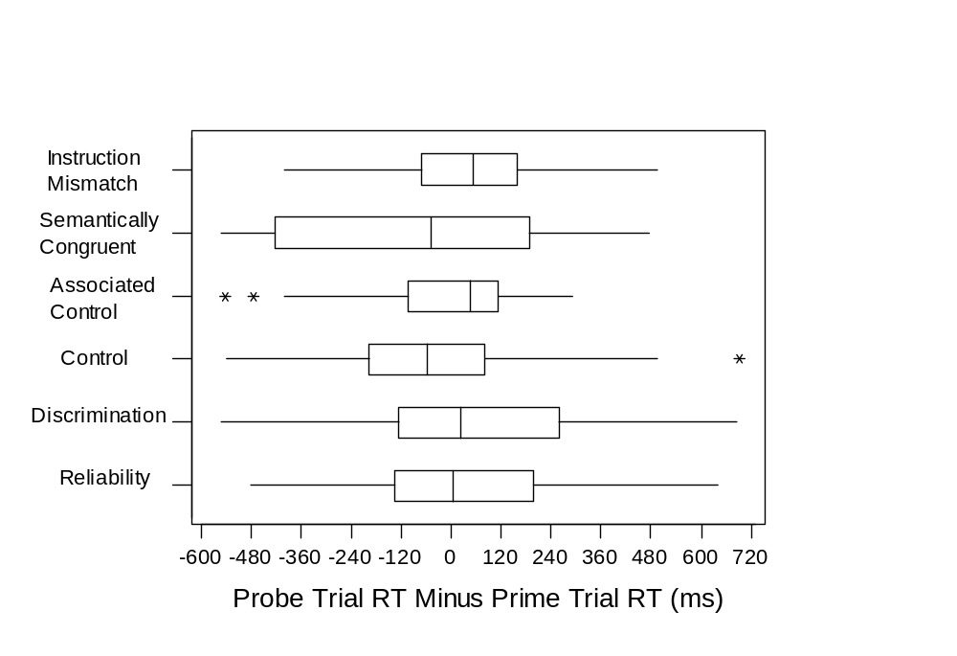Figure 6: Box plots of the result in Table 1. Note the outliers represented as stars.

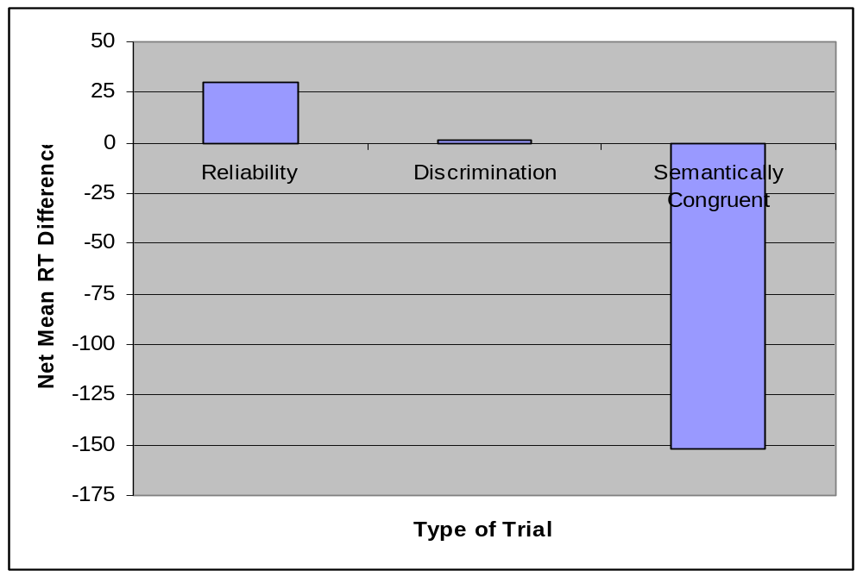Figure 7: Graphical display of net mean RT differences found in Table 2. Error bars omitted.

Response

Figure 8: Revised model of semantic information processing using the memory retrieval machine.
Here, the memory machine has been primed as a binary (large/small) processor. The processing is semantically congruent in this case.
Stimulus 1
Stimulus 2

Coding Machine

This paper was part of the work pursued while a student of Harvey Mudd College. Revised and reedited for presentation.

