|  |  |  |
| --- | --- | --- |
| RESTAURANT_ID (PK) | NAME | ADDRESS |
|  |  |  |

RESTAURANT

PARAMETER

|  |  |
| --- | --- |
| ID (PK) | NAME |
| 1 | Food |
| 2 | Ambiance |
| 3 | service |

RATINGS

|  |  |
| --- | --- |
| ID (PK) | NAME |
| 1 | WORST |
| 2 | BAD |
| 3 | OK |
| 4 | GOOD |
| 5 | EXCELLENT |

REVIEW

PK

|  |  |  |  |  |  |
| --- | --- | --- | --- | --- | --- |
| ID | NAME | RESTAURANTNAME | PARAMETERNAME | RATINGID | REVIEWDESCRIPTION |
|  |  |  |  |  |  |

**CLASS DIAGRAM**

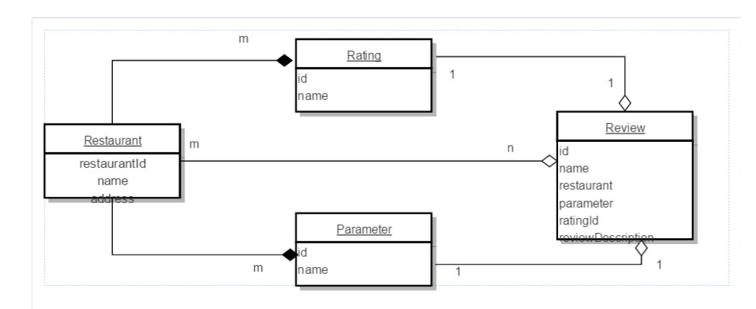

|  |
| --- |
| CREATE TABLE RESTAURANT(  -> RESTAURANT_ID INT NOT NULL AUTO_INCREMENT,  -> NAME VARCHAR(100) NOT NULL,  -> ADDRESS VARCHAR(500) NOT NULL,  -> PRIMARY KEY(RESTAURANT_ID));  INSERT INTO RESTAURANT(RESTAURANT_ID,NAME,ADDRESS) VALUES (1, "Nanadana","J P Nagar");  INSERT INTO RESTAURANT(NAME,ADDRESS) VALUES ("Andhra Spice","R R Nagar");  select * from restaurant;  CREATE TABLE RATINGS (  ID INT NOT NULL AUTO_INCREMENT,  NAME VARCHAR(100) NOT NULL,  PRIMARY KEY(ID));  INSERT INTO RATINGS(NAME) VALUES ("WORST");  INSERT INTO RATINGS(NAME) VALUES ("BAD");  INSERT INTO RATINGS(NAME) VALUES ("OK");  INSERT INTO RATINGS(NAME) VALUES ("GOOD");  INSERT INTO RATINGS(NAME) VALUES ("EXCELLENT");  select * from RATINGS;  CREATE TABLE PARAMETERS(  ID INT NOT NULL AUTO_INCREMENT,  NAME VARCHAR(100) NOT NULL,  PRIMARY KEY(ID));  INSERT INTO PARAMETERS(NAME) VALUES ("FOOD");  INSERT INTO PARAMETERS(NAME) VALUES ("AMBIANCE");  INSERT INTO PARAMETERS(NAME) VALUES ("SERVICE");  select * from PARAMETERS;  create table review (  id int not null auto_increment,  name varchar(100) not null,  restaurantName varchar(100) not null references restaurant(name),  parameterName varchar(100) not null references parameter(name),  ratingId int not null references ratings(id),  reviewDiscription varchar(500) not null,  primary key (id,restaurantName,parameterName));  insert into review(id,name,restaurantName,parameterName,ratingId,reviewDiscription) values(1,"Amita","BBQ","food",5,"Excellent");  insert into review(id,name,restaurantName,parameterName,ratingId,reviewDiscription) values(2,"Amita","BBQ","food",4,"Good");  insert into review(id,name,restaurantName,parameterName,ratingId,reviewDiscription) values(3,"Raj","A2B","food",3,"OK");  insert into review(id,name,restaurantName,parameterName,ratingId,reviewDiscription) values(4,"Rahul","A2B","food",2,"Bad");  insert into review(id,name,restaurantName,parameterName,ratingId,reviewDiscription) values(1,"Amita","BBQ","food",5,"Excellent");  insert into review(id,name,restaurantName,parameterName,ratingId,reviewDiscription) values(1,"Amita","BBQ","food",5,"Excellent");  insert into review(id,name,restaurantName,parameterName,ratingId,reviewDiscription) values(1,"Amita","BBQ","food",5,"Excellent");  insert into review(id,name,restaurantName,parameterName,ratingId,reviewDiscription) values(1,"Amita","BBQ","food",5,"Excellent");  **Get Overall Ratings:**  select restaurantName, parameterName, AVG(ratingId) from review where restaurantName="A2B" group by parameterName having parameterName="service";  **Fetch Restaurants based on parameter and restaurantName:**  select restaurantName, parameterName, AVG(ratingId) from review group by parameterName, restaurantName |